
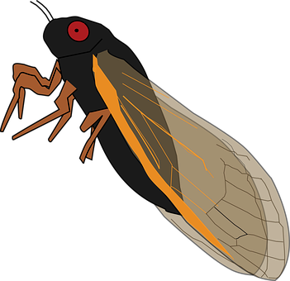Cicada

Red Wire: 5V to 24V (DC only)
Black Wire: GND
White Wire: GND to Activate
SND-BUG $19.00
Cicada

Red Wire: 5V to 24V (DC only)
Black Wire: GND
White Wire: GND to Activate
SND-BUG $19.00
Cicada

Red Wire: 5V to 24V (DC only)
Black Wire: GND
White Wire: GND to Activate
SND-BUG $19.00
Cicada

Red Wire: 5V to 24V (DC only)
Black Wire: GND
White Wire: GND to Activate
SND-BUG $19.00
Cicada

Red Wire: 5V to 24V (DC only)
Black Wire: GND
White Wire: GND to Activate
SND-BUG $19.00
Cicada

Red Wire: 5V to 24V (DC only)
Black Wire: GND
White Wire: GND to Activate
SND-BUG $19.00
Cicada

Red Wire: 5V to 24V (DC only)
Black Wire: GND
White Wire: GND to Activate
SND-BUG $19.00
Cicada

Red Wire: 5V to 24V (DC only)
Black Wire: GND
White Wire: GND to Activate
SND-BUG $19.00
Cicada

Red Wire: 5V to 24V (DC only)
Black Wire: GND
White Wire: GND to Activate
SND-BUG $19.00
Cicada

Red Wire: 5V to 24V (DC only)
Black Wire: GND
White Wire: GND to Activate
SND-BUG $19.00
www.iascaled.com
www.iascaled.com
www.iascaled.com
www.iascaled.com
www.iascaled.com
www.iascaled.com
www.iascaled.com
www.iascaled.com
www.iascaled.com
www.iascaled.com

