Crossing Bell
Default Bell
Crossing Bell
Safetran (Mechanical)
Crossing Bell
Safetran (Hybrid)
Crossing Bell
Union Switch & Signal Teardrop (Mechanical)
Crossing Bell
Western-Cullen-Hayes 333 (Mechanical)
Crossing Bell
Western-Cullen-Hayes 777 (Electronic)
Crossing Bell
Western Railroad Supply Type 222 (Mechanical)

Cicada
CTC Bell
US&S Model 506 CTC Console Bell
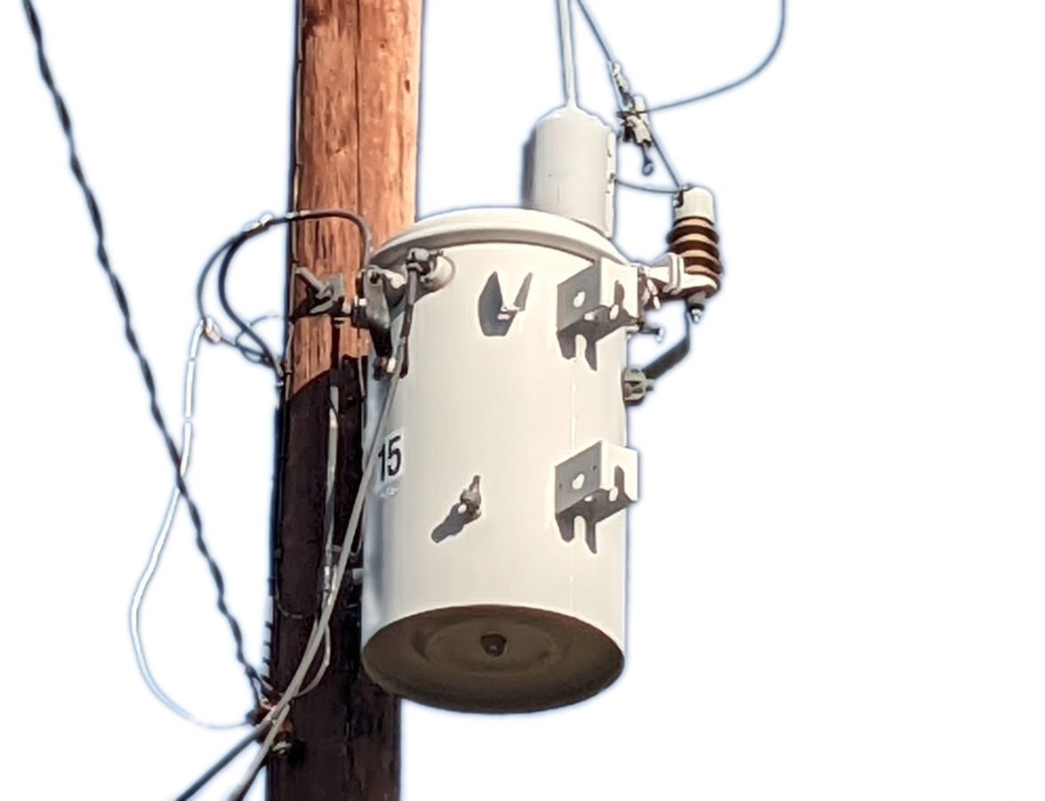
Transformer Hum

