
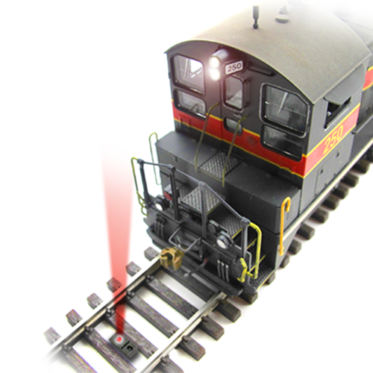
The TrainSpotter is a simple infrared proximity sensor that makes detection of model railroad locomotives or rolling stock easy and reliable. Just place the sensor where its invisible light beam will reflect off the object of interest and you're done - no time-consuming or frustrating adjustments! Based on modern silicon technology, this sensor is tolerant of ambient (background) lighting conditions, be it completely dark or under full lights, with no false triggering. Combined with a discrete under-track installation, this low-profile sensor solves many of the challenges that plague other optical detector products.

Features
● Small size (0.25" x 2.25")
● No adjustment needed!
● Simple, discrete under-track installation
● Variable release time
● Two opposite polarity, open-collector outputs (40V / 250mA capable)
● Tolerant of ambient (background) lighting conditions - no false triggering
● Powered from 5V to 24V
● Optional mounting bracket available

Typical Applications
● Activate grade crossing signals
● Trigger sounds
● Build an automatic interchange
● Indicate end-of-track in hidden staging yards
● Detect block occupancy for signal systems
● C/MRI track occupancy inputs
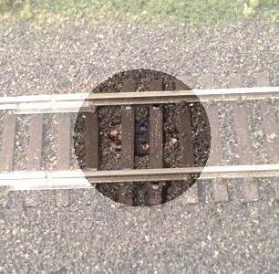

Installation
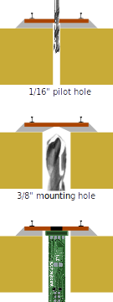
The sensor is designed to be installed up through the benchwork in a 3/8 inch (10 mm) hole. To install in existing track, first drill a 1/16” pilot hole between the ties. Then, from the bottom, drill a 3/8” hole up toward the track, using the pilot hole you just drilled as a guide. Work slowly and be very careful to not damage the ties (you might want to remove a couple of ties first and reinsert them after drilling the hole). Once the sensor is installed, be sure that both lenses are clear to shine up between any ties or ballast.
The module is not naturally water resistant, so be careful when ballasting. Some amount of water resistance can be added by coating everything (other than the lenses) with liquid electrical tape or similar sealant. Be very careful not to cloud or cover the sensor lenses.
The sensor can be secured in the hole using a variety of methods such as hot glue or by using a mounting bracket. See the Iowa Scaled Engineering website for more details and to order a mounting bracket.

Electrical Connections
Input power needs to be 5-24 volts of clean direct current (DC) for proper operation. Noisy power supplies may cause issues with detection, and supply voltages exceeding 24V DC may damage the device. The red wire should be connected to the positive side of the power supply and the black wire to the negative.
Two outputs are available, both of which are “open drain” (also known as “open collector”). This means that they act like a switch to the ground / negative lead. When an output is “active”, it will conduct current to ground. When an output is “inactive”, it will act like an open circuit and not pass any current. Each output can handle a maximum of 0.25 amps, and should be exposed to no more than a 40V DC supply. The white output is active when the sensor is detecting an object. The blue output is active when the sensor is not detecting an object.
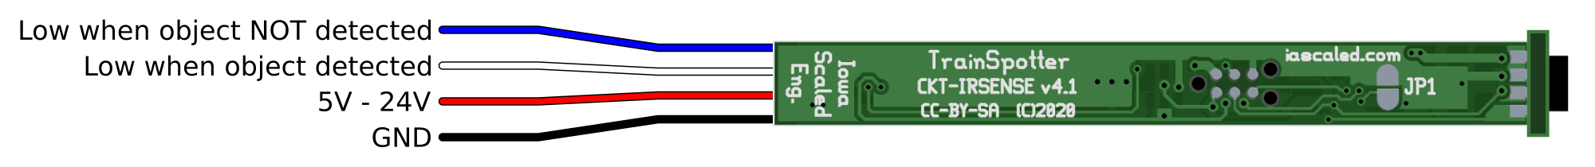Figure 1: CKT-IRSENSE Connections

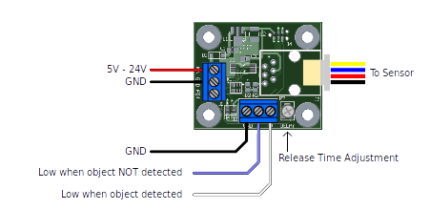Figure 2: CKT-IRSENSE-2PC Connections

Driving Other Circuits
If a logic level output is needed, to drive a grade crossing controller, for instance, use a 4.7k to 10k ohm resistor to pull the output up to the positive logic supply. See Figure 3. The CKT-IRSENSE should share the same ground connection (black wire) with the circuit being driven.
To drive an LED, connect a current-limiting resistor in series with the LED and connect the LED cathode to the CKT-IRSENSE output as shown in Figure 4. Figure 5 shows a similar method to drive a relay.
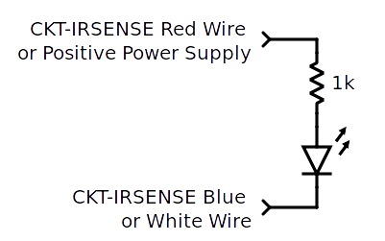Figure 4: Driving an LED
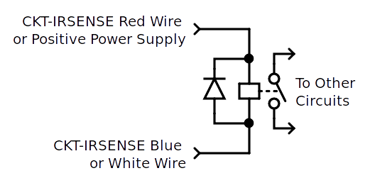Figure 5: Driving a Relay
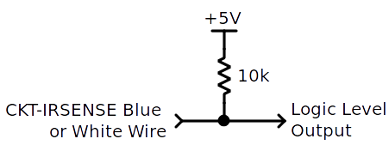Figure 3: Logic Level Output
Since the outputs are open drain, outputs from multiple sensors can be connected in parallel to create one common output. This common output will pull low whenever any one sensor pulls its output low.

Sensing Distance
The sensor is pre-calibrated to a typical detection range of ~1.5” and needs no user adjustment for most applications. However, the detection distance will vary based on the reflectivity of the object being sensed. If other ranges are needed, contact us for custom programmed devices. The detection range can be adjusted from approximately 0.5” to 3”.

Activation Time
The activation time is preset to 0.1 seconds. The outputs will indicate an object is detected if the object is present over the sensor for 2 consecutive readings spaced 100ms apart. This helps eliminate errant readings. As a consequence, there will be a slight (0.1s) delay before an object is detected. For most model railroad applications, this is not an issue. If longer (or shorter) activation times are required, we can provide custom programmed devices. Please contact us with your requirements.

Release Time
The default release time is preset to 0.1 seconds. The outputs will indicate an object is not detected if the sensor is clear for 2 consecutive readings spaced 100ms apart.
To stop the outputs from toggling, for example, in the spaces between rolling stock as it travels over the sensor, the release time can be increased. On the single piece version (CKT-IRSENSE) the release time can be changed to 5 seconds by shorting jumper JP1 on the back side. Solder this jumper closed to activate the longer delay.
For the 2-piece version (CKT-IRSENSE-2PC), there is an adjustment potentiometer (variable resistor) located next to the output terminal block. Rotating it clockwise will increase the release time, whereas rotating it counter-clockwise will decrease the release time. The maximum release time is 23 seconds.
Custom delay times (up to 23 minutes) are available for either version of the sensor upon request.

Automatic Interchange
An automated interchange track, similar to the one described in the September 2006 issue of Model Railroader magazine, can be assembled using a CKT-IRSENSE (or CKT-IRSENSE-2PC) and a relay module (ACC-RELAY1). The IR sensor is placed near the switch end of the interchange track. When the sensor is covered by a piece of rolling stock, the blue output line is released, causing the relay module (configured to activate with a low input) to be in the normal position. The normally-open (NO) contacts of the relay cut track power.
After a train picks up the cars covering the sensor, the blue output line then pulls low. This causes the relay to activate, closing the circuit between the COM and NO terminals, and applying power to the track. The locomotive is configured to push another cut of cars forward until they cover the sensor. At that point, track power is once again cut and the cars are available to be picked up by the next train.
The release time of the sensor can be used to delay the time between the cars being picked up and when the locomotive begins to push the next cut of cars. Custom delays, on the order of minutes, can be useful for this application. Contact us for details.
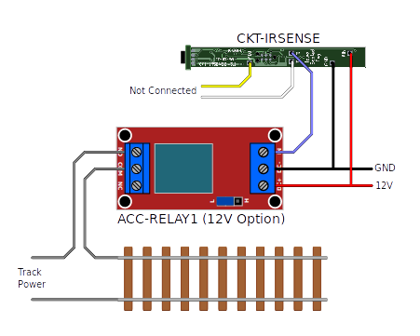Figure 6: Automatic Interchange

Ordering Information
Model | Description
CKT-IRSENSE | Reflective Infrared Proximity Sensor
CKT-IRSENSE-2PC | Reflective Infrared Proximity Sensor with Remote Sensor

Open Design
Iowa Scaled Engineering is committed to creating open designs that users are free to build, modify, adapt, improve, and share with others.
The design of the CKT-IRSENSE and CKT-IRSENSE-2PC hardware is open source hardware, and is made available under the terms of the Creative Commons Attribution-Share Alike v3.0 license, a copy of which is available from:
http://creativecommons.org/licenses/by-sa/3.0/
Design files can be found on the Iowa Scaled Engineering website:
http://www.iascaled.com/store/CKT-IRSENSE
http://www.iascaled.com/store/CKT-IRSENSE-2PC
The official Iowa Scaled Engineering firmware for the CKT-IRSENSE and CKT-IRSENSE-2PC is free software: you can redistribute it and/or modify it under the terms of the GNU General Public License as published by the Free Software Foundation, either version 3 of the License, or (at your option) any later version. A copy of the GNU GPL can be found at:
http://www.gnu.org/licenses/gpl.html
New firmware can be flashed into the CKT-IRSENSE through J1 or the CKT-IRSENSE-2PC through J4. The six land pads implement the standard AVR 6-pin ISP header on a connector compatible with the Tag-Connect TC2030 cable.
Stable releases of firmware and source code can be found on the Iowa Scaled Engineering website.


www.iascaled.com
support@iascaled.com

