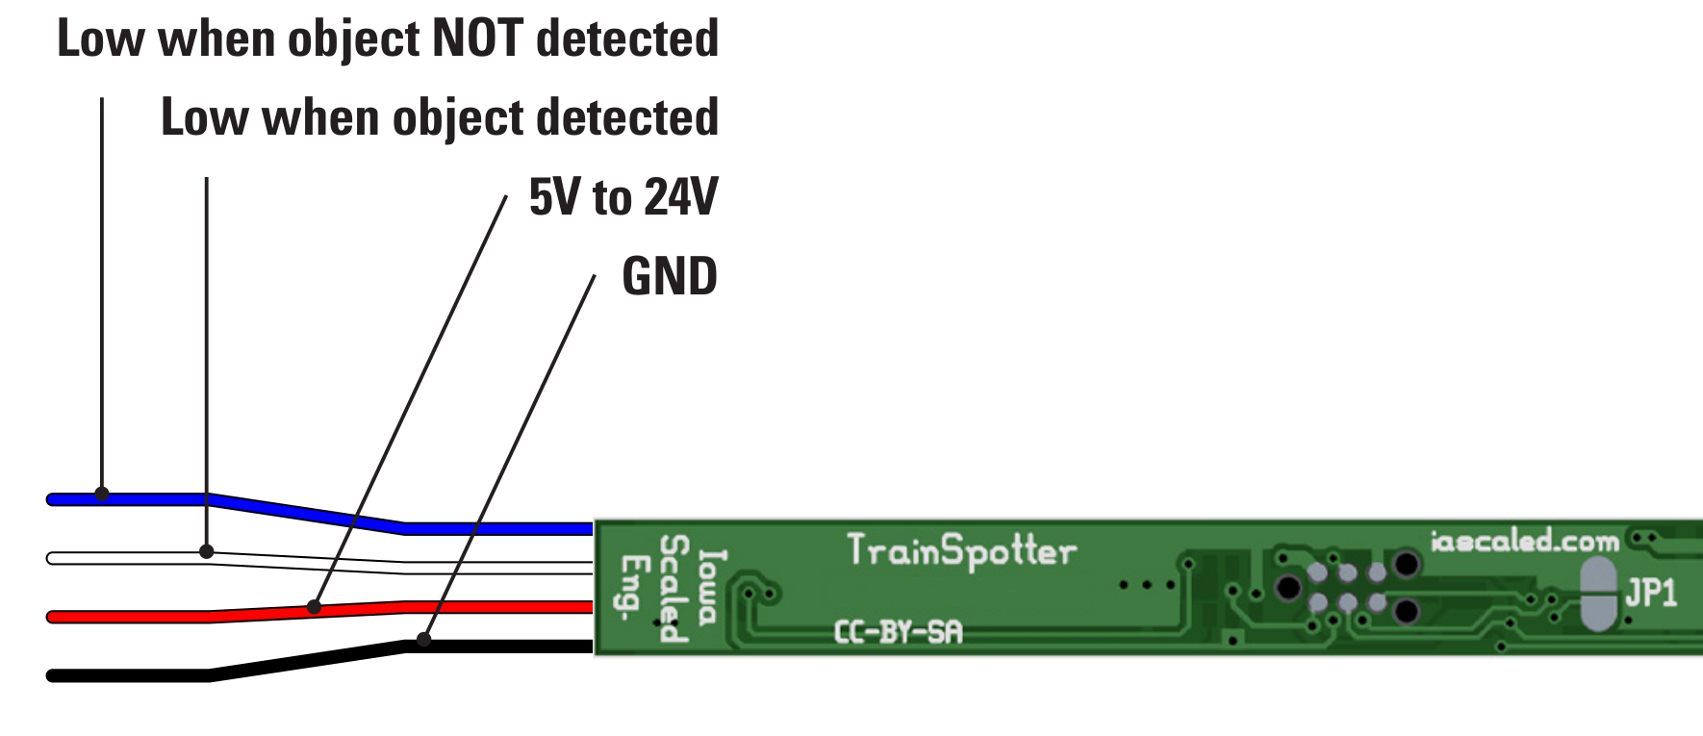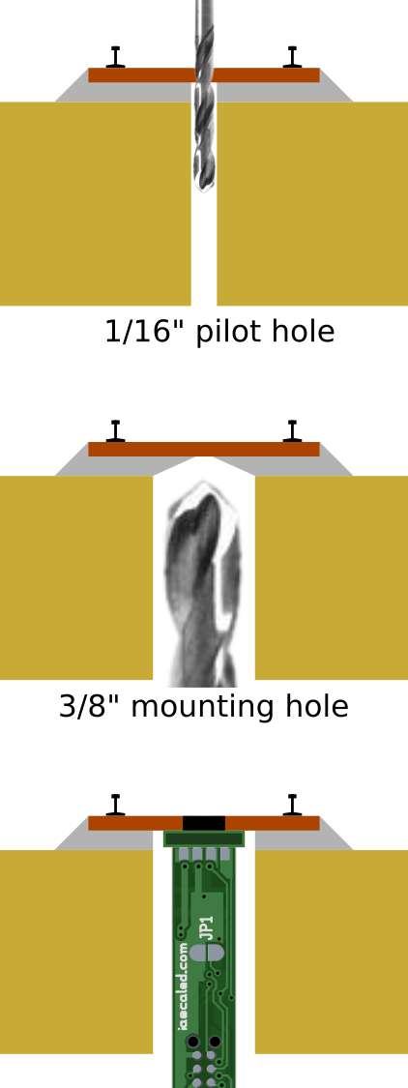The TrainSpotter is a simple infrared proximity sensor that makes detection of model railroad locomotives and rolling stock easy and reliable. Just place the sensor where its invisible light beam will reflect off the object of interest and you’re done – no time-consuming or frustrating adjustments! Based on modern silicon technology, this sensor is tolerant of ambient (background) lighting conditions, be it completely dark or under full lights, with no false triggering. With a discrete under-track installation, this low-profile sensor solves many of the challenges that plague other optical detector products.

Typical Applications
● Activate grade crossing signals
● Trigger sounds
● Build an automatic interchange
● Indicate end-of-track in hidden staging yards
● Detect block occupancy for signal systems

The TrainSpotter is a simple infrared proximity sensor that makes detection of model railroad locomotives and rolling stock easy and reliable. Just place the sensor where its invisible light beam will reflect off the object of interest and you’re done – no time-consuming or frustrating adjustments! Based on modern silicon technology, this sensor is tolerant of ambient (background) lighting conditions, be it completely dark or under full lights, with no false triggering. With a discrete under-track installation, this low-profile sensor solves many of the challenges that plague other optical detector products.

Typical Applications
● Activate grade crossing signals
● Trigger sounds
● Build an automatic interchange
● Indicate end-of-track in hidden staging yards
● Detect block occupancy for signal systems

The TrainSpotter is a simple infrared proximity sensor that makes detection of model railroad locomotives and rolling stock easy and reliable. Just place the sensor where its invisible light beam will reflect off the object of interest and you’re done – no time-consuming or frustrating adjustments! Based on modern silicon technology, this sensor is tolerant of ambient (background) lighting conditions, be it completely dark or under full lights, with no false triggering. With a discrete under-track installation, this low-profile sensor solves many of the challenges that plague other optical detector products.

Typical Applications
● Activate grade crossing signals
● Trigger sounds
● Build an automatic interchange
● Indicate end-of-track in hidden staging yards
● Detect block occupancy for signal systems

The TrainSpotter is a simple infrared proximity sensor that makes detection of model railroad locomotives and rolling stock easy and reliable. Just place the sensor where its invisible light beam will reflect off the object of interest and you’re done – no time-consuming or frustrating adjustments! Based on modern silicon technology, this sensor is tolerant of ambient (background) lighting conditions, be it completely dark or under full lights, with no false triggering. With a discrete under-track installation, this low-profile sensor solves many of the challenges that plague other optical detector products.

Typical Applications
● Activate grade crossing signals
● Trigger sounds
● Build an automatic interchange
● Indicate end-of-track in hidden staging yards
● Detect block occupancy for signal systems

