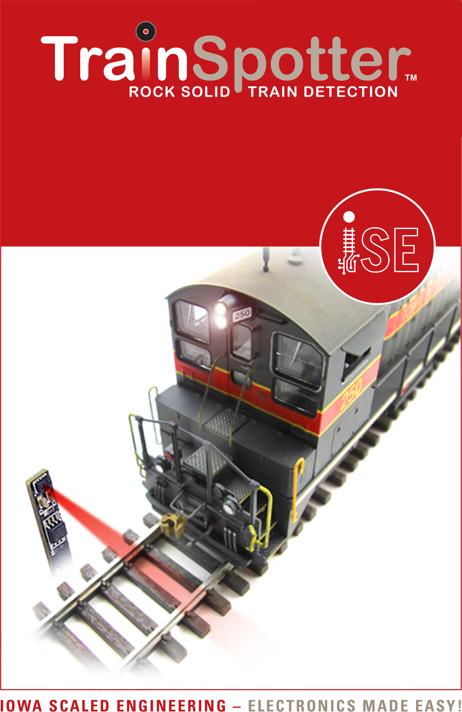
Reflective Infrared Proximity Sensor with Right-Angle Sensor

www.iascaled.com
2x CKT-IRSENSE-RA
With 8’ cables
Reflective Infrared Proximity Sensor with Right-Angle Sensor

www.iascaled.com
2x CKT-IRSENSE-RA
With 8’ cables
Reflective Infrared Proximity Sensor with Right-Angle Sensor

www.iascaled.com
2x CKT-IRSENSE-RA
With 8’ cables
Reflective Infrared Proximity Sensor with Right-Angle Sensor

www.iascaled.com
2x CKT-IRSENSE-RA
With 8’ cables

