
CKT-IRSENSE

The CKT-IRSENSE is a simple infrared proximity sensor that makes detection of model railroad locomotives or rolling stock easy and reliable. Just place the sensor where its invisible light beam will reflect off the object of interest and you're done – no time-consuming or frustrating adjustments! Based on modern silicon technology, this sensor is tolerant of ambient (background) lighting conditions, be it completely dark or under full lights, with no false triggering. Combined with a discrete under-track installation, this low-profile sensor solves many of the challenges that plague other optical detector products.
Applications
- Activate grade crossing signals
- Trigger sounds
- Build an automatic interchange
- Indicate end-of-track in hidden staging yards
- Detect block occupancy for signal systems
- C/MRI track occupancy inputs

For more detailed instructions and complete application diagrams, please download the
CKT-IRSENSE user manual:
http://www.iascaled.com/store/CKT-IRSENSE

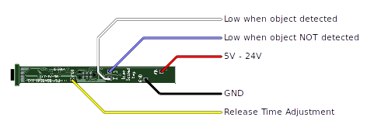
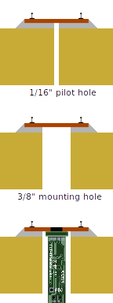Installation:
CKT-IRSENSE-2PC

The CKT-IRSENSE is a simple infrared proximity sensor that makes detection of model railroad locomotives or rolling stock easy and reliable. Just place the sensor where its invisible light beam will reflect off the object of interest and you're done – no time-consuming or frustrating adjustments! Based on modern silicon technology, this sensor is tolerant of ambient (background) lighting conditions, be it completely dark or under full lights, with no false triggering. Combined with a discrete under-track installation, this low-profile sensor solves many of the challenges that plague other optical detector products.
Applications
- Activate grade crossing signals
- Trigger sounds
- Build an automatic interchange
- Indicate end-of-track in hidden staging yards
- Detect block occupancy for signal systems
- C/MRI track occupancy inputs

For more detailed instructions and complete application diagrams, please download the
CKT-IRSENSE-2PC user manual:
http://www.iascaled.com/store/CKT-IRSENSE-2PC
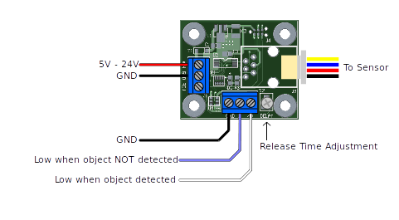
Installation:

