

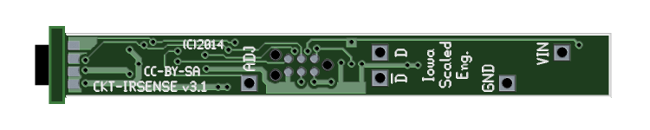
CKT-IRSENSE v3 User Manual

Features
- Small size (0.25" x 2.25")
- No adjustment needed
- Simple, discrete under-track installation
- Variable release time up to 20 seconds
- Two opposite polarity outputs (40V / 250mA capable)
- Tolerant of background lighting conditions (no false triggering)

Operation
The CKT-IRSENSE is an inexpensive infrared proximity sensor, designed primarily for model railroad use. At the top of the device are two small lenses - one emits a series of infrared pulses, which are then reflected by objects into the other lens, a receiver. By measuring the intensity of the returned pulses, the sensor can detect the presence and distance to an object. The device also automatically compensates for background lighting, eliminating false triggers.

Mechanical Installation
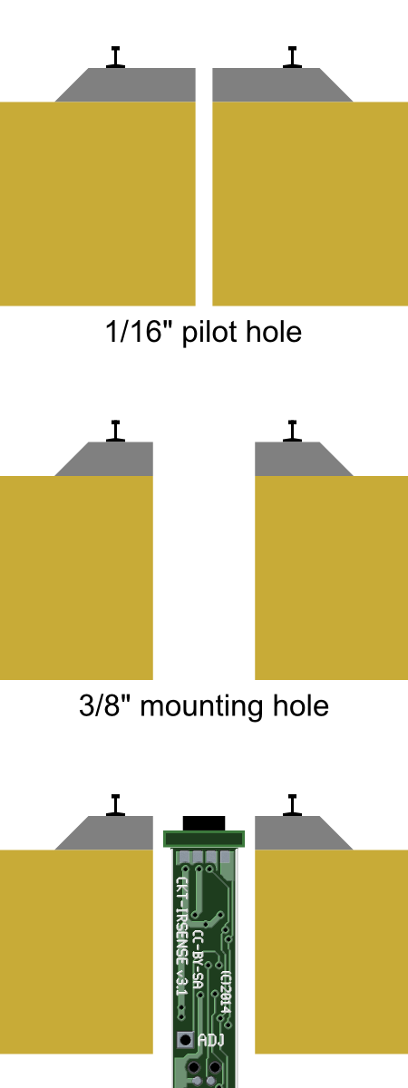
The detector is designed to be installed up through the benchwork in a 3/8 inch (10 mm) hole. To install in existing track, first drill a 1/16” pilot hole between the ties. Then, from the bottom, drill a 3/8” hole up toward the track, using the pilot hole you just drilled as a guide. Work slowly and be very careful to not damage the ties (you might want to remove a couple ties first and reinsert them after drilling the hole). Once the sensor is installed, be sure that both lenses are clear to shine up between any ties or ballast.

The module is not naturally water resistant, so be careful when ballasting. Some amount of water resistance can be added by coating everything (other than the lenses) with liquid electrical tape or similar sealant. Be very careful not to cloud or cover the detector lenses.

The sensor can be secured in the hole using a variety of methods such as hot glue or a bracket. See the Iowa Scaled Engineering website for more details and some example mounting brackets.

Electrical Connections
The CKT-IRSENSE needs 5-24 volts of clean direct current (DC) power to operate. Noisy power supplies may cause issues with detection, and supply voltages exceeding 25VDC may damage the device. The red wire should be connected to the positive side of the power supply and the black wire to the negative.

Two outputs are provided, both of which are “open drain” (otherwise known as “open collector”). This means that they act like a switch to the ground / negative lead. When an output is “active”, it will conduct current to ground. When an output is “inactive”, it will act like an open circuit and not pass current at all. Each output line can handle a maximum of 0.25 amps, and should be exposed to no more than a 40VDC supply. The white output is active when the sensor is detecting an object. The blue output is active when the sensor is not detecting an object.

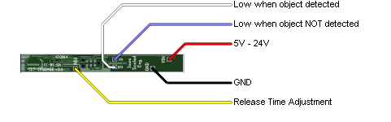
If a logic level output is desired, use a 4.7k-10k ohm resistor to pull up the output to the positive supply. To directly drive an LED, connect a current-limiting resistor in series with the LED and connect the LED cathode to the CKT-IRSENSE output. Some example connections are shown below.
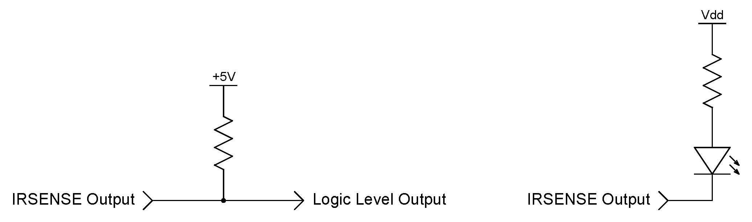

Activation Time
The activation time is factory set to 0.1 seconds. The outputs will indicate that an object has been detected if the object is present over the sensor for 2 consecutive readings spaced 100ms apart. This helps eliminate errant readings. As a consequence of this, though, there will be a slight (0.1s) delay for an object being detected. For most model railroad applications, this is not an issue. If longer (or shorter) activation times are required, we can provide custom programmed devices. Please contact us with your requirements.

Release Time
The release time is factory set to 0.1 seconds. The outputs will indicate that an object is no longer detected if the object is not present over the sensor for 2 consecutive readings spaced 100ms apart. This can be used to debounce the detector outputs to stop the outputs from toggling, for example, in the spaces between rolling stock as it travels over the sensor.

Longer release times are available by connecting a resistor between the yellow wire and ground (black wire) based on the following table.
Release Time vs. Resistor Value
Resistor | Delay | Resistor | Delay | Resistor | Delay
100k | 0.1s | 27k | 4.4s | 7.5k | 12.1s
82k | 0.3s | 24k | 5s | 6.8k | 12.7s
75k | 0.5s | 22k | 5.5s | 6.2k | 13.3s
68k | 0.8s | 20k | 6s | 5.6k | 13.9s
62k | 1s | 18k | 6.6s | 4.7k | 14.9s
56k | 1.4s | 16k | 7.3s | 3.9k | 15.9s
51k | 1.7s | 15k | 7.7s | 3k | 17.2s
47k | 2s | 13k | 8.6s | 2.4k | 18.1s
43k | 2.3s | 12k | 9.1s | 1.8k | 19.2s
39k | 2.7s | 11k | 9.7s | 1.3k | 20.1s
36k | 3.1s | 10k | 10.3s | 910 | 21s
33k | 3.4s | 9.1k | 10.9s | 430 | 22s
30k | 3.9s | 8.2k | 11.6s | 33 | 23s

Sensing Distance
The CKT-IRSENSE is pre-calibrated to a typical detection range (~ X inches) and needs no user adjustment for most applications. If other sensing distances are needed, contact us for custom programmed devices. The detection range can be changed from X to Y inches depending on the reflectivity of the object being sensed.

Applications
- Activate grade crossing signals
- Trigger a sound event using a CKT-SQUEAL sound player
- Simulating a spring switch using an MRServo switch machine
- Block detection for signal systems
- Occupancy detection on hidden tracks
- End-of-track indication in hidden staging yards
- C/MRI track occupancy inputs

Open Design
Iowa Scaled Engineering is committed to creating open designs that users are free to build, modify, adapt, improve, and share with others.

Hardware
The design of the CKT-IRSENSE hardware is open source hardware, and is made available under the term of the Creative Commons Attribution-Share Alike v3.0 license, a copy of which is available from: http://creativecommons.org/licenses/by-sa/3.0/

Design files can be found on the Iowa Scaled Engineering website:
http://www.iascaled.com/store/CKT-IRSENSE

Firmware
The official Iowa Scaled Engineering firmware for the CKT-IRSENSE is free software: you can redistribute it and/or modify it under the terms of the GNU General Public License as published by the Free Software Foundation, either version 3 of the License, or (at your option) any later version. A copy of the GNU GPL can be found at: http://www.gnu.org/licenses/gpl.html

New firmware can be flashed into the CKT-IRSENSE through J1. The six land pads implement the standard AVR 6-pin ISP header on a connector compatible with the Tag-Connect TC2030 cable.

Stable releases of firmware and source code can be found on the Iowa Scaled Engineering website: http://www.iascaled.com/store/CKT-IRSENSE
Iowa Scaled Engineering
http://www.iascaled.com/ support@iascaled.com

