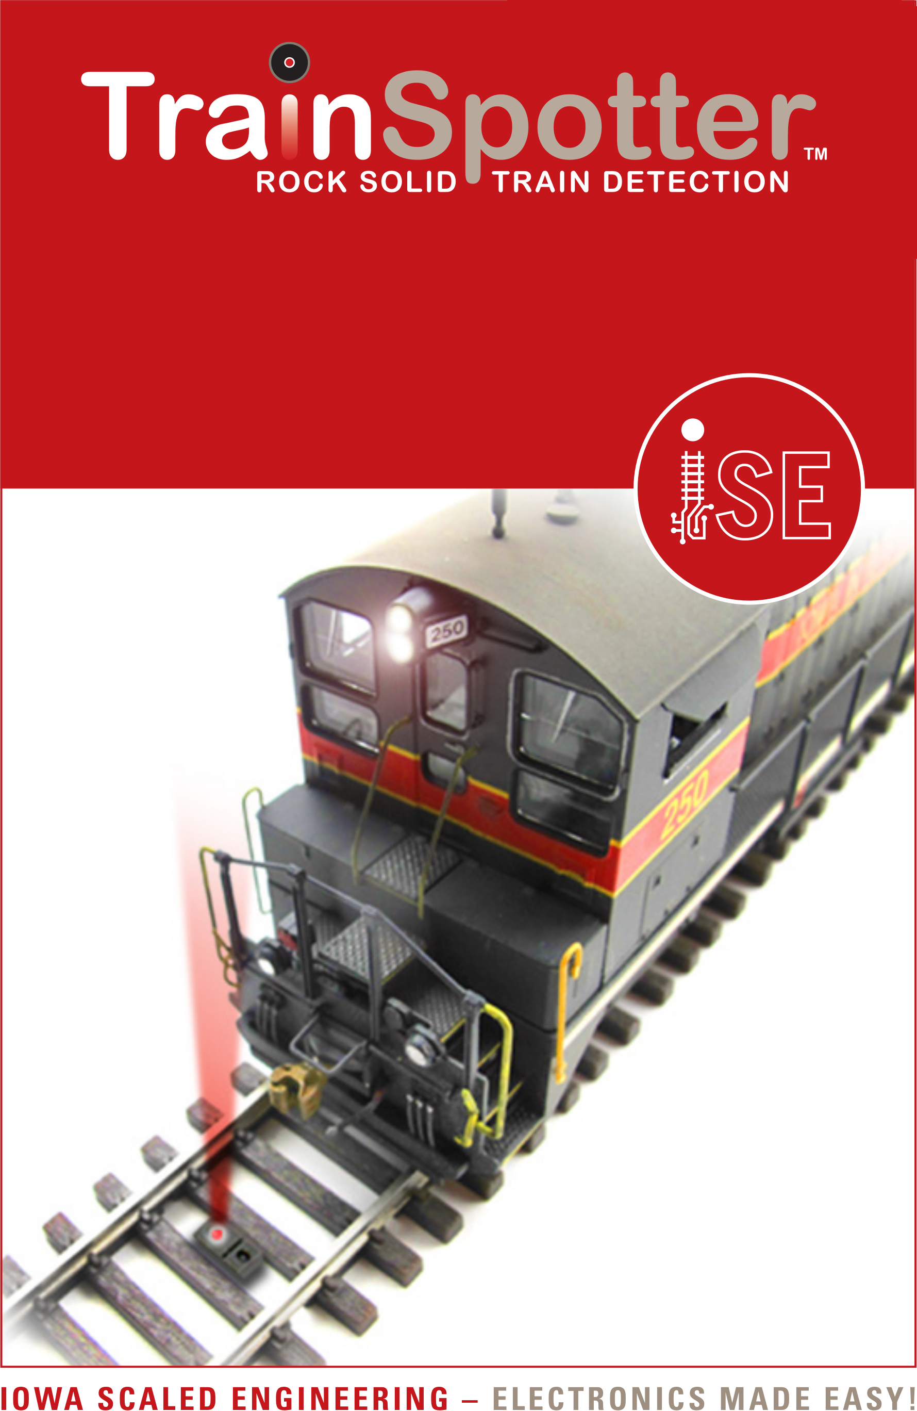
IR Sensor Mounting Bracket Kit

www.iascaled.com
ACC-IRBKT3D
$4.00
IR Sensor Mounting Bracket Kit

www.iascaled.com
ACC-IRBKT3D
$4.00
IR Sensor Mounting Bracket Kit

www.iascaled.com
ACC-IRBKT3D
$4.00
IR Sensor Mounting Bracket Kit

www.iascaled.com
ACC-IRBKT3D
$4.00

