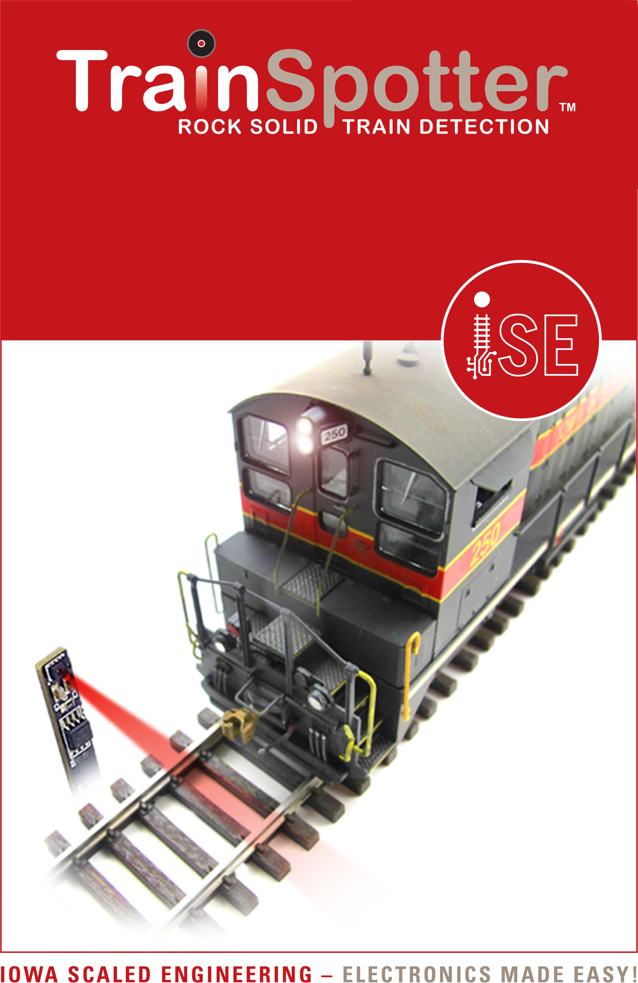
Reflective Infrared Proximity Sensor with Right-Angle Sensor

www.iascaled.com
CKT-IRSENSE-RA
$19.00
Reflective Infrared Proximity Sensor with Right-Angle Sensor

www.iascaled.com
CKT-IRSENSE-RA
$19.00
Reflective Infrared Proximity Sensor with Right-Angle Sensor

www.iascaled.com
CKT-IRSENSE-RA
$19.00
Reflective Infrared Proximity Sensor with Right-Angle Sensor

www.iascaled.com
CKT-IRSENSE-RA
$19.00

