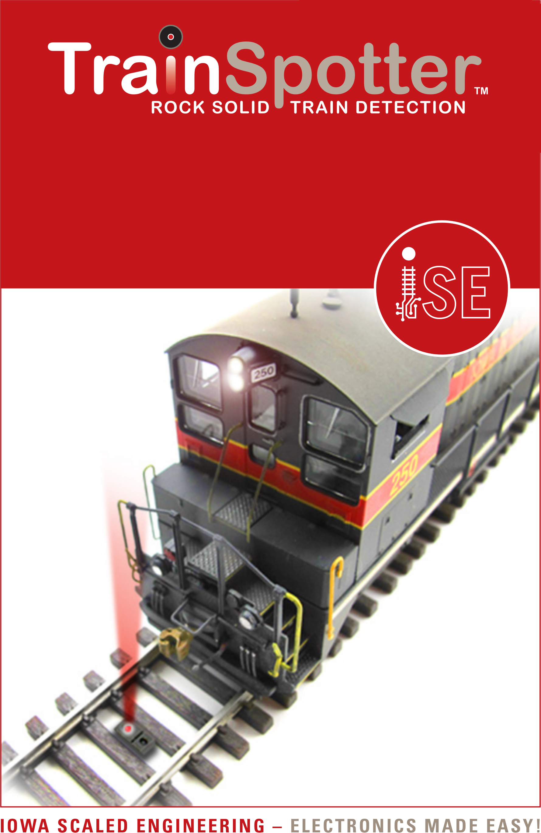
Reflective Infrared Proximity Sensor

www.iascaled.com
2x CKT-IRSENSE
With 8’ cables
Reflective Infrared Proximity Sensor

www.iascaled.com
2x CKT-IRSENSE
With 8’ cables
Reflective Infrared Proximity Sensor

www.iascaled.com
2x CKT-IRSENSE
With 8’ cables
Reflective Infrared Proximity Sensor

www.iascaled.com
2x CKT-IRSENSE
With 8’ cables

