
- Power from 12V
Verify power LED is lit
Loosen GND and track screws while powering up
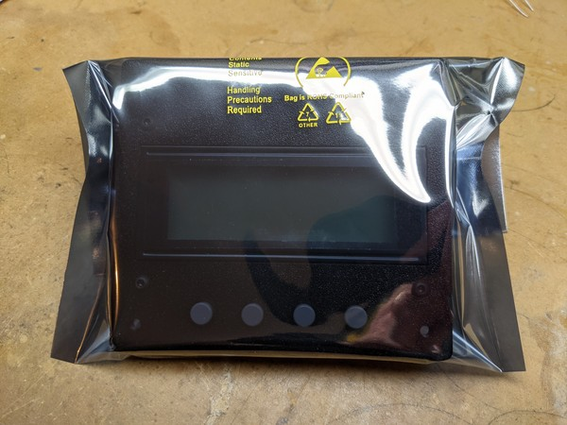Figure 1
- Factory Reset
- Attach 12Ω resistor to TRACK terminals
Monitor voltage and current
Verify both track LEDs are lit
- Enter Diagnostics menu
Short each sensor input to GND, verifying response on display
- Place in 6x8 anti-tatic bag (Figure 1)
Tape closed on back
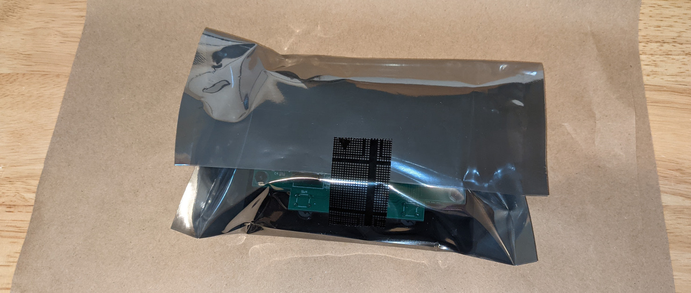Figure 2
- Place face down on folded packing paper (Figure 2)
- Wrap and fold paper loosely over front (Figure 3)
- Put layer of crinkle paper in box
- Place control unit in back of box, face down, with power supply toward front (Figure 4)
Figure 3
- Place selected IR sensor on top (Figure 5)
- Insert manual and close box
- Label box in middle of top lid, small piece of tape to hold closed
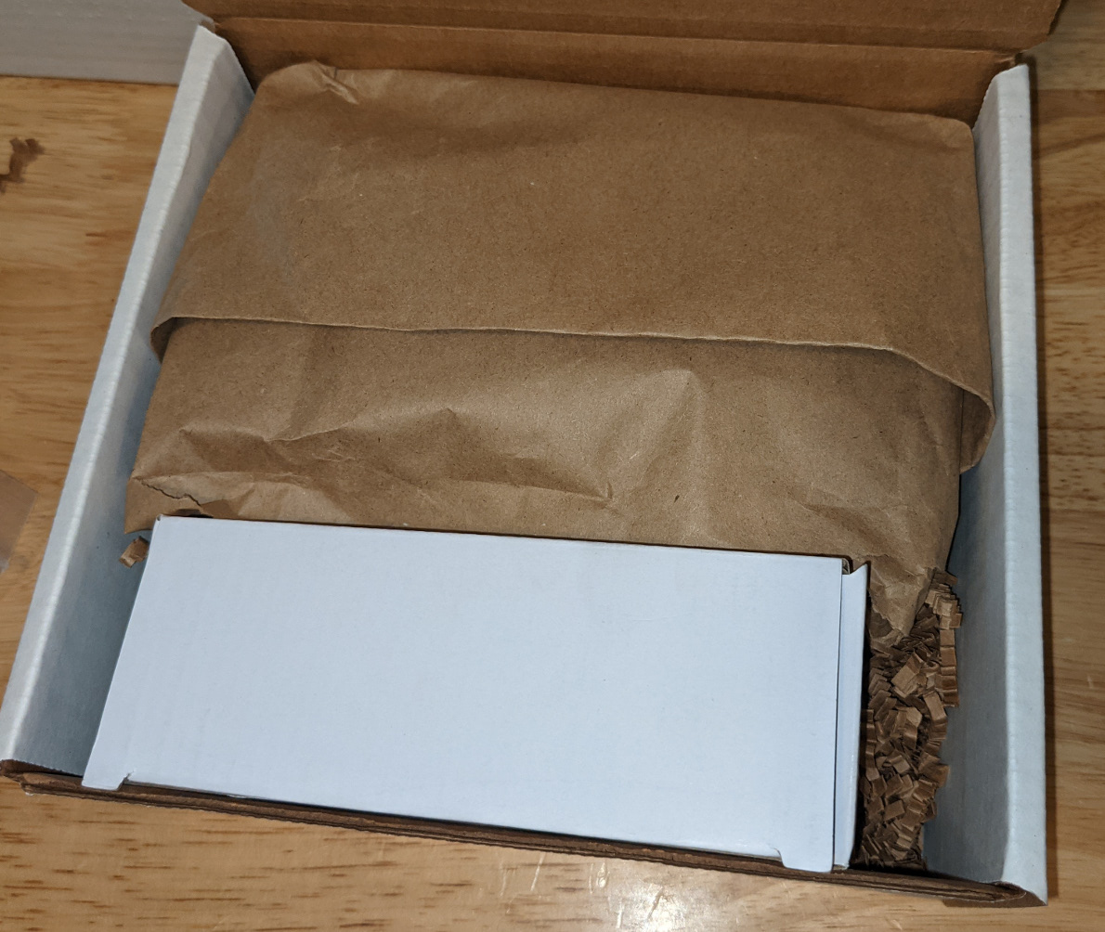Figure 4
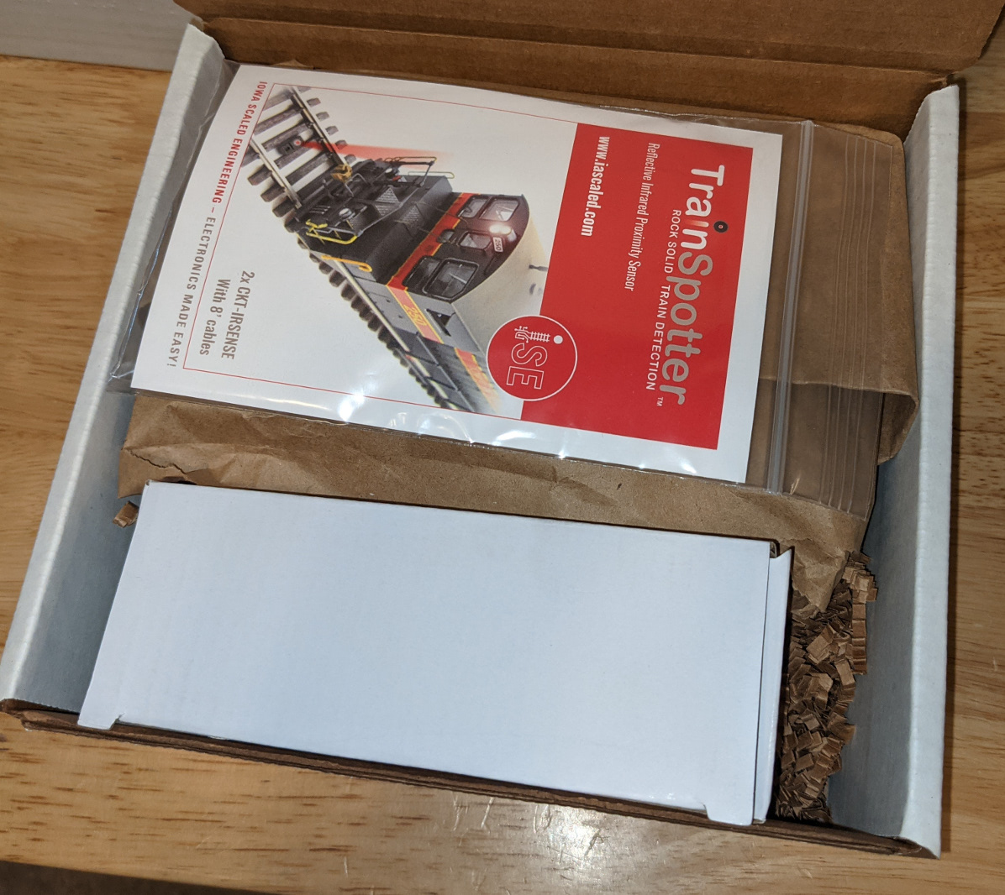Figure 5

