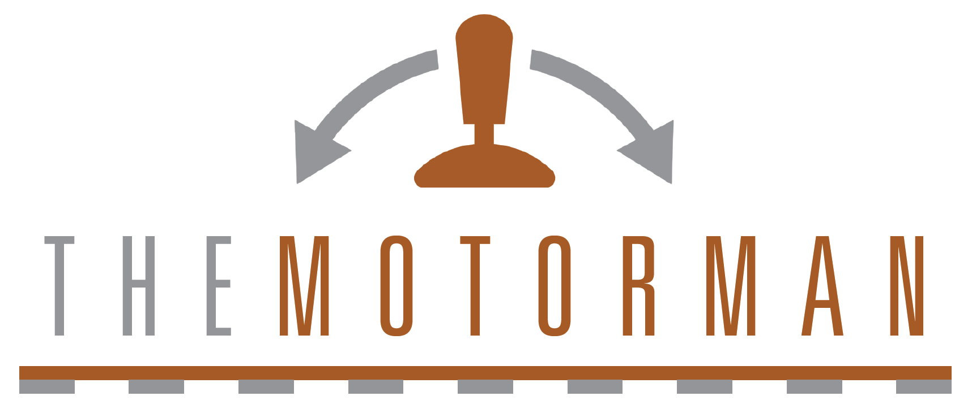

CKT-PINGPONG v1.1

September 16, 2020

The Motorman is an automatic train shuttle controller for both DC and DCC locomotives. Using TrainSpotter infrared proximity detectors at each end, The Motorman will continuously drive the train back and forth, automatically stopping and reversing at the end of track. With control of the speed, locomotive address, delay time, and other settings, a fully customized experience can be created.

Features
● Control DC or DCC locomotives
● Stores settings for up to 15 locomotives
● Adjustable acceleration and deceleration rates
● Operates any long or short DCC address, including consists
● Supports intermediate stops (with additional sensors)
● Operates up to 6 accessory decoders based on selectable trigger events
● Fully integrated unit with simple, intuitive interface
● Built-in track short circuit protection
● Optional track power switch for use with existing DC / DCC system

Typical Applications
● Train show demo layouts
● Museum displays
● Home layout automation

Installation

Wiring
The Motorman is supplied with a custom faceplate. It can be attached permanently to the layout fascia or a wall using screws through the four corner holes.
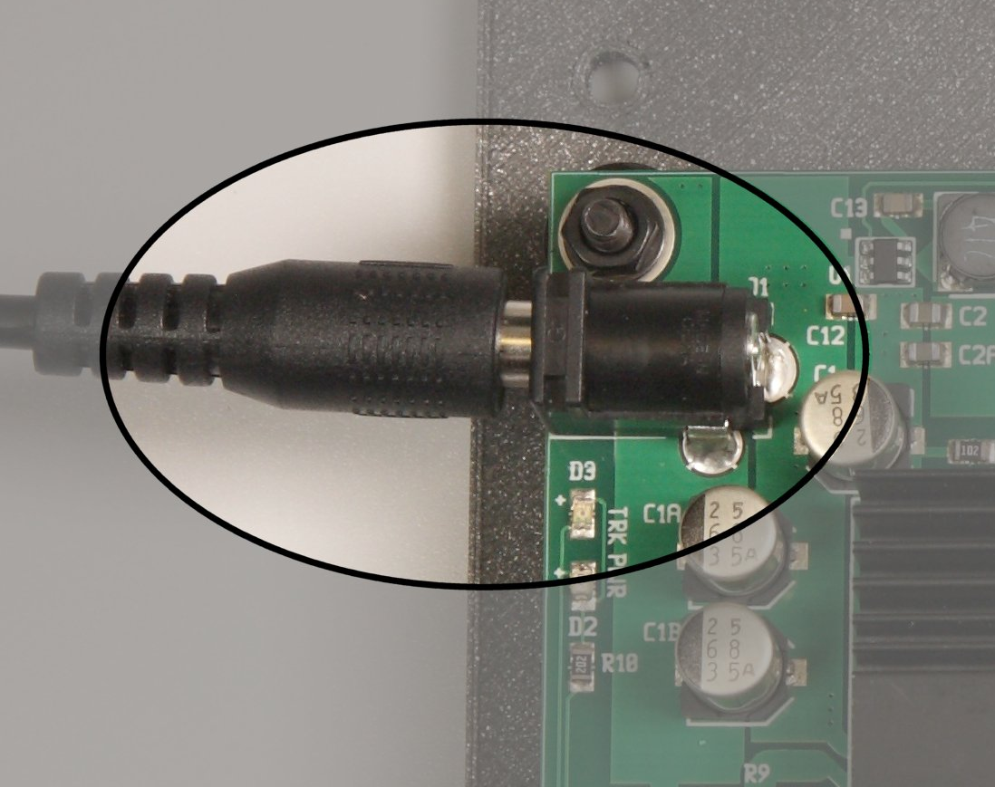Figure 1: Connecting Power
Power for The Motorman is provided by the supplied 12V DC power supply. Plug the barrel jack into the corresponding jack (J1) on the back side of the unit. See Figure 1.

When the Motorman is connected to the track, no other boosters or throttles can be connected to the track. Make sure the track section is isolated or damage to the Motorman will result. An optional track power switch is available to help isolate the Motorman and other track power sources.
Connect the track feeders to terminal block J2. See Figure 2. For DCC use, the polarity does not matter. If using DC mode, then the physical direction corresponding to forward and reverse will depend on the polarity of the feeder wires connected to the terminal block. If you end up with the direction opposite what you desire, then simply swap the two track wires in the terminal block.
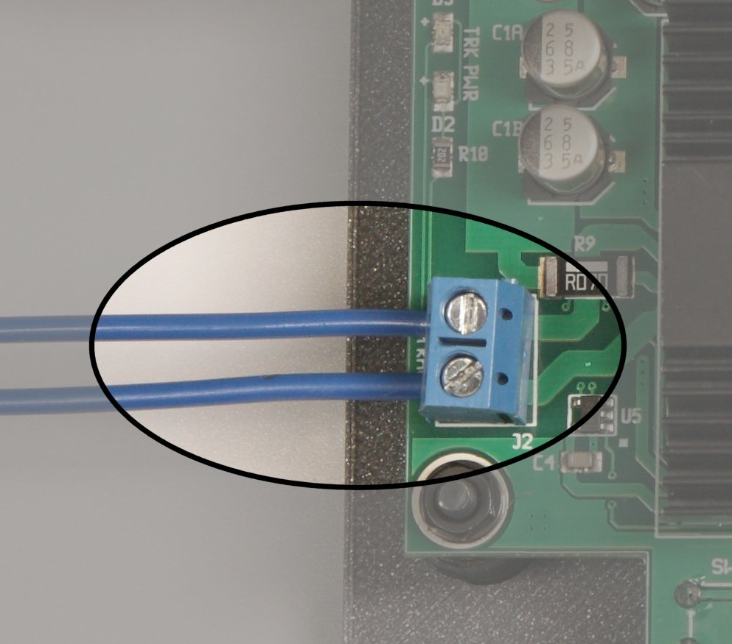Figure 2: Track Connections

Sensors
The left and right TrainSpotter end sensors connect to the terminal blocks J4 and J6 as shown in Figure 3. The red wires go to the +12V terminal. The black wires go to the GND terminal. The white wire from the left sensor goes to the LEFT terminal while the other white wire connects to the RGHT terminal. The inputs are active low, so any number of open drain output end sensors can be connected in parallel (i.e. to the same terminal).
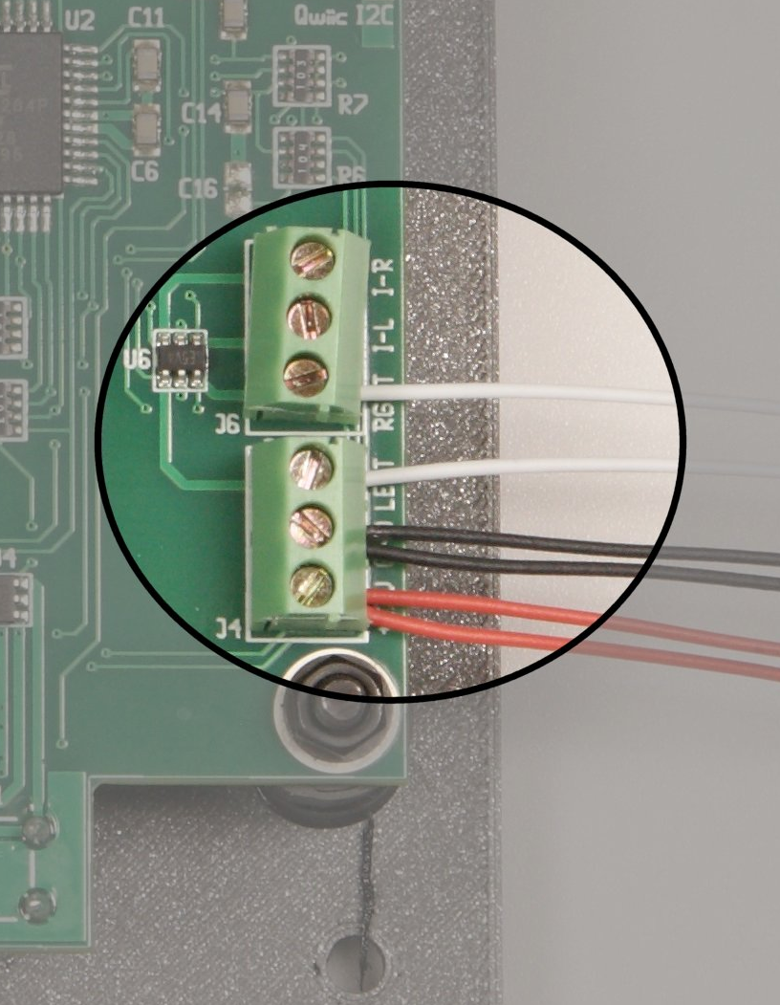Figure 3: Sensor Inputs
If you wish to use current-based detectors, an isolated block will be needed for the “trigger zone”. Any block detector that provides an open drain output can be used in place of the infrared TrainSpotter sensors, though obviously we recommend the Iowa Scaled Engineering CKT-BD1.
Optionally, intermediate sensors can also be installed for mid-run pauses. Inputs for left and right sensors are provided (labeled I-L and I-R, for intermediate left and right respectively), so that deceleration can stop the locomotive at approximately the same center point each time, based on deceleration rate. If current-based detection is used to cover the entire station block, or if the desire is to only use a single IR sensor, then connect the detector output to both the I-L and I-R terminals.
The sensor inputs (LEFT, RGHT, I-L, and I-R) are only rated to 3.3V. Do not exceed this or the Motorman will be damaged. Any open-drain sensor output should be safe.

Optional Track Power Switch
An optional upgrade kit is available that provides a high-current power switch for swapping control of the track between the Motoman and an existing DC or DCC system. The upgrade kit comes with a new faceplate, the switch, and instructions for upgrading the system. See the Iowa Scaled Engineering website for details.

Equipment Direction vs. Track Direction
An important concept to understand is the difference between track direction and equipment direction. Think of the problem this way – a locomotive can go forward or reverse independent of which direction it’s currently pointed. If you set a DCC locomotive on the track, forward is relative to the locomotive, not to which direction it is headed on the track. The locomotive can go forward to the left, or it can go forward to the right, depending on which way it’s pointed.
For the sensors installed along the track, their direction is always the same, because their relation to the track doesn’t move. One will be to the left, one will be to the right.
In this manual, the two ends of the track will be denoted as “left” and “right”, whereas the two directions of equipment travel will be denoted as “forward” and “reverse”.

Getting Started
This assumes that you have the Motorman connected to the track and you’re ready to run your first piece of equipment.
Step 1
If your locomotive is DC, go to the Configuration → DC/DCC Output screen and change the output type to DC. See page X.
If your locomotive is DCC, go to the Configuration → Locomotive Config screen and set configuration 01 for your locomotive address.
Step 2
Place your locomotive on the track somewhere between the end sensors. It should accelerate in what the Motorman thinks is the forward direction. The main screen should show “LRN”, indicating that the Motorman is learning which direction is forward.
Step 3
The engine will run until it reaches either end sensor, and at that point, the Motorman now knows if left is forward or right is forward. From this point, the locomotive will continue running between the two points and stopping at intermediate stations as configured.

Diagnostic Lights
A green LED on the back side, labeled “3.3V PWR” next to the heatsink, indicates that the unit is getting power.
Near the output, there is a blue and an amber LED. These indicate that track power is being applied. Blue indicates one polarity, and amber indicates the other. For DCC, both should be lit. For DC, only one will be lit, corresponding to the direction of travel (amber = forward, blue = reverse).

User Interface
The interface to The Motorman is based around the LCD screen and the four buttons beneath the screen. Each button acts as a “soft key” with its function defined by the text on the bottom row of the LCD screen. This makes navigating the various screens easy and intuitive.
The main screen is displayed by default and provides a quick overview of the most important details. The configuration screens can be accessed using the buttons under the screen.

The Main Screen
The main screen shows, at a glance, the status of the Motorman.
ADR:0600 12.1V 0.00A
SPD:F025 (F035) LRN RMP:02.0s L-?/R-?/I-
LOAD MANL STOP CONF
Address
The left side of first line shows you the address currently being controlled (“ADR:”). If the Motorman is set to DC operation, this will show *DC* rather than a DCC address. If a short DCC address is being controlled, the address will be displayed as “s123”, whereas long DCC addresses are displayed as four digits.
ADR:0600 12.1V 0.00A
SPD:F025 (F035) LRN RMP:02.0s L-?/R-?/I-
LOAD MANL STOP CONF
Track Voltage / Current
The current track voltage and current draw are displayed on the right side of the first line. In the event that too much current is being drawn (such as in a short) or the power driver on the back of the Motorman overheats, this will display **FAULT** instead.
ADR:0600 12.1V 0.00A
SPD:F025 (F035) LRN RMP:02.0s L-?/R-?/I-
LOAD MANL STOP CONF
Current and Target Speed
The start of the second line shows the current direction/speed and, in parentheses, the target direction and speed. Direction is F for forward and R for reverse, followed by a speed percentage (0-100%) of maximum. The target speed is the maximum speed/direction commanded – how fast the current speed accelerates or decelerates to that is based upon the ramp rate. Target speed is set as part of the locomotive profile.
ADR:0600 12.1V 0.00A
SPD:F025 (F035) LRN RMP:02.0s L-?/R-?/I-
LOAD MANL STOP CONF
Ramp Rate
ADR:0600 12.1V 0.00A
SPD:F025 (F035) LRN RMP:02.0s L-?/R-?/I-
LOAD MANL STOP CONF
On the third line, the current ramp rate is displayed on the left. This is the number of seconds it will take for the locomotive to accelerate from full stop to the set target speed, or to decelerate from the set target speed down to a full stop. Ramp rate is set as part of the locomotive profile.
Sensor Inputs
ADR:0600 12.1V 0.00A
SPD:F025 (F035) LRN RMP:02.0s L-?/R-?
LOAD MANL STOP CONF
On the right half of line three, the sensor input status is visible, along with how they correspond to the current equipment direction. The left hand sensor information is on the left hand side of the slash and starts with an L. The right hand sensor information is on the right side of the slash.
The character immediately following the L or R indicates the current sensor status. A dash (-) indicates that no sensors are currently activated. An asterisk (*) indicates that the left or right end sensor is currently activated.
If midpoint stops are enabled (Configuration → Midpoints Enable), the /I- will appear on the end. Otherwise, these spaces will be blank. When a midpoint sensor is tripped, an R will appear for right intermediate triggered, an L for left intermediate triggered, or an A for both right and left intermediate triggered.
ADR:0600 12.1V 0.00A
SPD:F025 (F035) LRN RMP:02.0s L-?/R-?/I-
LOAD MANL STOP CONF
Operational State
ADR:0600 12.1V 0.00A
SPD:F025 (F035) LRN RMP:02.0s L-?/R-?/I-
LOAD MANL STOP CONF
The current operating state is shown on the right side of the second line.
- LRN – Learning: The Motorman is learning which track direction corresponds with forward. Once an end sensor is reached, that track direction (left or right) will be deemed “forward” until such time that the locomotive is changed, the stop button is pressed (configurable), or the power is cycled. This association between left/right and forward/reverse will be indicated in the “Sensor Inputs” section of the main screen.
- FWD – Forward Travel: The locomotive is commanded to go forward at the speed commanded in the profile until either the end stop sensor learned as the forward end in LRN mode is reached (see the Sensor Inputs indicator above to see which direction is learned to the forward or reverse sensor), or an intermediate sensor the opposite of the forward end is reached. If the forward direction end sensor is tripped, the state will go to FDC. If the forward direction intermediate sensor is tripped, the state will go to FID.
- REV – Reverse Travel: The locomotive is commanded to go in reverse at the speed commanded in the profile until either the end stop sensor learned as the reverse end in LRN mode is reached (see the Sensor Inputs indicator above to see which direction is learned to the forward or reverse sensor), or an intermediate sensor the opposite of the reverse end is reached. If the forward direction end sensor is tripped, the state will go to RDC. If the forward direction intermediate sensor is tripped, the state will go to RID.
- FDC – Forward deceleration: The forward direction end sensor has been tripped and the speed is decreasing to zero, as set by the locomotive’s ramp rate. Once the current speed reaches zero, the state will transition to FTR.
- FTR – Forward to Reverse Delay: The locomotive has stopped its forward travel and is waiting the configured Endpoint Delay (“Endpoint Delay” in the Configuration screen) to reverse direction. Once the delay has expired, the state will transition to REV
- RDC – Reverse deceleration: The reverse direction end sensor has been tripped and the speed is decreasing to zero, as set by the locomotive’s ramp rate. Once the current speed reaches zero, the state will transition to RTF.
- RTF – Reverse to Forward Delay: The locomotive has stopped its reverse travel and is waiting the configured Endpoint Delay (see configuration screen) to reverse direction. Once the delay has expired, the state will transition to FWD
- FID – Forward Intermediate Deceleration: A forward intermediate sensor has been tripped and the equipment is decelerating to zero speed. Once speed reaches zero, state will transition to FIW.
- RID – Reverse Intermediate Deceleration: A reverse intermediate sensor has been tripped and the equipment is decelerating to zero speed. Once speed reaches zero, state will transition to RIW.
- FIW – Forward Intermediate Wait: The locomotive has stopped in the forward direction at an intermediate sensor, and will wait for the configured delay (“Midpoint Delay” in the configuration screen). Once the delay expires, state will transition to FIA.
- RIW - Reverse Intermediate Wait: The locomotive has stopped in the reverse direction at an intermediate sensor, and will wait for the configured delay (“Midpoint Delay” in the configuration screen). Once the delay expires, state will transition to RIA.
- FIA – Forward Intermediate Acceleration: The locomotive is accelerating forward out of an intermediate stop. As soon as the tripped intermediate sensor clears, state will transition to FWD.
- RIA – Reverse Intermediate Acceleration: The locomotive is accelerating in reverse out of an intermediate stop. As soon as the tripped intermediate sensor clears, state will transition to REV.
Main Screen Keys
ADR:0600 12.1V 0.00A
SPD:F025 (F035) LRN RMP:02.0s L-?/R-?/I-
LOAD MANL STOP CONF
LOAD – Enter the Load Locomotive screen. See page X. Loads a new pre-saved locomotive configuration to active in DCC mode. See “Load Locomotive Screen”. If the unit is in DC mode, equipment is not individually addressable and the LOAD button will be deactivated. (how?)
MANL – Enter the Manual Adjustment screen. See page X. Allows manual control of the direction and maximum speed.
STOP – Stop operation. Brings the locomotive to an immediate stop (no ramp rate) and optionally resets operating state to learning mode (see Configuration → Stop Relearn Dir). Upon stopping, this key changes to “RUN!” to restart operations.
RUN! – Starts operation. Upon starting, this key changes to “RUN!” to restart operations.
CONF – Enter the Configuration screen. See page X.

Load Locomotive
The Load Locomotive screen appears when the “LOAD” key is pressed on the main screen. Each row represents one saved DCC locomotive configuration (see Locomotive Configuration Screen). There are a total of 14 DCC configuration slots available.
01 A:s000 020 01.0
02*A:s000 020 01.0
>03 A:s000 020 01.0
UP DOWN SLCT CNCL
The > character is a cursor, showing you which configuration you are about to select. After that, each line shows the configuration slot number, the DCC address, maximum speed (0-100%) and ramp rate (00.1-25.5 seconds) of each configuration. In addition, the currently active configuration will be marked with an asterisk (*).
Use the UP/DOWN key to select the configuration and press the SLCT key to select it. To cancel without selecting a new configuration, press the CNCL key.

Manual Adjustment
The manual adjustment screen allows you to tweak the running speed and direction of the current locomotive configuration. This allows you to fine-tune how fast you want the locomotive to go without going back through the configuration process. Note that any changes here are only effective until a new locomotive configuration is loaded, or power is cycled.
Manual Adjustment
Run Speed: R020%
SPD+ SPD- F<>R BACK
Use the SPD+ and SPD- keys to adjust the speed in 1% increments. F<>R will change the direction of the locomotive. BACK exits to the main screen.

Configuration
The Configuration screen allows you to change how the Motorman behaves. Use the UP / DOWN keys until the cursor (>) is on the option you want to change, and then press the SLCT (select) key.
Locomotive Config
> Accessory Config
DC/DCC Output
UP DOWN SLCT BACK
Configurable options are as follows:
- Locomotive Config – Configure the 14 DCC locomotive slots as well as the DC control slot 0.
- Accessory Config – Configure accessory decoders to react to the Motorman
- DC/DCC Ouptut – Switch between DC and DCC output on the track
- Endpoint Delay – Configure the number of seconds (0 to 255 seconds) that equipment should wait when reaching either end sensor.
- Midpoint Delay – Configure the number of seconds (0 to 255 seconds) that equipment should wait when stopped because of a midpoint sensor.
- Midpoint Enable – Configure whether intermediate stops (midpoints) are currently enabled. If disabled, intermediate sensor input will be ignored.
- Pause on Start – Configure whether the unit will immediately start running the last active configuration upon startup, or if it will load the configuration but start in a paused state.
- Stop Relearns Dir – Configure whether the unit will go back to learning mode (to associate forward with the left or right sensor) in the event that the stop key is used from the main screen.
- Backlight Timeout – Configure the unit to shut off the backlight after 1 to 255 seconds of no keypresses, or always keep the display backlight active.
- Turn Off Backlight – Turn off the backlight immediately (regardless of timeout).
- Diagnostics – Show internal diagnostic information.
- Factory Reset – Remove all configuration options and return the unit to factory original configuration.

Locomotive Configuration
The Locomotive Configuration screen allows you to configure and store up to 15 locomotive configurations – one for DC operation and 14 for DCC operation.
00 **DC** 040 01.0
> 01 A:s000 020 02.5
02 A:5377 035 04.0
UP DOWN SLCT BACK
Configuration 00 is always DC, and is the only configuration for DC.
Configurations 01 to 14 are for DCC operation.
Each line shows the configuration slot number, DCC address (or **DC** for slot 0), maximum speed (0 to 100%) and ramp rate (0.1 to 25.5 seconds).
Use the UP/DOWN key to select the configuration to change and press the SLCT key to go into the Configure Locomotive screen #1. The BACK key will take you back to the Configuration screen.

Configure Locomotive #1
This screen allows you to set the locomotive address (if using one of the DCC configurations 01 to 14), maximum speed, and ramp rate. The configuration number being edited is in the upper left corner. Maximum speed (MAX) is 1 to 100%. Ramp is the number of seconds to accelerate between stopped and maximum speed, or decelerate between maximum speed and stopped.
01 ADDR MAX RAMP
s123 025 01.0
^
++ >> NEXT CNCL
The ++ key will increment the field pointed to by the cursor. The >> key will move the cursor (^) to the next field.
For configuration 00 (DC), SAVE will appear for the third key, since there are no functions for DC control. For configurations 01 to 14, the third key will display NEXT, taking you to Configure Locomotive screen #2. To cancel without saving any changes, press the CNCL key.

Configure Locomotive #2
This screen allows you to set DCC decoder function behavior. The left-most function (under the configuration number) is always active no matter the direction of travel, and can be used for things like “engine start” on sound decoders that need to be active for the locomotive to move. There are two additional functions for forward and two for reverse. These functions will only be active when a locomotive is moving in that direction of travel, and otherwise will be off.
01 FWD FWD REV REV
F00 F-- F-- F-- F--
^^
++ >> SAVE CNCL
F-- indicates that no function is selected. F00 to F28 will activate that function. F29 and above, supported by some European manufacturers as an extension of the NMRA standard, are not currently supported.
The ++ key will increment the field pointed to by the cursor. The >> key will move the cursor (^) to the next field. The SAVE key will save the configuration changes you’ve made to the selected locomotive configuration. To cancel without saving any changes, press the CNCL key.

Accessory Configuration
The Accessory Configuration screen allows you to configure and store up to 6 accessory decoder configurations (00 to 05) that will activate based on triggers. This screen allows you to see all of them at a glance and select one to change.
00 0001 LS-RC S [C]
01 0001 DISBL C [C]
>02 0001 DISBL C [C]
UP DOWN SLCT BACK
From left to right, each row shows the accessory slot number (00-05), the accessory decoder extended address (0001-2044), the trigger mode, the current state (S=set, C=cleared), and the startup state in braces.
Use the UP/DOWN key to select the accessory configuration to change and press the SLCT key to go into the Configure Accessory Screen. The BACK key will take you back to the Configuration screen.

Configure Accessory
The Accessory Configuration Screen allows you to change the behaviour of a given accessory configuration. It shows you the accessory configuration number on the left, followed by the accessory address, its initial state when the unit powers up (set or cleared), and its trigger mode.
ACC ADDR INIT TRIGR
00 0001 SET LS-RC
^
++ >> SAVE CNCL
The ++ key will increment or cycle through the field pointed to by the cursor. The >> key will move the cursor (^) to the next field. The SAVE key will save the configuration changes you’ve made to the selected locomotive configuration. To cancel without saving any changes, press the CNCL key.
Trigger mode governs when the accessory decoder is changed. Options are:
- DISBL – Disable – Do not use this accessory configuration at all. No initialization will be sent, and it will never change in response to sensor input.
- LS-RC – Left Set, Right Clear – Set the accessory when the left endstop sensor is triggered, clear the accessory when the right endstop sensor is triggered.
- LC-RS – Left Clear, Right Set – Clear the accessory when the left endstop sensor is triggered, set the accessory when the right endstop sensor is triggered.
- LSTOG – Left Stop Toggle – When the left endstop is reached, toggle the state of this accessory address (set will go to clear, clear will go to set). The right endstop has no effect.
- RSTOG – Right Stop Toggle – When the right endstop is reached, toggle the state of this accessory address (set will go to clear, clear will go to set). The left endstop has no effect.
- XSTOG – Both Stop Toggle – When either endstop is reached, toggle the state of this accessory address (set will go to clear, clear will go to set).
- INIT – Initialize Only – Set the accessory decoder to its configured initial state only when the unit powers up. Never changes based on sensors.
- LE_ST- Left End Station Trigger – Set the accessory when a locomotive reaches the left end sensor and clear it when it departs.
- RE_ST- Right End Station Trigger – Set the accessory when a locomotive reaches the right end sensor and clear it when it departs.
- XE_ST- Left End Station Trigger – Set the accessory when a locomotive reaches either end sensor and clear it when it departs.
- LI_ST- Left End Station Trigger – Set the accessory when a locomotive reaches the left intermediate sensor (right-bound equipment approaching an intermediate stop) and clear it when it departs.
- RI_ST- Right End Station Trigger – Set the accessory when a locomotive reaches the right intermediate sensor (left-bound equipment approaching an intermediate stop) and clear it when it departs.
- XI_ST- Left End Station Trigger – Set the accessory when a locomotive approaches an intermediate stop from either direction, and clear when it departs

Output Type
The Output Type screen selects whether the Motorman acts as a DCC command station or a regular DC throttle.
DC / DCC Mode
[*] DCC Trk Output
[ ] DC Trk Output
DCC DC SAVE CNCL
The DCC key selects DCC mode while the DC key selects DC mode. The SAVE key will save the selected setting. To cancel without saving any changes, press the CNCL key.

Endpoint Delay
The Endpoint Delay screen configures the delay at each end of the run, in seconds, from when the equipment is sent a zero speed command until the equipment is sent a command to run in the opposite direction.
Endpoint Delay
Seconds: 002s
^
++ >> SAVE CNCL
The ++ key will increment the digit pointed to by the cursor. The >> key will move the cursor (^) to the next field. The SAVE key will save the changes you’ve made to the endpoint delay. To cancel without saving any changes, press the CNCL key.

Midpoint Delay
The Midpoint Delay screen configures the delay at each midpoint stop, in seconds, from when the equipment is sent a zero speed command until the equipment is sent a command to run in the opposite direction. This is only effective if midpoint sensors are installed and midpoint stops are enabled (see Midpoints Enabled screen).
Midpoint Delay
Seconds: 002s
^
++ >> SAVE CNCL
The ++ key will increment the digit pointed to by the cursor. The >> key will move the cursor (^) to the next field. The SAVE key will save the changes you’ve made to the midpoint delay. To cancel without saving any changes, press the CNCL key.

Midpoints Enabled
The Midpoints Enabled screen configures whether midpoint stops are enabled. The default is disabled, to prevent any glitches on the unconnected midpoint sensor lines from disrupting normal operation. If you have midpoint sensors connected and want equipment to stop at midpoints, enable this feature.
Midpoint Stops
[*] Enable
[ ] Disable
ENBL DSBL SAVE CNCL
The ENBL key enables midpoint stops and the DSBL key disables midpoint stops. The SAVE key will save the selected setting. To cancel without saving any changes, press the CNCL key.

Pause on Start
This option configures whether the last selected locomotive will start running as soon as the unit powers up, or will start up paused and wait for the user to hit the RUN! key on the main screen before moving.
Start Locomotive:
[*] Running
[ ] Paused
RUN PAUS SAVE CNCL
The RUN key sets the unit to start running on power-up. The PAUS key sets the unit to start up with equipment paused. The SAVE key will save the selected setting. To cancel without saving any changes, press the CNCL key.

Backlight Timeout
This option configures how long the backlight will stay on after a key is pressed, from never turning off up to 250 seconds. Given the long life of backlights on LCDs, rated in the tens of thousands of operating hours, it isn’t necessary to turn the backlight off. However, in a dark room the display may be distracting. This default is value is “None”, which means “never turn off the backlight”.
Backlight Timeout
Seconds: 002s
^
++ >> SAVE CNCL
The ++ key will increment the time by 10 second increments. The -- key will decrease the time by 10 second increments. The SAVE key will save the changes you’ve made to the backlight timeouot. To cancel without saving any changes, press the CNCL key.

Factory Reset
The Factory Reset screen can be used to reset the Motorman and clear all configuration settings, restoring it back to the factory defaults. Doing so is purposefully a bit difficult, since we don’t want users to lose their settings accidentally. If you get to this screen and do not want to wipe out all of your configurations, just press the CNCL key.
CLEAR ALL SETTINGS?
Press YES 5 more
times to confirm
YES! CNCL
If you really do want to perform a factory reset, press the YES! key five times and you’ll be presented with this screen:
Press the YES! key one more time (now on the second key instead of the first) to erase all configuration information. The unit will restart with from-the-factory settings.
CLEAR ALL SETTINGS?
REALLY ERASE
EVERYTHING?
YES! CNCL

Ordering Information
Model | Description
CKT-PINGPONG | Automatic Train Shuttle
CKT-PINGPONG-SW | Track Power Switch and Faceplate Kit

Related Products
Model | Description
CKT-IRSENSE | Reflective Infrared Proximity Sensor
CKT-IRSENSE-2PC | Reflective Infrared Proximity Sensor with Remote Sensor
CKT-BD1 | DCC Current-Based Block Detector

Open Design
Iowa Scaled Engineering is committed to creating open designs that users are free to build, modify, adapt, improve, and share with others.
The design of the CKT-PINGPONG hardware is open source hardware, and is made available under the terms of the Creative Commons Attribution-Share Alike v3.0 license, a copy of which is available from:
http://creativecommons.org/licenses/by-sa/3.0/
Design files can be found on the Iowa Scaled Engineering website:
http://www.iascaled.com/store/CKT-PINGPONG
The official Iowa Scaled Engineering firmware for the CKT-PINGPONG is free software: you can redistribute it and/or modify it under the terms of the GNU General Public License as published by the Free Software Foundation, either version 3 of the License, or (at your option) any later version. A copy of the GNU GPL can be found at:
http://www.gnu.org/licenses/gpl.html
New firmware can be flashed into the CKT-PINGPONG through J3.
Stable releases of firmware and source code can be found on the Iowa Scaled Engineering website.

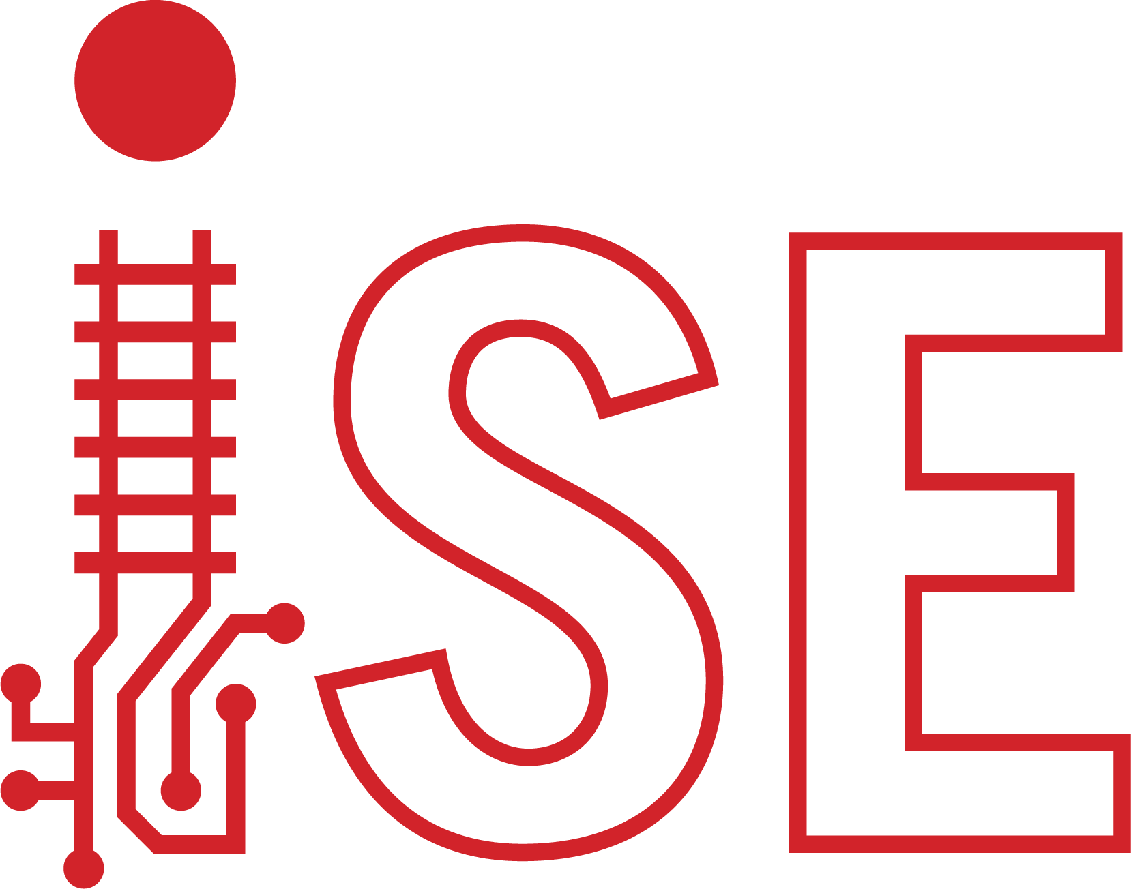
www.iascaled.com
support@iascaled.com

