

CKT-SIGNAL v2 Instructions

Assembly
The CKT-SIGNAL uses 1206 size surface mount (SMT) LEDs and 0805 size SMT resistors. The use of solder flux is highly recommended. Apply the flux to the PCB solder pads. Then place and align the component using tweezers. Put a small amount of solder on the tip of the soldering iron and touch it to one terminal of the component, while holding it in place with tweezers, to tack the component in place. Finally, use a small amount of solder to attach the other side of the component. For improved looks, solder braid can be used sparingly to pull off any excess solder. The board can also be scrubbed or placed in an ultrasonic cleaner with isopropyl alcohol to remove any remaining traces of flux.

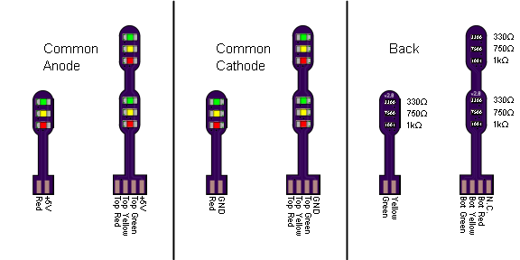

Open Design
Iowa Scaled Engineering is committed to creating open designs that users are free to build, modify, adapt, improve, and share with others.

Hardware
The design of the CKT-SQUEAL hardware is open source hardware, and is made available under the terms of the Creative Commons Attribution-Share Alike v3.0 license, a copy of which is available from: http://creativecommons.org/licenses/by-sa/3.0/
Design files can be found on the Iowa Scaled Engineering website:
http://www.iascaled.com/store/CKT-SIGNAL-1X
http://www.iascaled.com/store/CKT-SIGNAL-2X

