Time Lock Switch Controller

CKT-TIMELOCK
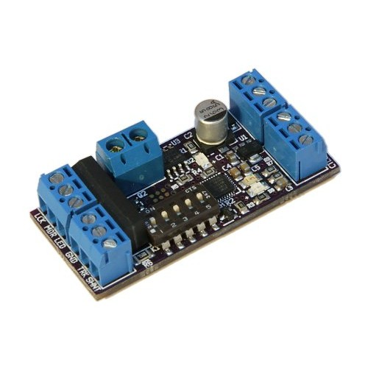
Time lock switches are used on prototype railroads to prevent a crew from opening a switch in front of an oncoming train. The Time Lock Switch Controller provides an easy way to add prototypical time-locked switches to your model railroad. For those with Centralized Traffic Control (CTC) or other dispatcher controlled power switches, the Time Lock Switch Controller can be used to simulate dual-control power switches, allowing the crew to override a power switch locally.

Features
● Simulates time lock switches and dual-control power switches
● Adjustable time delay, from 5 - 240 seconds
● Built-in 2kΩ shunt resistor and relay for triggering current-based block detectors
● Directly drives MRServo switch machines or popular stall-motor type machines
● Requires only a single input for turnout direction
● Includes key switch with 2 keys and a white LED

The Prototype
Prototype railroads use time locks on uncontrolled switches in signaled territory – often into industrial sidings - to prevent a crew from opening a switch in front of an oncoming train that is expecting clear track based on the last signal they saw. The time delay between a crew requesting to operate the switch and actually being able to move the points is enough that any train already past the nearest block signals would have also passed the switch.
When a crew wants to unlock one of these uncontrolled switches, they unlock the control box and start a timer running. As soon as the timer starts, it shunts the rails, dropping any nearby signal to red and thereby warning any approaching equipment. After enough time elapses, the timer expires and allows the crew to hand-operate the switch. When complete, the crew returns the switch to normal and returns the timer to its normally locked state. This releases the shunt on the rails, and everything returns to normal.
While common on the prototype, this unique element of switching industries is seldom modeled. Now, with the CKT-TIMELOCK, it is easy to add additional realism for your switch crews on your layout.

Dual-Control Power Switches
Even the best of machinery fails, and when that machinery is a switch at a busy control point, there is not always time to wait for the maintainer to get there. That's why most prototype power switch machines on North American railways are “dual-control,” meaning they can be operated remotely under power or operated locally with a hand-throw lever.
Normally, while the switch is “in power” and being operated by the dispatcher through the signal system, the points cannot be moved by the local crew. When a switch fails to operate for the dispatcher (or fails to show that it is moving correctly), the dispatcher can authorize the crew to take the switch “out of power” and hand operate it.
When a switch machine is being hand-operated, this will show the switch in the dispatch system as being out of correspondence and not permit any route to be lined through the control point. There is, however, no timeout. Once the crew receives authorization, the switch can immediately be taken out of power and hand operated.
(Note: This doesn't mean that the control point has no time lock. If a route is lined, the dispatcher can issue a command to knock it down, but it won't happen instantaneously. It will issue a request that starts a timer. When that timer expires – again based on how long it would take a train that was too close to stop to get through the control point – then the signals will drop. Obviously no permission to hand operate would be granted as long as the control point was lined up.)

Power
The CKT-TIMELOCK requires 8V to 16V of clean DC power.

Inputs – Time Lock Configuration
In Time Lock mode, the device needs at minimum two inputs – the turnout direction input and the lock switch input. Optionally, a third input can be provided to tell it which position is “normal”, ie. locked to the main.
The turnout position input (CTL IN) should be connected to ground for one turnout position and either left floating or connected to a positive voltage (min 3.5V, max 16VDC) for the opposite turnout position. This allows fascia turnout controls to be as simple as an SPST toggle between the direction input and ground, or to be fed from an existing DC control signal.
The lock input (LCK) should be connected through the keylock switch to ground. Do not expose the lock input to more than 5VDC or the CKT-TIMELOCK will be damaged.
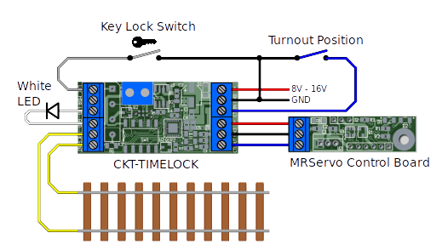Figure 1: Inputs for Time Lock Configuration
By default, the “normal” position for the track switch is assumed to be whatever state it is in when the turnout position input is high. Optionally, the manual direction input (MDR - normally not used in Time Lock mode) can be grounded to reverse this making the “normal” position of the switch its position when the input is grounded. The state of the various inputs, LEDs, and outputs for the various modes of operation are shown in Table 1 (Normal Operation) and Table 2 (Reversed Operation).

Table 1: State Table for Normal Operation (MDR disconnected/high)
Ctrl Input | Lock Input | Timer State | Timer LED | Switch Ctrl | Track Shunt
High/Open | High/Open | Locked | Off | High | Off
Low | High/Open | Locked | Off | High | Off
High/Open | Low | Running timer | Blinking | High | On
Low | Low | Running timer | Blinking | High | On
High/Open | Low | Timer expired | On | High | On
Low | Low | Timer expired | On | Low | On
High/Open | High/Open | Timer expired | Off | High | Off
Low | High/Open | Timer expired | On | Low | On

Table 2: State Table for Reversed Operation (MDR grounded)
Ctrl Input | Lock Input | Timer State | Timer LED | Switch Ctrl | Track Shunt
High/Open | High/Open | Locked | Off | Low | Off
Low | High/Open | Locked | Off | Low | Off
High/Open | Low | Running timer | Blinking | Low | On
Low | Low | Running timer | Blinking | Low | On
High/Open | Low | Timer expired | On | High | On
Low | Low | Timer expired | On | Low | On
High/Open | High/Open | Timer expired | On | High | On
Low | High/Open | Timer expired | Off | Low | Off

Inputs – Dual Control Configuration
In Dual Control mode, the device needs three inputs – the power switch direction input, the lock switch input, and the manual direction input.
The power switch position input (CTL IN) should be connected to ground for one turnout position and either left floating or connected to a positive voltage (min 3.5V, max 16VDC) for the opposite turnout position. Most of the time, this will come from the signal logic driving your control point which will relay dispatcher commands to the switch.
The manual switch direction input (MDR) should be wired to the fascia toggle switch that will provide local (simulating manual) switch control. The control switch should be an SPST or SPDT type, with the MDR line either grounded or left floating depending on switch position. Do not expose the MDR input to more than 5VDC or damage may result.

The lock input (LCK) should be connected through the keylock switch to ground. Do not expose the lock input to more than 5VDC or damage may result.
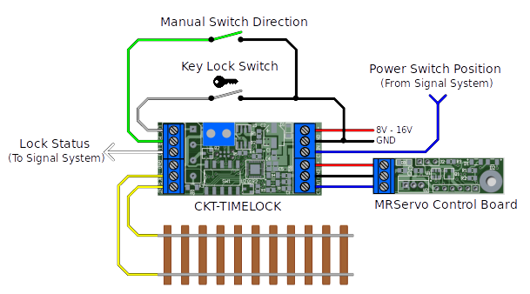Figure 2: Inputs for Dual Control Configuration

Outputs
The CKT-TIMELOCK is capable of driving both Iowa Scaled Engineering's MRServo line of servo switch machines as well as popular stall-type motors. For MRServo, just connect CTLOUT, GND, and V+ from the terminal block to their corresponding terminal on the MRServo control board.
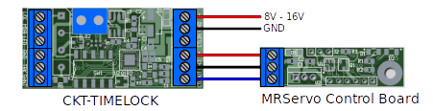
For stall type machines (such as the Circuitron Tortoise™) , a bipolar 100mA drive between V+ and GND is available from the two position terminal block on the side of the board. Just connect the stall motor to these terminals and the CKT-TIMELOCK will run the switch machine.
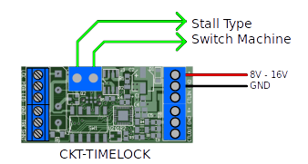
For Time Lock mode, a time lock LED output is provided as “LED”. The current limiting resistor is already included, so externally an LED just needs to be connected between the LED terminal and ground. The positive terminal (anode) of the LED should go to the LED terminal. Most prototype electric time locks use a white light, so a white LED is recommended.
For Dual-Control mode, the time lock LED output is used to indicate whether the switch machine is under manual control (LED output is high, +5V), or under power control (LED output is low, 0V). It can be used to drive an LED, or alternately can be used as a logic-level input back into a signal system to indicate that the switch is currently under manual control.
For both modes, when the system is unlocked/manual operation, relay K1 will shunt the two “TRK SHNT” terminals together through a 2kΩ, ¼-watt resistor. This should be sufficient for shunting the rails in Time Lock mode for systems using current-based block detectors, and will work on both DC and DCC systems. The relay contacts can also be used to provide a logic input
In Dual Control mode, this isolated closure can interface with the control point logic, or can – less prototypically – just be used to shunt the rails within the control point to prevent a route from being lined. How exactly this is connected is left up to the user, as there are far too many different types of model signal systems out there to provide a universal answer.

Configuration
The device is configured using the five onboard DIP switches. Switch SW5 controls what the CKT-TIMELOCK is emulating. If the switch is set to “On”, the device will behave in Dual Control mode. If the switch is set to “Off”, the device will behave as a Time Lock controller. For Time Lock mode, the other four DIP switches (SW1 to SW4) set the timeout according to Table 3.
For Dual Control mode, switches SW1 to SW4 do nothing.
Table 3: Time Lock DIP Switch Settings
Timeout (seconds) | SW4 | SW3 | SW2 | SW1
5 | Off | Off | Off | Off
10 | Off | Off | Off | On
15 | Off | Off | On | Off
20 | Off | Off | On | On
25 | Off | On | Off | Off
30 | Off | On | Off | On
35 | Off | On | On | Off
40 | Off | On | On | On
45 | On | Off | Off | Off
50 | On | Off | Off | On
55 | On | Off | On | Off
60 | On | Off | On | On
90 | On | On | Off | Off
120 | On | On | Off | On
180 | On | On | On | Off
240 | On | On | On | On

Diagnostic Lights
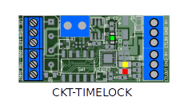
The CKT-TIMELOCK comes with three indicator lights, shown in Table 4, that indicate the current status and any problems.
Table 4: LED Indicators
LED Color | If Solid... | If Blinking...
Green (D2) | Power is on | Regulator is overheating because of hardware failure or excessive input voltage
Red (D3) | Track occupancy shunt relay is energized because switch is not locked | n/a
Yellow (D4) | n/a (currently unused) | n/a (currently unused)

Open Design
Iowa Scaled Engineering is committed to creating open designs that users are free to build, modify, adapt, improve, and share with others.
The design of the CKT-TIMELOCK hardware is open source hardware, and is made available under the terms of the Creative Commons Attribution-Share Alike v3.0 license, a copy of which is available from:
http://creativecommons.org/licenses/by-sa/3.0/
Design files can be found on the Iowa Scaled Engineering website:
http://www.iascaled.com/store/CKT-TIMELOCK
The official Iowa Scaled Engineering firmware for the CKT-TIMELOCK is free software: you can redistribute it and/or modify it under the terms of the GNU General Public License as published by the Free Software Foundation, either version 3 of the License, or (at your option) any later version. A copy of the GNU GPL can be found at:
http://www.gnu.org/licenses/gpl.html
New firmware can be flashed into the CKT-TIMELOCK through J3. The six land pads implement the standard AVR 6-pin ISP header on a connector compatible with the Tag-Connect TC2030 cable.
Stable releases of firmware and source code can be found on the Iowa Scaled Engineering website.


www.iascaled.com
support@iascaled.com

