

Interlocking-In-A-Box

Features
- Fully automatic interlocking with built-in signal logic
- Ability to simulate trains on any track based on fast time
- Configurable time lock and timeout delays to suit any application
- Supports up to one siding on each of the main lines with appropriate signal indications
- Interfaces with current-based or infrared block detectors (sold separately)
- Simulated trains can trigger 3rd party sound modules for enhanced realism
- Optional automatic interchange can be triggered by simulated trains
- Simple configuration with the MRGUI application

Description
The Iowa Scaled Engineering Interlocking-In-A-Box (MRB-IIAB) provides the signal logic to control a fully automatic interlocking on a model railroad. It can be used to manage a crossing of two active main lines with complete signal systems on both, or more typically, it can be used to manage the crossing of an active (modeled) main line and an inactive (dummy) main line. Each main line can have one siding, on either side of the diamond, and the signals respond appropriately based on the position of the switch points.
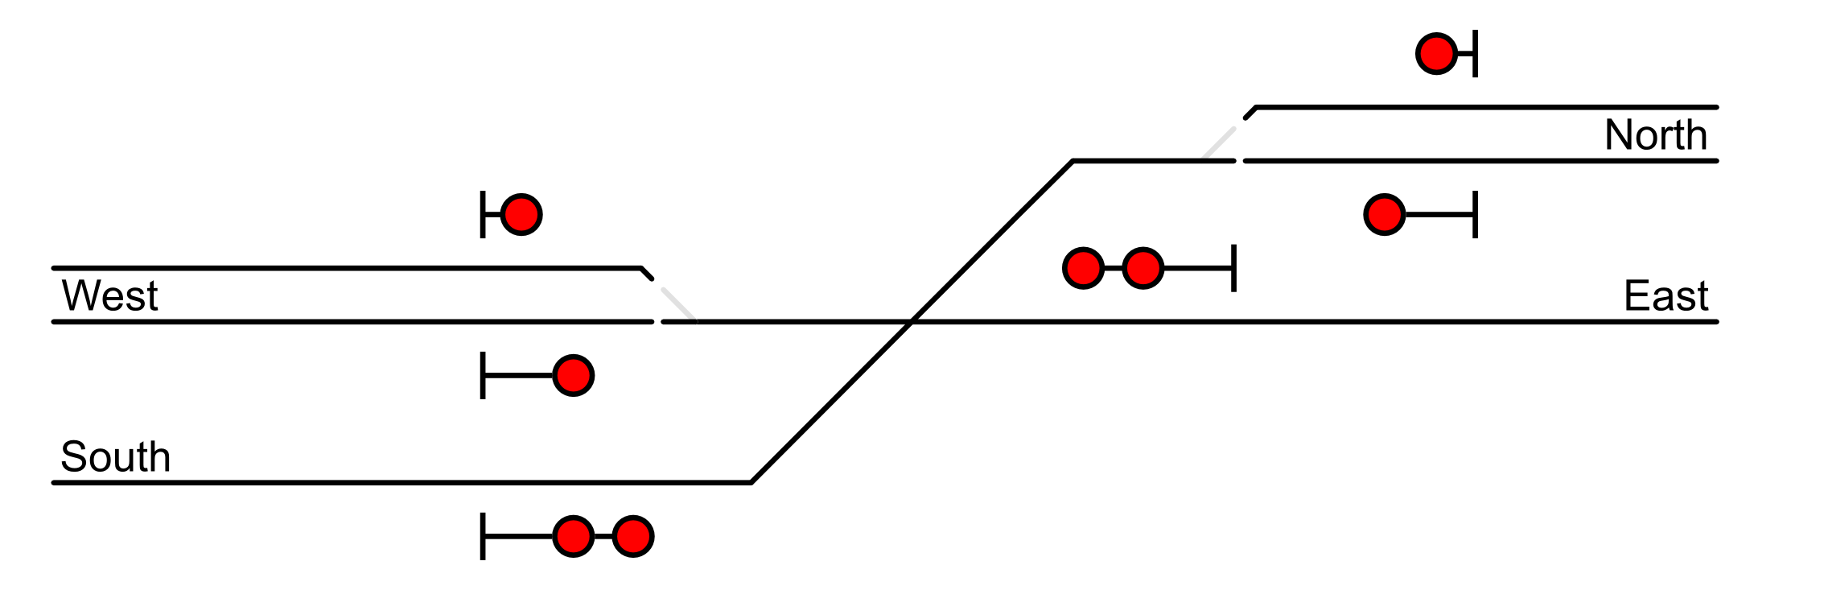Figure 1: Full Track Schematic
As shown in Figure 1, the “west” and “north” tracks have one signal head per track that can be driven. On the “east” and “south” tracks, two signal heads can be driven to control access into the siding on the opposite side. Although defined as shown above, the MRB-IIAB is flexible enough to handle other configurations such as no sidings or sidings on opposite sides (e.g. “east” and/or “south) of the diamond. More complex situations (such as sidings directly opposite the diamond) may require custom firmware – contact us for details.
The MRB-IIAB can also enhanced the realism of a dummy main line by simulating trains – and optionally triggering a sound module – on the dummy main line, preventing movement through the diamond on the the active main line while the simulated train is present. Schedules for simulated trains are loaded into the module and then triggered based on fast time from an MRB-FCM fast clock module (sold separately). Up to 32 scheduled trains can be programmed into each MRB-IIAB module. Additionally, each simulated train can also trigger an automatic interchange, delivering cars to be picked up by the next main line train.
Track occupancy inputs accept logic-level signals from a variety of occupancy detectors. Both current-based (DCC) detectors such as the MRB-BD42 and optical/IR detectors such as the CKT-IRSENSE can be used. Other 3rd party detectors can also be used as long as they provide a logic level (or open-drain) output.
Signals are driven with 5V outputs capable of sourcing 10mA or sinking 20mA each. Configuration options allow the MRB-IIAB to control any combination of common-anode (+) and common-cathode (-) LED signals. Additional circuitry may be needed to drive incandescent type signals – contact us for details.

Installation
The MRB-IIAB consists of an input/output board containing 40 I/O terminals, a microcontroller, voltage regulators, and an MRBus connection. The basic connections are shown below:

Power
Figure 2: Basic MRB-IIAB Connections
There are two power inputs to the MRB-IIAB. Connector J1, on the left, powers the input and output circuitry. The power source connected to J1 must be capable of supplying the full output current for all signals connected to the module. Connector J3, on the right, powers the microcontroller and other logic. A clean 7V – 15V DC power source must be applied to both inputs for proper operation.
Typically, when using the MRBus connection to network multiple MRB-IIAB modules and a fast clock, J3 is connected to the MRBus power lines. A local power source can then be used to supply the signals at each interlocking via J1. If only a single MRB-IIAB module is being used, then both J1 and J3 can be connected to the same power source.

Inputs and Outputs
The 40 I/O terminals are split into five banks, each bank containing 8 pins. The input / output assignments for each terminal are shown in Table 1. Between the banks of terminals are GND and 5V terminal blocks. These are provided as convenient locations to terminate the common terminal of signals, to power block detectors, or provide a pull-up voltage for open-drain inputs.

Table 1: Input / Output Assignments
Terminal | Direction | Description
PORT A
A0 | Output | Signal West Main (Green)
A1 | Output | Signal West Main (Yellow)
A2 | Output | Signal West Main (Red)
A3 | Output | Signal West Siding (Green)
A4 | Output | Signal West Siding (Yellow)
A5 | Output | Signal West Siding (Red)
A6 | Output | Signal East Top (Green)
A7 | Output | Signal East Top (Yellow)
PORT B
B0 | Output | Signal East Top (Red)
B1 | Output | Signal East Bottom (Green)
B2 | Output | Signal East Bottom (Yellow)
B3 | Output | Signal East Bottom (Red)
B4 | Output | Signal North Main (Green)
B5 | Output | Signal North Main (Yellow)
B6 | Output | Signal North Main (Red)
B7 | Output | Signal North Siding (Green)
PORT C
C0 | Output | Signal North Siding (Yellow)
C1 | Output | Signal North Siding (Red)
C2 | Output | Signal South Top (Green)
C3 | Output | Signal South Top (Yellow)
C4 | Output | Signal South Top (Red)
C5 | Output | Signal South Bottom (Green)
C6 | Output | Signal South Bottom (Yellow)
C7 | Output | Signal South Bottom (Red)

Terminal | Direction | Description
PORT D
D0 | Input | Block Detector (West Main)
D1 | Input | Block Detector (West Siding)
D2 | Input | Block Detector (East)
D3 | Input | Block Detector (North Main)
D4 | Input | Block Detector (North Siding)
D5 | Input | Block Detector (South)
D6 | Input | Block Detector (Diamond)
D7 | Input | Block Detector (Automatic Interchange)
PORT E
E0 | Input | Turnout Position (West)
E1 | Input | Unused. Connect to GND.
E2 | Input | Turnout Position (North)
E3 | Input | Unused. Connect to GND.
E4 | Output | Unused. Do not connect.
E5 | Output | Automatic Interchange Relay
E6 | Output | Sound 0 Trigger
E7 | Output | Sound 1 Trigger

Signals
The MRB-IIAB can be configured to drive common-anode (Figure 3) or common-cathode (Figure 4) signals. This polarity can be configured on an output-by-output basis, providing maximum flexibility for any signal installation. Although designed to drive LEDs, incandescent lamps can also be driven with additional circuitry – contact us for details.

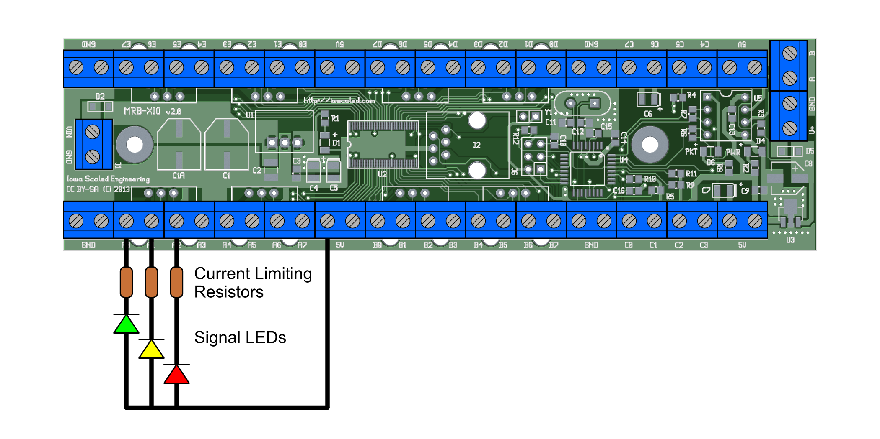Figure 3: Wiring Common Anode Signals
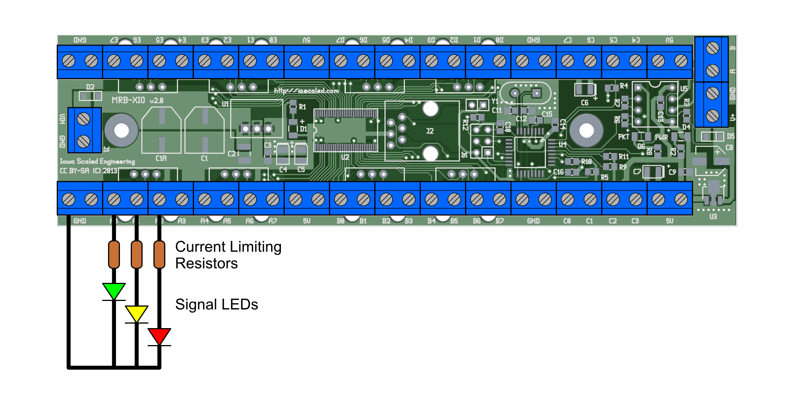Figure 4: Wiring Common Cathode Signals

The outputs of the MRB-IIAB are 5V logic level signals. To prevent permanent damage to the signal LEDs, be sure to include appropriate current limiting resistors.
Leave any unused signal outputs disconnected. Connecting any signal output to 5V, GND, or any other power source may damage the MRB-IIAB module.

Detectors
IR, BD4X
pull-ups on detector inputs
Tie off unused inputs

Other Functions
Sound triggers
Auto interchange relay

MRBus

Configuration

Operation
Signal logic overview (using test case diagrams?)

Applications
2 active main lines
1 active, 1 dummy
Swapping sidings
Changing signal color for proceed (main and siding)
auto interchange
using sound outputs to trigger crossing gates

Related Products
MRB-FCM
CKT-IRSENSE
MRB-BD4X

Open Design
Iowa Scaled Engineering is committed to creating open designs that users are free to build, modify, adapt, improve, and share with others.

Hardware
The design of the MRB-IIAB hardware is open source hardware, and is made available under the terms of the Creative Commons Attribution-Share Alike v3.0 license, a copy of which is available from: http://creativecommons.org/licenses/by-sa/3.0/
Design files can be found on the Iowa Scaled Engineering website:
http://www.iascaled.com/store/MRB-IIAB

Firmware
The official Iowa Scaled Engineering firmware for the MRB-IIAB is free software: you can redistribute it and/or modify it under the terms of the GNU General Public License as published by the Free Software Foundation, either version 3 of the License, or (at your option) any later version. A copy of the GNU GPL can be found at: http://www.gnu.org/licenses/gpl.html
Stable releases of firmware and source code can be found on the Iowa Scaled Engineering website: http://www.iascaled.com/store/MRB-IIAB

