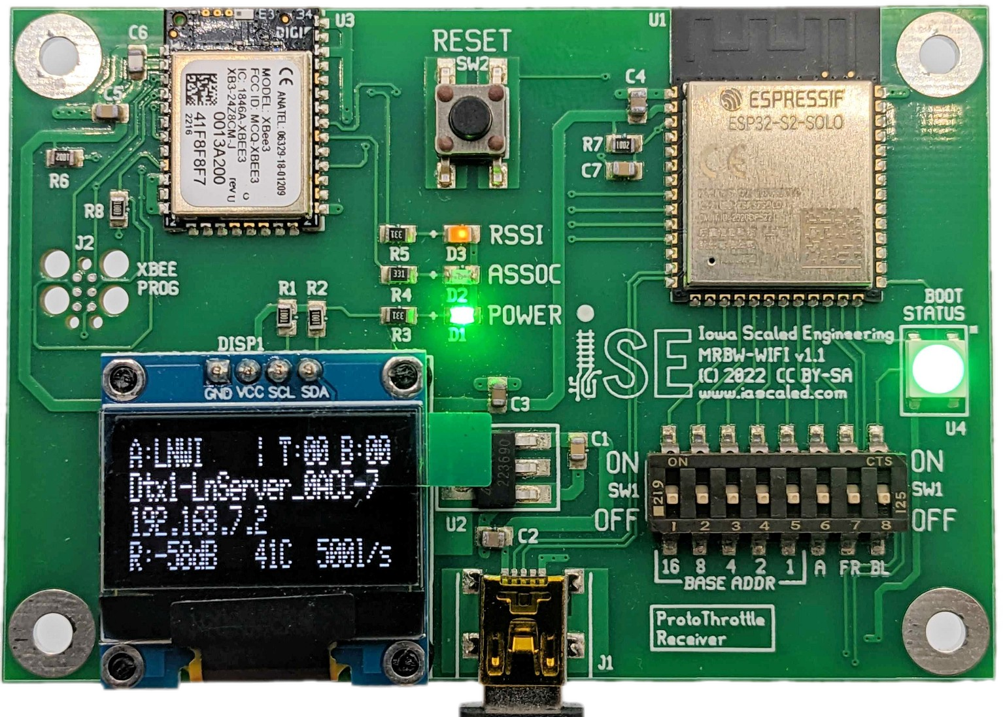


Receiver for WiFi Systems
v1.0


IOWA SCALED ENGINEERING – ELECTRONICS MADE EASY

Getting Started
For most users, getting started will just be a matter of powering up the unit using the included USB cable and power supply. If you need to change your base address from the default of zero, set the DIP switches to match what you have configured in your ProtoThrottle.
The new receiver should find Digitrax LNWIs, DCC-EX systems, MRC WiFi modules, and ESU CabControl systems in their default configurations automatically and attach to them with no user intervention.
If your LNWI has a password, or you’re attaching to a network to connect to a JMRI WiThrottle server, you’ll need to use a text editor to set a few values in the config.txt file. Plug the USB cable into your computer instead and see the instructions under “WiFi / Network Configuration”.

Switch Configuration
There are eight switches located to the right of the screen. Moving the switch up (away from the edge of the board with the USB connector) turns it “ON”, and moving the switch down (towards the edge) turns it “OFF”.
Switch | Function
BASE ADDR  16, 8, 4, 2, 1 | Set the radio base address of this receiver for the ProtoThrottle. Add the value(s) of the switches that are in the ON position to get the address. Program this value into the ProtoThrottle using the COMM CFG – BASE ADR menu. The base address should not be the same on any receivers within radio range of each other. Example: If you want base address 5, set switch 1 and 4 to “on”.
A | Reserved for future use.
FR | Factory Reset – If this switch is ON when the unit is powered up (or when the reset button is pressed), the receiver will restore the config.txt file to its factory default state.
BL | Bootloader – LEAVE THIS SWITCH OFF  While you won’t break anything by turning it on, having this switch on will cause the device to come up in various bootloader modes that can be used to upgrade firmware or recover a bricked device. See the “Firmware Updates” section for details.

WiFi / Network Configuration
For systems using ESU CabControl, Digitrax LNWI, DCC-EX or MRC WiFi wireless systems in their default configuration, no configuration changes should be needed. The receiver should automatically find your network and connect to it.
If you are using a JMRI WiThrottle server, have a password on your LNWI, or other more complex configuration, some adjustments may be needed.
Plug the ProtoThrottle WiFi Reciever into your computer and it should appear as a drive. On it, you should see a file called “config.txt”. Open it with a basic text editor (Notepad, Notepad++, TextEdit, etc.), make appropriate changes, and then save it again. Saving the file will cause the receiver to restart, reloading your changes.
The file has a simple key = value format per line – no quotes or anything else are needed or wanted. The keys and values are case sensitive, however, and must be typed accurately. Any line without a value will be ignored.

Key | Value(s) | Usage
mode | lnwi  withrottle  esu  dccex | Configure which type of server. ‘lnwi’ is specifically for Digitrax LNWIs , and ‘dccex’ is specifically for DCC-EX systems. All other WiThrottle-compatible servers should use ‘withrottle’. ESU CabControl systems use ‘esu’.  If this option is specified without specifying ssid and password, it will limit network automatic discovery to only those types of servers (LNWIs, DCC-EXs and ESUs, primarily).
ssid | (your wireless network name) | Name of your WiFi network. If you specify this, please also specify mode and password.
password | (your wireless network password) | Your WiFi network password. Leave blank for open/unsecured networks.
serverIP | (server IP address) | To save time searching for your WiThrottle server on a network, a specific server IP or address can be specified here.
serverPort | (server port) | Normally the server port will be assumed from the server type. However, if you want to run your WiThrottle or ESU server on a non-standard port, it can be specified here.
fastClockSource | none  cmdstn | Some WiThrottle connections are capable of sending fast time to the throttles. Set this to “cmdstn” in order to use the command station fast time. Leave this at none to use other fast time sources.

Main Screen
In order to show you a variety of status information, the receiver has a small OLED screen on board. While the actual screen is just black and white, the various fields are color highlighted to help explain them.
A:LNWI / T:01 B:00
Dtx1-LnServer_0ACC-7
L:192.168.7.1
R:-78dB 48C 525l/s

Element | Meaning
A: | Command station discovery method.  A=automatic, C=from config.txt
LNWI | Command station type.  LNWI, ESU, WTHR, DCCX, or NONE
/ | Spinner – will spin every second to confirm the receiver is still operating.
T:01 | Number of throttles actively connected to the receiver.
B:00 | Base address selected via the switches to the right of the screen. If another base at the same address is within range, the B will be changed to an asterisk.
Dtx1-Ln... | Network SSID the receiver is attached to, or (Searching...) if it hasn’t yet found a network
L:192.168.7.1 | If L is the first character, the IP address of the receiver or (Not Connected) if the receiver has not yet connected to a WiFi network. If C is the first character, the IP address of the command station. Switches between the two every two seconds.
R:-78dB | WiFi signal strength. The more negative the number, the less signal strength.
48C | Current temperature of the receiver CPU.
525l/s | Loops per second – how fast the software is running and processing incoming requests from the command station and the throttle.

Boot Status LED
On the right side of the board above the switches is a large, multi-color LED that is used to communicate status of the board at a glance, and in places where the board isn’t able to use the main screen to communicate.
During startup, the LED will briefly go purple. This indicates that the BL switch can be flipped to enter the firmware update process. See the next section for details.
During normal operation, the light will be red if the device hasn’t found a wireless network to join, yellow once it’s found the network but hasn’t found the command station / withrottle server, and green once it’s happily connected. If the light starts blinking between blue and green, it means that another conflicting ProtoThrottle receiver on the same base address is within range.

Firmware Updates
From time to time, we may release firmware updates to add new functionality or fix bugs in the receiver. In order to update, you’ll download UF2 firmware from our website. Plug your receiver into your computer’s USB port. Holding the receiver with your left hand, press “RESET” and immediately flip the BL switch with your right hand while the LED is purple. You only have one second to do it, so it’s best to have your fingernail on the switch before hitting reset. If successful, you’ll see a drive come up with three files – current.uf2, index.htm, and info_uf2.txt. Copy the UF2 firmware file that you downloaded onto this drive. The status LED will blink from green to yellow and eventually the receiver should reset. Once complete, turn the BL switch back off and hit RESET again, and you should see the new firmware version on the boot screen.

Factory Reset
If your receiver ever gets in a state where your config.txt is messed up or your computer cannot read it, you can restore it to factory condition by setting the FR switch to ON and briefly pushing the reset button. Your receiver will reboot, the status LED will turn blue as it overwrites the old config.txt with a fresh copy (this may take several seconds longer than a normal startup), and then will start up normally. Don’t forget to turn the FR switch back off once the receiver has booted, or it will overwrite the config.txt file again!

Like almost all Iowa Scaled Engineering products, the
MRBW-WIFI is open source hardware and software. Source code is made available under the GNU General Public License v3, and all other documentation under Creative Commons. All of our hardware design files and source code are available from our Github account:
https://github.com/IowaScaledEngineering/mrbw-wifi
We would very much like to acknowledge and thank some other open source projects that have made developing the MRBW-WIFI significantly easier: Adafruit’s tinyuf2 bootloader, the Espressif ESP32-S2 Arduino framework, and the Platform.IO team who have built a great embedded development environment.
Also, ISE would like to thank ESU for providing detailed protocol information about how to connect to their command station, as well as Brett Hoffman and the JMRI team for making the excellent WiThrottle protocol a standard.

ProtoThrottle WiFi Receiver
Model: MRBW-WIFI, Hardware Version: 1.1
Iowa Scaled Engineering, LLC
support@iascaled.com
This product is not a toy. For ages 14 and over.
Contains FCC ID: MCQ-XBEE3 and 2AC7Z-ESPS2SOLO2U
This device complies with part 15 of the FCC Rules. Operation is subject to the following two conditions: (1) This device may not cause harmful interference, and (2) this device must accept any interference received, including interference that may cause undesired operation. Changes or modification to the device could void the user’s authority to operate the equipment.
Contains IC: 1846A-XBEE3 and IC: 21098-ESP32S2SOLO
This device complies with Industry Canada’s license-exempt RSSs. Operation is subject to the following two conditions:
(1) This device may not cause interference; and (2) This device must accept any interference, including interference that may cause undesired operation of the device.
Le présent appareil est conforme aux CNR d’Industrie Canada applicables aux appareils radio exempts de licence. L’exploitation est autorisée aux deux conditions suivantes:
(1) l’appareil ne doit pas produire de brouillage, et (2) l’utilisateur de l’appareil doit accepter tout brouillage radioélectrique subi, même si le brouillage est susceptible d’en compromettre le fonctionnement. Changes or modification to the device could void the user’s authority to operate the equipment. Des changements ou des modifications à l’appareil pourraient annuler l’autorité de l’utilisateur à utiliser l’équipement

Visit the Iowa Scaled Engineering website
and store to learn more about our full line
of model railroad electronics.

www.iascaled.com

