
MRServo™ Switch Machine Instructions

MRServo™ is a low-profile, slow motion switch machine for driving N, HO, S, and O scale model railroad turnouts. The MRServo control board drives a small servo, which throws the switch via spring steel wire. The servo is only actively driven while throwing the points, and depends upon the spring wire to provide tension on the points. Therefore, these small, inexpensive servos should provide years of quiet, calibration-free, low power operation.

MRServo-1  The basic version that provides a cost-effective, reliable slow motion turnout drive. It does not include any accessory contacts, but has a header so you can add them later. | MRServo-2  Everything the MRServo-1 has, plus a relay that provides two sets of accessory contacts that switch based on turnout position | MRServo-3  Everything the MRServo-1 has, but with one set of accessory contacts and one set of PowerFrog contacts for powering turnout frogs and point rails.

Wiring MRServo
MRServo requires a stable 8-16 volt DC power supply. Lower voltages are preferred; higher voltages will only cause the regulator on the board to get hotter. On MRServo-2 and MRServo-3, the relay contacts are rated for 1 amp at 24 volts. Exceeding this may cause long term damage to the contacts or the board traces.

The control input determines which way the servo will throw. The easiest way to control MRServo is by connecting the control input through a switch to ground. When grounded, the turnout will throw one direction, and when left floating, it will throw in the reverse direction. The control input can tolerate being driven up to MRServo's supply voltage.
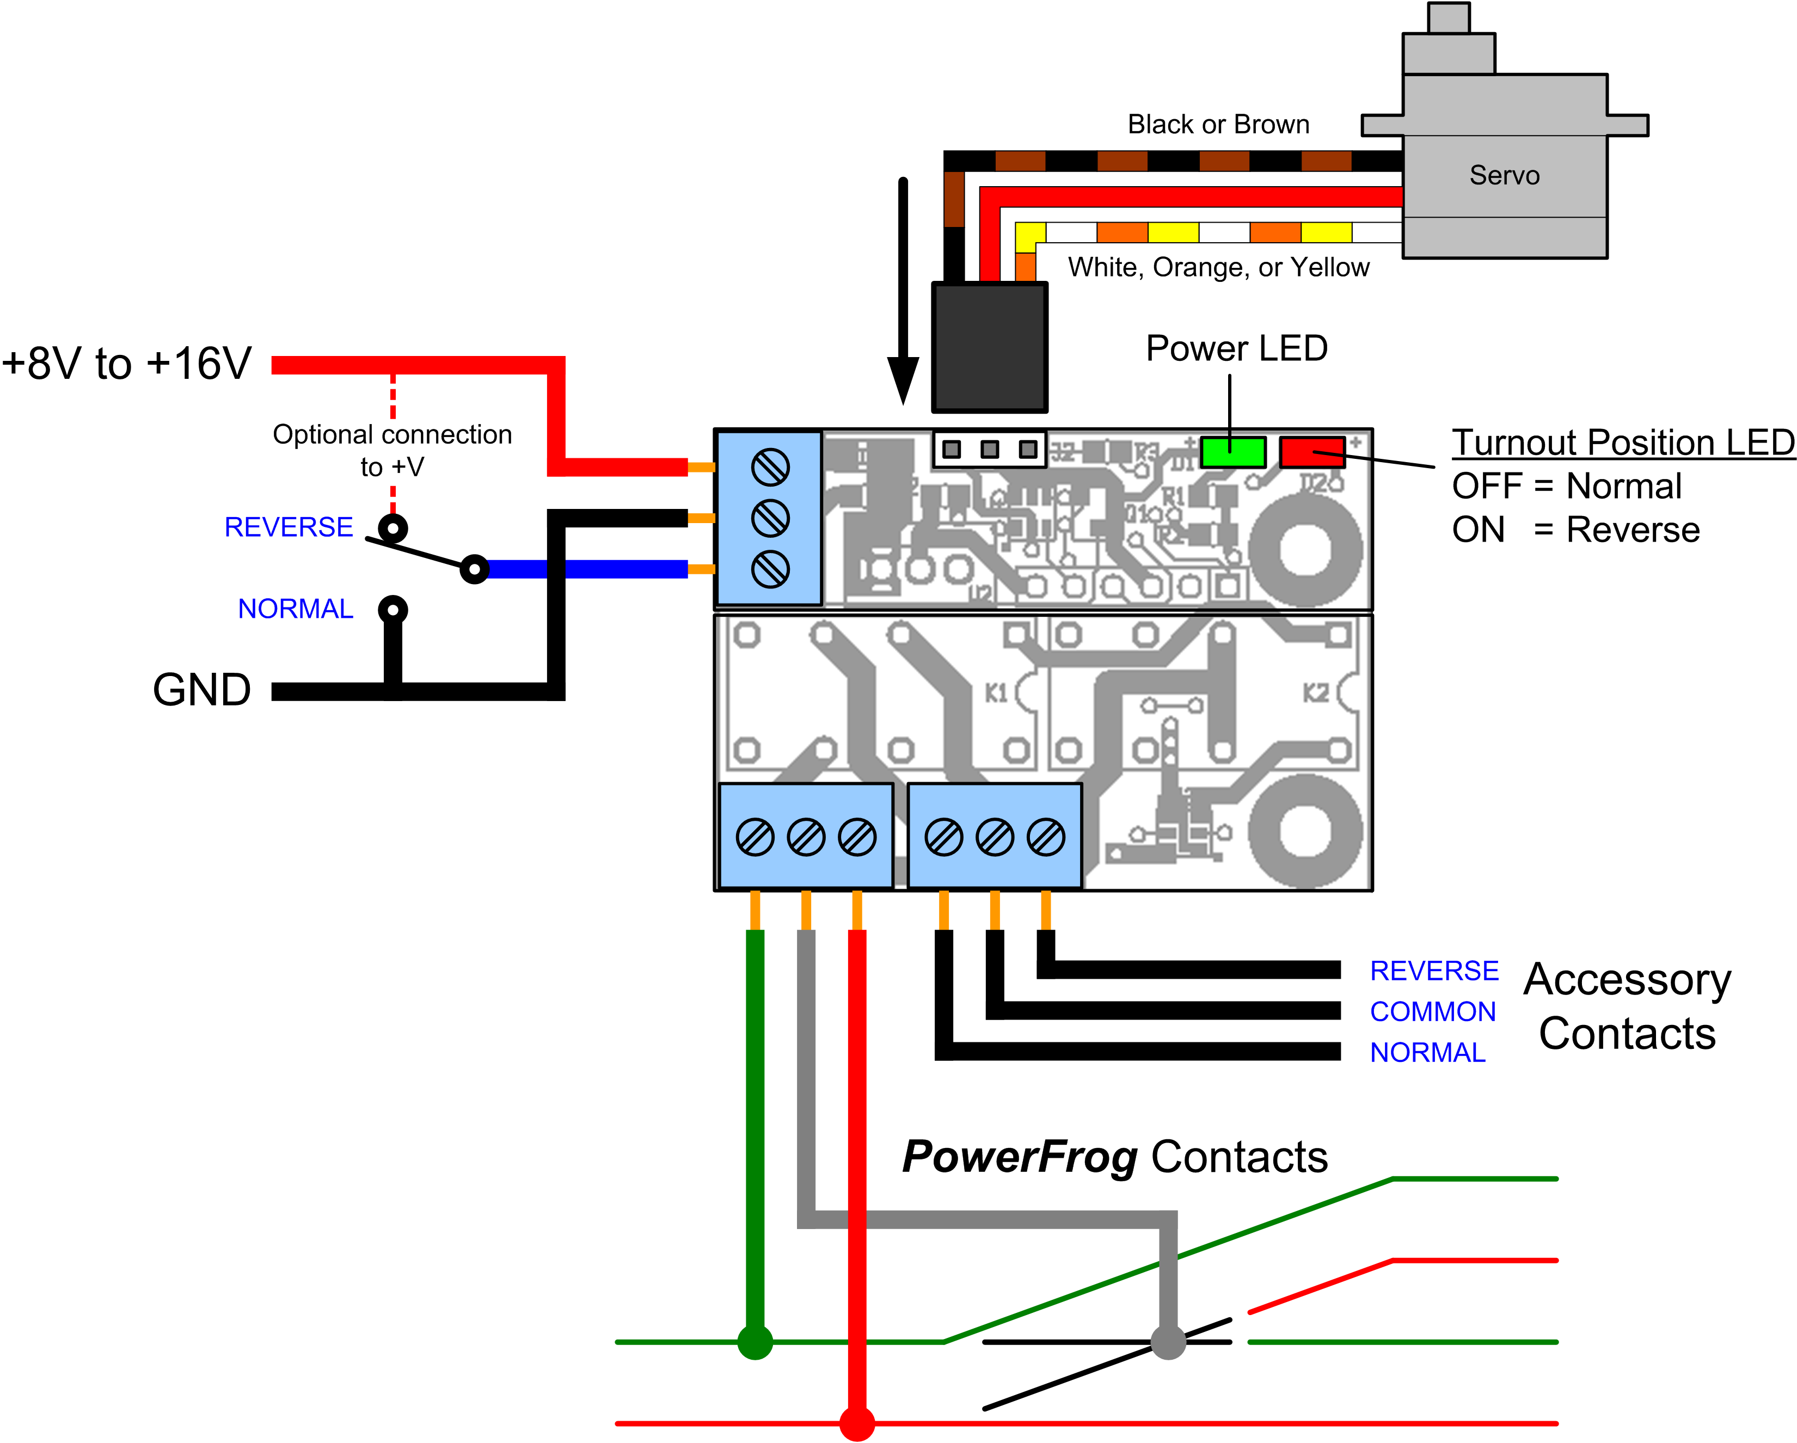Typical wiring for a MRServo-3. MRServo-1 boards will only have the upper half of the board (power, control, and servo connections), and MRServo-2 boards will have an additional set of accessory contacts (with the same pinout as the first) in place of the PowerFrog contacts.

PowerFrog
The exclusive PowerFrog feature found on MRServo-3 boards provides a reliable, short-proof way to route power to solid frog turnouts. (Examples include handlaid turnouts or Peco Electrofrog™, Shinohara™, and Walthers™ models.) These turnouts will create a short if the points make contact with the opposing rail before the contacts driving the frog switch polarity. Traditionally, the solution has been to add additional gaps in the point rails, isolating just the frog. With PowerFrog, this is no longer necessary. When MRServo starts to throw the points, it momentarily isolates the frog entirely. Once the servo completes throwing the points, it sets the direction relay to the correct polarity and, after a small delay, re-energizes the frog.

Installation Instructions
Note: 0.025” piano wire is suggested for most turnouts. It's flexible enough to act as a spring, maintaining tension on the points even once the servo powers down. 0.032” can be used for stiffer turnouts, such as those with an overcenter spring.

Step 1: Measure off 2.5 inches of 0.025” piano wire | Step 2: Make a 90 degree bend 1/4” from the end
Step 3: Make another bend 1/4” from the first | Step 4: Make a third bend one servo horn width from the second bend
Step 5: Insert through servo horn | Step 6: Secure by clamping down with pliers  (be gentle, or you may break the servo horn plastic)
Step 7:  Tape Mount: Remove servo labels and clean surface thoroughly with rubbing alcohol. Once clean, attach double sided mounting tape.  Bracket Mount: Clip the control board into the bracket. Attach the servo to the bracket with screws. | Step 8: Manually turn the servo to point the throw wire straight up at the midpoint between the ends of throw. Insert screw to hold servo horn.
Step 9: Center turnout throw bar and insert throw wire from bottom of layout. When everything is lined up, lightly stick servo to benchwork. | Step 10: Connect the wires and test operation. Once correct alignment is confirmed (wire should bend to keep pressure on the points in both directions when servo powers down), firmly press servo to benchwork.

Warranty
MRServo boards and servos are covered for life as long as operated within rated limits. Send us the defective unit and we'll send you a new one. You pay postage on the return, we'll pay to send you a new one.


Quality Model Railroad Electronic Products
Visit us on the web at http://www.iascaled.com or email us at support@iascaled.com

