

MSS-CASCADE User Manual
From the official Modular Signal System website: “MSS Cascade Elements define signal block boundaries, where one block ends and the next begins. The wire pattern "cascades" the track occupancy status from one block to the next, in both directions.”

Features
- Completely integrated Modular Signal System “Cascade” type module
- Compliant with the MSS v2.0.0 specification
- Easy installation with connectors and terminal blocks
- Dual extremely sensitive (12-15k ohms) isolated DCC block detectors
- Simple sensitivity adjustment
- Isolated detection to prevent coupling track power and signal systems
- Integrated “foolproof” ISE CKT-IRSENSE optical detector
- Capable of driving a wide variety of signal heads:
  - 3 LED common anode (+)
  - 3 LED common cathode (-)
  - Red/green single LED, 3 wire common anode (+)
  - Red/green single LED, 3 wire common cathode (-)
  - Red/green single LED, 2 wire
- Supports single or dual headed signals for each direction
- Supports MSS “diverging approach indication”
- Configurable signal aspects and approach lighting
- Auxiliary occupancy input for both A and B blocks

Overview
The MSS-CASCADE module is designed to be compatible with the Modular Signal System v2.0.1 specification ( http://modularsignalsystem.info/ ). It is designed to provide basic ABS signaling functionality at a block boundary. It contains dual integrated DCC current block detectors, an optical detector based on the foolproof Iowa Scaled Engineering CKT-IRSENSE, MSS occupancy bus logic, LED signal drivers, and power supply, which provides the complete “cascade” unit described in the standard.

Installation / Wiring Diagram
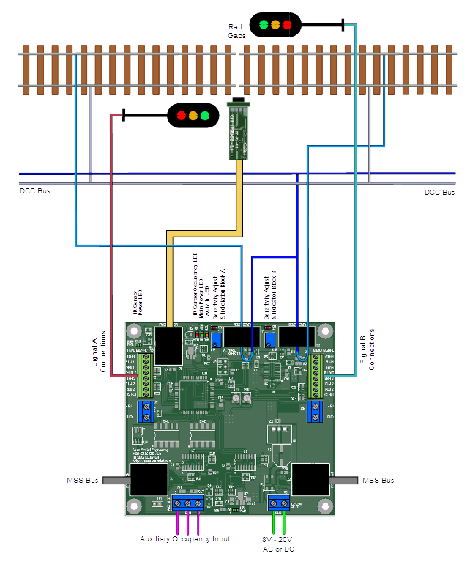

Installation
The MSS-CASCADE module is designed to be easy to install. There are three key pieces to a successful installation – wiring the DCC block detectors, installing the infrared detector, and connecting the signals.

Quick Start Checklist
- Wire the track through the block detectors - “Wiring for Block Detection”
- Install the optical detector - “Installing the Infrared Sensor”
- Wire your signals - “Wiring the Signals”
- Configure your signal type – Table X-1
- Configure your desired aspects – Table X-2 (single headed) or X-3 (dual headed)
- Connect 12-20V AC or DC power to the terminals marked “PWR”
- Power up the module and set block detector sensitivity – see “Sensitivity Adjustment”
- Connect with other MSS modules to make your signal system function

Wiring for Block Detection
Track power must be isolated on both rails at each end of the module, per the MSS standard. In addition, the detected rail (the one whose leads pass through the current transformers) must be gapped at the block boundary where you will place the signals.
Any track elements on the module that you do not want to have detect – such as industry spurs, secondary tracks, etc. - must be isolated from the detected mainline and fed with wires that do not go through the detector transformers.
Connect all feeders from the detected rail on the “A” side of the signal together and then feed that connection back through the current transformer (the large black tombstone looking item on the PCB) marked “A DETECTOR”. Likewise, collect all feeders from the detected rail on B side and run them through the “B DETECTOR” transformer. We recommend combining them into a single wire before passing them through the transformer.
Only one pass is necessary – multiple loops will likely make the detector too sensitive.
The MSS-CASCADE also requires power to operate. At a minimum, the module needs 12VDC applied to J3, the two position terminal block on the left side of the board. It can accept up to 20 volts AC or DC, so that it can be fed from the Free-mo accessory bus or any other low voltage power supply that might be handy (including DCC track power, if necessary, though it is not recommended).
Once installed, the block detector has to be calibrated to the installed track and wiring. See the “Sensitivity Adjust” section for this simple procedure.

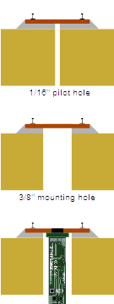
Installing the Infrared Sensor
The infrared sensor included with the MSS-CASCADE uses the same type of sensor as the CKT-IRSENSE, Iowa Scaled's highly reliable standalone sensor. However, the control logic is integrated into the MSS-CASCADE board rather than being up near the sensor head. It uses an inexpensive reflective infrared digital proximity sensor. At the top of the device are two small lenses - one emits a series of infrared pulses, which are then reflected by objects into the other lens, a receiver. By measuring the intensity of the returned pulses, the sensor can detect the presence of and distance to an object. The device also automatically compensates for background lighting, eliminating false triggers. No adjustment to the sensor should be needed.
The detector is designed to be installed up through the benchwork in a 3/8 inch (10 mm) hole. To install in existing track, first drill a 1/16” pilot hole between the ties. Then, from the bottom, drill a 3/8” hole up toward the track, using the pilot hole you just drilled as a guide. Work slowly and be very careful to not damage the ties (you might want to remove a couple of ties first and reinsert them after drilling the hole). Once the sensor is installed, be sure that both lenses are clear to shine up between any ties or ballast.
The module is not naturally water resistant, so be careful when ballasting. Some amount of water resistance can be added by coating everything (other than the lenses) with liquid electrical tape or similar sealant. Be very careful not to cloud or cover the detector lenses.
The sensor can be secured in the hole using a variety of methods such as hot glue or by using a mounting bracket. See the Iowa Scaled Engineering website for more details and some example mounting brackets.
Once the module is installed, plug the modular jack on the end into the socket on the MSS-CASCADE marked “IR DETECTOR”.

Wiring the Signals
The MSS-CASCADE is set up to drive most North American prototype LED signals directly. The MSS-CASCADE cannot source enough current to drive lightbulb-based signals directly. Connecting them may cause damage to the board.
The board includes on-board resistors, saving you the time of installing them in each of the individual signal leads. If your signals already have resistors, you may need to remove them to get them to light to an acceptable brightness (or at all).
For LED signals other than 2-wire red/green LEDs, one side of all the LEDs will be wired together into a common lead. Sometimes this is the positive side, sometimes this is the negative side. There's no particular standard. It's necessary to determine whether your chosen signals are common anode (common positive) or common cathode (common negative). Signals from Tomar (other than searchlight styles), BLMA, Details West, and NJ International typically are common anode. Signals from Atlas and Tomar's searchlights are common cathode. When it doubt, please check the manufacturer documentation or ask them.

Signal Output Terminals
Signal outputs are the small 8-position terminal blocks on each side of the board. The signal connected to the “A” side should face the “A” side track block, and the signal connected on the “B” side should face the “B” side track block. Under the 8-position block is a larger 2 position block. This provides +5VDC and Ground, which are used for the common signal lead.


WARNING! DO NOT connect anything to the “R1 ALT” or “R2 ALT” terminals unless you are using 2-wire red/green LEDs, as shown in example #5 below. DAMAGE WILL RESULT OTHERWISE, as these terminals do not contain currently limiting resistors.

Single vs. Dual Head
Single-headed signals should always be connected to the “#1” set of signal outputs (GRN 1, YLW 1, RED 1, etc.)
Dual-headed signals should have their upper head connected to the #1 set of outputs and lower head connected to the #2 set of signal outputs.
Note: In cases where the signal is configured as single-headed, the aspect will be mirrored on the #2 terminals, and they'll be configured as a 3-light, common anode no matter what the primary head is set up as. This is convenient for making fascia signal repeaters out of three LEDs.

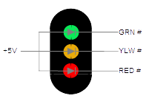
Example 1: Three Light, Common Anode
Connect the common lead to the +5V terminal, and then the red, yellow, and green negative leads to the RED, YLW, and GRN terminals for the appropriate signal head. Three light signals from Tomar, BLMA, Details West, and NJ International are commonly this type.

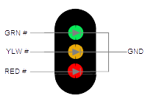
Example 2: Three Light, Common Cathode
Connect the common lead to the GND terminal, and then the red, yellow, and green positive leads to the RED, YLW, and GRN terminals. Atlas signals are commonly this type.

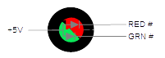
Example 3: Red/Green Dual Color LED, 3-wire, Common Anode
Connect the common lead to the +5V terminal, and then the red and green negative leads to the RED and GRN terminals. Leave YLW unconnected.

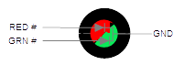
Example 4: Red/Green Dual Color LED, 3-wire, Common Cathode
Connect the common lead to the GND terminal, and then the red and green positive leads to the RED and GRN terminals. Leave YLW unconnected. Tomar searchlights are commonly this type.

Example 5: Red/Green Dual Color LED, 2-wire
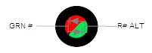
Since LEDs will only light when current is applied in the correct direction, it's possible to drive two of them with only two wires by putting them in opposite directions. These types of signals (almost always searchlight style, eg US&S H-series and GRS SA prototypes) will have only a single LED and two wires. To make red, current is applied one direction, and to make green it's reversed. The eye will perceive yellow if the red and green are alternated very quickly (50 times a second or more). These are fairly rare – no known major manufacturer makes a signal with these LEDs, but they have been used in scratchbuilt signals.
In this case (and this case only), connect one lead of the LED into the “GRN” terminal and the other into the corresponding “R# ALT” terminal. The ALT red terminal does not have a resistor in line with it, making sure that your two-leaded LED is only driven through the single resistor in the green line.
If the LED produces red when you expect green and green when you expect red, reverse the leads.

Tuning the Yellow
In any of the red/green dual color LED setups, the eye is tricked into seeing yellow by giving it both red and green light. However, these must be in the right proportion, otherwise the color will look quite off. There are two small potentiometers on board that adjust the red/green balance for these three signal configurations. First, trigger a signal condition that will cause a yellow aspect. Then, using a small flatheaded screwdriver, slowly turn the potentiometer for either the A or B side (whichever you're working on) back and forth until you find an acceptable yellow balance.

Other Types of Signals
The board should be able to control any semaphore signal driver that accepts logic level inputs for various aspects. Configure the signal for common cathode and connect the red, yellow, and green wires to the various clear, caution, and restricting inputs. Also make sure to pick an indication set that doesn't include any flashing aspects or you'll get very strange waving semaphore blades.
Pennsylvania position light signals and B&O/C&O CPLs require special considerations. Please contact us for details.

Sensitivity Adjustment
Contrary to popular belief, an empty track block does not always draw zero current. Because of resistive leakage through scenery (including wooden ties in varying humidity) and capacitive effects between the rails and feeder wires, there's often a very small leakage current. Thus, a sensitivity adjustment is provided to allow you to calibrate this out, minimizing false detection while keeping the very highest levels of sensitivity.
Once the board is installed, apply DCC power to the track bus inputs with absolutely nothing on the track. If the “OCC” red LED comes on solid, turn the sensitivity adjustment potentiometer counter-clockwise with a small flathead screwdriver slowly until the light turns off.
If the “OCC” red LED is off, turn the potentiometer slowly clockwise until the light comes on, then back it off until the light turns off.
Test the sensitivity by placing a locomotive or a piece of resistor-equipped rolling stock across the rails. The OCC light should come on when the equipment is on the track, and turn off after a short delay when the equipment is removed.
If the detector trips without equipment, continue making slight counter-clockwise adjustments until the module no longer detects phantom equipment. Sometimes humidity, changes in track voltage, twisting of wires, etc. can change the amount of quiescent current being drawn and trigger the detector. The detector is adequately sensitive that it can be desensitized quite a bit before it's unable to detect resistor-equipped cars.

Auxiliary Input
Most signal systems require that any turnout off the signaled mainline must be wired to trigger detection if it's thrown against the main. The aux input pins can be used to connect auxillary contacts on switch machines, ground throws, or more complex items like the Iowa Scaled CKT-TIMELOCK switch time lock simulator into the occupancy bus without a direct electrical interconnection.
When the pins are shorted but no occupancy is detected, the “OCC” red LED will blink and occupancy sent on the MSS bus. If occupancy is detected, the “OCC” red LED will go on solid, regardless of the axillary input.

While it's safest to not connect the auxiliary input terminals to anything but each other through an isolated electrical switch, it is possible to drive them with a logic circuit. If you do want to connect them to some sort of logic, the input is negative true (meaning, 0V triggers occupancy), and never exceed 5VDC or the module will be destroyed.

Configuration Switches

Switch  Bank | Switch | Function
SW1 | 1 | Signal Head Type Configuration  See table X-1
SW1 | 2 | Signal Head Type Configuration  See table X-1
SW1 | 3 | Signal Head Type Configuration  See table X-1
SW1 | 4 | On = Signal A has two signal heads  Off = Signal A has a single signal head
SW1 | 5 | On = Signal B has two signal heads  Off = Signal B has a single signal head
SW2 | 1 | Signal A Aspect Configuration  See table X-2 if signal A is configured as single headed (SW1-4 = Off)  See table X-3 if signal A is configured as dual headed (SW1-4 = On)
SW2 | 2
SW3 | 3 | Signal B Aspect Configuration  See table X-2 if signal B is configured as single headed (SW1-5 = Off)  See table X-3 if signal B is configured as dual headed (SW1-5 = On)
SW2 | 4
SW2 | 5 | On = Signals approach lit  Off = Signals always lit

A Note On Signals – Aspects vs. Indications
Aspect is how the signal looks, ie. the color of light illuminated on each target.
Indication is the meaning of a particular set of aspects, ie. green over red is an indication of clear, meaning proceed at track speed.
The configuration tables in this document specifically call out the aspects, as while the aspect arrangement may be similar across railroads, the indication names often differ.

Table X-1: Signal Head Type Configuration
SW1-3 | SW1-2 | SW1-1 | Signal Type
Off | Off | Off | 3-wire R/Y/G LEDs with a common anode (+) terminal
Off | Off | On | 3-wire R/Y/G LEDs with a common cathode (-) terminal
Off | On | Off | 3-wire bi-color R/G LED with a common anode (+) terminal
Off | On | On | 3-wire bi-color R/G LED with a common cathode (-) terminal
On | Off | Off | 2-wire bi-color R/G LED
On | Off | On | Reserved for future use
On | On | Off | Reserved for future use
On | On | On | Reserved for future use

Note: If a signal is configured as single-headed (SW1-4 for signal A, and SW1-5 for signal B), the LED outputs for the second head automatically become a 3-wire R/Y/G LED driver that mirrors the aspect of the head. This is useful for fascia repeaters, etc.

Table X-2: Signal Aspect Configuration for Single-Headed Signals
Switch Configuration |  | Aspect for Most Restricting Input
SW2-2 (A)  SW2-4 (B) | SW2-1 (A)  SW2-3 (B) | Stop | Advance Approach | Diverging  Approach | Approach | Clear
Off | Off | Red | Flashing Ylw | Yellow | Yellow | Green
Off | On | Red | Flashing Ylw | Green | Yellow | Green
On | Off | Red | Green | Yellow | Yellow | Green
On | On | Red | Green | Green | Yellow | Green

Table X-3: Signal Aspect Configuration for Dual-Headed Signals
Switch Configuration |  | Signal  Head | Aspect for Most Restricting Input
SW2-2 (A)  SW2-4 (B) | SW2-1 (A)  SW2-3 (B) |  | Stop | Advance Approach | Diverging  Approach | Approach | Clear
Off | Off | Upper | Red | Fl Ylw | Yellow | Yellow | Green
Off | Off | Lower | Red | Red | Yellow | Red | Red
Off | On | Upper | Red | Fl Ylw | Yellow | Yellow | Green
Off | On | Lower | Red | Red | Green | Red | Red
On | Off | Upper | Red | Fl Ylw | Yellow | Yellow | Green
On | Off | Lower | Red | Red | Fl Green | Red | Red
On | On | Upper | Red | Green | Yellow | Yellow | Green
On | On | Lower | Red | Red | Yellow | Red | Red

Diagnostic Indicator Lights
LED Name / Color | Location | If Solid... | If Blinking... | If Off...
Red (D2) | Near “A Detector” | Track occupancy detected for A end block | Auxiliary occupancy A input is active | Occupancy not detected
Red (D3) | Near “B Detector” | Track occupancy detected for B end block | Auxiliary occupancy B input is active | Occupancy not detected
Red (IR / D8) | Near IR detector jack | Track occupancy detected by optical detector | Communications failure with IR sensor – check cable | Occupancy not detected
Yellow (ACT / D4) | Near IR detector jack | Board malfunction | Board is operating normally | Board malfunction
Green (PWR / D1) | Near IR detector jack | 5V Power is on | Power is unstable. Onboard regulator may be overheating because of hardware failure or excessive input voltage | No power applied to PWR terminals or board power supply has failed.
Green (3.3V / D10) | Near IR detector jack | 3.3V Power is on | Power regulator failure due to overload, check IR sensor for shorts | No power to board or IR sensor cabling has a short
Green (12V / D9) | Near PWR connector | 12V Power is on | Power regulator failure | No power to board or regulator failure

Modular Signal System Bus
The Modular Signal System bus is constructed out of commodity network cables. An odd number of crossover elements – either crossover modules like this one or crossover Cat5 network cables – must exist between cascade elements.
Note: Only use “Cat5” or “Cat5e” type crossover cables. These only cross over two pair of the four within the cable. “Cat6” or “Cat7” crossover cables cross over all four pair, and will not work with the Modular Signal System.
For more details on the Modular Signal System, including the specification and other compatible products, see the MSS website:
http://modularsignalsystem.info/index.html

Open Design
Iowa Scaled Engineering is committed to creating open designs that users are free to build, modify, adapt, improve, and share with others.

Hardware
The design of the MSS-CASCADE hardware is open source hardware, and is made available under the terms of the Creative Commons Attribution-Share Alike v3.0 license, a copy of which is available from: http://creativecommons.org/licenses/by-sa/3.0/
Design files can be found on the Iowa Scaled Engineering's Github site:
https://github.com/IowaScaledEngineering/mss-cascade
Details on the Modular Signal System standard can be found on the MSS website:
http://modularsignalsystem.info/index.html

Firmware
The official Iowa Scaled Engineering firmware for the MSS-CASCADE is free software: you can redistribute it and/or modify it under the terms of the GNU General Public License as published by the Free Software Foundation, either version 3 of the License, or (at your option) any later version. A copy of the GNU GPL can be found at: http://www.gnu.org/licenses/gpl.html
New firmware can be flashed into the MSS-CASCADE through J4. The six contacts are a standard AVR 6-pin ISCP programmer connection.
Iowa Scaled Engineering
http://www.iascaled.com/ support@iascaled.com

