

MSS-CROSSOVER User Manual

Features
- Completely integrated Modular Signal System “Crossover” type module
- Compliant with the MSS v2.0.1 specification
- Easy installation with connectors and terminal blocks
- Extremely sensitive (12-15k ohms) isolated DCC block detector
- Simple sensitivity adjustment
- Isolated detection to prevent coupling track power and signal systems
- Auxiliary occupancy input for showing “occupancy” in response to open siding switches

Overview
The MSS-CROSSOVER module is designed to be compatible with the Modular Signal System v2.0.0 specification ( http://modularsignalsystem.info/ ). It contains an integrated DCC current block detector, MSS occupancy bus crossover, and power supply, which provides the complete “crossover” unit described in the standard. It is intended to provide block detection on modules that do not have signals themselves, but need detection for signaled modules on either side.

Installation
The MSS-CROSSOVER module is extremely easy to install.
Track power must be isolated on both rails at each end of the module, per the MSS standard. The connection between one track rail (on the section to be detected) and the modular track power bus must make one pass through the detector's current transformer (T1, the large black tombstone looking item on the PCB). Only one pass is necessary – multiple loops will likely make the detector too sensitive.
Any track elements on the module that you do not want to have detect – such as industry spurs, secondary tracks, etc. - must be isolated from the detected mainline and fed with wires that do not go through the detector transformer.
The MSS-CROSSOVER also requires power to operate. At a minimum, the module needs 8VDC applied to J3, the two position terminal block on the left side of the board. It can accept up to 20 volts AC or DC, so that it can be fed from the Free-mo accessory bus or any other low voltage power supply that might be handy (including DCC track power, if necessary, though it is not recommended).
Once installed, the block detector has to be calibrated to the installed track and wiring. See the “Sensitivity Adjust” section for this simple procedure.

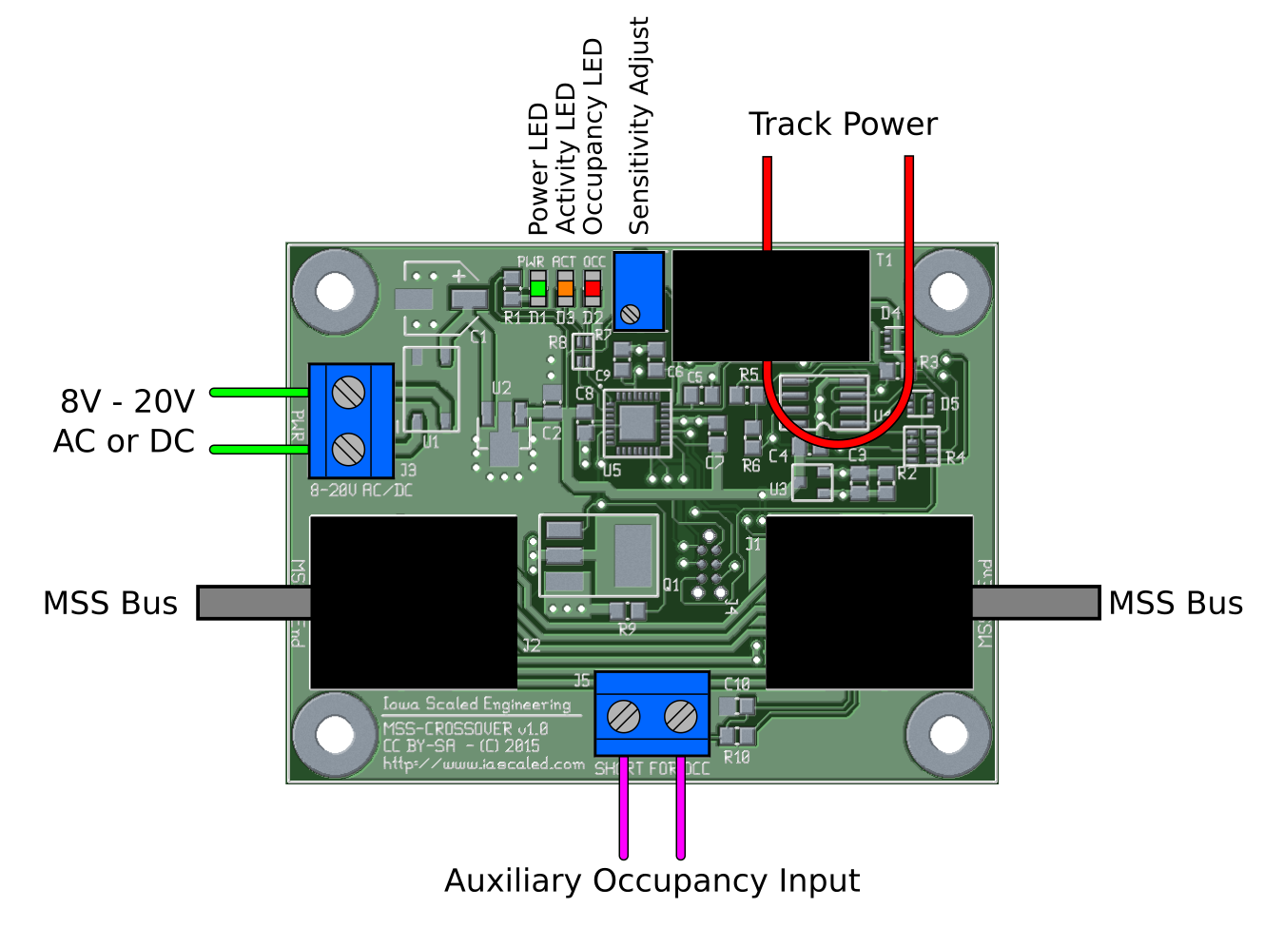
Sensitivity Adjustment
Contrary to popular belief, an empty track block does not always draw zero current. Because of resistive leakage through scenery (including wooden ties in varying humidity) and capacitive effects between the rails and feeder wires, there's often a very small leakage current. Thus, a sensitivity adjustment is provided to allow you to calibrate this out, minimizing false detection while keeping the very highest levels of sensitivity.
Once the board is installed, apply DCC power to the track bus inputs with absolutely nothing on the track. If the “OCC” red LED comes on solid, turn the sensitivity adjustment potentiometer counter-clockwise with a small flathead screwdriver slowly until the light turns off.
If the “OCC” red LED is off, turn the potentiometer slowly clockwise until the light comes on, then back it off until the light turns off.
Test the sensitivity by placing a locomotive or a piece of resistor-equipped rolling stock across the rails. The OCC light should come on when the equipment is on the track, and turn off after a short delay when the equipment is removed.
If the detector trips without equipment, continue making slight counter-clockwise adjustments until the module no longer detects phantom equipment. Sometimes humidity, changes in track voltage, twisting of wires, etc. can change the amount of quiescent current being drawn and trigger the detector. The detector is adequately sensitive that it can be desensitized quite a bit before it's unable to detect resistor-equipped cars.

Auxiliary Input
Most signal systems require that any turnout off the signaled mainline must be wired to trigger detection if it's thrown against the main. The aux input pins can be used to connect auxillary contacts on switch machines, ground throws, or more complex items like the Iowa Scaled CKT-TIMELOCK switch time lock simulator into the occupancy bus without a direct electrical interconnection.
When the pins are shorted but no occupancy is detected, the “OCC” red LED will blink and occupancy sent on the MSS bus. If occupancy is detected, the “OCC” red LED will go on solid, regardless of the axillary input.


While it's safest to not connect the auxiliary input terminals to anything but each other through an isolated electrical switch, it is possible to drive them with a logic circuit. If you do want to connect them to some sort of logic, the input is negative true (meaning, 0V triggers occupancy), and never exceed 5VDC or the module will be destroyed.

Diagnostic Indicator Lights
LED Color | If Solid... | If Blinking... | If Off...
Red (OCC) | Track occupancy detected | Auxiliary occupancy input is active | Occupancy not detected
Yellow (AUX) | Board malfunction | Board is operating normally | Board malfunction
Green (PWR) | Power is on | Power is unusable or  onboard regulator is overheating because of hardware failure or excessive input voltage | No power applied to PWR terminals

Jumper JP1
Note: JP1 was added in hardware revision 1.1. V1.0 does not have JP1, wires 7 and 5 are permanently bonded.
Jumper JP1 connects MSS bus pin 7 to ground. The MSS 2.0.1 specification defines that pin 7 is nominally ground, but may be used by vendors for alternate purposes if that purpose is well documented. If the MSS-CROSSOVER is connected to a system where MSS bus wire 7 is used for an alternate purpose, remove the jumper from JP1. Otherwise, leave it in place to maximize the ground connection reliability.

Modular Signal System Bus
The Modular Signal System bus is constructed out of commodity network cables. An odd number of crossover elements – either crossover modules like this one or crossover Cat5 network cables – must exist between cascade elements. Typically a module with an MSS-CROSSOVER module will use the single crossover in the module itself, and use normal, “straight through” network cables to RJ45 female-female couplers at the end of the module. However, “crossover” type network cables can be used as long as they're used on both sides of the module, keeping a guaranteed odd number of crossovers between cascade modules.
Note: Only use “Cat5” or “Cat5e” type crossover cables. These only cross over two pair of the four within the cable. “Cat6” or “Cat7” crossover cables cross over all four pair, and will not work with the Modular Signal System.
For more details on the Modular Signal System, including guides for the end user, the specification, and other compatible products, see the MSS website:
http://www.modularsignalsystem.info

Open Design
Iowa Scaled Engineering is committed to creating open designs that users are free to build, modify, adapt, improve, and share with others.

Hardware
The design of the CKT-IRSENSE hardware is open source hardware, and is made available under the terms of the Creative Commons Attribution-Share Alike v3.0 license, a copy of which is available from: http://creativecommons.org/licenses/by-sa/3.0/
Design files can be found on the Iowa Scaled Engineering's Github site:
https://github.com/IowaScaledEngineering/mss-crossover

Firmware
The official Iowa Scaled Engineering firmware for the MSS-CROSSOVER is free software: you can redistribute it and/or modify it under the terms of the GNU General Public License as published by the Free Software Foundation, either version 3 of the License, or (at your option) any later version. A copy of the GNU GPL can be found at: http://www.gnu.org/licenses/gpl.html
New firmware can be flashed into the MSS-CROSSOVER through J4. The six contacts are designed to mate with a Tag Connect TC2030-IDC-NL pogo-pin programming tail plugged into a standard AVR 6-pin ISCP programmer.
Iowa Scaled Engineering
http://www.iascaled.com/ support@iascaled.com

