
Power
The Squealer can be powered from 5V to 24V DC, applied through connector J1 (positive to VIN, negative to GND). Alternatively, the mini USB jack can be used to power the Squealer, either from a USB charging block or a laptop/PC.

Sensor
The motion sensor is connected to, and powered from, the Squealer board. The red wire from the motion sensor connects to J2 (SNS PWR) using any of the three terminal positions. Similarly, the black wire from the sensor connects to J3 (SNS GND) using any of its three terminal positions. The sensors output wires (white and blue) both need to connect to the IN1 and/or IN2 terminals on J4. Both wires must be connected, but it does not matter to which terminal (IN1 or IN2) they connect – either, or both, will work exactly the same. Please note that the center terminal on J4 is ground, so don’t use that one. J8 (IN3/IN4) should have no wires connected to it.
The sensor can be installed below the track, up through the benchwork. The sensor itself is the square element on top and must not be covered by ties, ballast, or other obstructions. Note that there is both a small emitter opening and a large imaging array on top – both must be exposed to “see” the motion of a train going over the sensor.
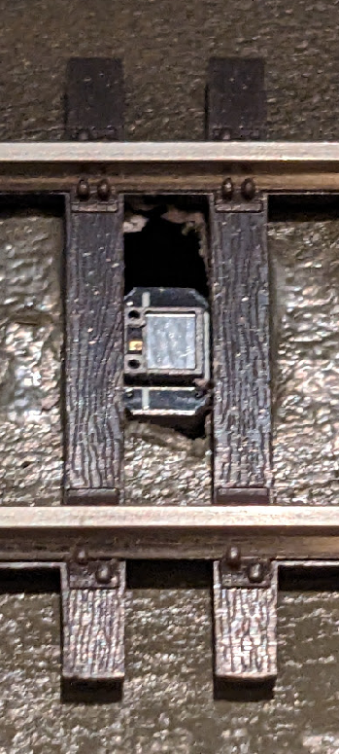
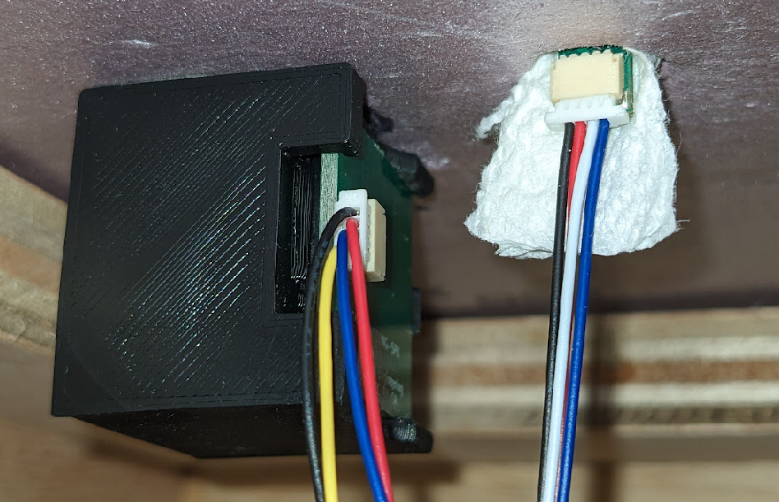
Emitter Opening

Imaging Array
Although the sensor and the control electronics are relatively robust, standard electronics precautions should be taken – avoid static electricity, don’t let it get wet, keep conductive materials away, etc. For initial testing purposes, it is probably wise to mount the sensor in a temporary manner, either using the provided bracket or a small piece of tissue wedged into the hole along with the sensor stalk.

Speaker
The speaker connects to connector J6 (SPK OUT) on the Squealer board. The plastic speaker enclosure can be mounted above the layout and disguised, or mounted below the layout. For better sound localization, it may help to drill a hole through the layout scenery and mount the speaker below, aiming the small opening on the side of the speaker enclosure up through the hole. However, this is very much a matter of choice (and experimentation) at this point.

Operation
About 3 seconds after application of power, the blue light will blink to indicate that the Squealer is ready to go. If using the built-in sounds (no SD card, or no valid WAV files on the SD card), the blue LED will blink twice. If an SD card is inserted with valid WAV files on it, then the blue LED will blink four times.
After the initial blink code, the Squealer will start playing the sounds. It is normally muted until the motion sensor indicates motion. At that point, the volume will ramp to the set level. Be aware that there are silences built in to the default sound track so you may not immediately hear any noise. However, the blue LED on the Squealer board will always indicate the current detection status.

Volume
The volume has 16 levels. It comes preset at level 10, which plays the sounds without modification. Levels 1-9 are attenuation (quieter), with level 0 being muted (no sound). Five volume levels are also provided that amplify the sound. These levels (11-15) should be used with caution since they can cause the audio levels to clip and distort, but can be useful if using a custom audio track recorded at a low volume level.
To change volume, press the VOL UP or VOL DN button. The amber LED will blink briefly in response to pressing the button. When setting volume level 10, the amber LED will blink somewhat longer than normal to indicate it is at level 10. The volume setting is saved each time it is changed and will be recalled on future power cycles.

Custom Sounds
Custom sounds can be loaded onto the Squealer using a micro SD card. The SD card must be formatted as FAT (which is pretty typical). The sounds must also meet the following requirements:
- WAV file named with a .wav extension (e.g. mp3 or other formats won’t work)
- Be in the root directory of the SD card (all other sub-directories are ignored)
- 16-bit, mono format (8-bit or stereo files are ignored)
- 8kHz, 16kHz, 32kHz, or 44.1kHz sample rate
The Squealer will load all valid files found on the SD card and begin playing them in a random order, one right after another. The fade-in/fade-out behavior described above under Operation still applies.

