# **INTRODUCTION**

# **DESIGN CONCEPT**

The design concept of this webpage was to include various different styles and typographies centred around the themes of modern minimalism with clear-cut navigation and user-focused interactivity. This website was built with aspirations to provide an engaging yet seamless experience for both old and new visitors in terms of layout, functionality and aesthetics.

In terms of visual experiences, the colour palette, dominated by shades of blue and white, was chosen to evoke a sense of calm and trust yet still encapsulating the sensation of a thriving gym community. The consistent clean colour scheme throughout the website is easy on the eyes and encourages prolonged engagement with the content. With the typography, the fonts are clean, sans serif and consistently sized which promotes readability and consistency across the website. Large, high-quality background and card images are incorporated throughout the website, enhancing visual engagement without overwhelming the layout nor the user experience. The buttons are styled with smooth edges, hover transitions and effects with contrasting colours to be visually distinct yet inviting user curiosity and interaction.

In terms of website layout rationale, the main goal was to provide clarity and ease of use. A fixed navigation bar across the website allows users to easily explore all major sections while the image banners provide immediate visual and thematic context. Besides that, content is broken down into visually separated cards, a conscious design to allow for modular reading, primary focused on mobile devices where users may prefer smaller sized content over long paragraphs. Furthermore, a fixed footer across all pages reinforces branding and provides a quick access to all the other pages and policy information without cluttering the top of the page.

These design decisions reflect the company's preference in terms of target audiences, consisting of digitally literate users aged 18 to 50 with expectations for a visually appealing, intuitive, responsive yet fast experience. The design supports the overall project goals by promoting user interaction, trust, and transparency. Functional design implementation was taken into consideration too. Firstly, with the use of a local storage the team has implemented a function to manage the login state and dynamically update the navigation bar which enhances user experience. However, it must be advised that since the website uses a localhost to store the data of user logins, users should not use any real information when testing the website to prevent data theft. A back to top feature was also implemented to provide users ease access to the top of the page, primarily mobile users on longer pages with more content.

Some changes were made from the initial draft to prove both usability and aesthetics. These include the addition of dynamic user interface elements (like the login dropdown), refinement of the service and package card layouts for better alignment and responsiveness, and the consolidation of styles into an external CSS file to improve maintainability. These enhancements were guided by user feedback and iterative testing, ensuring the final design is both functional and polished.

In conclusion, this website design demonstrates a thoughtful balance of aesthetics, usability, and user-centric design principles, aligning well with its intended goals and audience expectations.

# Challenges and Solution

# **Implementation and Results**

The Herculean Gym website was developed using custom HTML, CSS and JavaScript without importing any frameworks. We structured the site with semantic HTML5 elements (e.g., <header>, <nav>, <section>, <footer>) across five pages: Home, About Us, Contact Us, Services and Packages. Besides, The style.css file apply a cohesive design for colour and layout (e.g., -- primary-blue: #0052a3), enhanced by media queries for responsiveness. Apart from that, JavaScript in script.js is to handle user authentication(login/logout), a back-to-top button and form validation, including a check for empty form submission. To improve our teamwork, we set up a repository in GitHub and connecting our work to each other. Overall, we keep tackle issues for cross browser compatibility and different devices viewport to make sure that we are building a website that’s ready for people that eagerly wants to go gym and improve their quality of life.

Test cases and result:

Navigation test: Clicked all navigation links on desktop and mobile.

Result: Links redirect correctly, with hover effects on desktop and responsive stacking at 768px while display the sign in/user profile correctly, confirming usability.



Figure navigation bar on desktop view

Figure navigation bar on mobile view (when signing in)

Login Functionality: Enter valid credentials and invalid data for sign in/sign out. After successfully sign up user must be able to login, and displaying user profile in the nav bar. For this test case, we use a valid data (email: [test@example.com](mailto:test@example.com), first name: John, last name: Doe, DOB: 9/9/1999, password:tes123) and some invalid data(e.g. putting a birthday on future, using non exist user credentials to sign in) to test the functionality of the sign in/sign up pages.

Result: Valid login/registration showed the success message, errors (“Please enter a valid email address, “please lengthen this text to 6 characters or more”, “value must be today or earlier”) but not limited to the examples appeared.A screenshot of a computer

Figure birthday validation

Figure password validation

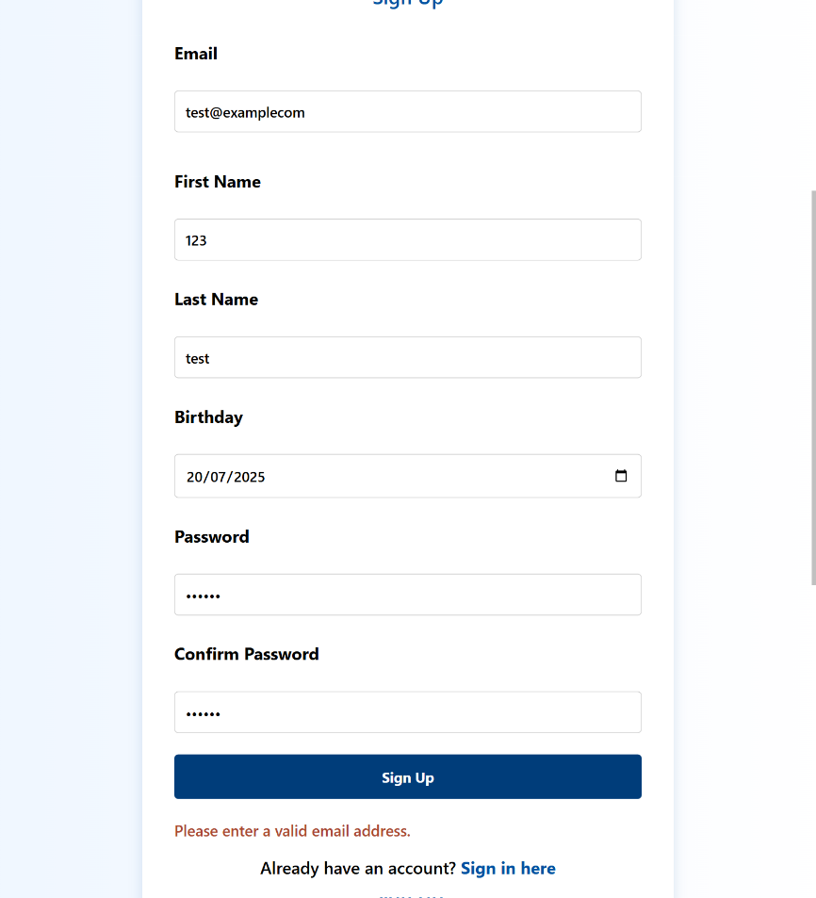

Figure email validation

Figure non-existing account trying to sign in

Responsiveness: Viewed all pages on 1920x1080, 768x1024, and 375x667.

Result: Layouts adapted without scrolling, with media queries adjusting navigation and content.

Figure example webpage on 1920x1080 viewport

Figure example webpage on 768x1024 viewport

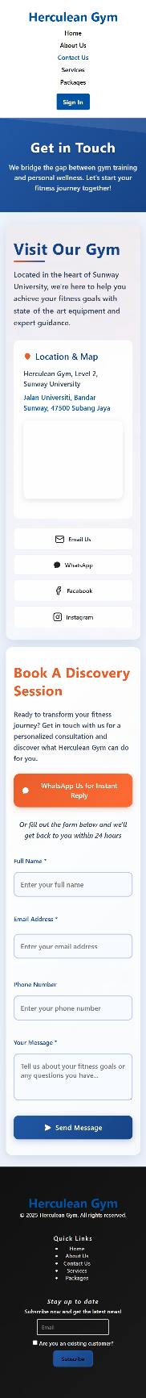

Figure example webpage on 375x667 viewport

Packages Table Usability: Checked the table in packages.html on desktop and mobile.

Result: Content was readable, with checkmarks and tooltips visible, and columns stacked on mobile.

Figure packages table

-References (if any)

-Appendix