ALBOR LAB SIMULATION
Enterprise / Corporate Assurance

Treasury, reconciliation and decision evidence
ALBOR-15 | Twelve pending documentary hypotheses
Client  Albor Bank FICTIONAL | Assessor  iphobiuss · Synthetic documentary exercise
Date  2026-10-13 | Version  1.0
SIMULATION

Table of Contents
1 Executive summary of the documentary scenario
2 Scope, method and interpretation limits before turning a partial observation into a conclusion about an economic obligation
3 Twenty-four pending criteria
4 Findings Summary
5 Findings
6 Correction sequence and closure decision
7 Long references and representation boundaries
8 Editorial appendix ALBOR15_INDEX_WWWWWWWWWWWWWWWWWWWWWWWWWWWWWWWWWWWWWWWWWWWWWWWWWWWWWWWWWWWWWWWW
9 Asset inventory
10 Coverage and limitations
11 Remediation tracking and retest

1 Executive summary of the documentary scenario
Albor Bank is entirely fictional and is used to review how a technical report is produced and read. The scenario focuses on the treasury desk: instruction preparation, beneficiary maintenance, internal reservations, reconciliation, operational authorization and evidence retention. Twelve documentary hypotheses are linked to six invented assets. All remain Open and Unverified. The twenty-four acceptance criteria are Pending. No infrastructure was accessed, credential used, transfer submitted or banking-system response measured.
The central thread is that a visible decision needs an explainable relationship with the content it authorizes and the effect it produces. Approving a container does not establish approval of all its future content. Receiving a response does not establish absence of a partial effect. Retaining a file likewise does not establish that it contains the entire expected population. These distinctions organize the hypotheses without turning them into confirmed vulnerabilities.
The first proposed decision for a real team would be agreement on who can declare each transition valid. Treasury must explain the economic meaning of an instruction; operations must bound recovery from an ambiguous state; the evidence owner must establish which materials were available for a conclusion. The document proposes responsibilities by function, does not assign failures to individuals, and does not replace an authorized review of actual contracts.
Qualitative priority orders pending work. It is neither an estimated loss nor a likelihood of exploitation. No CVSS is calculated, no contractual correction deadline is assigned, and compliance is not certified. Before executing criteria, the team would need laboratory data, operating boundaries, authorized accounts and a stopping rule. Every subsequent conclusion would identify which assumptions were verified.
All three figures are diagrams generated by code, without fabricated screenshots of a banking interface. The layout appendix deliberately includes long references and extended captions to test report-gen. A correct exporter result means preservation and presentation of these contents; it does not mean the fictional bank passed security tests.

2 Scope, method and interpretation limits before turning a partial observation into a conclusion about an economic obligation
The object of review is a control relationship rather than an exploitation sequence. Each record separates context, hypothesis, possible consequence, proposed correction and two pending criteria. The relationship between these fields should allow another person to challenge causality: if a condition does not hold, the proposed impact may not follow. The record must preserve that possibility instead of presenting a closed narrative.
A future test would first define the population: instruction revision, time window, actor, permission and deciding service. Observations would then distinguish a transport response from an economic transition. Minimum evidence would include stable correlation and a negative control. An isolated visual capture could guide investigation but would not independently establish completeness, authorization or absence of other effects.
Case addresses use .example domains or documentation ranges and are not requested. Long strings verify representation boundaries: displayed text, link destination, repeated parameters, percent escapes and composed or decomposed Unicode sequences. They must not change merely to improve page appearance. If an editing engine retains an early line break, the QA report must disclose it; inserting invisible characters and calling the literal identical is unacceptable.
Accepting a banking correction would require identifying the examined revision, observing positive and negative controls, reviewing persisted effects and documenting the uncovered population. A hash helps establish byte identity against a reference but does not establish completeness or authenticity with respect to an issuer. Closure needs relevant evidence, not just a file that opens or a report that looks formal.
This round remains documentary. The tracking records at the end are review plans without execution, with an empty test date and a Not verifiable result. Tables inside a quotation and a list are editorial stimuli; they add no performed tests and do not change the twenty-four pending criteria.

3 Twenty-four pending criteria
Criterion | Hypothesis | Status
ALB-C01-1 | ALB-01 | Pending; not executed
ALB-C01-2 | ALB-01 | Pending; not executed
ALB-C02-1 | ALB-02 | Pending; not executed
ALB-C02-2 | ALB-02 | Pending; not executed
ALB-C03-1 | ALB-03 | Pending; not executed
ALB-C03-2 | ALB-03 | Pending; not executed
ALB-C04-1 | ALB-04 | Pending; not executed
ALB-C04-2 | ALB-04 | Pending; not executed
ALB-C05-1 | ALB-05 | Pending; not executed
ALB-C05-2 | ALB-05 | Pending; not executed
ALB-C06-1 | ALB-06 | Pending; not executed
ALB-C06-2 | ALB-06 | Pending; not executed
ALB-C07-1 | ALB-07 | Pending; not executed
ALB-C07-2 | ALB-07 | Pending; not executed
ALB-C08-1 | ALB-08 | Pending; not executed
ALB-C08-2 | ALB-08 | Pending; not executed
ALB-C09-1 | ALB-09 | Pending; not executed
ALB-C09-2 | ALB-09 | Pending; not executed
ALB-C10-1 | ALB-10 | Pending; not executed
ALB-C10-2 | ALB-10 | Pending; not executed
ALB-C11-1 | ALB-11 | Pending; not executed
ALB-C11-2 | ALB-11 | Pending; not executed
ALB-C12-1 | ALB-12 | Pending; not executed
ALB-C12-2 | ALB-12 | Pending; not executed

4 Findings Summary
The report contains 12 findings with the following recorded severity classification: 8 high, 4 medium.
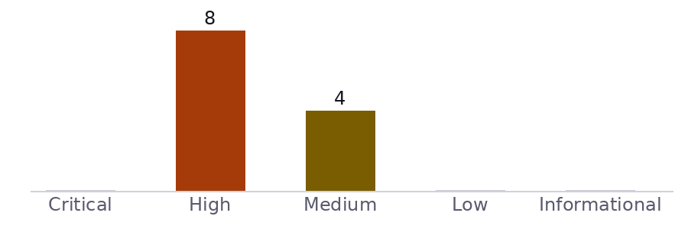
# | Severity | Finding
1 | High | Batch approval may not bind the exact revision of its instructions
2 | High | A beneficiary template may change after selection
3 | High | Instruction rejection may conceal a partial accounting effect
4 | High | A delayed instruction may cross the close of an operating window
5 | High | Reconciliation queries may cross authorized scopes
6 | High | A manual adjustment may lose its link to the economic obligation
7 | High | Permission revocation may not reach active sessions
8 | High | Restoration may alter antifraud event retention
9 | Medium | A liquidity forecast may combine a recent population with an older balance
10 | Medium | Quote validity may be checked only when the form opens
11 | Medium | An evidence export may lose authorization controls
12 | Medium | An exception may close with insufficient documentary evidence

5 Findings

ALB-01 Batch approval may not bind the exact revision of its instructions High
Affected Domain ALB-A01 treasury.albor.example
Description (Incl. Root Cause)

Model context
The fictional treasury desk prepares a batch of internal transfers and requests approval before submission. The model allows an instruction to be corrected while another person reads the review screen. Service responses, actual signatures and execution records are unavailable.

Documentary hypothesis
The documentary hypothesis is that a batch identifier retains approval after its economic content changes. The risk depends on a decision being associated with the container name instead of an immutable revision of the instructions. A visible approved badge does not establish which amounts, accounts and dates the reviewer accepted.
Security Impact
If confirmed, a later modification could use a decision issued for different content. The possible effect is an obligation outside the reviewed authorization. No movement of funds was observed; the qualitative priority only orders a future review.
Remediation
Define an immutable revision of the approved set and verify it where submission is accepted. Every economic edit must invalidate the earlier authorization. Preserve the relationship between person, revision and decision, including rejected modifications; adding another screen label is insufficient.

References
- https://review.albor.example/round15/ALB-01?state=pending&execution=none#criteria

Detailed Walkthrough
ALB-C01-1
Pending: approve a laboratory revision, change an account and verify that submission requires a new decision; preserve both revisions and the rejection response.
ALB-C01-2
Pending: repeat an unchanged authorized submission and demonstrate that no obligation is duplicated; connect the observation to the accounting state, rather than only a transport status.
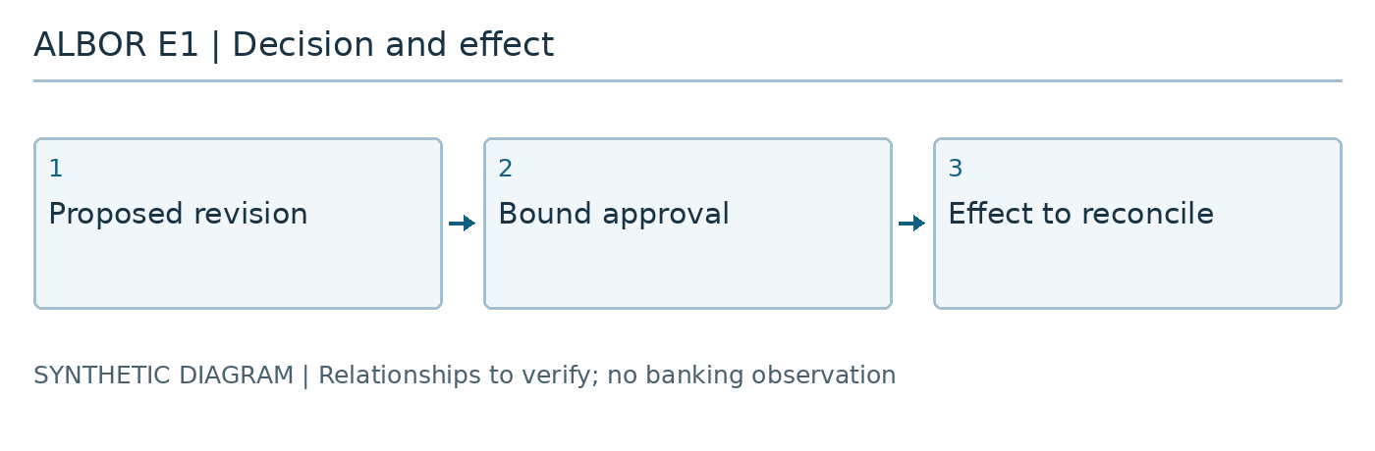
Figure 1.
Affected assets
- treasury.albor.example

ALB-02 A liquidity forecast may combine a recent population with an older balance Medium
Affected Domain ALB-A01 treasury.albor.example
Description (Incl. Root Cause)

Model context
The treasury panel combines pending requests and closing balances to support a funding decision. In this scenario the two sources refresh through independent channels. The document contains neither customer balances nor actual delay measurements.

Documentary hypothesis
The hypothesis is an arithmetically consistent total whose population belongs to different instants. A panel refresh timestamp may describe the query while concealing the age of an input. The relevant control is the temporal contract of each datum, not simply successful arithmetic.
Security Impact
A funding decision could rely on availability that no longer exists or obligations outside the selected window. Consequences depend on treasury policy; no loss, likelihood or contractual breach is assigned.
Remediation
Expose the instant and population of each input and withhold a recommendation when their combination violates a documented rule. Allow a clearly identified partial view. Retain enough detail to reconstruct the total without presenting incomplete information as a definitive position.

References
- https://review.albor.example/round15/ALB-02?state=pending&execution=none#criteria

Detailed Walkthrough
ALB-C02-1
Pending: delay only the balance source in an authorized environment and verify that the view distinguishes query freshness from content freshness without inventing a balance.
ALB-C02-2
Pending: introduce an instruction at the window boundary and reconstruct by identifier which elements enter each total and which remain explicitly pending.
Affected assets
- treasury.albor.example

ALB-03 A beneficiary template may change after selection High
Affected Domain ALB-A02 beneficiaries.albor.example
Description (Incl. Root Cause)

Model context
The fictional catalog allows the desk to reuse a beneficiary template instead of entering an account for every operation. The case separates selection, preparation and instruction acceptance. No account in the document belongs to an actual person.

Documentary hypothesis
The proposed hypothesis is that an instruction retains only the mutable template identifier. If the details change after selection, an executor might resolve a destination different from the one shown to the operator. Unauthorized catalog access is not assumed: even a legitimate correction needs a rule for instructions already prepared.
Security Impact
The same visible reference could explain two different economic destinations. This would complicate attribution and decisions about obligations requiring review. The case does not establish that an operation was sent to an incorrect destination.
Remediation
Bind each instruction to the beneficiary revision actually accepted and show material changes before another authorization. Separate catalog correction from modification of existing instructions. History must reconstruct the earlier value without replacing it with the current destination.

References
- https://review.albor.example/round15/ALB-03?state=pending&execution=none#criteria

Detailed Walkthrough
ALB-C03-1
Pending: prepare an instruction with a laboratory revision, modify the template and verify that the operation retains the accepted revision or requires explicit new approval.
ALB-C03-2
Pending: query the historical explanation from an authorized account and confirm that it identifies the destination decided at the time while distinguishing it from the current catalog revision.
Affected assets
- beneficiaries.albor.example

ALB-04 Quote validity may be checked only when the form opens Medium
Affected Domain ALB-A02 beneficiaries.albor.example
Description (Incl. Root Cause)

Model context
A treasury instruction may retain a quote while an operator completes other details. The model distinguishes receipt time, declared expiry and acceptance time. It contains no market prices or actual commercial commitments.

Documentary hypothesis
The hypothesis is that the form checks validity on loading and the server later accepts the same value without reassessing its contract. An active screen does not establish continued availability of a quote. The comparison must also define which clock and instant decide the boundary.
Security Impact
An instruction might arrive with a condition that is no longer offered, creating a discrepancy between operator intent and the recorded commitment. This effect remains unverified and cannot support a monetary difference calculation.
Remediation
Apply the validity rule at economic acceptance and return an explicit reason when the condition changes. Renewal must produce a visible decision rather than silently substitute a price. Record the relevant instants and the rule revision used for each decision.

References
- https://review.albor.example/round15/ALB-04?state=pending&execution=none#criteria

Detailed Walkthrough
ALB-C04-1
Pending: submit a laboratory quote on either side of its controlled expiry and check the server decision while preserving the clocks and comparison contract.
ALB-C04-2
Pending: simulate renewal and confirm that the interface requests acceptance of the new condition before continuing, preserving the history of both decisions.
Affected assets
- beneficiaries.albor.example

ALB-05 Instruction rejection may conceal a partial accounting effect High
Affected Domain ALB-A03 192.0.2.153
Description (Incl. Root Cause)

Model context
The documentary queue separates internal reservation from final instruction acceptance. The scenario allows a rejection response after part of the work has started. It does not assume that one database transaction covers every modeled dependency.

Documentary hypothesis
The hypothesis is that the visible state closes as rejected without explaining whether a reservation or intermediate posting remains active. Transport rejection and absence of an obligation are not equivalent. Sending a compensation likewise does not establish that it was accepted and applied.
Security Impact
The desk could treat capacity as available while it remains reserved, or retry an instruction whose effect is unresolved. Qualitative risk depends on the relationship between states; this report supplies no observed banking entry.
Remediation
Define explicit intermediate states and reconcile effects without equating failure with nonexecution. Preserve the identities of reservation, instruction and compensation. Independent operations may continue only when ambiguities that cannot affect them have been bounded.

References
- https://review.albor.example/round15/ALB-05?state=pending&execution=none#criteria

Detailed Walkthrough
ALB-C05-1
Pending: trigger a controlled rejection between reservation and acceptance in a laboratory and reconstruct every persisted effect, including those requiring later resolution.
ALB-C05-2
Pending: retry the instruction from its ambiguous state and verify that no obligation increases and no pending reservation disappears; document the release decision.
Affected assets
- 192.0.2.153

ALB-06 A delayed instruction may cross the close of an operating window High
Affected Domain ALB-A03 192.0.2.153
Description (Incl. Root Cause)

Model context
The desk uses processing windows with a documentary close for reconciliation. An instruction can wait in a queue and arrive after closure despite earlier preparation. The windows are invented exercise rules rather than schedules of an actual financial network.

Documentary hypothesis
The hypothesis is that the consumer uses preparation time to admit the instruction into a window already closed. The issue is not only clock handling: ownership of membership decisions and treatment of late delivery also matter. Changing a row date to make it fit would conceal the original sequence.
Security Impact
The reconciled population might change after the team treats it as complete. A later report would show differences difficult to attribute to a specific operation. No actual accounting close is claimed to have changed.
Remediation
Assign window membership through a verifiable decision and preserve preparation, receipt and acceptance as distinct instants. Late deliveries must be rejected or enter a visible exception with ownership and review. Do not reopen a closed population through a silent update.

References
- https://review.albor.example/round15/ALB-06?state=pending&execution=none#criteria

Detailed Walkthrough
ALB-C06-1
Pending: hold a laboratory instruction until after closure and verify that its treatment matches the declared policy while preserving the original temporal sequence.
ALB-C06-2
Pending: repeat the late delivery and reconstruct the reconciled population before and after; verify that every exception has an explicit decision and cannot duplicate effects.
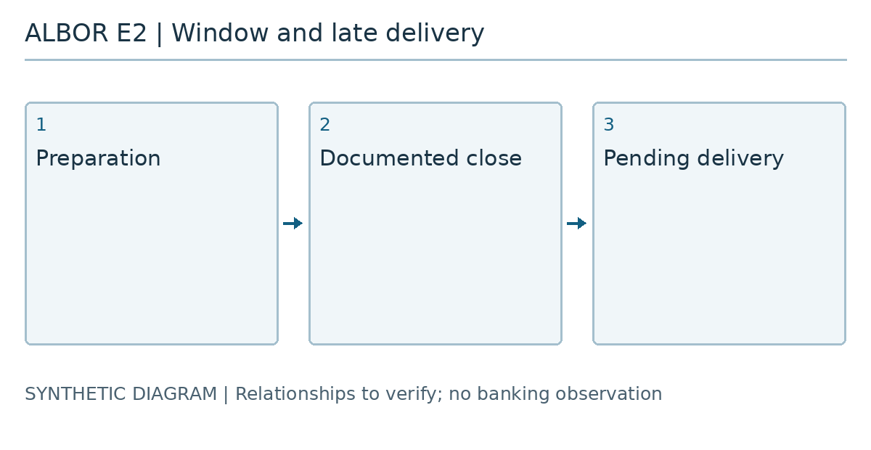
Figure 2. ALB-E2-L01: Preparation and receipt are distinct instants.
ALB-E2-L02: Late delivery remains pending; no test was executed.
Affected assets
- 192.0.2.153

ALB-07 Reconciliation queries may cross authorized scopes High
Affected Domain ALB-A04 reconcile.albor.example
Description (Incl. Root Cause)

Model context
Reconciler ALB-A04 connects treasury movements with accounts, batches and operating entities. In this documentary exercise, the proposed matrix distinguishes viewing and adjustment roles but does not yet provide verifiable evidence of each query's scope. The hypothesis remains open and unverified; no actual banking information has been accessed.

Documentary hypothesis
A query authorized for one batch could return movements or aggregates from another scope if ownership checks occur only in the initial form. The same concern requires review of saved searches, pagination and the retrieval of earlier results.
Security Impact
If confirmed, an operator could infer balances or counterparty relationships outside their responsibility. Unrelated results could also enter an otherwise legitimate reconciliation, weakening the subsequent explanation of discrepancies and treasury decisions. The documentary record does not establish that either consequence has occurred.
Remediation
Define effective scope by operator, entity and batch; enforce it for every request and derived result. Return consistent responses for objects outside that scope and record denial decisions without copying financial data. Review aggregates, filters and cached results as part of the same authorization boundary.

References
- https://review.albor.example/round15/ALB-07?state=pending&execution=none#criteria

Detailed Walkthrough
ALB-C07-1
Pending: demonstrate with two separate synthetic scopes that queries, pagination, aggregates and caches retain authorized ownership and disclose no cross-scope results.
ALB-C07-2
Pending: retain requests, authorization decisions and anonymized results that let a reviewer reproduce each denied operation and each permitted access.
Affected assets
- reconcile.albor.example

ALB-08 A manual adjustment may lose its link to the economic obligation High
Affected Domain ALB-A04 reconcile.albor.example
Description (Incl. Root Cause)

Model context
ALB-A04 supports manual adjustments to explain reconciliation differences. The fictional case describes a request, an approval and a proposed posting, but must still demonstrate how their relationship survives revisions and retries. This is a documentary observation: the hypothesis is open and unverified and does not establish a posting.

Documentary hypothesis
An adjustment could retain an earlier approval after its amount, currency, value date or associated obligation changes. A reversal might also lose its connection to the original adjustment if both operations rely on references that remain editable.
Security Impact
If confirmed, a decision valid for one obligation could justify a different one, or a reversal could appear to be an independent movement. This would complicate accountability and the verification that approved changes match the effect recorded by treasury operations.
Remediation
Bind every adjustment version to a stable obligation identifier and its economic attributes. Invalidate approval when those attributes change, separate submission from authorization, and explicitly connect originals, retries and reversals. Preserve an immutable history containing the reason, actor and state of each transition.

References
- https://review.albor.example/round15/ALB-08?state=pending&execution=none#criteria

Detailed Walkthrough
ALB-C08-1
Pending: demonstrate that changing amount, currency, value date or obligation requires fresh approval and prevents reuse of authorization for earlier versions.
ALB-C08-2
Pending: reconstruct a synthetic adjustment with a retry and reversal, verifying a unique correspondence between approved versions, the linked obligation and resulting movements.
Affected assets
- reconcile.albor.example

ALB-09 Permission revocation may not reach active sessions High
Affected Domain ALB-A05 operations.albor.example
Description (Incl. Root Cause)

Model context
Operations console ALB-A05 distributes responsibilities during shift changes. Its documentary design removes permissions when an assignment ends, but evidence is missing for existing sessions and work initiated before removal. The hypothesis remains open and unverified; no real account has been used and no production revocation has been performed.

Documentary hypothesis
An operator whose permission has expired could retain approval or task execution capabilities through an active session, a stale browser tab or a queued job. Updating the directory alone does not demonstrate that subsequent authorization decisions reflect the change.
Security Impact
If confirmed, activity after handover could be attributed to a responsibility that has already ended. This would introduce uncertainty into shift supervision and allow sensitive operations to continue beyond the approved period, even without a new authentication event.
Remediation
Set a measurable maximum propagation time for revocation. Reevaluate permissions when executing sensitive actions and deferred jobs; invalidate sessions or credentials where appropriate. Record the effective removal time and distinguish operations completed before it from those subsequently cancelled or denied.

References
- https://review.albor.example/round15/ALB-09?state=pending&execution=none#criteria

Detailed Walkthrough
ALB-C09-1
Pending: remove a synthetic permission and verify denial within the approved time limit for an active session, a stale tab and a fresh request.
ALB-C09-2
Pending: verify that a queued job reevaluates authorization at execution and records a traceable decision when the required permission no longer exists.
Affected assets
- operations.albor.example

ALB-10 An evidence export may lose authorization controls Medium
Affected Domain ALB-A05 operations.albor.example
Description (Incl. Root Cause)

Model context
ALB-A05 prepares evidence packages for operational review and archiving. The fictional workflow separates requesting, generating and downloading a package, potentially at different times. The documentation does not yet demonstrate that every stage maintains the same authorized scope. The hypothesis remains open and unverified; no real document has been extracted.

Documentary hypothesis
An export could contain attachments from other entities, restricted fields or earlier results if the initial selection replaces authorization for each item. A persistent download link could remain usable after removal of the permission that originally justified generating the package.
Security Impact
If confirmed, reconciliation information or internal decisions could circulate beyond the intended recipient. Beyond unauthorized access, a mixture of scopes could cause a reviewer to support conclusions with records outside their assignment.
Remediation
Check authorization and classification for every item during generation and again at download. Minimize fields, bind the result to its requester and scope, limit its validity and record delivery. Include a content manifest that supports checking exclusions without revealing the excluded material.

References
- https://review.albor.example/round15/ALB-10?state=pending&execution=none#criteria

Detailed Walkthrough
ALB-C10-1
Pending: generate a mixed synthetic package and verify that it contains only authorized items and fields, including attachments and related documents.
ALB-C10-2
Pending: verify that an operator not authorized for this package, an expired link and a revoked permission each prevent its download and produce a recorded authorization decision.
Affected assets
- operations.albor.example

ALB-11 Restoration may alter antifraud event retention High
Affected Domain ALB-A06 archive.albor.example
Description (Incl. Root Cause)

Model context
Document archive ALB-A06 retains events and references used to review treasury-related antifraud alerts. The scenario includes backup recovery after an interruption, but does not provide a complete reconciliation between restored events and retention policies. The hypothesis is open and unverified; no banking system has been restored.

Documentary hypothesis
Recovery could restore events without their original retention dates, preservation holds or links to active cases. It could also restart counters from the restoration time, changing the authorized period even when the recovered files remain readable and appear complete.
Security Impact
If confirmed, evidence still required could be deleted, or data could remain longer than intended. Internal investigations would struggle to justify case continuity, particularly when an alert includes records both before and after the recovery point. Neither deletion nor excessive retention has been demonstrated here.
Remediation
Include policies, holds, identifiers and relationships within backup scope. Validate their consistency before restarting automatic deletion and reconcile recovered events against an independent inventory. Document differences, accountable owners and treatment decisions, protecting cases whose retention requirements cannot yet be determined.

References
- https://review.albor.example/round15/ALB-11?state=pending&execution=none#criteria

Detailed Walkthrough
ALB-C11-1
Pending: restore a synthetic set containing different dates and preservation holds, verifying that restoration never silently restarts the applicable retention period.
ALB-C11-2
Pending: compare inventories before and after recovery, resolve discrepancies and demonstrate that deletion remains suspended for cases whose retention requirements are undetermined.
Affected assets
- archive.albor.example

ALB-12 An exception may close with insufficient documentary evidence Medium
Affected Domain ALB-A06 archive.albor.example
Description (Incl. Root Cause)

Model context
ALB-A06 assembles treasury exception cases and their supporting documents. The workflow allows closure to be proposed after comments and attachments are added, but must still demonstrate that approval distinguishes complete, partial and unverifiable evidence. The hypothesis remains open and unverified; no banking case file has been reviewed.

Documentary hypothesis
An exception could close with a readable attachment that does not establish the required criterion, or with references to withdrawn documents. A favorable comment could be mistaken for independent verification if the application presents both as a single approval decision.
Security Impact
If confirmed, the pending inventory would show matters as resolved without adequate support. A handover or later review could overlook obligations that remain open and lose the context needed to decide whether the case should be reopened.
Remediation
Define closure criteria for each exception type and connect every criterion to identifiable evidence, its version and the review outcome. Separate document submission, verification and final authorization. Preserve explicit limitations and require accountable acceptance, an expiry and follow-up whenever an exception to the criteria is allowed.

References
- https://review.albor.example/round15/ALB-12?state=pending&execution=none#criteria

Detailed Walkthrough
ALB-C12-1
Pending: attempt to close synthetic cases with partial, withdrawn and unverifiable evidence, confirming that the workflow identifies and blocks unmet criteria.
ALB-C12-2
Pending: reconstruct an authorized closure and a temporary acceptance, verifying separate responsible actors, exact documents, outstanding limitations and a review date where applicable.
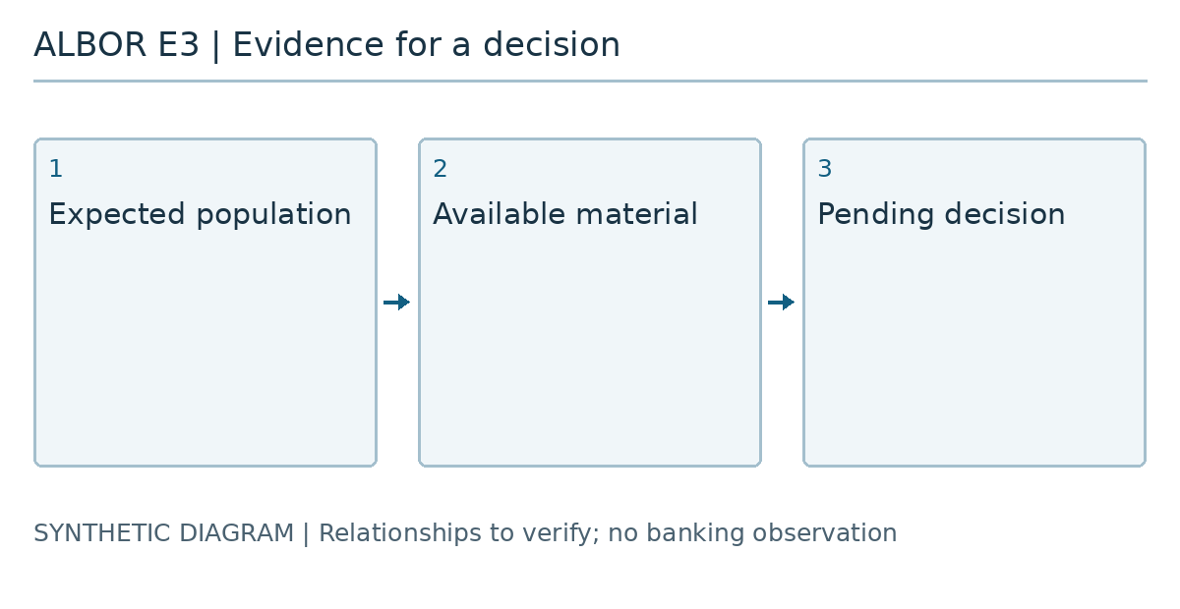
Figure 3. ALB-E3-L01 | ALB-01: Define the population intended for review.
ALB-E3-L02 | ALB-01: Identify the applicable contract revision.
ALB-E3-L03 | ALB-01: Record which material is missing for comparison.
ALB-E3-L04 | ALB-01: Preserve the negative control that remains pending.
ALB-E3-L05 | ALB-01: Explain why no closure decision exists.
ALB-E3-L06 | ALB-02: Define the population intended for review.
ALB-E3-L07 | ALB-02: Identify the applicable contract revision.
ALB-E3-L08 | ALB-02: Record which material is missing for comparison.
ALB-E3-L09 | ALB-02: Preserve the negative control that remains pending.
ALB-E3-L10 | ALB-02: Explain why no closure decision exists.
ALB-E3-L11 | ALB-03: Define the population intended for review.
ALB-E3-L12 | ALB-03: Identify the applicable contract revision.
ALB-E3-L13 | ALB-03: Record which material is missing for comparison.
ALB-E3-L14 | ALB-03: Preserve the negative control that remains pending.
ALB-E3-L15 | ALB-03: Explain why no closure decision exists.
ALB-E3-L16 | ALB-04: Define the population intended for review.
ALB-E3-L17 | ALB-04: Identify the applicable contract revision.
ALB-E3-L18 | ALB-04: Record which material is missing for comparison.
ALB-E3-L19 | ALB-04: Preserve the negative control that remains pending.
ALB-E3-L20 | ALB-04: Explain why no closure decision exists.
ALB-E3-L21 | ALB-05: Define the population intended for review.
ALB-E3-L22 | ALB-05: Identify the applicable contract revision.
ALB-E3-L23 | ALB-05: Record which material is missing for comparison.
ALB-E3-L24 | ALB-05: Preserve the negative control that remains pending.
ALB-E3-L25 | ALB-05: Explain why no closure decision exists.
ALB-E3-L26 | ALB-06: Define the population intended for review.
ALB-E3-L27 | ALB-06: Identify the applicable contract revision.
ALB-E3-L28 | ALB-06: Record which material is missing for comparison.
ALB-E3-L29 | ALB-06: Preserve the negative control that remains pending.
ALB-E3-L30 | ALB-06: Explain why no closure decision exists.
ALB-E3-L31 | ALB-07: Define the population intended for review.
ALB-E3-L32 | ALB-07: Identify the applicable contract revision.
ALB-E3-L33 | ALB-07: Record which material is missing for comparison.
ALB-E3-L34 | ALB-07: Preserve the negative control that remains pending.
ALB-E3-L35 | ALB-07: Explain why no closure decision exists.
ALB-E3-L36 | ALB-08: Define the population intended for review.
ALB-E3-L37 | ALB-08: Identify the applicable contract revision.
ALB-E3-L38 | ALB-08: Record which material is missing for comparison.
ALB-E3-L39 | ALB-08: Preserve the negative control that remains pending.
ALB-E3-L40 | ALB-08: Explain why no closure decision exists.
ALB-E3-L41 | ALB-09: Define the population intended for review.
ALB-E3-L42 | ALB-09: Identify the applicable contract revision.
ALB-E3-L43 | ALB-09: Record which material is missing for comparison.
ALB-E3-L44 | ALB-09: Preserve the negative control that remains pending.
ALB-E3-L45 | ALB-09: Explain why no closure decision exists.
ALB-E3-L46 | ALB-10: Define the population intended for review.
ALB-E3-L47 | ALB-10: Identify the applicable contract revision.
ALB-E3-L48 | ALB-10: Record which material is missing for comparison.
ALB-E3-L49 | ALB-10: Preserve the negative control that remains pending.
ALB-E3-L50 | ALB-10: Explain why no closure decision exists.
ALB-E3-L51 | ALB-11: Define the population intended for review.
ALB-E3-L52 | ALB-11: Identify the applicable contract revision.
ALB-E3-L53 | ALB-11: Record which material is missing for comparison.
ALB-E3-L54 | ALB-11: Preserve the negative control that remains pending.
ALB-E3-L55 | ALB-11: Explain why no closure decision exists.
ALB-E3-L56 | ALB-12: Define the population intended for review.
ALB-E3-L57 | ALB-12: Identify the applicable contract revision.
ALB-E3-L58 | ALB-12: Record which material is missing for comparison.
ALB-E3-L59 | ALB-12: Preserve the negative control that remains pending.
ALB-E3-L60 | ALB-12: Explain why no closure decision exists.
Affected assets
- archive.albor.example

6 Correction sequence and closure decision

Proposed order
First, bound instruction revisions and states across ALB-A01, ALB-A02 and ALB-A03. Reconciliation cannot explain a state change while the meanings of approved, reserved or rejected remain ambiguous. This stage requires a documented business decision before screen changes.
Next, verify that ALB-A04 preserves the population and economic relationships when producing queries and adjustments. An adjustment should not erase the operation it explains. Console ALB-A05 must enforce permission and revocation at the service that materializes a change; hiding a button does not replace that control.
Finally, review whether ALB-A06 retains relevant evidence and can explain its absences. Recovery may reopen independent functions when ambiguities that cannot affect them are bounded. An isolated exception does not require stopping the entire bank; it does require explaining why a reopened function does not depend on it.

Closure decision
Each owner should propose which observation would close a hypothesis and which uncertainty would remain. Independent review should reconstruct that reasoning without relying on operator memory. Missing material must remain a visible limitation. Accepting uncertainty is a different decision from declaring a correction verified.

7 Long references and representation boundaries
The following strings are documentary editorial stimuli. Preserve text and destination, including empty, repeated and escaped parameters. Short prefixes expose an early break that wastes the remaining line space.
URL: https://treasury.albor.example/revisions/ALB%2D015/0123456789ABCDEFGHIJKLMNOPQRSTUVWXYZ0123456789ABCDEFGHIJKLMNOPQRSTUVWXYZ0123456789ABCDEFGHIJKLMNOPQRSTUVWXYZ0123456789ABCDEFGHIJKLMNOPQRSTUVWXYZ0123456789ABCDEFGHIJKLMNOPQRSTUVWXYZ?state=pending&empty=&repeated=one&repeated=two&literal=%252F&value=A%26B#review(15)
LINK: https://treasury.albor.example/revisions/ALB%2D015/0123456789ABCDEFGHIJKLMNOPQRSTUVWXYZ0123456789ABCDEFGHIJKLMNOPQRSTUVWXYZ0123456789ABCDEFGHIJKLMNOPQRSTUVWXYZ0123456789ABCDEFGHIJKLMNOPQRSTUVWXYZ0123456789ABCDEFGHIJKLMNOPQRSTUVWXYZ?state=pending&empty=&repeated=one&repeated=two&literal=%252F&value=A%26B#review(15)
URL: https://archive.albor.example/café/東京?label=Δ&revision=ALB%2D015#revisión
LINK: https://archive.albor.example/café/東京?label=Δ&revision=ALB%2D015#revisión
URL: https://archive.albor.example/café/source?normalization=preserve&escaped=%E2%88%92#pending
LINK: https://archive.albor.example/café/source?normalization=preserve&escaped=%E2%88%92#pending
TOKEN: ALBOR15_UNSEPARATED_IDENTIFIER_0123456789ABCDEFGHIJKLMNOPQRSTUVWXYZ0123456789ABCDEFGHIJKLMNOPQRSTUVWXYZ0123456789ABCDEFGHIJKLMNOPQRSTUVWXYZ0123456789ABCDEFGHIJKLMNOPQRSTUVWXYZ0123456789ABCDEFGHIJKLMNOPQRSTUVWXYZ
Prose before the identifier ALBOR15_UNSEPARATED_IDENTIFIER_0123456789ABCDEFGHIJKLMNOPQRSTUVWXYZ0123456789ABCDEFGHIJKLMNOPQRSTUVWXYZ0123456789ABCDEFGHIJKLMNOPQRSTUVWXYZ0123456789ABCDEFGHIJKLMNOPQRSTUVWXYZ0123456789ABCDEFGHIJKLMNOPQRSTUVWXYZ and prose afterwards.
- URL: https://treasury.albor.example/revisions/ALB%2D015/0123456789ABCDEFGHIJKLMNOPQRSTUVWXYZ0123456789ABCDEFGHIJKLMNOPQRSTUVWXYZ0123456789ABCDEFGHIJKLMNOPQRSTUVWXYZ0123456789ABCDEFGHIJKLMNOPQRSTUVWXYZ0123456789ABCDEFGHIJKLMNOPQRSTUVWXYZ?state=pending&empty=&repeated=one&repeated=two&literal=%252F&value=A%26B#review(15)
- TOKEN: ALBOR15_UNSEPARATED_IDENTIFIER_0123456789ABCDEFGHIJKLMNOPQRSTUVWXYZ0123456789ABCDEFGHIJKLMNOPQRSTUVWXYZ0123456789ABCDEFGHIJKLMNOPQRSTUVWXYZ0123456789ABCDEFGHIJKLMNOPQRSTUVWXYZ0123456789ABCDEFGHIJKLMNOPQRSTUVWXYZ
- Level three: preserve order and membership.
Literal | Context
URL: https://treasury.albor.example/revisions/ALB%2D015/0123456789ABCDEFGHIJKLMNOPQRSTUVWXYZ0123456789ABCDEFGHIJKLMNOPQRSTUVWXYZ0123456789ABCDEFGHIJKLMNOPQRSTUVWXYZ0123456789ABCDEFGHIJKLMNOPQRSTUVWXYZ0123456789ABCDEFGHIJKLMNOPQRSTUVWXYZ?state=pending&empty=&repeated=one&repeated=two&literal=%252F&value=A%26B#review(15) | Documentary destination, not requested
TOKEN: ALBOR15_UNSEPARATED_IDENTIFIER_0123456789ABCDEFGHIJKLMNOPQRSTUVWXYZ0123456789ABCDEFGHIJKLMNOPQRSTUVWXYZ0123456789ABCDEFGHIJKLMNOPQRSTUVWXYZ0123456789ABCDEFGHIJKLMNOPQRSTUVWXYZ0123456789ABCDEFGHIJKLMNOPQRSTUVWXYZ | Source contains an unbroken identifier

Boundary | Value
31 | TOKEN: AAAAAAAAAAAAAAAAAAAAAAAAAAAAAAA
32 | TOKEN: BBBBBBBBBBBBBBBBBBBBBBBBBBBBBBBB
63 | TOKEN: CCCCCCCCCCCCCCCCCCCCCCCCCCCCCCCCCCCCCCCCCCCCCCCCCCCCCCCCCCCCCCC
64 | TOKEN: DDDDDDDDDDDDDDDDDDDDDDDDDDDDDDDDDDDDDDDDDDDDDDDDDDDDDDDDDDDDDDDD
24 | TOKEN: ABCD1234ABCD1234ABCD1234
72 | TOKEN: 0123456789ABCDEFGHIJKLMNOPQRSTUVWXYZ0123456789ABCDEFGHIJKLMNOPQRSTUVWXYZ

8 Editorial appendix ALBOR15_INDEX_WWWWWWWWWWWWWWWWWWWWWWWWWWWWWWWWWWWWWWWWWWWWWWWWWWWWWWWWWWWWWWWW
The following block verifies text preservation and does not represent an executed terminal. Figure E1 has no textual caption; E2 contains two explicit lines; E3 contains sixty explicit lines with unique identifiers. An extended caption may continue on another page but must not clip or replace the figure. The following titles test index width without changing their destinations.

Text after h5
Reading continues as prose. It must not remain inside a code frame or lose its separation from the heading.

Text after h6
The relationship between the preceding block and this paragraph remains editorial rather than newly observed evidence.
café | café | 東京 | Δ | A B | A | B | =1+1 | −0.01 | tt fi fl st ffi ffl
{
"case": "ALBOR-15",
"execution": "not_performed",
"path": "C:\\AlborLab\\Treasury",
"literal": "<value> & \"quoted\"",
"state": "pending",
"unicode": [
"café",
"café",
"東京"
]
}
Prose continues outside the code.

9 Asset inventory
Asset | Target | Type | Notes
ALB-A01 | treasury.albor.example | server | Instruction preparation and approval; not contacted
ALB-A02 | beneficiaries.albor.example | server | Beneficiary and condition catalog; not contacted
ALB-A03 | 192.0.2.153 | server | Documentary reservation and instruction queue; not contacted
ALB-A04 | reconcile.albor.example | server | Reconciliation and adjustment explanation; not contacted
ALB-A05 | operations.albor.example | server | Shift and export console; not contacted
ALB-A06 | archive.albor.example | server | Document archive and retention; not contacted

10 Coverage and limitations
Test | Asset | Status | Notes
Instruction preparation and approval | treasury.albor.example | Pending | Pending documentary review; not executed.
Beneficiary and condition catalog | beneficiaries.albor.example | Pending | Pending documentary review; not executed.
Documentary reservation and instruction queue | 192.0.2.153 | Pending | Pending documentary review; not executed.
Reconciliation and adjustment explanation | reconcile.albor.example | Pending | Pending documentary review; not executed.
Shift and export console | operations.albor.example | Pending | Pending documentary review; not executed.
Document archive and retention | archive.albor.example | Pending | Pending documentary review; not executed.

Limitations
Synthetic case. Twelve open, unverified hypotheses; twenty-four pending criteria. No infrastructure access, exploitation, transfers or banking observations. Three diagrams generated by code. No CVSS, estimated losses or compliance claims. Tracking records are documentary plans without execution; exporter limitations are evaluated separately.

11 Remediation tracking and retest
Open: 12
Finding | Status | Owner | Due date | Last retest
ALB-01 · Batch approval may not bind the exact revision of its instructions | Open | Albor documentary team
ALB-02 · A liquidity forecast may combine a recent population with an older balance | Open | Albor documentary team
ALB-03 · A beneficiary template may change after selection | Open | Albor documentary team
ALB-04 · Quote validity may be checked only when the form opens | Open | Albor documentary team
ALB-05 · Instruction rejection may conceal a partial accounting effect | Open | Albor documentary team
ALB-06 · A delayed instruction may cross the close of an operating window | Open | Albor documentary team
ALB-07 · Reconciliation queries may cross authorized scopes | Open | Albor documentary team
ALB-08 · A manual adjustment may lose its link to the economic obligation | Open | Albor documentary team
ALB-09 · Permission revocation may not reach active sessions | Open | Albor documentary team
ALB-10 · An evidence export may lose authorization controls | Open | Albor documentary team
ALB-11 · Restoration may alter antifraud event retention | Open | Albor documentary team
ALB-12 · An exception may close with insufficient documentary evidence | Open | Albor documentary team

Technical verification
Finding | Verification
ALB-01 | Unverified
ALB-02 | Unverified
ALB-03 | Unverified
ALB-04 | Unverified
ALB-05 | Unverified
ALB-06 | Unverified
ALB-07 | Unverified
ALB-08 | Unverified
ALB-09 | Unverified
ALB-10 | Unverified
ALB-11 | Unverified
ALB-12 | Unverified

ALB-02 · Not verifiable
Assessor: Documentary plan; not executed
Documentary plan without execution. The test date is empty. These sixteen rows are table stimuli rather than additional acceptance criteria.
Record | Status | Explanation
ALB-R1-01 | Pending | Editorial row without execution or closure decision.
ALB-R1-02 | Pending | Editorial row without execution or closure decision.
ALB-R1-03 | Pending | Editorial row without execution or closure decision.
ALB-R1-04 | Pending | Editorial row without execution or closure decision.
ALB-R1-05 | Pending | Editorial row without execution or closure decision.
ALB-R1-06 | Pending | Editorial row without execution or closure decision.
ALB-R1-07 | Pending | Editorial row without execution or closure decision.
ALB-R1-08 | Pending | Editorial row without execution or closure decision.
ALB-R1-09 | Pending | Editorial row without execution or closure decision.
ALB-R1-10 | Pending | Editorial row without execution or closure decision.
ALB-R1-11 | Pending | Editorial row without execution or closure decision.
ALB-R1-12 | Pending | Editorial row without execution or closure decision.
ALB-R1-13 | Pending | Editorial row without execution or closure decision.
ALB-R1-14 | Pending | Editorial row without execution or closure decision.
ALB-R1-15 | Pending | Editorial row without execution or closure decision.
ALB-R1-16 | Pending | Editorial row without execution or closure decision.

ALB-03 · Not verifiable
Assessor: Documentary plan; not executed
Documentary plan without execution. The test date is empty. These sixteen rows are table stimuli rather than additional acceptance criteria.
- Keep the table inside this list item.
Record | Status | Explanation
ALB-R2-01 | Pending | Editorial row without execution or closure decision.
ALB-R2-02 | Pending | Editorial row without execution or closure decision.
ALB-R2-03 | Pending | Editorial row without execution or closure decision.
ALB-R2-04 | Pending | Editorial row without execution or closure decision.
ALB-R2-05 | Pending | Editorial row without execution or closure decision.
ALB-R2-06 | Pending | Editorial row without execution or closure decision.
ALB-R2-07 | Pending | Editorial row without execution or closure decision.
ALB-R2-08 | Pending | Editorial row without execution or closure decision.
ALB-R2-09 | Pending | Editorial row without execution or closure decision.
ALB-R2-10 | Pending | Editorial row without execution or closure decision.
ALB-R2-11 | Pending | Editorial row without execution or closure decision.
ALB-R2-12 | Pending | Editorial row without execution or closure decision.
ALB-R2-13 | Pending | Editorial row without execution or closure decision.
ALB-R2-14 | Pending | Editorial row without execution or closure decision.
ALB-R2-15 | Pending | Editorial row without execution or closure decision.
ALB-R2-16 | Pending | Editorial row without execution or closure decision.

