FINANCE TRACKER WEB APPLICATION
By
Long Lin Tean

A REPORT SUBMITTED TO
Universiti Tunku Abdul Rahman
in partial fulfillment of the requirements for the degree of
BACHELOR OF COMPUTER SCIENCE (HONOURS)
Faculty of Information and Communication Technology (Kampar Campus)

JUNE 2026

COPYRIGHT STATEMENT

© 2026 Long Lin Tean. All rights reserved.

This Final Year Project proposal is submitted in partial fulfillment of the requirements for the degree of Bachelor of Computer Science (Honours) at Universiti Tunku Abdul Rahman (UTAR). This Final Year Project proposal represents the work of the author, except where due acknowledgment has been made in the text. No part of this Final Year Project proposal may be reproduced, stored, or transmitted in any form or by any means, whether electronic, mechanical, photocopying, recording, or otherwise, without the prior written permission of the author or UTAR, in accordance with UTAR's Intellectual Property Policy.

ABSTRACT

In this project, the design and development of a personal finance tracker and management web-based application are presented. It includes the capability to efficiently track an individual's income, expenses, budgets, and analysis. It was developed by utilizing React for the frontend and Supabase for the backend in order to enhance the salability and authentication of the application, then deploying it using Vercel and Github. Some of the key functionalities of this web-based application include the basic CRUD operations of transaction, budget, category, and a visualization analysis part. In addition to the listed functionalities, this application will also prioritize usability and accessibility in which everyone can access the financial tracker application.

This project aims to provide an increased awareness among the users about their financial status and how they manage their finances in order to make sound financial decisions. This report aims to discuss the development process of this web-based application, its architectural design, functionality, challenges encountered, and future improvements.

Area of Study: Software Engineering, Database Management.

Keywords: Financial Tracker, Personal Finance Management, Budget Planning. Expense Tracking, Financial Analysis.

TABLE OF CONTENTS

TITLE PAGE | i
COPYRIGHT STATEMENT | ii
ABSTRACT | iii
TABLE OF CONTENTS | iv
LIST OF FIGURES | x
LIST OF TABLES | xi
LIST OF ABBREVIATIONS | xii
CHAPTER 1 INTRODUCTION | 1
1.1 Problem Statement and Motivation | 1
1.2 Project Scope | 2
1.3 Project Objectives | 3
1.4 Impact, Significance and Contribution | 4
1.5 Background Information | 5

CHAPTER 2 LITERATURE REVIEW | 6
- Review of the technologies  - Hardware Platform | 6  6
2.1.2 Firmware/OS | 6
2.1.3 Database | 7
2.1.4 Programming Language | 8
2.1.5 Algorithm | 9
2.1.5.1 OCR and Parsing | 9
2.1.5.2 Forecasting | 10
2.1.5.3 Scenario Simulation | 12
2.1.5.4 Notification Logic | 14
2.1.5.5 Heatmap | 15
2.1.5.5 Transaction Automation | 17
2.1.6 Summary of the Technologies Review | 18
2.2 Previous works on Financial Tracking Web Applications | 20
2.2.1 GoodBudget | 20
2.2.2 Money Lover | 21
2.1.3 Fina Money | 21
2.3 Strengths | 22
2.4 Weakness | 23
2.4.1 Financial Trackers that requires one to pay | 23
2.4.2 Financial Trackers that are “Free to Use” | 25
2.4.3 Fina Money’s Customization Issue | 26
2.5 Summary of the Existing System | 27
CHAPTER 3 System Methodology/Approach | 28
3.1 System Design Diagram | 28
3.1.1 System Architecture Diagram | 28
3.1.2 Use Case Diagram and Description | 29
3.1.3 Activity Diagram | 31

3.1.3.1 Receipt Scanning | 31
3.1.3.2 Transaction Automation | 32
3.1.3.3 Notification System | 33
3.1.3.4 Heatmap | 34
3.1.3.5 Scenario Simulation | 35
3.1.3.6 Basic CRUD Operations | 36
CHAPTER 4 System Design | 37
4.1 System Block Diagram | 37
4.2 System Components Specifications | 38
4.2.1 User and Authentication Component | 38
4.2.2 Transaction Management Component | 38
4.2.3 Category Management Component | 39
4.2.4 Budget Management Component | 39
4.2.5 Analysis Component | 40
4.2.6 Receipt Camera and OCR Component | 40
4.2.7 Forecasting Component | 41
4.2.8 Scenario Simulation and Smart Suggestion Component | 41
4.2.9 Automation Component | 42
4.2.10 Notification Component | 43
4.2.11 Supabase and Database Component | 43
4.3 Software, Hardware and Components Design | 43
4.3.1 Hardware Components | 43
4.3.2 Software Components | 44
4.3.3 Software Component Connections | 44
4.3.4 Database Component | 45

4.3.5 ERD Diagram | 45
4.4 System Components Interaction Operations | 46
4.4.1 User Authentication and Data Loading | 46
4.4.2 Transaction and Category Operations | 46
4.4.3 Budget Management Operations | 47
4.4.4 Analysis and Visualization Operation | 48
4.4.5 Receipt Scanning Operation | 49
4.4.6 Automation Operation | 50
4.4.7 Notification Operation | 50
CHAPTER 5 System Implementation | 51
5.1 Hardware Setup | 51
5.2 Software Setup | 51
5.2.1 Development Tools | 51
5.2.2 Dependencies | 52
5.2.3 Supabase Configuration | 52
5.2.4 Database Setup | 53
5.2.5 Running the Application | 53
5.2.6 Building the Application | 52
5.2.7 Software Setup Procedure | 54
5.3 System Operation | 55
5.3.1 Login and Authentication | 55
5.3.2 Transaction, Category, Camera/Upload Receipt Image,  Automation | 56
5.3.3 Budget Management | 60
5.3.4 Analysis Management | 62
5.5 Implementation Issues and Challenges | 66
5.6 Concluding Remark | 67
CHAPTER 6 System Evaluation and Discussion | 68
6.1 System Testing and Performance Metrics | 68
CHAPTER 7 Conclusion and Recommendation | 69
7.1 Conclusin | 69
REFERENCES | 70

APPENDIX A - Poster | 71
APPENDIX B – Mobile User Interface | 72
APPENDIX C – SupaBase SQL Setup | 76

LIST OF FIGURES

Figure Number | Title | Page
Figure 2.1 | Process of Image to Text Output | 9
Figure 2.2 | Process of Forecasting | 11
Figure 2.3 | Process of Calculating the Suggestion Amount | 13
Figure 2.4 | Notification Process | 14
Figure 2.5 | Process of the Heatmap | 15
Figure 2.6 | Process of the Automation System | 17
Figure 2.7 | Fast Budget Subscription Check Webpage | 23
Figure 2.8 | Spendee Pricing Section | 24
Figure 2.9 | Monarch Pricing Webpage | 24
Figure 2.10 | Goodbudget Dashboard | 25
Figure 2.11 | Money Lover Dashboard | 26
Figure 3.1 | Architecture Diagram | 28
Figure 3.2 | Use Case Diagram | 29
Figure 3.3 | Receipt Scanning Activity Diagram | 31
Figure 3.4 | Automation Activity Diagram | 32
Figure 3.5 | Notification Activity Diagram | 33
Figure 3.6 | Heatmap Activity Diagram | 34
Figure 3.7 | Scenario Simulation Activity Diagram | 35
Figure 3.8 | Basic CRUD Operation Activity Diagram | 36
Figure 4.1 | System Block Diagram | 37
Figure 4.2 | Software Component Connections | 44
Figure 4.3 | ERD Diagram | 45
Figure 4.4 | Transaction Flow | 46
Figure 4.5 | Budget Flow | 47
Figure 4.6 | Analysis Flow | 48
Figure 4.7 | Receipt Scanning Sequence Diagram | 49
Figure 4.8 | Automation Execution Process | 50
Figure 5.1 | Sign in Page | 55

Figure 5.2 | Create Account Page | 55
Figure 5.3 | Explorer Page | 56
Figure 5.4 | Add transaction Pop Up | 56
Figure 5.5 | Transaction Details | 57
Figure 5.6 | Edit Transaction Pop Up | 57
Figure 5.7 | Delete Transaction | 58
Figure 5.8 | Add Category | 58
Figure 5.9 | Edit Category | 59
Figure 5.10 | Automation Interface | 59
Figure 5.11 | Automation List | 59
Figure 5.12 | Notification List | 60
Figure 5.13 | Budget Interface | 60
Figure 5.14 | Add Budget | 61
Figure 5.15 | Edit Budget | 61
Figure 5.16 | Analysis Interface | 62
Figure 5.16.1 | Analysis Interface 2 | 62
Figure 5.16.2 | Analysis Interface 3 | 63
Figure 5.16.3 | Analysis Interface 4 | 63
Figure 5.17 | Forecast | 64
Figure 5.18 | Scenario Simulation | 64
Figure 5.18.2 | Forecast with Scenario Simulation | 64
Figure 5.19 | Heatmap | 65
Figure 5.19.1 | Heatmap List | 65

LIST OF TABLES

Table Number | Title | Page
Table 2.1 | Alternatives for Database | 7
Table 2.2 | Scenario and Suggestion Rules | 13
Table 2.3 | Notification Rules based on Budget Threshold | 13
Table 2.4 | Classification of Heatmap Intensity | 16
Table 2.5 | List of Technology Used and its Role | 18
Table 2.6 | Algorithm/Method and its Role | 19
Table 2.7 | Feature Comparison with other Systems | 27
Table 3.1 | Use Case Description | 30
Table 4.1 | User and Authentication Components | 38
Table 4.2 | Transaction Management Components | 38
Table 4.3 | Category Management Components | 39
Table 4.4 | Budget Management Component | 39
Table 4.5 | Analysis Component | 40
Table 4.6 | Receipt Camera and OCR Component | 40
Table 4.7 | Forecasting Component | 41
Table 4.8 | Scenario Simulation and Smart Suggestion Component | 41
Table 4.9 | Automation Component | 42
Table 4.10 | Notification Component | 42
Table 4.11 | Supabase and Database Component | 43
Table 4.12 | Hardware Components | 43
Table 4.13 | Software Components | 44
Table 4.14 | Database Component | 45
Table 5.1 | Hardware Specifications | 51
Table 5.2 | Software Development Tools | 51

LIST OF ABBREVIATIONS

CRUD  OCR | Create, Read, Update, Delete  Optical Character Recognition

CHAPTER 1

Introduction

Problem Statement and Motivation

The financial trackers in our world today vary widely but they are known to have their unique set of problems that makes it difficult to make use of them.
Although majority of the financial trackers available today are intended to be helpful in nature or give the most efficient services possible, it is usually overdone making them overwhelm instead. On the user side, as the daily items are getting expensive, they may not even realize that their spending habits may not be able to sustain them. This is especially true for teenagers and college students where they overspend on food or just simply buying items without proper money saving techniques applied.
Furthermore, it is also important to know whether the user is still financially sustainable when they make a big purchase, this is hard to plan and decide when they do not keep track of their finances.

This project is also to enhance and tune the previous version of this system, adding quality-of-life changes and optimization towards the user experience. Main limitation of the previous version is that the system is finicky to navigate and slight confusion on the features usage due to my lack of experience on how to design the UI and the heaviness of the code. There is also another problem with the implementation of features as the finance tracker are extremely populated online therefore the idea of a novelty may prove difficult.

Project Scope

This project’s target is to develop a fully functional financial tracker web application on computer/laptop that aims to be accessible and user friendly to everyone though it is mainly made for students, but it is not production ready because there are major limitations. The system will be a simple interface that has transaction creation and tracking, category management to fill in transactions, budget creation with selected category, and financial analysis tool based on selected budget.

The deliverables of this project is planned to add sort of an automation by literally adding an automation feature to add transactions with settings, and able to take photo or upload receipt to edit the details further. Features added to provide more information such as the heatmap and notification in order to give insight or warning to the user about their spending.

Project Objectives

The goal of this version of this project is to improve the user experience and adding new features to the system.

The goal consists of:
    - Heatmap implementation of daily expenses.
    - Notification system to warn budget usage limit.
    - Automation feature to automatically add transaction.
    - Upload or taking a photo of receipt to speed up adding transaction process.

This project will not cover any advanced features, bank linkage, or investment related features. This project will also not be tackling the scalability limitation.

Impact, Significance and Contribution

This project simplifies navigation process to track and analysing personal finances. With this the user can have easier time to understand the concept of this application and which then start to use it early. In this world where there are so many finance tracker that each have their own complexity, cluttering user interface with many features to go through, why not have a simple financial tracker that do exactly what it advertises itself. This will prove to be more important as today economy is starting to get expensive (at least in Malaysia).

With the previous project limitation in mind, the method of implementation of existing feature from other systems proven to be useful here as it provides information that easy to access and make decisions on.

Background Information

Personal financial management is an important tool in one’s life, as planning of your future especially when one has a dream goal such as buying a car or a house requires one to have a good track of their current and future financial standing. These existing financial trackers help this aspect by providing services such as monitoring processes of budgeting, spending, saving, investing and so on. Since old times people would rely on manual keeping and spreadsheet tracking to today’s digital solutions; However, today’s existing solutions are too cluttered to understand for the average user who just want to do the basics or simply do not have the available features for a good financial management.

Key terms include:
    - Budgeting. Creating a plan to restrict the way you spend money, placing money or resources into categories based on personal interests.
    - Expense Tracking. Record and monitor expenditures.
    - Financial Analysis. Using data analysis and through visualization methods such as charts to give detailed information about their finance.
    - User-centered Design. Develop software that mainly targets the needs and valuable services provided to users.

CHAPTER 2
Literature Reviews

Review of the technologies
    - Hardware Platform
Since this system is a web application, there are no extra special gadgets/hardware needed to run the system. Naturally an internet connection and a laptop, computer, mobile phone or any generally used devices of sorts are needed; though one might need to install a camera if the user decides to use it on a desktop to use the camera feature. The camera is not necessarily the compulsory hardware needed to run the web application; it is mainly used as an option for the user to scan the receipt. Therefore, this is still within the state of availability and accessibility of users.

Even if the user has a camera, the feature may not work as proper as there are many factors to consider such as angle, lighting, quality and more.

Firmware/OS
With the system being a web application, we do not need a dedicated firmware since a web application is not an embedded system. A commonly used modern web browser is sufficient like Google Chrome, Brave, FireFox are able to access this system, this also does not affect operating systems. And of course the web application will ask for permission first before accessing the user’s camera. Keep in mind that there might be browsers out there that may not support this embedded camera in the web browser.

    - Database
This system is using PostgreSQL as database due to its ability to store data in a proper and structural order including SQL queries. This database is perfect for this project because this project contains related entities such as users, transactions, categories, budgets, notifications and automations.

Supabase would be the one that act as the backbone of this entire system; providing various services such as PostgreSQL database, authentication, API and row level security. Row level security essentially means the user can only access to their own records. Supabase also allows the frontend framework, React to communicate to Supabase database without creating another server. Table 2.1 shows the alternatives for database.

Besides PostgreSQL and Supabase, there are other alternative too:

Database | Advantage | Disadvantage
Firebase | Easy to setup and has real time  features | Not suitable for complex database  queries
MySQL | Simplicity and popular | Requires another server
Table 2.1 Alternatives for Database

Programming Language

JavaScript is the main language used in this system due to many modern browsers support this language and has built in library for user interactions, form validation, API communication and logic.
JSX (JavaScript XML) paired with React to define user interface. JSX are also allows JavaScript to reuse the code components.
SQL is the database language. Used to creating tables, policies, queries, and edit database. Which in this case it is communicating with the database in Supabase.
CSS is the main component in managing the visual and design layout of the system, all the component placements, responsiveness and visual feedback are from here.
React, it is the framework/library for making components for user interface. This allows the web application to have multiple reusable components to run multiple features.
Rechart and Flatpickr are the library for creating charts for visual analytics and datetime picker respectively.
Lastly Vite, the main use for this system progression throughout my coding. A very fast development tool that able to generate a local server to deploy the current state of the project.

Algorithm

      - OCR and Parsing

OCR (Optical Character Recognition is used to convert image to text, in this case it is used to read receipts into texts. Tesseract.js is the library for JavaScript to perform OCR. Remind that the OCR is not great if the image quality and readability if affected. Figure below is the process of image to text output.
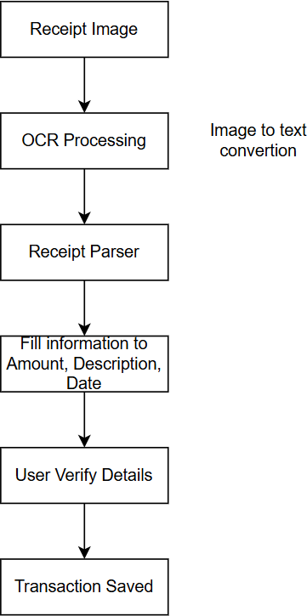

Figure 2.1 Process of Image to Text Output

Forecasting

This forecasting feature estimates the user spending of the next 3 months based on the expenses of their past 6 months. This forecasting also shows the information of the 6th month. This does not take account of sudden increase in expenses, inflation, spending due to events; Furthermore, it assumes a consistent behaviour of the user income/expense behaviour.
Let:

Ii = total income in month i Ei = total expenses in month i
∑6 𝐸
Average Monthly Expense = ^{𝑖=1} ^{𝑖}
6

∑6 𝐼
Average Monthly Income = ^{𝑖=1} ^{𝑖}
6
Forecast Expense = Average Monthly Expense × 6

Forecast Balance = (Average Monthly Income – Average Monthly Expense) x 6
Forecast Spending is used to show the spending total after 6 months ahead. The other part of the forecasting where it shows the next 3 months is similar to the above equations:
Monthly Balance = (Average Monthly Income – Average Monthly Expense)
Cumulative Balancem = Monthly Balance × m, where m = 1,2,3

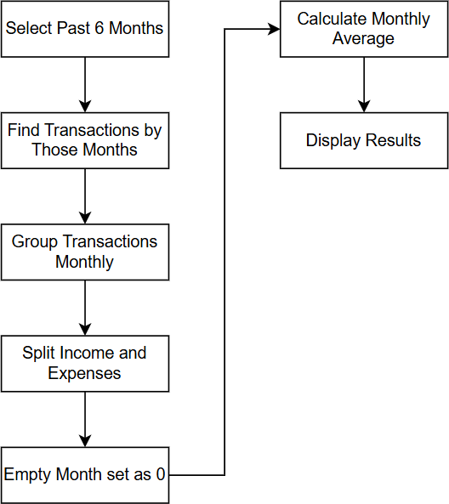

Figure 2.2 Process of Forecasting

Figure 2.1 shows the flowchart of the forecasting process to output.

Scenario Simulation

Scenario simulation is a simple but powerful tool to help users to visualize the effect of their set amount or percentage of income or/and expense, and budget values. With the amount/percentage set by the user, the system will show the scenario with that set magnitude to their current records without tampering the original record. It also shows extra information when the user use this and the forecasting together to simulate their decision making scenario.
The set percentage are calculated as:

Simulated Amount = Current Amount × ( 1 + ^{Set} ^{Percentage})
100
Set amount:

Simulated Amount = Current Amount + Adjustment Amount

On the forecasting section, it will show extra information called impact summary and it is calculated as:
Monthly Impact = Simulated Amount – Current Amount Cumulative Impactm = Monthly Impact × m, where m = 1,2,3
m is the next 1st month, 2nd month and the 3rd month.

Theres a thing called suggestion where is recommends the user by an optimized expense adjustment based on their current financial standing, this is to help the user to realize and potentially prevent their future budget problems. Figure below is the process of the system.
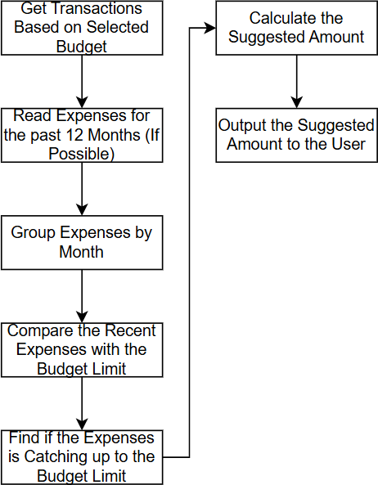

Figure 2.3 Process of Calculating the Suggestion Amount The calculation of the threshold of the budget limit which is set to 75%:
Target Expense = Budget Limit × 0.75

If the latest expense exceeded the threshold, suggested amount will be calculated as:

Suggested Amount(expense reduction) = ^{Current} ^{Expense} ⁻ ^{Target} ^{Expense} × 100
Current Expense

Table below are the list of suggestions based on different scenarios:

Scenario | Suggested
Expense exceeds target expense | Expense reduction
Expenses are increasing rapidly | Preventive expense reduction
Expenses are within target expense and  stable | No action needed
No budget but expenses are increasing | Reduction based on the trend
Not enough data | Tells the user that it can’t create suggestion.
Table 2.2 Scenario and Suggestion Rules

Notification Logic

This system has a real time notification system that compares the user spending with the budget limit. It is shown as a bell icon which will then has a drop down menu when clicked. Table below shows the lists of the threshold of a budget limit shown to the user before a notification is sent:

Budget Limit Exceed threshold (%) | Notification
75 | Spending warning
90 | Near limit warning
100 | Budget exceeded alert
Table 2.3 Notification Rules based on Budget Threshold

These notifications at certain thresholds will allow early warning to the user about their budget limit.
Furthermore, it also has a notification send to user if the user enters a large amount in a transaction that caused to exceed the budget limit, current month budget has no transactions, category involved in multiple budgets, untouched money has been rollover from the last budget period, and the current month budget is new and no spending baseline yet. User can dismiss notifications with an option to undo if it was dismissed on accident. Downside is that this system does not consider the behaviour of the user, it can only follow predefined conditions. Figure below shows the notification process.
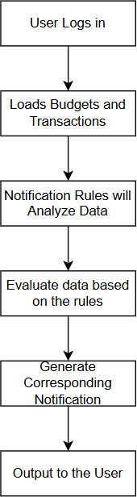

Figure 2.4 Notification Process

Heatmap

Heatmap is used as as expense visualization implementation used to show the expense intensity of that day. Heatmap is useful as it is easy to look at colours instead of numbers. It is also helpful for users to understand their spending patterns throughout a period within the selected year. Figure below is the process of the heatmap.
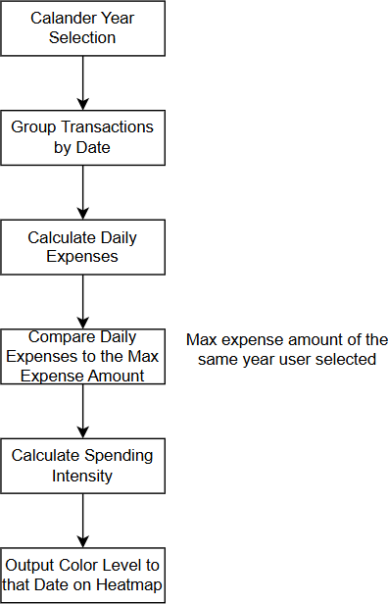

Figure 2.5 Process of the Heatmap Daily sum of transaction (expense) equation:
𝑚
Dd =∑ 𝐴_{𝑗}
𝑗=1

Where:

Dd is the total transaction amount for date d Aj is the amount of transaction j.
m is the number of transactions recorded on date d.

To calculate the intensity:

Id = min ( 𝐷𝑑 , 1)
𝐷𝑚𝑎𝑥
Where:

Id is the intensity of that day

Dmax is the maximum daily amount based on the selected year

Dd is the expense amount for that day

Table below is the classification based on the intensity into colours

Intensity of that day | Meaning | Color
0 | No records | Light grey
0 < I < 0.25 | Low activity | Light green
0.25 ≤ I < 0.50 | Medium activity | Medium green
0.50 ≤ I < 0.75 | High activity | Dark green
I ≥ 0.75 | Very high activity | Very dark green
Table 2.4 Classification of Heatmap Intensity

Other than the heatmap itself, the interactive aspect is what makes this heatmap useful. By using the simulation feature logic into here, multiple specific day can be selected and perform its own individual expense reduction of the user choice in percentage. Then the system will calculate the results after the expense reduction without modifying the original records.

Transaction Automation

A recurring transaction automation is basically meant to enter transaction at a specified rate with details entered. This is mainly to reduce the need for the user to manually enter such transactions and occurs frequently. Users can set the amount, start date, and frequency of the automation. Users can create multiple automations as the same time and are able to pause, continue, delete or edit that individual automation at any time. The figure below shows the process on how the automation figure works.
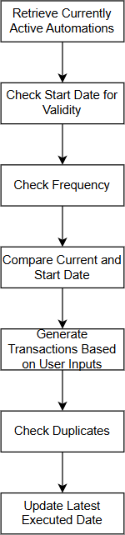

Figure 2.6 Process of the Automation System

User can set the frequency to daily (1 day), weekly (same weekday, 7 days), monthly (same day of the next month, else set as the next month’s last day) or a custom set duration using days as the number. Even if the user did not log in for days, the automation feature will still fill up the missing dates if it is following the frequency.
Do note that this feature is client side triggered with database persistence, it is not reliant on server side (mainly to store the existence of it) Lastly it does have an anti duplication system to avoid glitches and repeated transaction on the same period.

Summary of the Technologies Review

Table below is the list of technology used and its role.

Technology | Role
Phone, Computer, etc. and camera | Access to the web application and to capture  receipts without special hardware.
Web browser | Runs the web application
JavaScript and JSX | Application logic and user interface
React | Create reusable interface components
Vite | Development and building environment
Supabase | Authentication, API, and other backend services
PostgreSQL | Database
Tesseract.js | Extract image and turn to text
Recharts | Display charts and Visual analysis
Flatpickr | Date time picker
CSS | User interface designs and layout responsiveness
Table 2.5 List of Technology Used and its Role

These technologies are what deemed as the optimal choices for this system while maintaining the free to use characteristic. React and JavaScript act as the frontend and the user interface while Vite is used as a quick hot start of a server for development and a build environment. Supabase and PostgreSQL act as the backend of the system. Tesseract.js, Recharts and Flatpickr are libraries that helps in easing the development process by already providing quality of life features.

Table below shows the algorithm and processing methods.

Algorithm/Method | Role
Receipt OCR and parsing | Turn image to text and extract  information from receipt.
Forecasting | Calculate the average future income,  expenses and balance.
Simulation | Turn hypothetical scenarios and turn to  readable analytical data.
Heatmap | Provide expense spending information  by date.
Transaction automation | Generate transactions automatically.
Notification | Give early alerts/warnings.
Table 2.6 Algorithm/Method and its Role

These algorithms are mainly set with predefined rules and data processing methods to help in managing the user finance. With after gaining information from receipt, the parsing has set rules to find relevant details to fit into the transaction. Forecasting that calculates average income and expenses for the past 6 months. Simulation that create visualization of user set scenarios whether it is income or/and expenses, with a suggestion feature that suggests based on the user spending behaviour. Heatmap that track expenses on each day using colour intensity as classification with a scenario visualizer on individual dates. Automation that fills in transactions at a frequency set by the user. Lastly, notification system that alerts user on certain events.

Previous works on Financial Tracking Web Applications.

    - GoodBudget

Goodbudget[1] is like what the current project is aiming for, it uses the same envelop budgeting method where income and expenses are categorized as “envelopes” for transactions specified by users. This systematic method helps in user to plan on how to allocate their finance in a category, meaning each transaction has a reason why it is at the specified place.
This financial tracker features:

- Envelop budgeting allocation method

- Manual transaction input (in the free version)

- Track expense and income

- Share to a number of devices/users (varies based on subscriptions)

- Various reports and analysis.

Money Lover

Money Lover[2] has a simple aim which is focus on expense tracking, budgeting and visualization of the transactions. Selling point is that it is easy to use and accessible for everyone who have a browser.
Features include:

- Expense and income tracking

- Categorization

- Budget planning through category

- Type of wallets support (cash, bank)

- Bill reminders

- Bank account integration

2.1.3 Fina Money

Fina Money[3] uses modern budgeting and financial tracking tool, it has a lot of customizable options and very flexible to any user personal approach to this tracker.
This financial tracker features:

- Comple control of categories to create.

- Build own dashboard.

- Own financial designs.

- Flexible budgeting, users can freely decide how their budget works.

- Track spending patterns and give insights.

- AI assistant

Strengths

There are very few available financial tracker web application that are usable from their free version, this fact alone is enough to stand out as a strength of a financial tracker. Example such as Fina Money and Goodbudget have a free version that are good enough to use as a user even though it is restricted; Further remarks for Fina Money, it has so many various customizable sections that suits everyone to use.
Furthermore, these financial trackers also have a well structured way of storing users financial budgeting which is the envelop style where transactions are categorized. They also provide multiple currency types into the transactions which allows wider demographics.

Weaknesses

    - Financial Trackers that requires one to pay

Almost all the available financial trackers out there require one to pay a fee to use their services in a timely basis. Some even rarely provide a free version of their services which then it has been heavily restricted. At best these financial trackers give free trials and then requires you to pay the subscription which I find it pointless if the user want a to use a financial tracker long term. Figure 2.1 to 2.3 below shows the pricing of some of the available financial trackers.
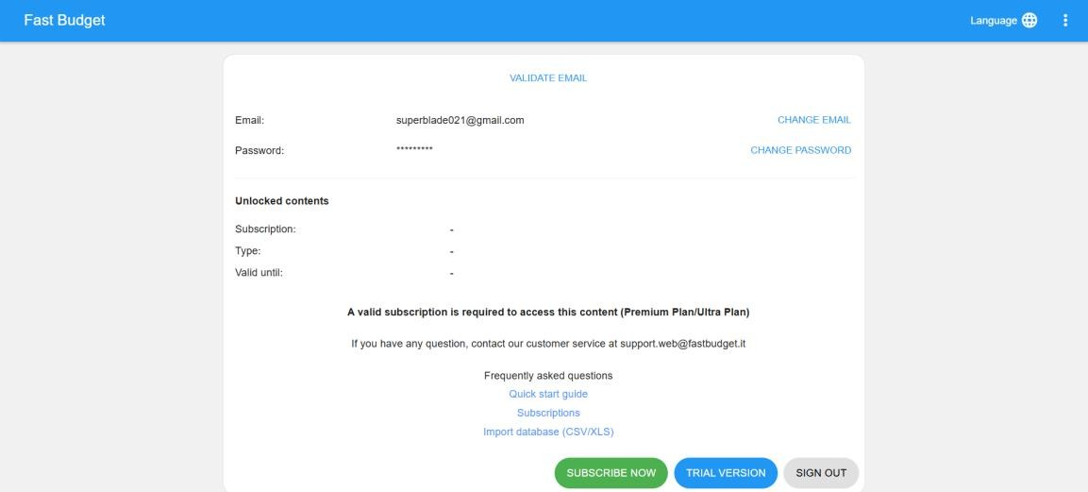

Figure 2.7 Fast Budget Subscription Check Webpage

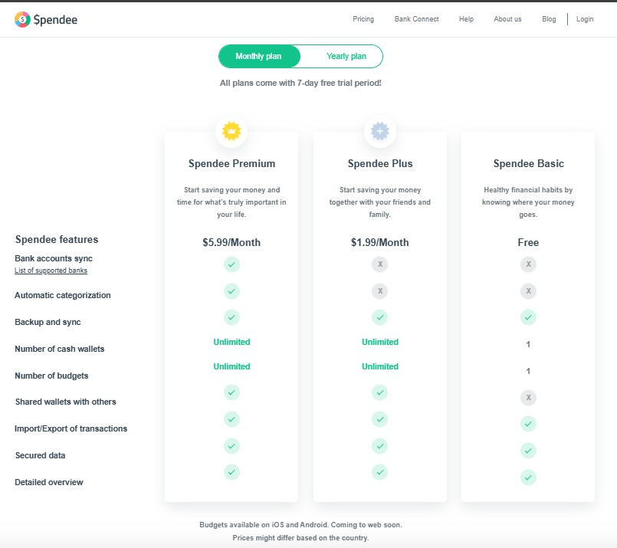
Figure 2.8 Spendee Pricing Section
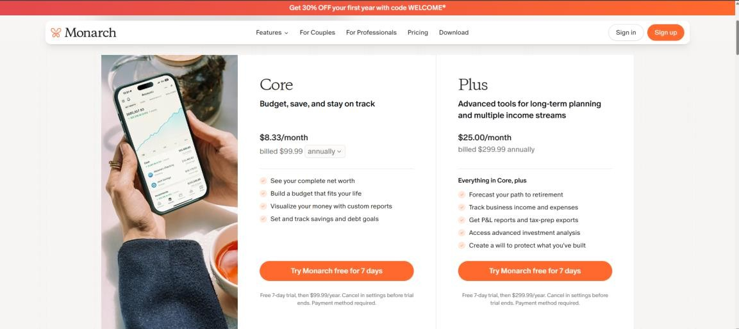

Figure 2.9 Monarch Pricing Webpage

Financial Trackers that are “Free to Use”

Few that I found online that are I would consider free to use, Goodbudget which has premium version but still able to use it for free, it has similar feature as this project with budgets, analysis, transactions and more. But for the user interface section, there are too many functions present with a lot of navigation through although there are guides; Furthermore, although there are a lot of analysis report types, there are no visualization such as statistics or graph at the analysis section, it is just pure calculation of total spent and earned. About its free version, it limits the amount of category and transaction allowed to store with limited amount of Next is Money Lover, this financial tracker has a premium version but still usable without paying regardless in return of a more annoying way of tracking things as it claimed; However there are little to no features, containing just a wallet as what we call category in our project and transaction only. Even though from its pricing section it shows that the product has budgeting and categorizing feature, these features are not available at least from the free version nor create one from the free version. Figure 2.4 and 2.5 shows the default dashboard when first starting/look to use their services.

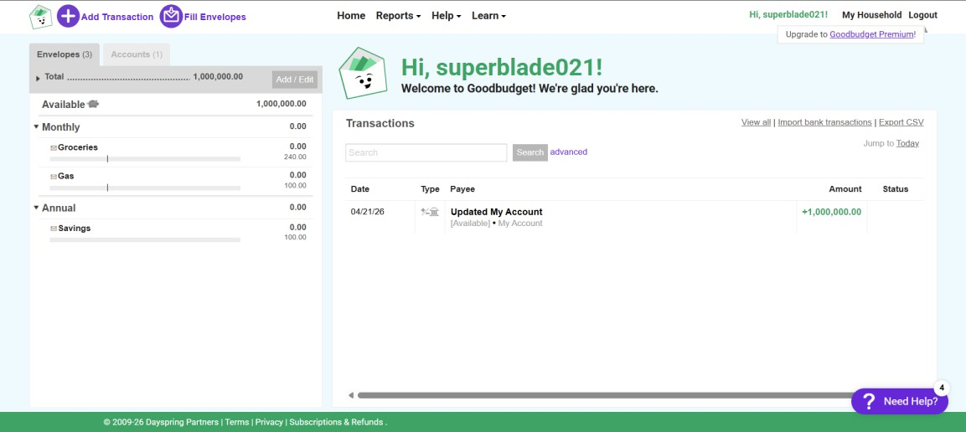

Figure 2.10 Goodbudget Dashboard

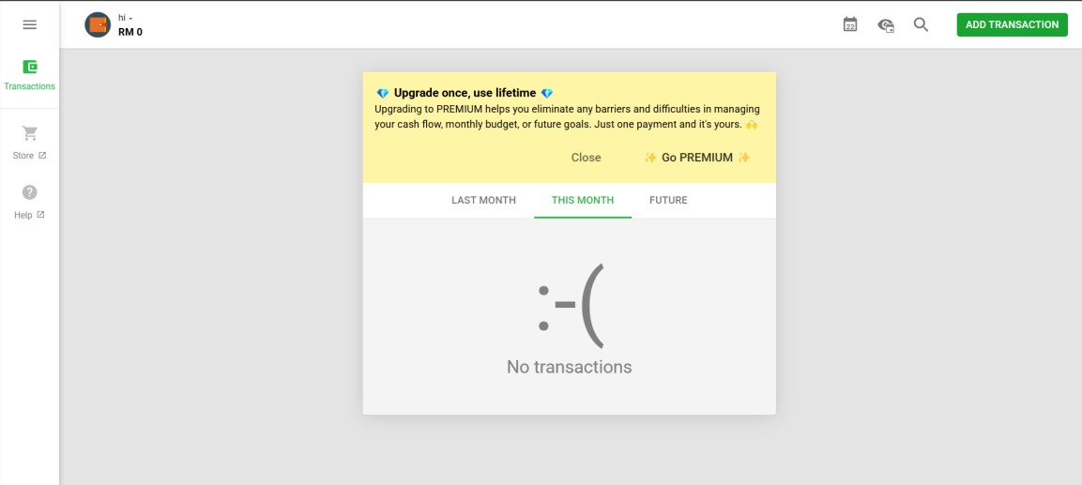

Figure 2.11 Money Lover Dashboard

Fina Money’s Customization Issue

Fina Money although it is fully customizable, this can be also its weakness.
This is due to users may not know what they really need or it can be too much customization to do where users may struggle to know what they want on their screen. Therefore, this project where the customization are mostly limited to the create, read, update and delete operation of categories and transactions. Furthermore, every click or decision made will cause a lot of things to happen on the screen and one might have difficulty to navigate through as there is no fixed guidance and takes time to understand the application fully.

Summary of the Existing Systems

Table below shows specifically the features available from other existing system to this system.

Feature | Goodbudget | Money Lover | Fina Money | Proposed System
Budget  management | Envelop based | Category  based | Customizable | Category based
Visual  analysis | Very limited | No | Yes | Yes (Charts and  heatmap)
Receipt  camera/OCR | No | No | No | Yes
Transaction  Automation | Limited | No | Yes | Yes
Notifications | Limited | Yes | Yes (AI) | In app alerts
Forecasting | Limited | No | Yes, requires  setup | Yes
Scenario  Simulation | No | No | No | Yes
Accessibility | Free plan | Free plan | Free plan | Completely free  for all features
Table 2.7 Feature Comparison with other Systems

Fina money is the most flexible financial tracker as of today. It allows users to manage categories, dashboard information, analyse spending behaviours, and AI support. However, too much flexibility may increase complexity and may need unnecessary setup to perform the desired results.
Table above shows that the other systems does provide some of the features but a few of them are limited to it. Some features such as scenario simulation and camera based receipt handling, and heatmap analysis is what only the proposed system has. The main selling point is that this proposed system is completely free to use as all of the technology used are open source.

CHAPTER 3
System Methodology/Approach
  - System Design Diagram
    - System Architecture Diagram
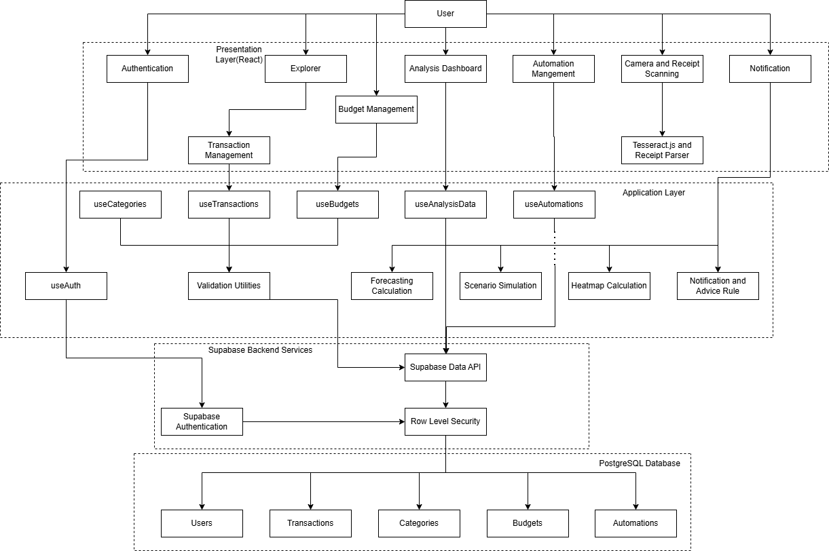
Figure 3.1 Architecture Diagram

Figure 2.12 shows this system’s architecture. Presentation (Frontend) layer is where the user interface occurs, guiding users to use the explorer (transactions and categories, budgets), analysis(scenario simulation, heatmap, forecasting), and notification.
Application layer is where data and user actions are processed. Custom hooks to communicate with Supabase, utilities handle validation, receipt parsing, notification and automation rules, and calculation for heatmap, simulation scenario and forecast.

Supabase backend and PostgreSQL layer is where user authentication, database API access and storage, and row level security.

Use Case Diagram and Description
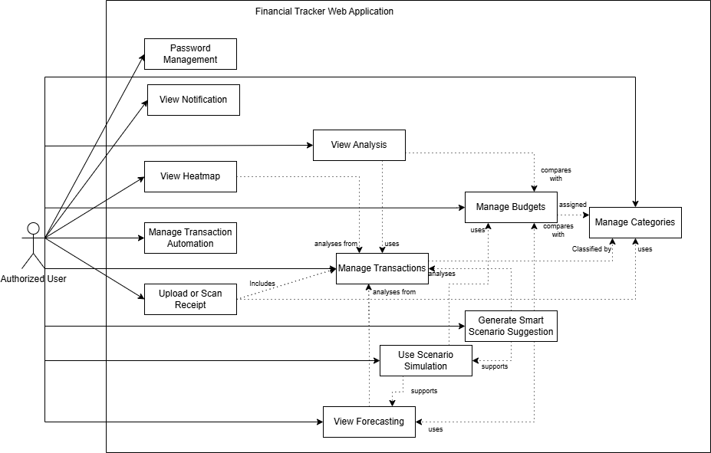

Figure 3.2 Use Case Diagram

Figure above is the use case diagram. A user must have created a usable account to become an authorized user. The Receipt scanning/upload are used to create a transaction in a pseudo automatic manner. While the smart suggestion is embedded in the scenario simulation feature that also able to run its results based on forecasting.

Table below shows the use case descriptions:

Use case | Description
Password Management | Users can change or recover their  password.
Manage Categories | Users can perform CRUD in categories.
View Notifications | Output alerts about the user financial  standings.
View Analysis | Shows in depth details about the user  income and expense.
View Heatmap | Show daily expenses in form of intensity with temporary adjustable  expenses as simulation.
Manage Budgets | Users can perform CRUD and manage  the categories.
Manage Categories | Users can perform CRUD in categories.
Manage Transaction Automation | Users can perform CRUD in transaction  automation rules.
Upload or Scan Receipt | Upload or take photo of a receipt, then  OCR will turn the image to text to obtain relevant information.
Manage Transactions | Users can perform CRUD in income or  expense transactions.
Generate Smart Scenario Suggestion | Analyze the budget limit with the user  spending behavior to suggest adjusted expense for simulation.
Use scenario simulation | Users can simulate changes in income  and/or expenses without changing the actual data.
View Forecasting | Estimate future income and expenses  then show the user the balance based on the user past transaction data.
Table 3.1 Use Case Description

Activity Diagram

      - Receipt Scanning

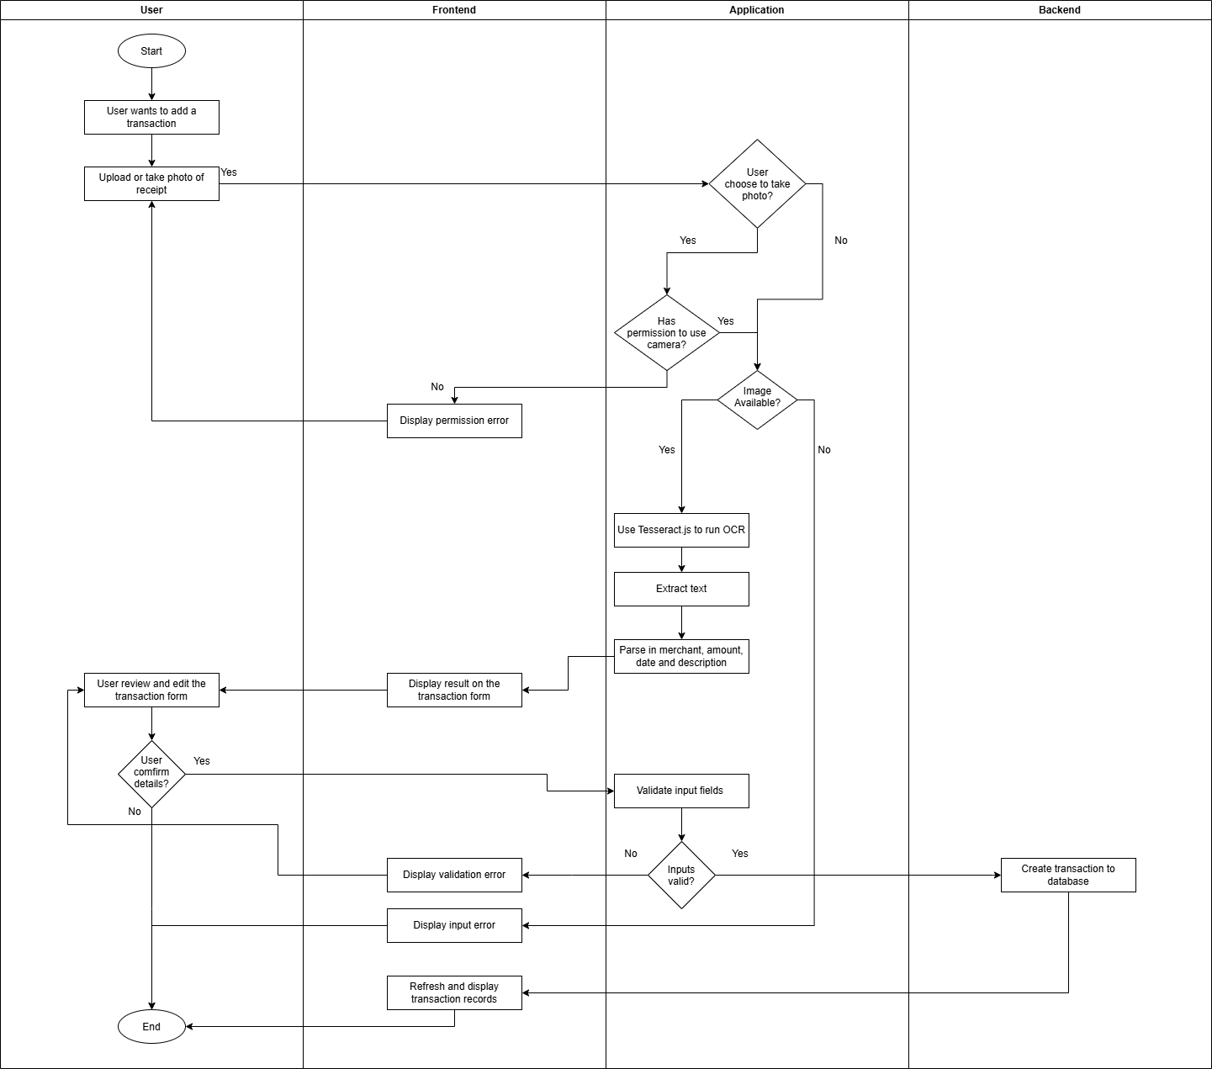
Figure 3.3 Receipt Scanning Activity Diagram

Transaction Automation
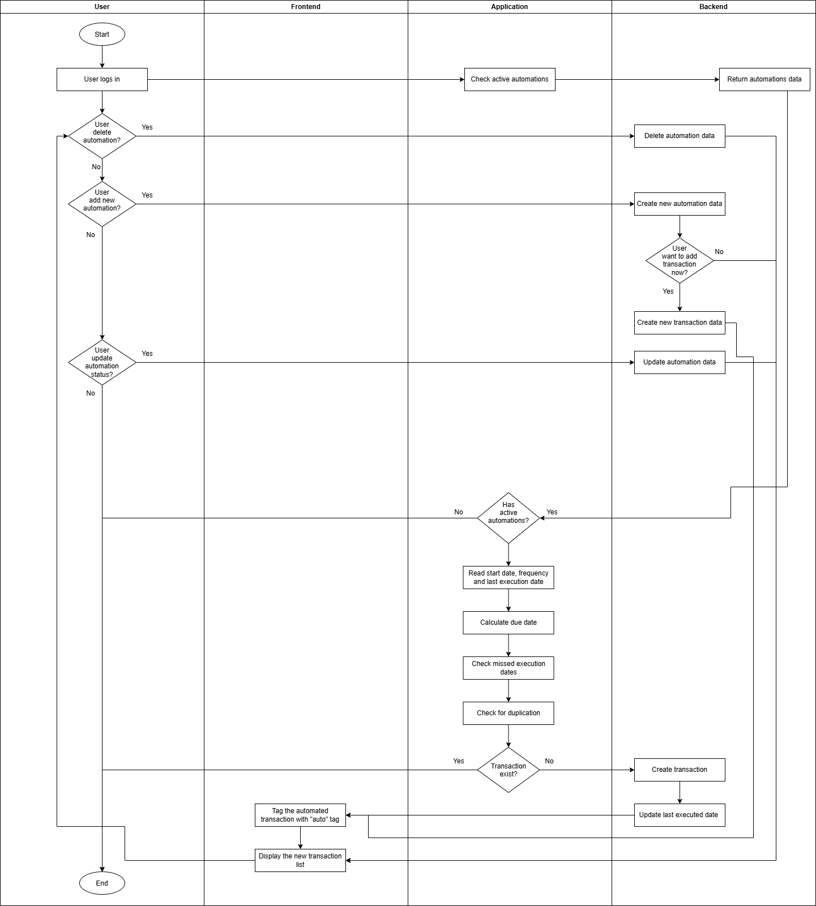
Figure 3.4 Automation Activity Diagram

Notification System
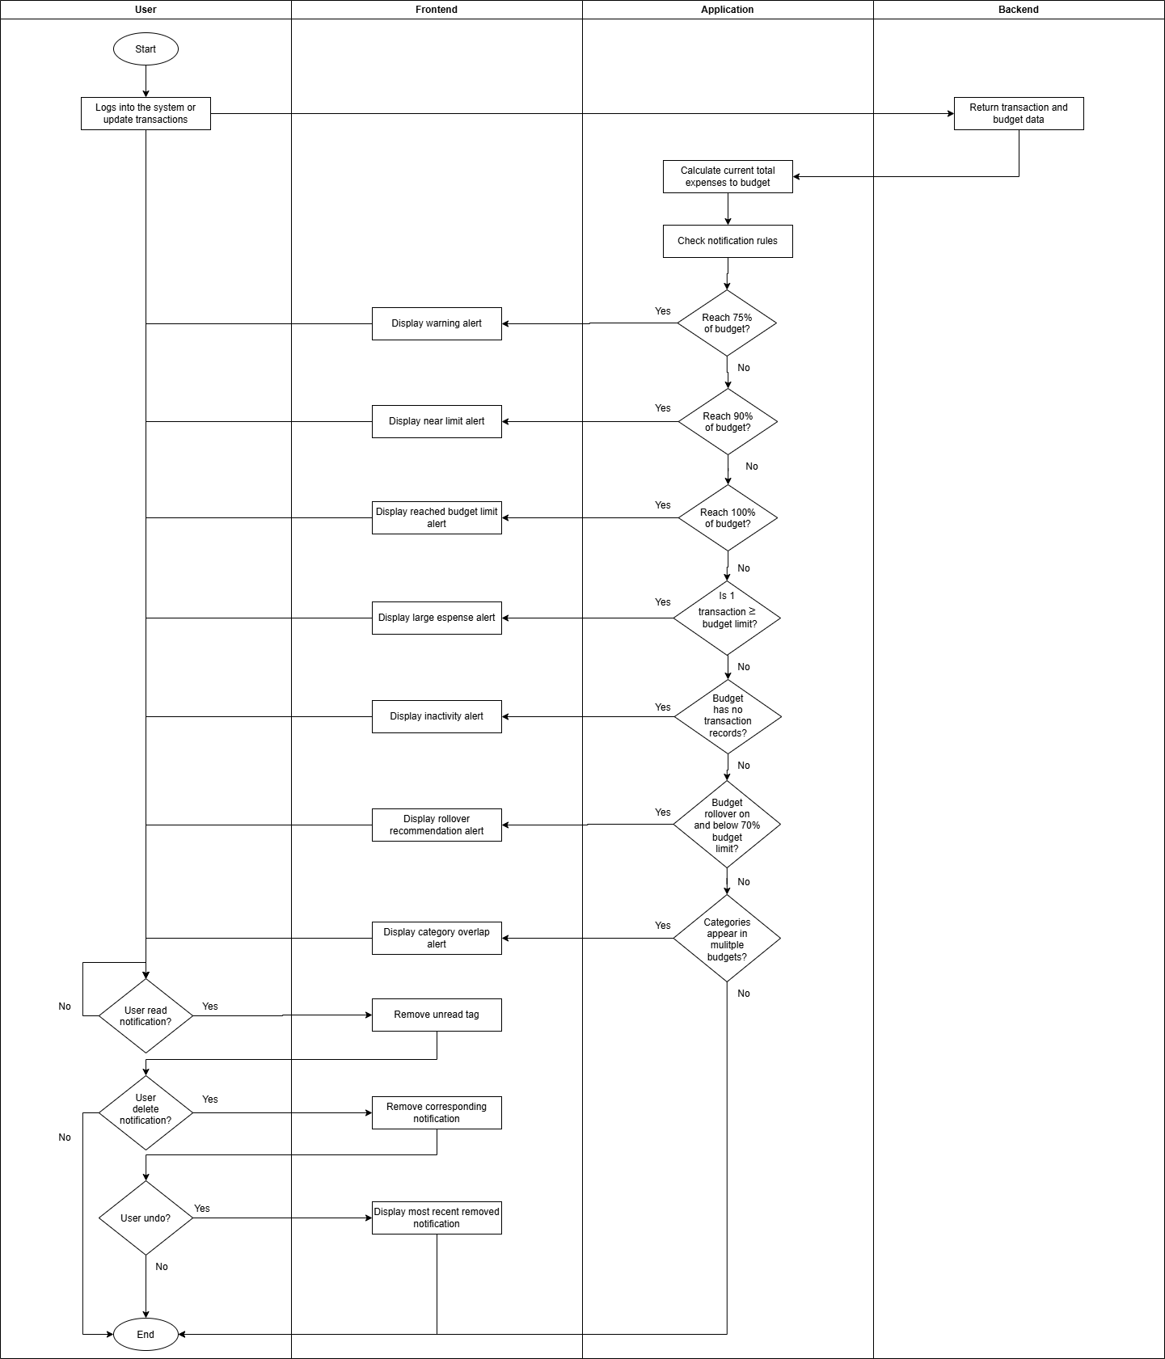
Figure 3.5 Notification Activity Diagram

3.1.2.4 Heatmap
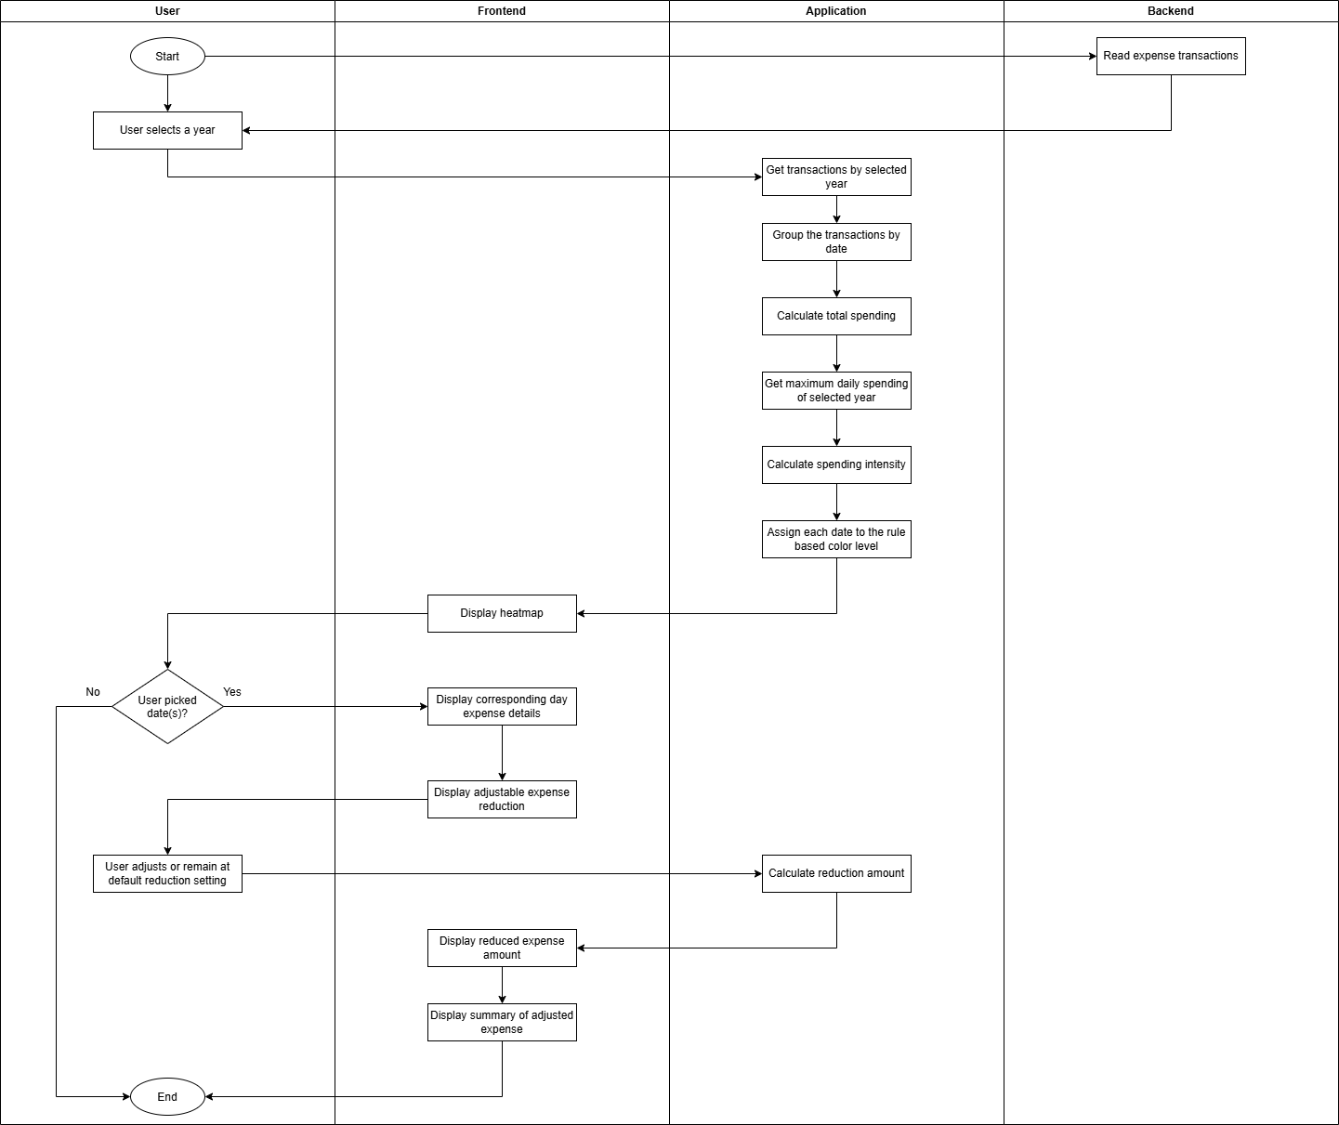
Figure 3.6 Heatmap Activity Diagram

Scenario Simulation
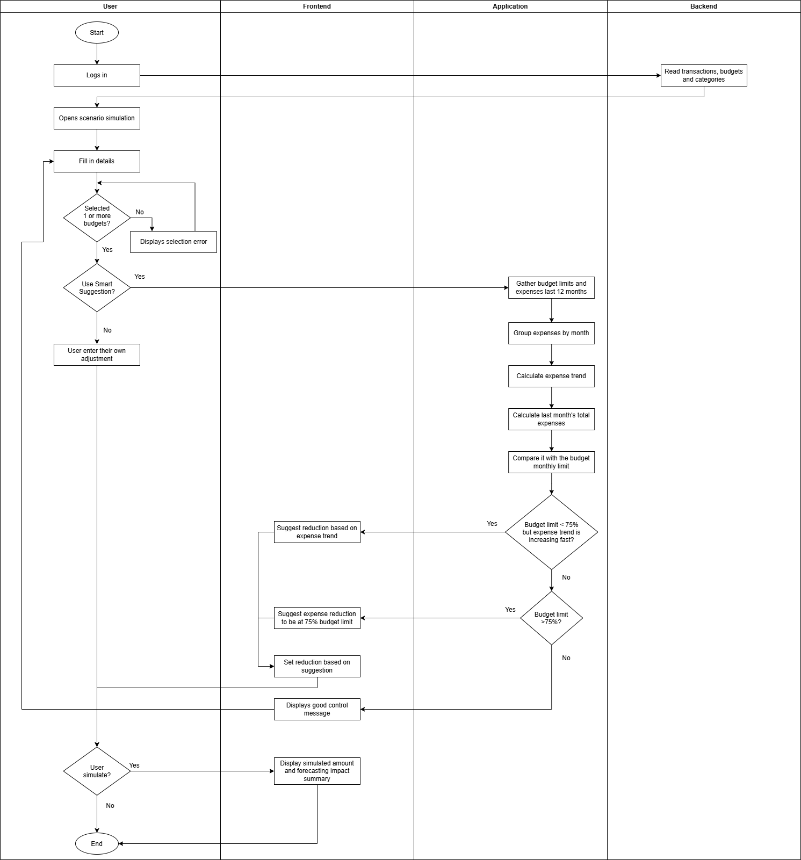
Figure 3.7 Scenario Simulation Activity Diagram

Basic CRUD Operations
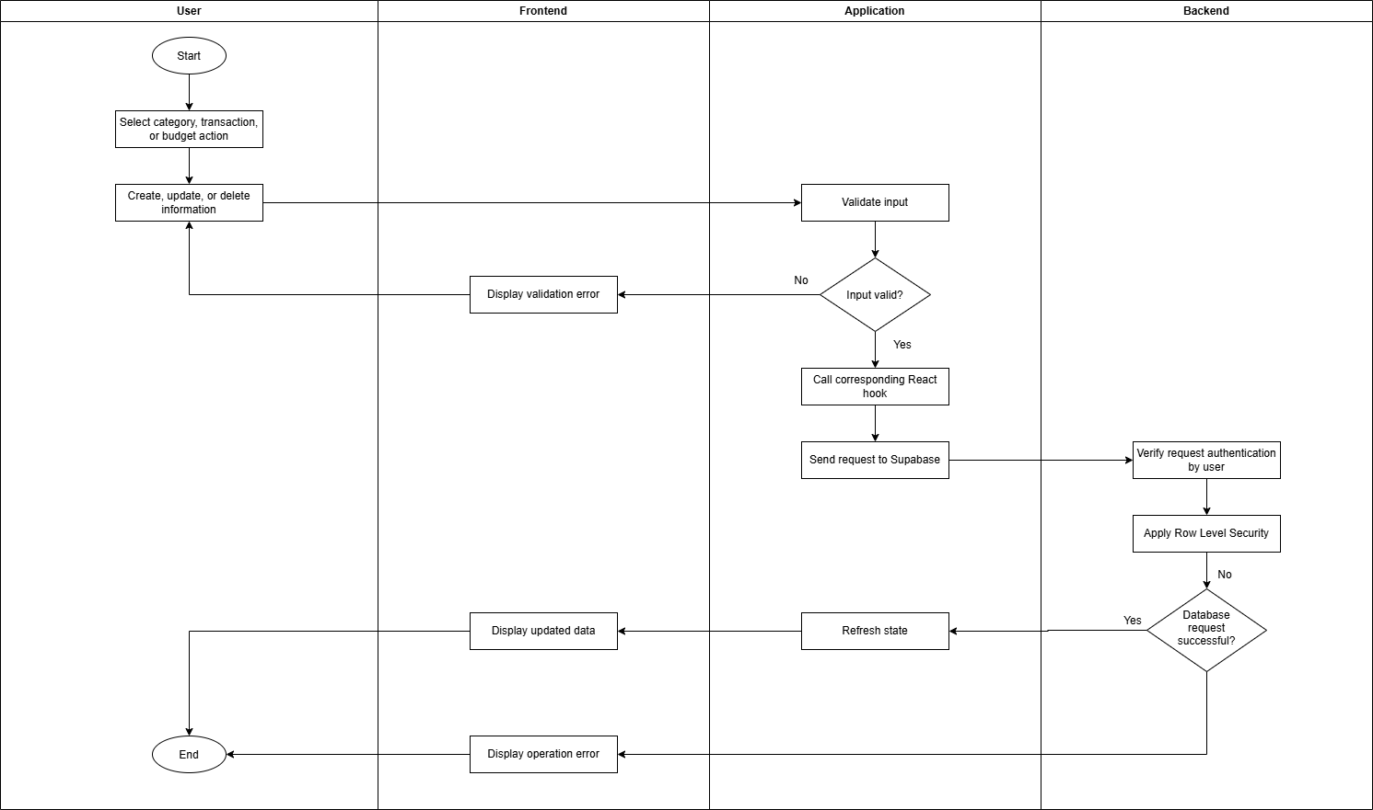
Figure 3.8 Basic CRUD Operation Activity Diagram

Chapter 4: System Design

  - System Block Diagram
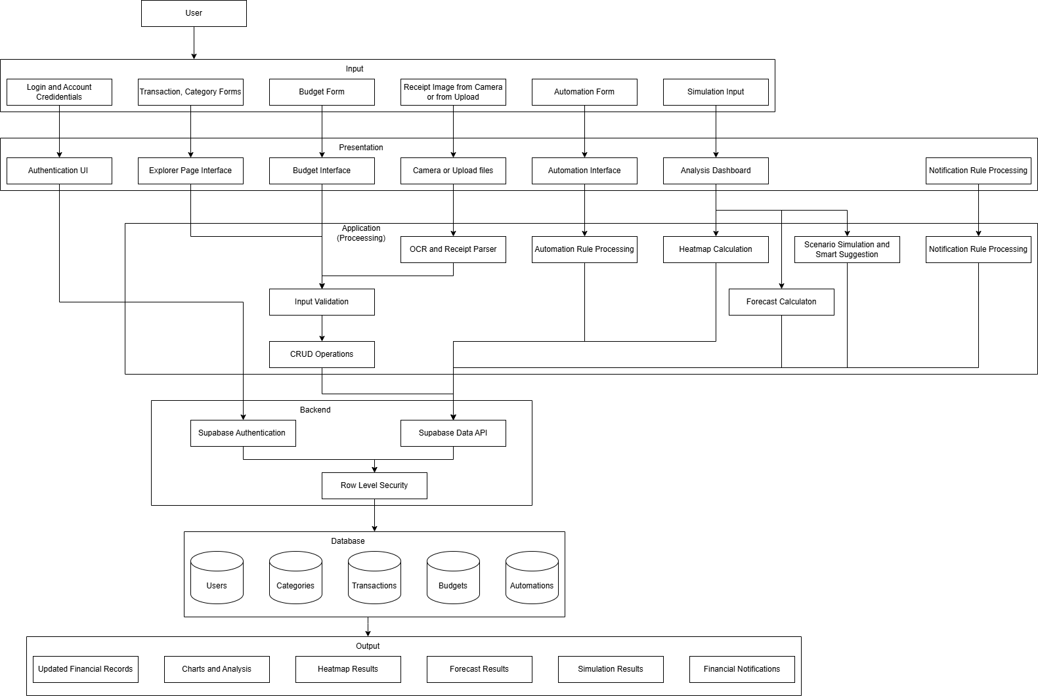
Figure 4.1 System Block Diagram

  - System Components Specifications

    - User and Authentication Component

This component is to let users register, log in and out, recover or change their password. The Supabase authentication service is to validate the user authenticity and the session information. After authentication, the system will have the authorized user generate information by the system (ID) to obtain their financial data. Supabase also provides Row Level Security.

Item | Specification
Input | Email, password, authentication
Processing | Supabase authentication and session validation
Output | Authentication session result
Technology | Supabase Auth
Security | Row Level Security
Table 4.1 User and Authentication Components

    - Transaction Management Component

This component allows users to perform CRUD transactions. Each transaction has as amount, type, category, description, date, and user identifier for Row Level Security. The input will be validated before updating it to Supabase. If the Supabase request is successful the newly updated transaction list and the analytical data will be refreshed.

Item | Specification
Input | Transaction type, amount, category, description, date
Processing | Validation and CRUD operations
Output | Updated transaction list
Database table | transactions
Related component(s) | Category management
Table 4.2 Transaction Management Components

    - Category Management Component

Allows user to perform CRUD on categories. Category is to group transactions which then correlates them to budgets. Categories are tied to an user which each category has a name, and colour name.

Item | Specification
Input | Category name, colour
Processing | Validation and CRUD operations
Output | Updated category list
Database table | categories
Related features (used by) | Transactions, budgets, analysis
Table 4.3 Category Management Components

    - Budget Management Component

Allows the user to perform CRUD on budgets, the budgets are set on a monthly basis and it is based on selected category(ies). Each budget have name, selected category(ies), monthly limit, and rollover option. Budget will then calculate the expense total and compare it with its budget limit, this will produce results and data for other components. One budget can contain multiple categories but will be alerted by the notification.

Item | Specification
Input | Name, category(ies), monthly limit, rollover  option.
Processing | Validation and expense calculation
Output | Summary and budget limit data
Database table | Budgets
Related component(s) | Categories, transactions, notifications
Table 4.4 Budget Management Component

    - Analysis Component

Obtain data from transaction, category and budget to create summaries and charts. The analysis panel will display income and expense totals, category expense comparisons, monthly trends, and other budget related information. The analysis is based on selection of budgets and can be further filtered down with a selected time period.

Item | Specification
Input | Selected budgets, time range
Processing | Data collection and comparison
Output | Charts, summaries, trend
Technology | React, Recharts
Table 4.5 Analysis Component

    - Receipt Camera and OCR Component

Users can use camera to take photo or upload a receipt image. Tesseract.js will run the OCR to convert the image to text, followed by the parser to extract relevant information to fill up the text fields including amount, description, date. User will then verify the content before it is added to the transaction list. This component does not choose the transaction type automatically and will be defaulted to expense, the OCR will also most likely to produce non desired results.

Item | Specification
Input | Receipt image
Processing | OCR and text parsing
Output | Amount, date, description
Technology | Teserract.js
Last action | User validates the information and saves transaction
Table 4.6 Receipt Camera and OCR Component

    - Forecasting Component

This component attempts to predict the future financial standing of the user by using income and expense from the past 6 months of transactions. The system will then calculate the average of income and expense which then be used to visualize the results for the next 3 months visually and 6 months in text. If it is used by the simulation scenario, it will affect the forecast values and show the impact summary of it.

Item | Specification
Input | Past 6 months of income and expense
Processing | Monthly grouping and average calculation
Output | Monthly average values and 3-month visualizer  and 6-month in text
Limitation | Only predict based on consistency and current  available data, outside events cannot be predicted
Table 4.7 Forecasting Component

    - Scenario Simulation and Smart Suggestion Component

User can use this component to create their desired scenario by changing the values of income or expense of set amount or percentage without modifying the original data. It has a smart suggestion function that analyse recent expenses with its correlated budget limit to provide adjustment recommendation based on its set rules. This component will affect forecast and provide impact summary for it.

Item | Specification
Input | Selected budget, simulation type (income,  expense), adjustment (amount or percentage)
Processing | Calculate monthly and cumulative impact
Output | Adjusted financial data and forecast results
Affected component | Forecast
Smart Suggestion recommendation method | Rule based
Table 4.8 Scenario Simulation and Smart Suggestion Component

    - Automation Component

Users can set automation(s) by filling up its start date, amount, category, type, option to add transaction now, and frequency. Once automation is created it cannot be edited. The system will check whether the automation status is set to active, then it checks for due or missed dates to create and fill those up with the automated transactions. Each automation has the option to pause or delete where paused automation can be resume back. Transactions that is automatically generated will have the auto tag on them.

Item | Specification
Input | Amount, category, frequency, start date, option  to add transaction now
Processing | Date comparison, reads latest execution date,  backfilling
Output | Recurring transaction records
Database table | Automations
Limitation | Execution checks only when the user log into  their account.
Table 4.9 Automation Component

    - Notification Component

Generate in app alerts based on rules and data from budgets and transaction. Alerts may be given if the user reaches certain budget limit thresholds, a single large expense that exceeded the budget limit, budget with no activity, rollover conditions met, or category appearing in multiple budgets.

Item | Specifications
Input | Budgets and transactions expenses
Processing | Rule based condition
Output | In-app notifications
Deliverables | Notification bell and drop-down menu
Notification alert method | Rule based
Table 4.10 Notification Component

    - Supabase and Database Component

Provides services such as authentication, API access, Row Level Security. PostgreSQL is the database integrated into Supabase to store data. Custom React hooks and JavaScript client are used to communicate with Supabase.

Item | Specificaiton
Supabase Auth | User authentication and sessions
Data API | CRUD request
Row Level Security | Access to user owned records only
PostgreSQl | Stores data
Table 4.11 Supabase and Database Component

  - Software, Hardware and Components Design

This system is a web based application there are no circuits or anything like electronic component required, so there is no diagram for such.
    - Hardware Components

Component | Function | Requirement
Laptop or desktop | Runs the web browser and the  web application | Modern web browser
Smart phone or tablet | Runs the web browser and the  web application on mobile | Modern web browser
Camera (built in or external) | Take photo of receipt image | Camera is optional, required  when user wants to take photo
Display | Display forms, charts, records,  etc. | Screen
Internet connection | Connect to Supabase services | Required for cloud
Table 4.12 Hardware Components

    - Software Components

Component | Function
React | Reusable component based user interface
Vite | Development and build tool
JavaScript and JSX | Implementation for application logic and  interface components
Supabase client | Communicates React frontend to Supabase  services
PostgreSQL | Database
Tesseract.js | Receipt OCR
Recharts | Display charts and analysis
Browser camera API | Capture receipt image
ESLint | Support tool for code debugging
Node.js and npm | Development tool and manage dependencies
Flatpickr | Display selectable dates
Table 4.13 Software Components

    - Software Component Connections
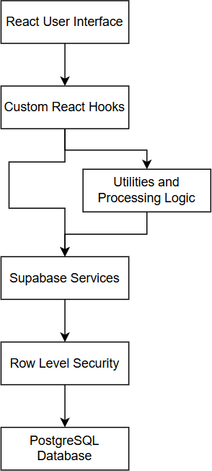

Figure 4.1 Software Component Connections

Figure above shows the workflow of software components. When user perform a CRUD action in general, the React hooks will custom react hooks will understand what operations is done. Certain operations will need run some processing logic beforehand, then it will request query and access to Supabase. Supabase will process the request and give restricted access to the user. Finally, when the operation is successful, the database will return or update the data.

    - Database Component

Entity | Purpose
Users | Stores user profile and authentication information
Categories | Group transactions
Transactions | Stores income or expense financial records
Budgets | Stores category based budgets
Automations | Stores recurring transaction rules.
Table 4.14 Database Component

    - ERD Diagram
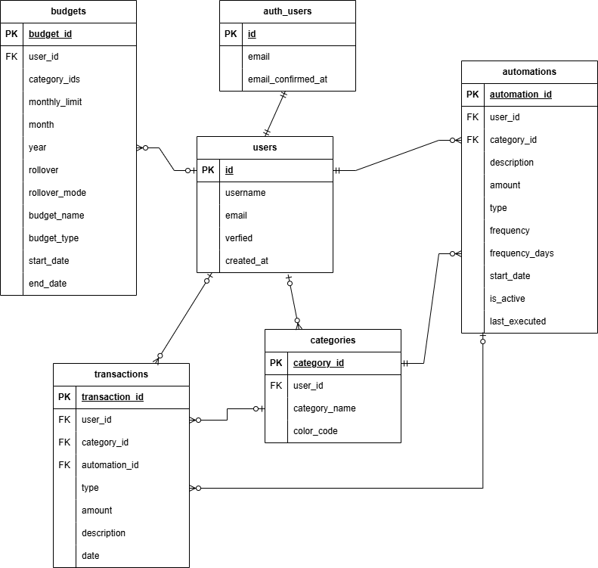

Figure 4.2 ERD Diagram

Figure above shows the ERD diagram of the system, note that auth_users is not treated as an existing table in the database. It is handled by Supabase Auth that stores accounts into that table.

  - System Components Interaction Operations

    - User Authentication and Data Loading

How this works is very similar to 4.3.3 about how Supabase verify the right user. User will login with credentials, these credentials will then be verified by the Supabase authentication. React will retrieve the authenticated user session and loads the user data through Supabase. Row Level Security makes sure that only that specific user’s data are returned to React, and the returned data will be stored in React state through custom hooks and send to related interface components. We will see the following figures will follow the similar flow stated in this section.

    - Transaction and Category Operations
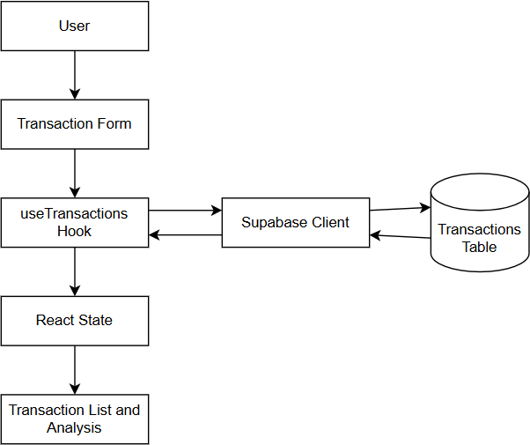

Figure 4.3 Transaction Flow

Figure above shows the transaction flow. When a user perform CRUD, the transaction operation will go through the custom hook. This hook will send the request to Supabase database. When successful the React state will be updated to provide the latest data.

    - Budget Management Operations
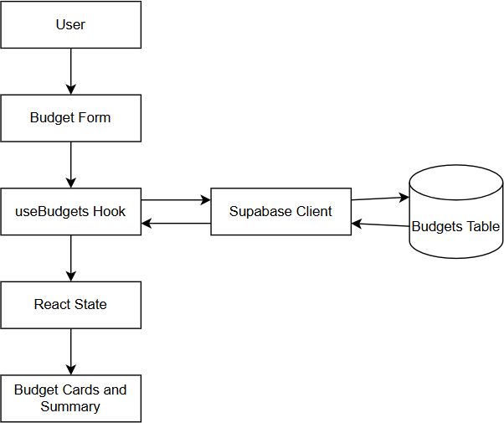

Figure 4.4 Budget Flow

Figure above shows the budget flow. Again, works exactly the same way as how 4.4.2 flow.

    - Analysis and Visualization Operation
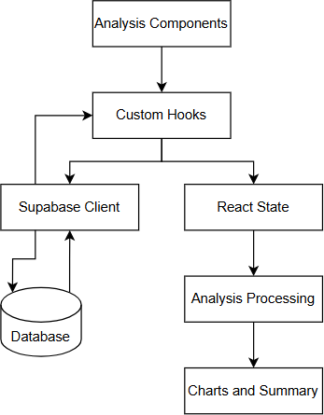

Figure 4.5 Analysis Flow

Figure above shows the analysis flow. The difference with this diagram with the previous 2 is that the analysis components will not wait for user inputs, each analysis components will request for unretrieved data through custom hooks. Retrieved data will not be asked to retrieve again for different components. Which then will be stored in react state, runs calculations and them display the results to the user.

    - Receipt Scanning Operation
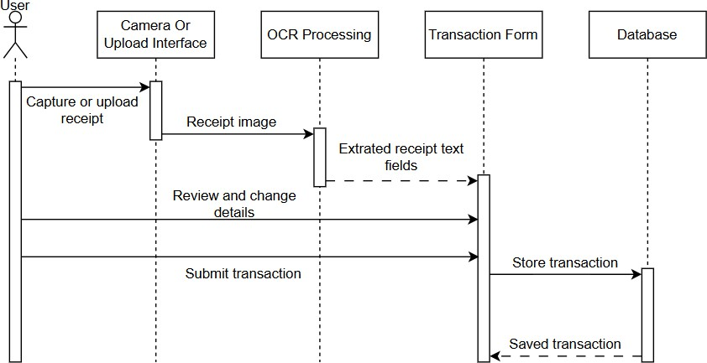

Figure 4.6 Receipt Scanning Sequence Diagram

Figure above shows the receipt scanning diagram. User will upload or capture an image, which then it will be undergo OCR processing. The OCR will extract relevant texts and fill in the transaction form for the user to view. User will then do corrections and verify the information and confirm the decision. Then the transaction will be stored to database and display the newly updated transaction list. Note that the OCR only fills in as suggested data, not accurate and reliable data. If the user deny camera access, the system will display error message, the user will then either give permission, upload image, or manually fill in the form.

    - Automation Operations

This Automation works the same as 4.4.2 and 4.4.1. The differences of this is that the user has the option to create the transaction immediately when the automation is created. However, the execution process is different. Figure below shows the automation process.
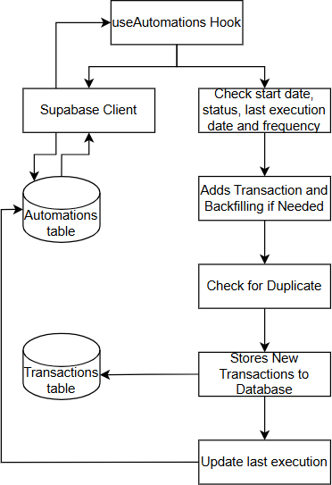

Figure 4.7 Automation Execution Process

The system will request and retrieve the automations data for that user. Then the system will read the relevant information of each automation. If the conditions met, the system would then add new transactions and fill missed transactions. But before actually adding the transaction, the duplication check would run to avoid errors. If the duplication check pass, then it will add the transaction to both user interface and the database. Lastly the last execution date of that automation will be updated to the database.

    - Notification Operation

Notification operation is completely based on client side. The system sends the retrieved data to the notification system instead of it requesting data. Then the notification will run the process based on predefined rules which then display to the user to see.

Chapter 5 System Implementation

  - Hardware Setup

This is the setup for running the system on my end, note that these are not the minimum requirements as I do not have the resources to do so. Table below shows the hardware specifications.

Hardware | Recommended Specification
Computer or laptop | Intel Core i5
Memory | 16GB
Storage | It’s a web application, no storage needed but at  least have 1GB of storage
Display | Minimum resolution of 1366x768
Mobile device | Android or IOS for responsive testing
Camera | Receipt scanning, optional
Internet connection | Required to connect to Supabase and OCR
Table 5.1 Hardware Specifications

Also note that the camera can be installed externally or use the built in camera, as long as it can capture image with your best quality as option.

  - Software Setup

The entire development process and testing is done in Android and Windows 11.

    - Development Tools

Software | Purpose
Visual Studio Code | Writing source code
Node.js | Runs JavaScript and the development  environment
Npm | Install and manage project dependencies
Vite | Runs development server locally
Git | Source code versions management
Vercel | Deploying and testing the web application
Table 5.2 Software Development Tools

    - Dependencies

The dependencies are stored and defined in package.json. This file includes React, Supabase client, Reharts, Flatpicke, Tesseract.js, and other required libraries.
It was then installed using this line:

npm install

The line above reads the package file and download the required packages for the system.

    - Supabase Configuration

Supabase is used for authorization, database storage and backend communication. External uses are for removing unverified accounts that lasted for longer than 1 day using the service called Cron. Below are the sql configuration to do so in Supabase:
CREATE OR REPLACE FUNCTION public.delete_unverified_users() RETURNS void
LANGUAGE sql SECURITY DEFINER
SET search_path = public AS $$
DELETE FROM public.users u USING auth.users a
WHERE u.id = a.id

AND a.email_confirmed_at IS NULL

AND a.created_at < NOW() - INTERVAL '1 day';

DELETE FROM auth.users

WHERE email_confirmed_at IS NULL

AND created_at < NOW() - INTERVAL '1 day';

$$;

The Supabase client is placed in src/lib/supabase.js. It requires 2 variables which are: VITE_SUPABASE_URL
VITE_SUPABASE_ANON_KEY

These variables are then declared in a .env.local file to connect to a specific Supabase project and never be exposed to the public as it contains the Supabse API key.
Next it also required to navigate to authentication, settings, email and then enable email verification. The email provider, SMTP settings and the email template is of choice.
    - Database Setup

Supabase has a database service, and in this system, it is configured using SQL commands that can be run on Supabase using SQL editor. After that, confirm that the table and ERD, Row Level Security, and Authentication configuration are created.
    - Running the Application

To run the server locally, type the following command to the terminal in Visual Studio Code: npm run dev
Give it a few seconds and it will show you 3 different links to choose from to run the server.

Another option is to deploy it on Vercel, it is very useful tool to deploy applications by connecting your Vercel to specified GitHub repository. So from Visual Studio Code, push the currect project to Git, then from Vercel connect it to Git and you can choose which version to deploy.
    - Building the Application

The command line below is used for a production build:

npm run build

This command compiles React application to deployable files. It also helps in debugging. Speaking of debugging:
npm run lint

This command line checks JavaScript and JSX for errors. npm test
The command line is configured and ran to test the functionality of the application.

    - Software Setup Procedure

Since it can deploy locally or using Vercel, Vercel would be omitted for the steps needed since it only need to push it to GitHub and using Vercel to connect to that Git repository.
So, there are the steps to run it locally:

      - Download the source code
      - Install Node.js and Visual Studio Code
      - Open the project in Visual Studio Code
      - Run npm install
      - Go to Supabase, create a new project and copy the Supabase project URL and the anon key.
      - In Visual Studio Code, create/find .env.local file and fill in the variables: VITE_SUPABASE_URL = https://supabase_project_url VITE_SUPABASE_ANON_KEY = anon key
      - Back to Supabase, navigate to authentication, settings, email. Then, enable email verification or similar. Choose the email provider or SMTP settings. Change the email template if needed.
      - Navigate to the SQL editor and paste the supabase_setup.sql file onto it, remember to run. It is optional to save it.
      - Check the tables for users, categories, transactions, budgets, automations. And check for Row Level Security even if only you will be using it
      - In Visual Studio Code, run the following commands in order: npm run lint
npm run test npm run dev
      - If the order is run correctly, 3 URL will be displayed and hold Ctrl button and click on any of the 3 links to run the application whether in a web browser or in Visual Studio Code.

  - System Operation

    - Login and Authentication

Figures below are the login page and create account page. The user are required to key in their email and password in order to access the application. If user creates a new account then, the user has to go an extra step to go to their email to verify the account.
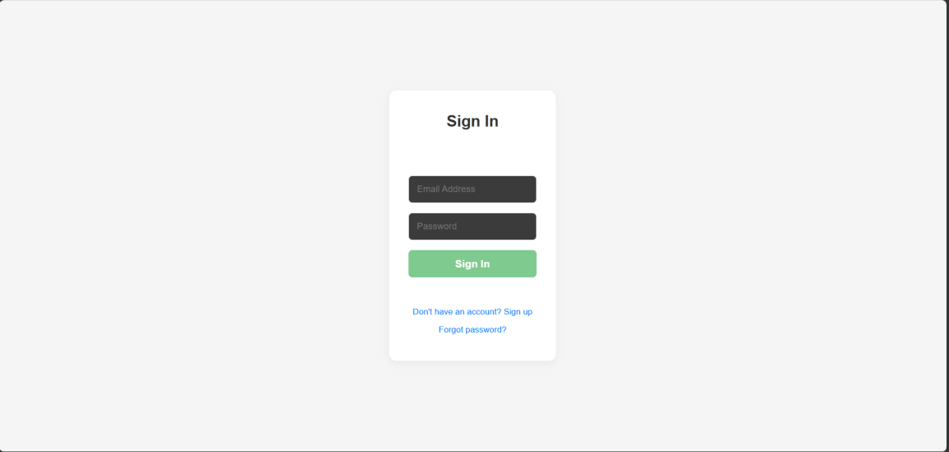

Figure 5.1 Sign in Page
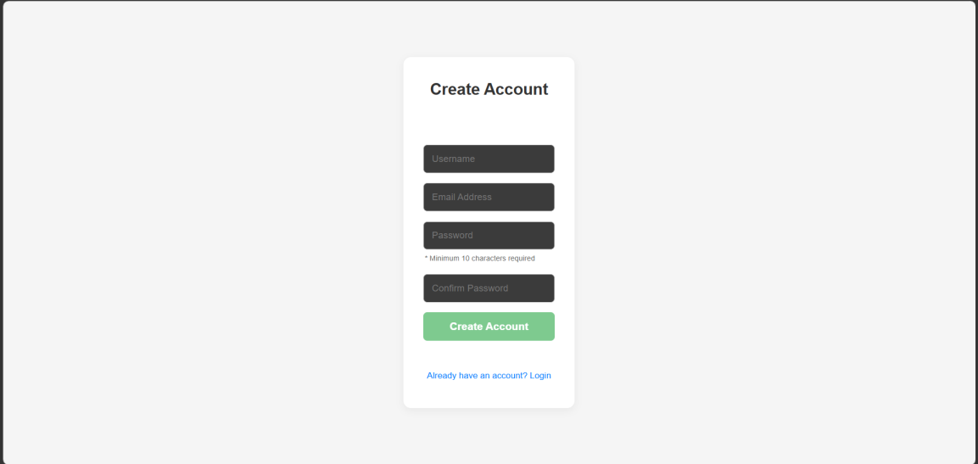

Figure 5.2 Create Account Page

    - Transaction, Category, Camera/Upload Receipt Image, Automation

This is essentially the entire content of the explorer page where user can perform CRUD to the transaction list and category list. The transaction interface will also shows the camera/upload user interface at the same time.
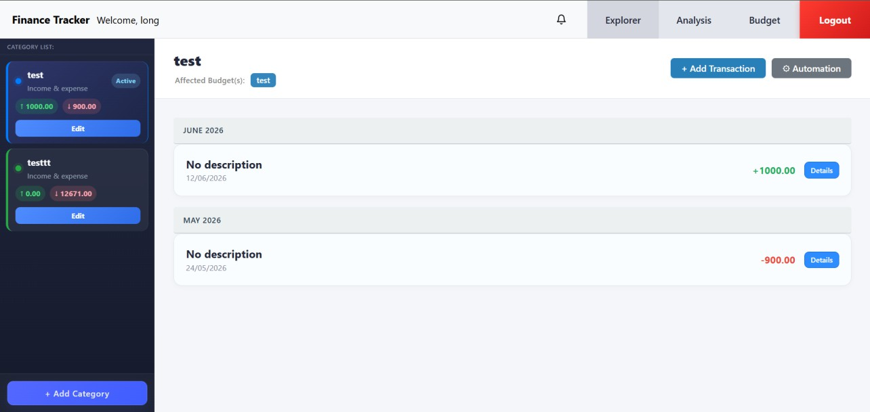

Figure 5.3 Explorer Page
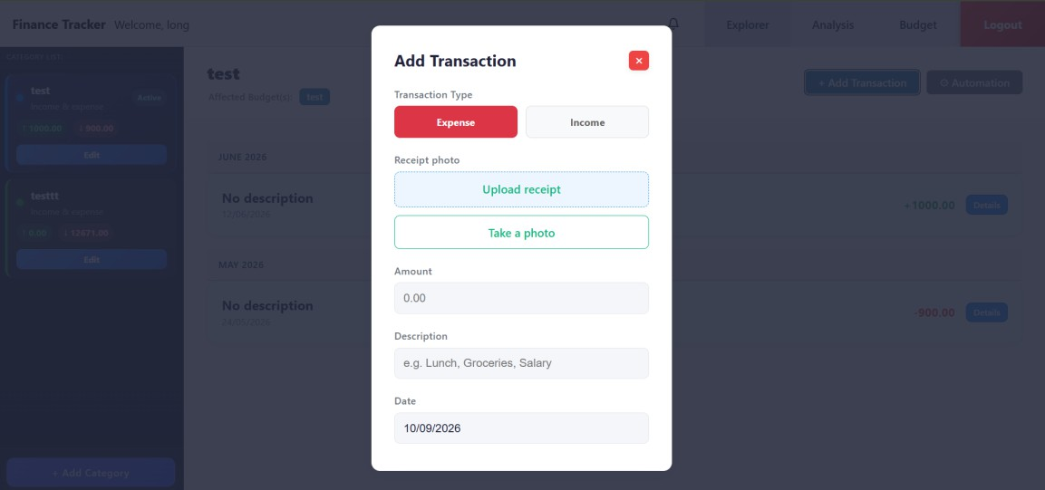

Figure 5.4 Add Transition Pop Up

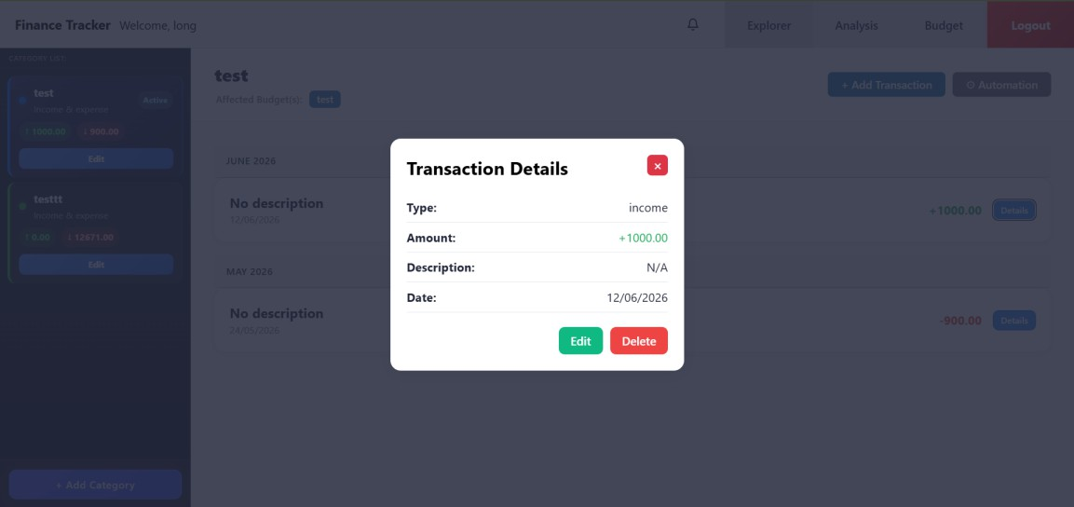

Figure 5.5 Transaction Details
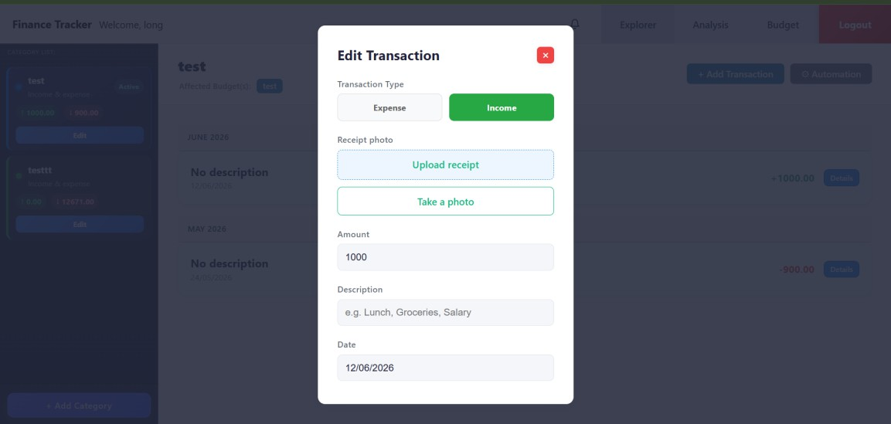

Figure 5.6 Edit Transaction Pop Up

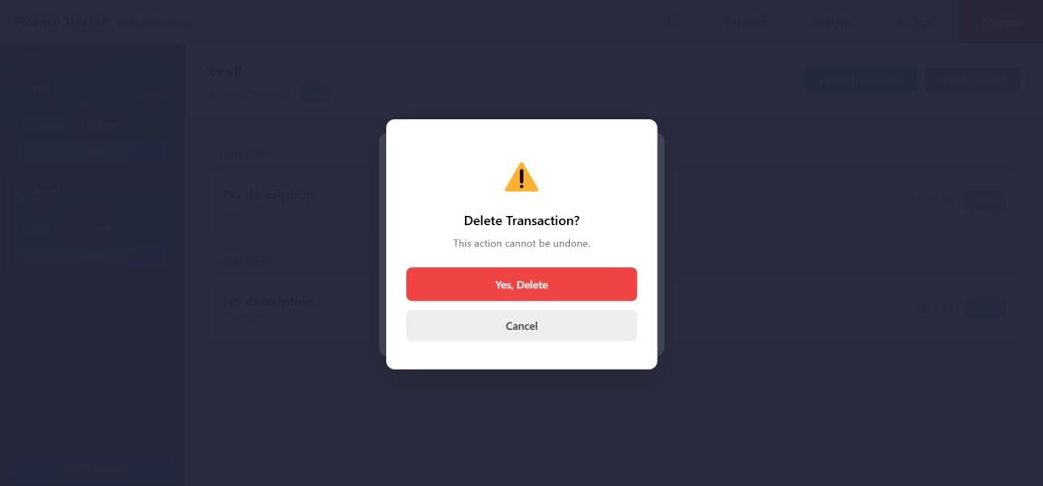

Figure 5.7 Delete Transaction

Figure 5.6 shows the deletion pop up for transaction. This delete interface would be similar for every other delete operation with just the change of words as difference. Therefore, delete operations for other parts will be not shown.
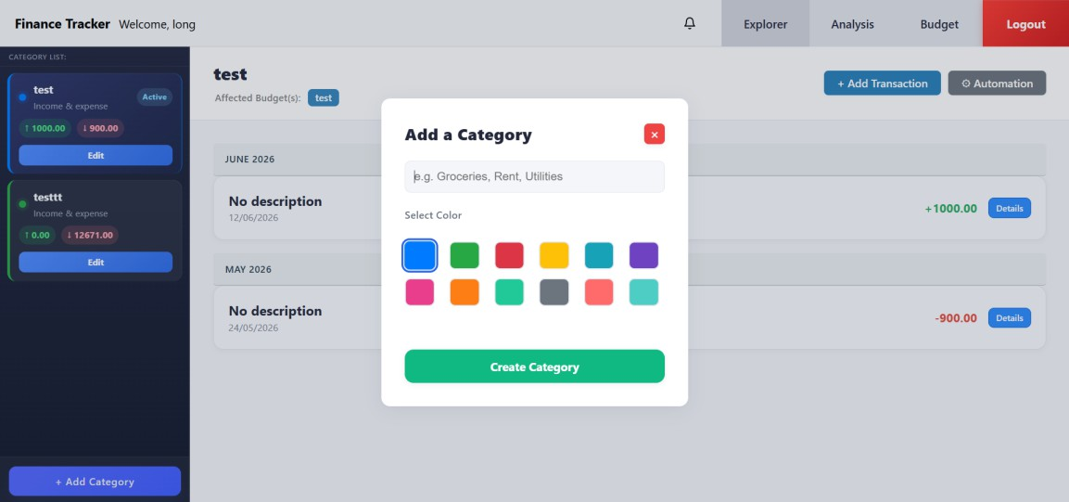

Figure 5.8 Add Category

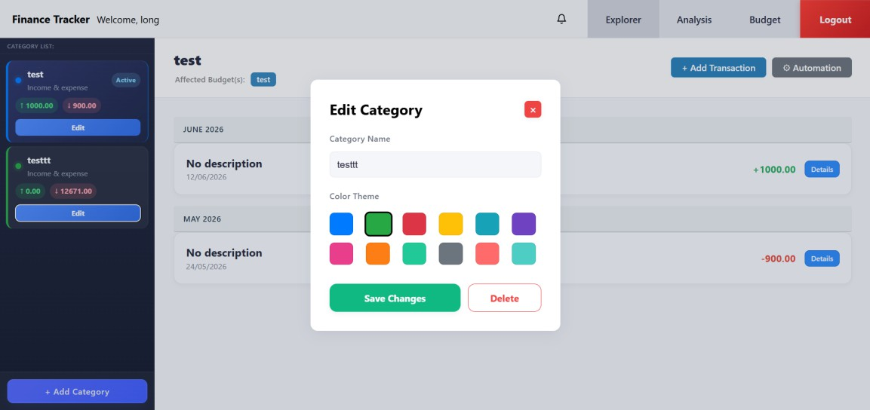

Figure 5.9 Edit Category
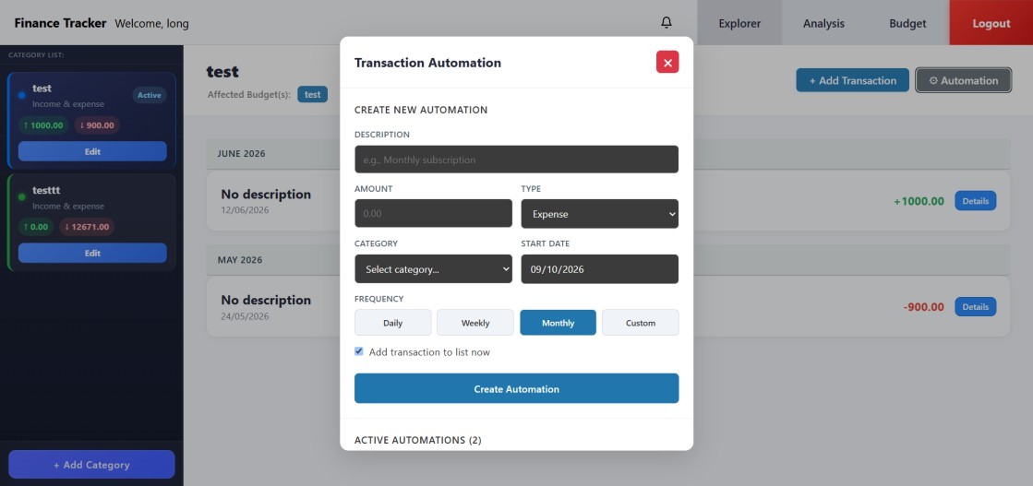

Figure 5.10 Automation Interface
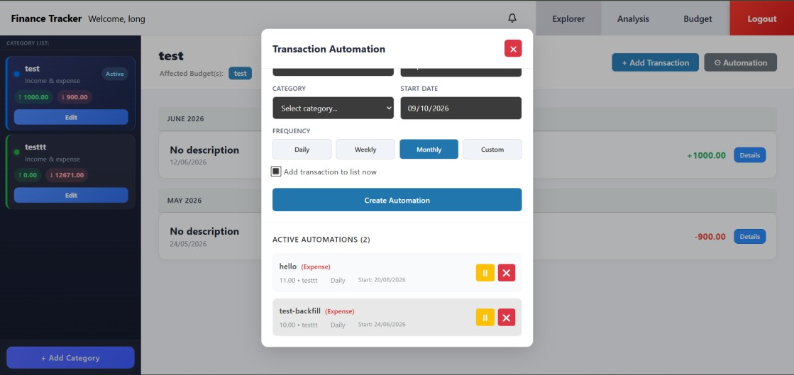

Figure 5.11 Automation List

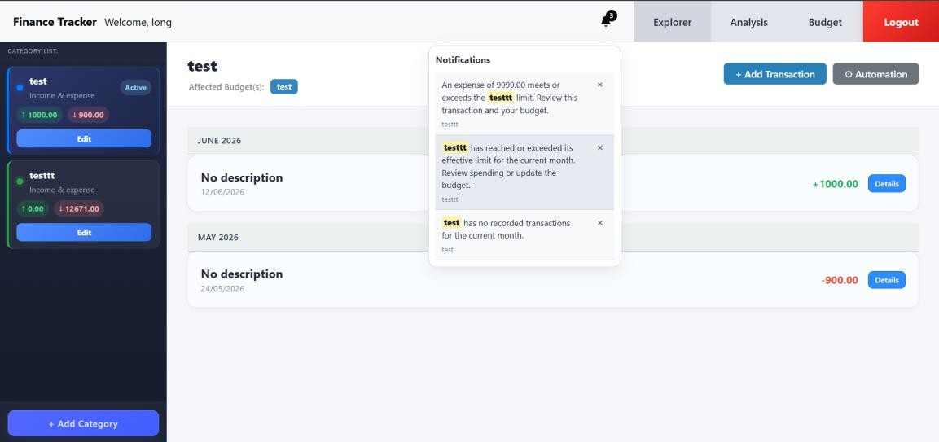

Figure 5.12 Notification List

Figure above shows the notification list, there is no suitable section to place it so it is placed here instead.

    - Budget Management

Budget section is also similar to the transaction management where it is mostly CRUD operations.
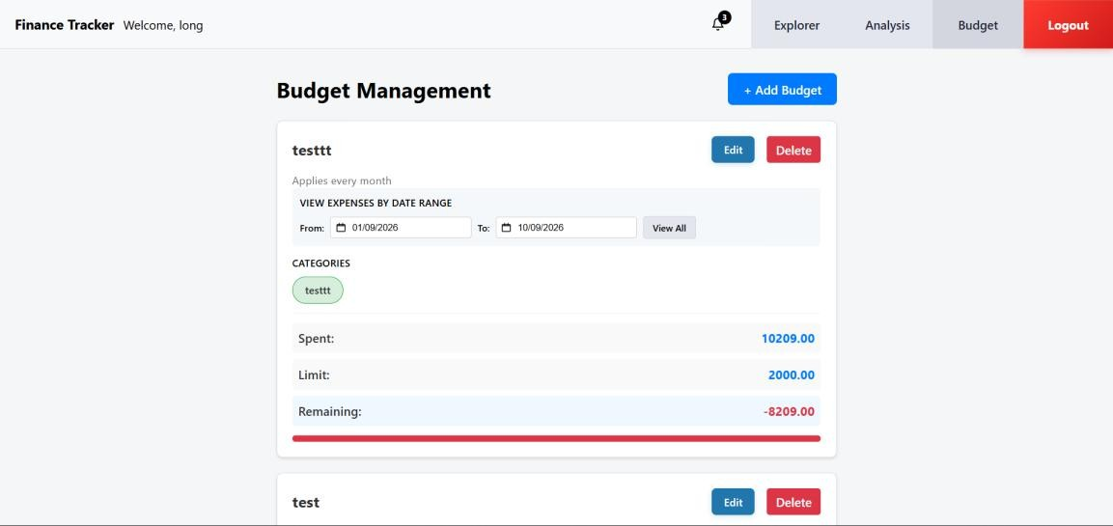

Figure 5.13 Budget Interface

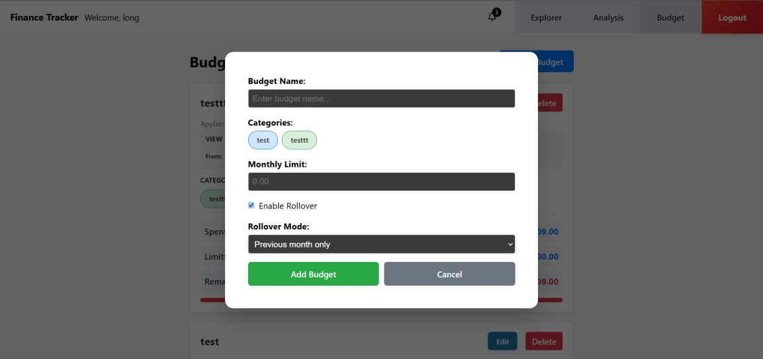

Figure 5.14 Add Budget
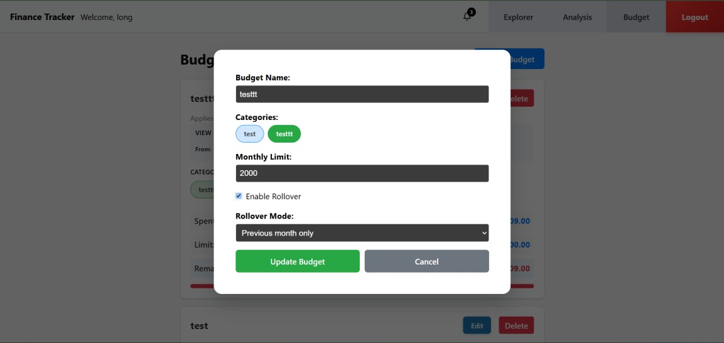

Figure 5.15 Edit Budget

    - Analysis Management

This part is mainly about showing statistics based on selected budgets.
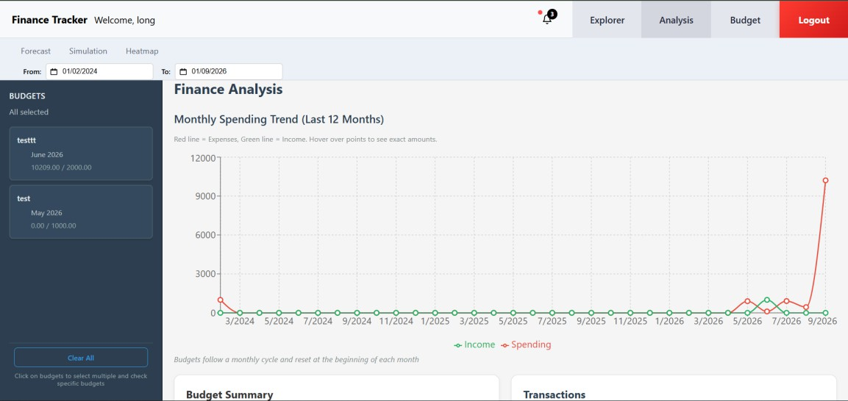

Figure 5.16 Analysis Interface
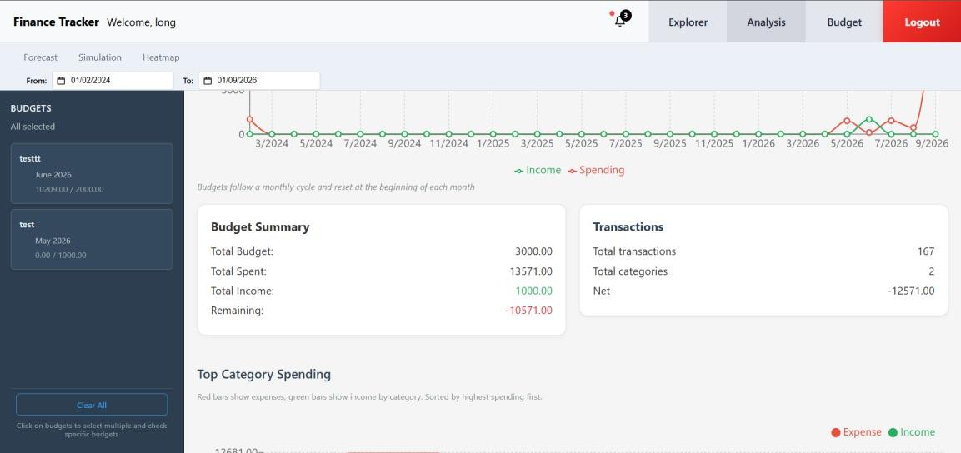

Figure 5.16.1 Analysis Interface 2

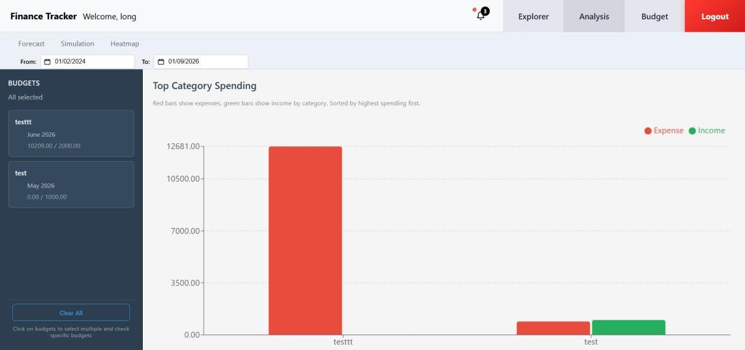

Figure 5.16.2 Analysis Interface 3

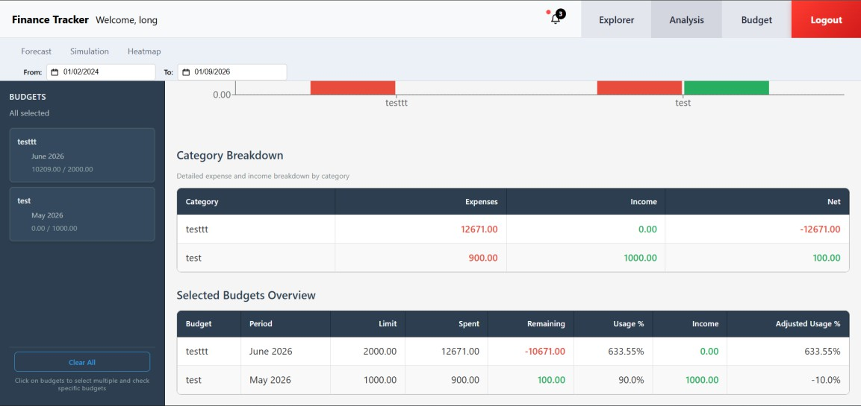

Figure 5.16.3 Analysis Interface 4

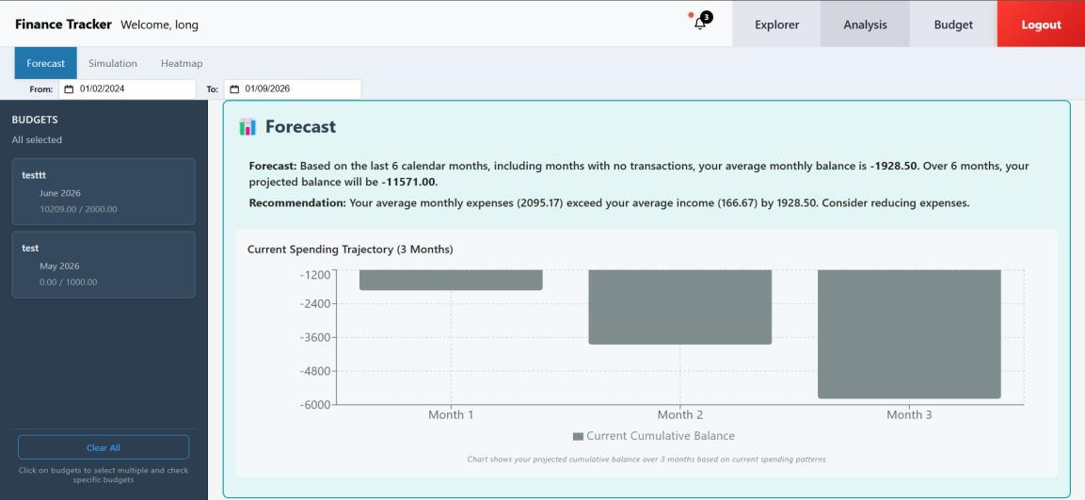

Figure 5.17 Forecast
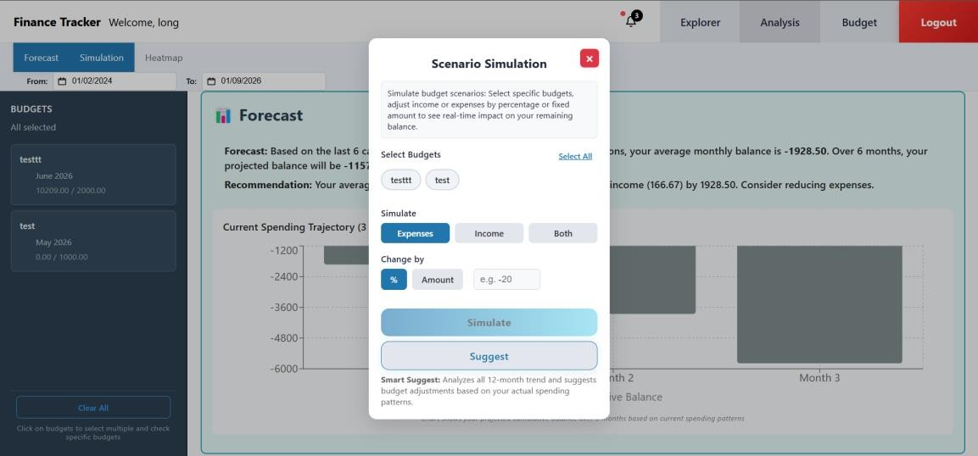

Figure 5.18 Scenario Simulation
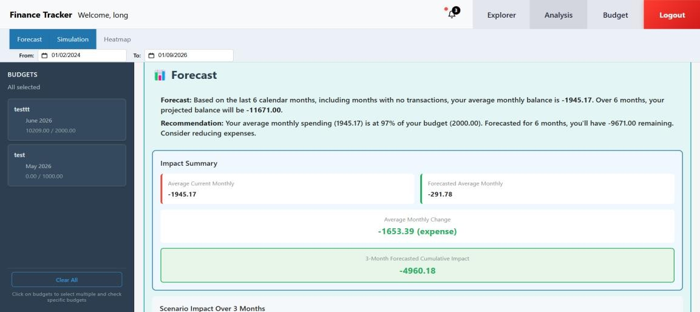

Figure 5.18.2 Forecast with Scenario Simulation

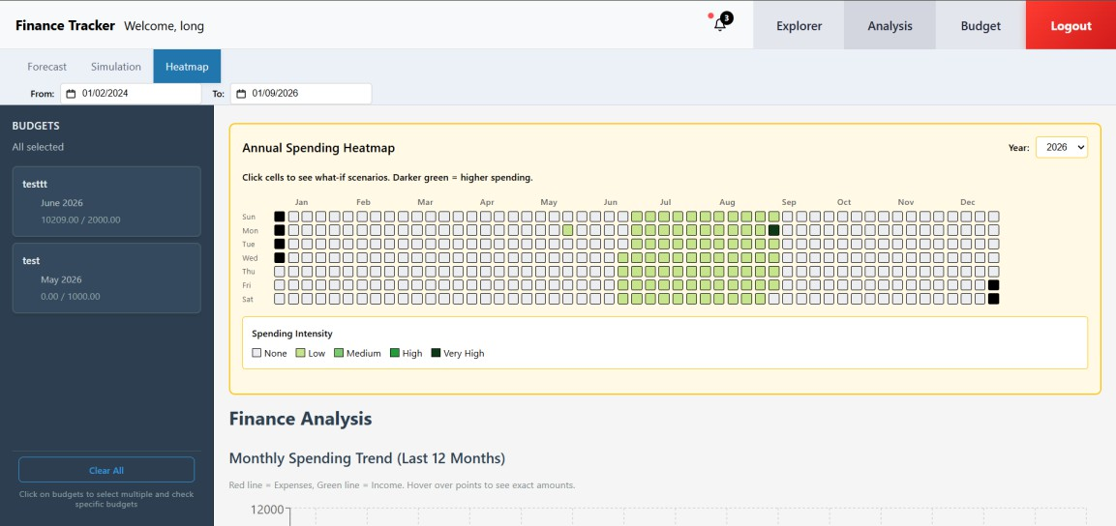

Figure 5.19 Heatmap
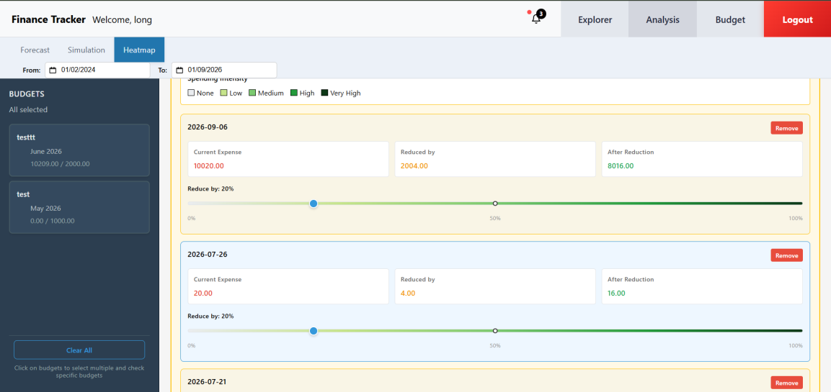

Figure 5.19.1 Heatmap List

  - Implementation Issues and Challenges

The main challenge is the data consistency. Because all features in this project are linked together especially with category, budget and transaction. Therefore, validation between operations is made, followed by the database schema to be updated to maintain integrity and prevent broken references.

This is also true for all the new features added into this project, all are connected back to the database in one way or another, there is not really an independent feature where it works alone. So, the features are reformatted so that if the data has been retrieved then there is no need to redo it again, and then the challenge is to refresh any sort of CRUD operations done while maintaining real time response for better user experience.

The trouble of finding logic errors aside, automation and the OCR reading is the hardest feature to implement so far. Automation has this persistent issue where it has very inconsistent on adding transaction, it shown occasional missing records, duplication or not able to backfill at all. Furthermore, each debugging attempt are delayed for at least a week in order to see the results of the debugging. A sophisticated setup is required on the duplication check, adding new attributes to the automations table, and more algorithms added in order to improve the logic.

OCR reading challenge is the improvement of the OCR itself. There are many factors of poor image quality such as lighting, angle, camera quality and more. However, those are not something that can be controlled much from the developer side. Furthermore, since Tesseract.js is a browser side client, it is impossible to train the OCR using existing data. Therefore, the best thing could be done is the preprocessing aspect to make the image as clear as possible before extracting text from it and allows the user to correct the fields before finalizing the transaction.

Notification features is also a challenge since it needs to be relevant, and no sort of duplication happens. Furthermore, notification should made to predict user actions in case user errors or important events happened. So, the real challenge here is to try to understand and predict on the possibility of user errors, how to detect it and display it to the user.

As for personal challenge, as in FYP1 the trouble of UI designing is still there. The main challenge is to display features and reacting to user events smoothly optimizing the communication between frontend to database, then I need to compact and design for mobile friendly purpose which is very complex to do so. Lastly, the next struggle is to improve the algorithm of each calculation to improve the efficiency and performance of the application as some of them recalculates the same thing to fill in another algorithm.

  - Concluding Remark

The personal finance tracker has been successfully developed on helping users in managing their finances better by adding and optimising the features to provide the most relevant information and experience. Thanks to React and Supabase the system able to handle data efficiently, storage and real time response.

Chapter 6 System Evaluation and Discussion

  - System Testing and Performance Metrics

OCR doesn’t have much solutions to train it, at best it to train how it read the texts after extraction and fill it in the transaction form. This test is run using Node.js test runner to run the test files in JavaScript automatically. Each test contain text cases with many combinations about the merchant, amount, date, and description, the test will be looking at the parsing robustness.

In 100 test cases, all passed with 0 failure in 212.207ms, which is very good on paper, but what really matters is the accuracy of the extracted data which unfortunately cannot be trained.

Quantity of the test cases don’t really matter here as there are only so much combination between those elements and vagueness of each of them, therefore 100 tests is more than enough to test the robustness.

Chapter 7 Conclusion and Recommendation

  - Conclusion

In my opinion, I think that the project has successfully achieved its objectives. Even though there isn’t much done to this version of the project. But there are a lot of optimizations and refinement behind the smooth interface and performance of the system. Each of the added features are facing the same challenge where it has to intertwine with the database data making it sensitive to errors. And each of these added features also provide a substantial enhancement to the system to provide better quality of life and information to the user. It is also thankfully that there are enough open source libraries and third party software out there especially for frontend and backend to help in the development of this project as it still maintains its status as complete free to use.
  - Recommendation

Next, with me being a student with no budget for this project, there are a lot of improvements to be made. Mainly the scalability and the OCR model machine learning implementation. AI implementation should not be as simple as assisting user, it should be used as reading the user spending behaviour and produce accurate results on the analysis especially in forecasting and notification feature.
Notification feature can be enchanted with a reminder logic that can remind the user with monthly fees such as rent and bills.
Any rule based feature implemented in this system including notification can be improved with giving information dynamically instead of rules based since this can read the user unpredictable spending pattern.

REFERENCES
- “Log In | Personal Budget Software | Goodbudget,” goodbudget.com. https://goodbudget.com/login

- F. T. C. Ltd, “How to be a financially successful person? | Money Lover,” Moneylover. https://moneylover.me/

- “Fina Money,” www.fina.money. https://www.fina.money/

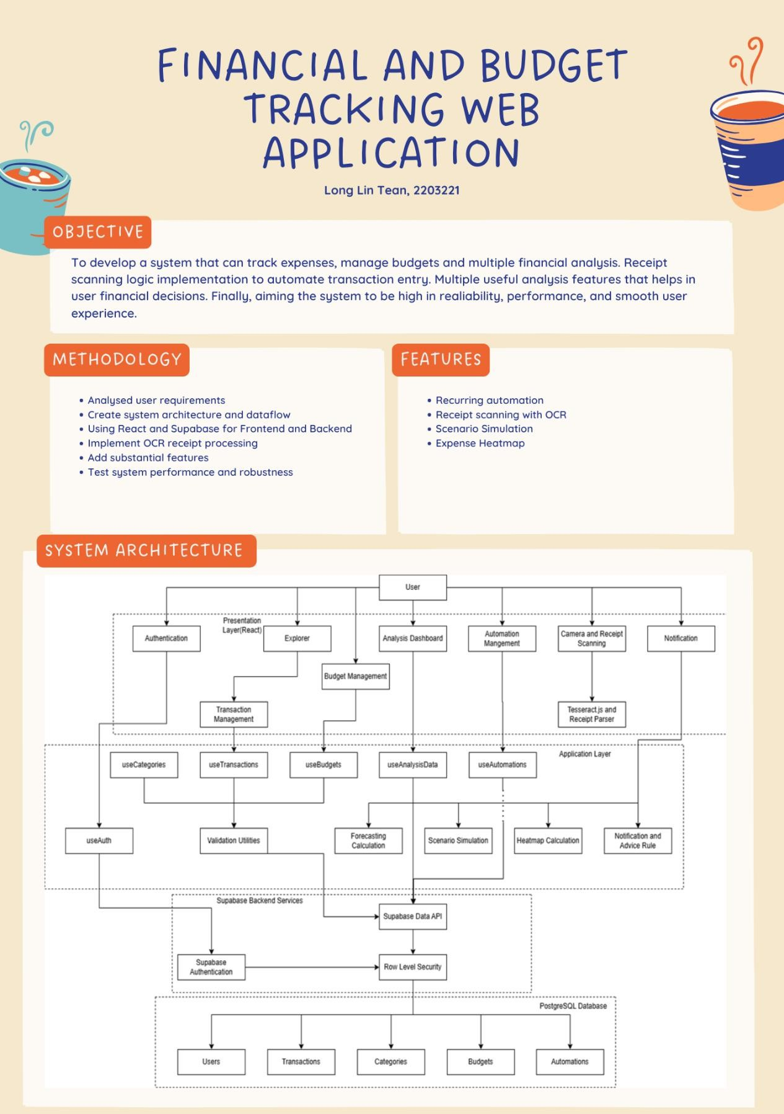

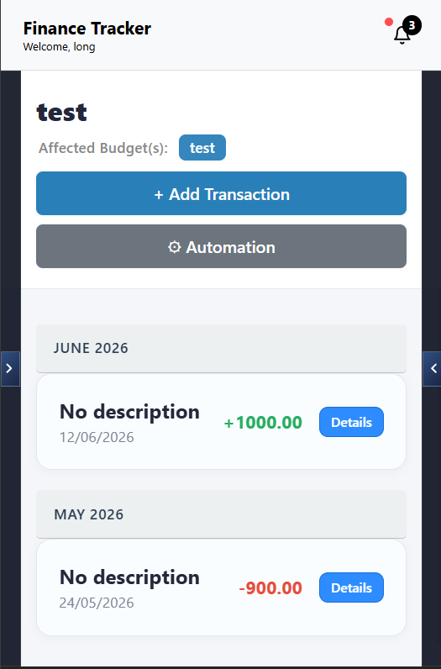

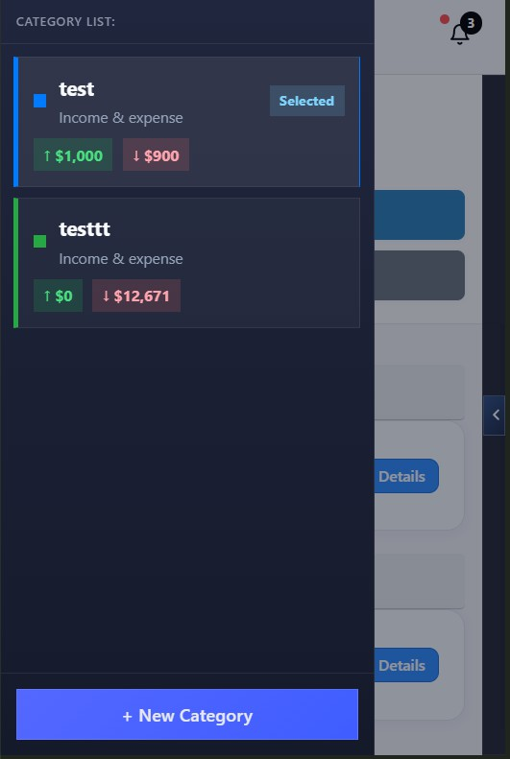

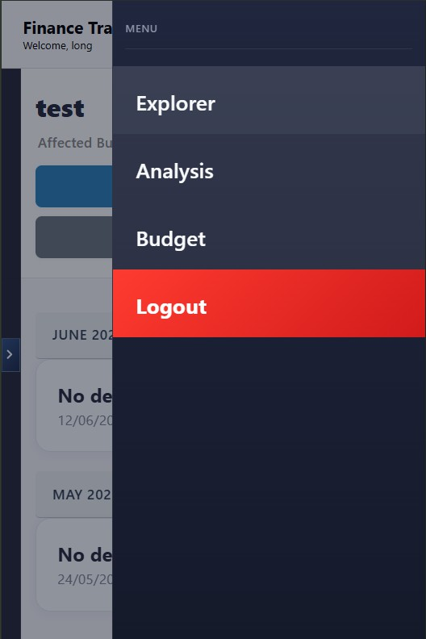

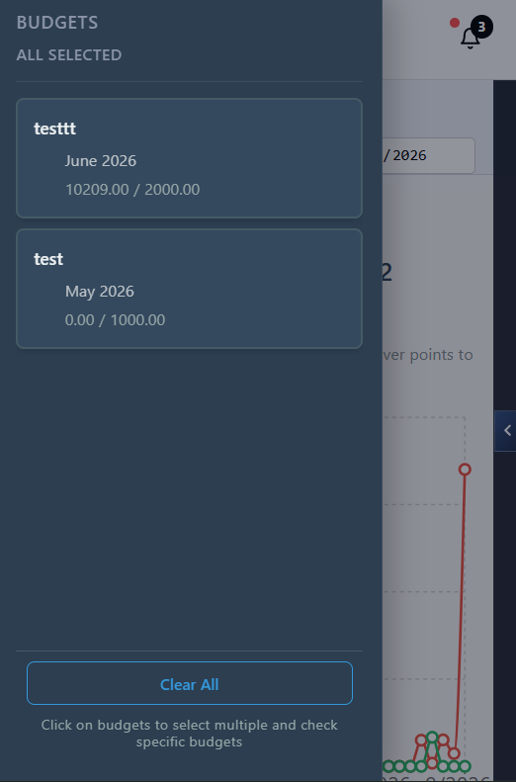

APPENDIX C – Supabase SQL Setup
-- Finance Tracker Supabase setup. Safe to rerun after the initial schema exists.

CREATE TABLE IF NOT EXISTS public.users (
id UUID PRIMARY KEY REFERENCES auth.users ON DELETE CASCADE,
username TEXT UNIQUE NOT NULL, email TEXT UNIQUE NOT NULL,
verified BOOLEAN NOT NULL DEFAULT FALSE,
created_at TIMESTAMP WITH TIME ZONE DEFAULT NOW(),
verification_token UUID DEFAULT gen_random_uuid()
);

CREATE TABLE IF NOT EXISTS public.categories (
category_id UUID DEFAULT gen_random_uuid() PRIMARY KEY, user_id UUID REFERENCES public.users(id) ON DELETE CASCADE, category_name TEXT NOT NULL,
color_code TEXT DEFAULT '#007bff'
);

CREATE TABLE IF NOT EXISTS public.transactions (
transaction_id UUID DEFAULT gen_random_uuid() PRIMARY KEY, user_id UUID REFERENCES public.users(id) ON DELETE CASCADE,
category_id UUID REFERENCES public.categories(category_id) ON DELETE CASCADE,
type TEXT CHECK (type IN ('income', 'expense')) NOT NULL, amount DECIMAL(12,2) NOT NULL,
description TEXT,
date DATE NOT NULL DEFAULT CURRENT_DATE

CREATE TABLE IF NOT EXISTS public.budgets (
budget_id UUID DEFAULT gen_random_uuid() PRIMARY KEY, user_id UUID REFERENCES public.users(id) ON DELETE CASCADE, category_ids UUID[] DEFAULT '{}',
monthly_limit DECIMAL(12,2) NOT NULL,
month INTEGER NOT NULL CHECK (month BETWEEN 1 AND 12), year INTEGER NOT NULL,
rollover BOOLEAN DEFAULT FALSE,
rollover_mode TEXT DEFAULT 'previous-month' CHECK (rollover_mode IN ('previous-month', 'full'))
);

CREATE TABLE IF NOT EXISTS public.automations (
automation_id UUID DEFAULT gen_random_uuid() PRIMARY KEY,
user_id UUID NOT NULL REFERENCES public.users(id) ON DELETE CASCADE,
category_id UUID NOT NULL REFERENCES public.categories(category_id) ON DELETE CASCADE,
description TEXT NOT NULL, amount DECIMAL(12,2) NOT NULL,
type TEXT NOT NULL CHECK (type IN ('income', 'expense')),
frequency TEXT NOT NULL CHECK (frequency IN ('daily', 'weekly', 'monthly', 'custom')),
frequency_days INTEGER, start_date DATE NOT NULL, is_active BOOLEAN DEFAULT TRUE,
last_executed TIMESTAMP WITH TIME ZONE,
created_at TIMESTAMP WITH TIME ZONE DEFAULT NOW(), updated_at TIMESTAMP WITH TIME ZONE DEFAULT NOW()

ALTER TABLE public.budgets
ADD COLUMN IF NOT EXISTS category_ids UUID[] DEFAULT '{}',
ADD COLUMN IF NOT EXISTS budget_name TEXT,
ADD COLUMN IF NOT EXISTS budget_type TEXT DEFAULT 'monthly', ADD COLUMN IF NOT EXISTS start_date DATE,
ADD COLUMN IF NOT EXISTS end_date DATE;

ALTER TABLE public.categories DROP COLUMN IF EXISTS type;

ALTER TABLE public.transactions
ADD COLUMN IF NOT EXISTS automation_id UUID;

DO $$ BEGIN
IF NOT EXISTS (
SELECT 1 FROM pg_constraint
WHERE conname = 'transactions_automation_id_fkey' AND conrelid = 'public.transactions'::regclass
) THEN
ALTER TABLE public.transactions
ADD CONSTRAINT transactions_automation_id_fkey FOREIGN KEY (automation_id)
REFERENCES public.automations(automation_id) ON DELETE SET NULL;
END IF;
END;
$$;

DO $$ BEGIN
IF EXISTS (
SELECT 1 FROM information_schema.columns WHERE table_schema = 'public'
AND table_name = 'budgets'
AND column_name = 'category_id'
) THEN
EXECUTE 'UPDATE public.budgets
SET category_ids = ARRAY[category_id]
WHERE (category_ids IS NULL OR category_ids = ''{}'') AND category_id IS NOT NULL';
END IF;
END;
$$;

UPDATE public.budgets SET
budget_type = 'monthly',
start_date = DATE_TRUNC('month', TO_DATE(year::text || '-' || LPAD(month::text, 2, '0') || '-01', 'YYYY-MM-DD'))::DATE,
end_date = (DATE_TRUNC('month', TO_DATE(year::text || '-' || LPAD(month::text, 2, '0') || '-01', 'YYYY-MM-DD')) + INTERVAL '1 month' -
INTERVAL '1 day')::DATE
WHERE (budget_type = 'monthly' OR budget_type IS NULL) AND start_date IS NULL;

CREATE INDEX IF NOT EXISTS idx_categories_user_id ON public.categories(user_id);

CREATE INDEX IF NOT EXISTS idx_transactions_user_id ON public.transactions(user_id);
CREATE INDEX IF NOT EXISTS idx_transactions_category_id ON public.transactions(category_id);
CREATE INDEX IF NOT EXISTS idx_transactions_date ON public.transactions(date);
CREATE INDEX IF NOT EXISTS idx_transactions_automation_id ON public.transactions(automation_id);
CREATE INDEX IF NOT EXISTS idx_budgets_user_id ON public.budgets(user_id);
CREATE INDEX IF NOT EXISTS idx_budgets_category_ids ON public.budgets USING GIN(category_ids);
CREATE INDEX IF NOT EXISTS idx_budgets_date_range ON public.budgets(start_date, end_date);
CREATE INDEX IF NOT EXISTS idx_automations_user_id ON public.automations(user_id);
CREATE INDEX IF NOT EXISTS idx_automations_category_id ON public.automations(category_id);
CREATE INDEX IF NOT EXISTS idx_automations_is_active ON public.automations(is_active);

ALTER TABLE public.users ENABLE ROW LEVEL SECURITY;
ALTER TABLE public.categories ENABLE ROW LEVEL SECURITY; ALTER TABLE public.transactions ENABLE ROW LEVEL SECURITY; ALTER TABLE public.budgets ENABLE ROW LEVEL SECURITY;
ALTER TABLE public.automations ENABLE ROW LEVEL SECURITY;

DROP POLICY IF EXISTS "Users can select their own verified row" ON public.users;
DROP POLICY IF EXISTS "Users can select their own row" ON public.users; CREATE POLICY "Users can select their own row" ON public.users
FOR SELECT USING (auth.uid() = id);

DROP POLICY IF EXISTS "Users can update their own verified row" ON public.users;
DROP POLICY IF EXISTS "Users can update their own row" ON public.users; CREATE POLICY "Users can update their own row" ON public.users
FOR UPDATE USING (auth.uid() = id) WITH CHECK (auth.uid() = id);

DROP POLICY IF EXISTS "Users can select their own categories" ON public.categories;
CREATE POLICY "Users can select their own categories" ON public.categories FOR SELECT USING (auth.uid() = user_id);
DROP POLICY IF EXISTS "Users can insert their own categories" ON public.categories;
CREATE POLICY "Users can insert their own categories" ON public.categories FOR INSERT WITH CHECK (auth.uid() = user_id);
DROP POLICY IF EXISTS "Users can update their own categories" ON public.categories;
CREATE POLICY "Users can update their own categories" ON public.categories FOR UPDATE USING (auth.uid() = user_id) WITH CHECK (auth.uid() = user_id);
DROP POLICY IF EXISTS "Users can delete their own categories" ON public.categories;
CREATE POLICY "Users can delete their own categories" ON public.categories FOR DELETE USING (auth.uid() = user_id);

DROP POLICY IF EXISTS "Users can select their own transactions" ON public.transactions;
CREATE POLICY "Users can select their own transactions" ON public.transactions FOR SELECT USING (auth.uid() = user_id);
DROP POLICY IF EXISTS "Users can insert their own transactions" ON public.transactions;
CREATE POLICY "Users can insert their own transactions" ON public.transactions FOR INSERT WITH CHECK (auth.uid() = user_id);
DROP POLICY IF EXISTS "Users can update their own transactions" ON public.transactions;

CREATE POLICY "Users can update their own transactions" ON public.transactions FOR UPDATE USING (auth.uid() = user_id) WITH CHECK (auth.uid() = user_id);
DROP POLICY IF EXISTS "Users can delete their own transactions" ON public.transactions;
CREATE POLICY "Users can delete their own transactions" ON public.transactions FOR DELETE USING (auth.uid() = user_id);

DROP POLICY IF EXISTS "Users can select their own budgets" ON public.budgets;
CREATE POLICY "Users can select their own budgets" ON public.budgets FOR SELECT USING (auth.uid() = user_id);
DROP POLICY IF EXISTS "Users can insert their own budgets" ON public.budgets;
CREATE POLICY "Users can insert their own budgets" ON public.budgets FOR INSERT WITH CHECK (auth.uid() = user_id);
DROP POLICY IF EXISTS "Users can update their own budgets" ON public.budgets;
CREATE POLICY "Users can update their own budgets" ON public.budgets FOR UPDATE USING (auth.uid() = user_id) WITH CHECK (auth.uid() = user_id);
DROP POLICY IF EXISTS "Users can delete their own budgets" ON public.budgets;
CREATE POLICY "Users can delete their own budgets" ON public.budgets FOR DELETE USING (auth.uid() = user_id);

DROP POLICY IF EXISTS "Users can select their own automations" ON public.automations;
CREATE POLICY "Users can select their own automations" ON public.automations FOR SELECT USING (auth.uid() = user_id);
DROP POLICY IF EXISTS "Users can insert their own automations" ON public.automations;
CREATE POLICY "Users can insert their own automations" ON public.automations FOR INSERT WITH CHECK (auth.uid() = user_id);
DROP POLICY IF EXISTS "Users can update their own automations" ON public.automations;

CREATE POLICY "Users can update their own automations" ON public.automations FOR UPDATE USING (auth.uid() = user_id) WITH CHECK (auth.uid() = user_id);
DROP POLICY IF EXISTS "Users can delete their own automations" ON public.automations;
CREATE POLICY "Users can delete their own automations" ON public.automations FOR DELETE USING (auth.uid() = user_id);

CREATE OR REPLACE FUNCTION public.update_automation_timestamp() RETURNS TRIGGER AS $$
BEGIN
NEW.updated_at = NOW(); RETURN NEW;
END;
$$ LANGUAGE plpgsql SECURITY DEFINER SET search_path = public;

REVOKE ALL ON FUNCTION public.update_automation_timestamp() FROM PUBLIC, anon, authenticated;

DROP TRIGGER IF EXISTS trigger_update_automation_timestamp ON public.automations;
CREATE TRIGGER trigger_update_automation_timestamp BEFORE UPDATE ON public.automations
FOR EACH ROW EXECUTE FUNCTION public.update_automation_timestamp();

CREATE OR REPLACE FUNCTION public.handle_new_user() RETURNS TRIGGER AS $$
BEGIN
INSERT INTO public.users (id, email, username) VALUES (NEW.id, NEW.email, NEW.email)
ON CONFLICT (id) DO NOTHING;

RETURN NEW; END;
$$ LANGUAGE plpgsql SECURITY DEFINER SET search_path = public, auth;

REVOKE ALL ON FUNCTION public.handle_new_user() FROM PUBLIC, anon, authenticated;

DROP TRIGGER IF EXISTS on_auth_user_created ON auth.users; CREATE TRIGGER on_auth_user_created
AFTER INSERT ON auth.users
FOR EACH ROW EXECUTE FUNCTION public.handle_new_user();

CREATE OR REPLACE FUNCTION public.refresh_verified() RETURNS TRIGGER
LANGUAGE plpgsql SECURITY DEFINER
SET search_path = public, auth AS $$
BEGIN
IF NEW.email_confirmed_at IS NOT NULL THEN
UPDATE public.users SET verified = TRUE WHERE id = NEW.id; END IF;
RETURN NEW; END;
$$;

REVOKE ALL ON FUNCTION public.refresh_verified() FROM PUBLIC, anon, authenticated;

DROP TRIGGER IF EXISTS on_auth_user_updated ON auth.users;

CREATE TRIGGER on_auth_user_updated
AFTER UPDATE OF email_confirmed_at ON auth.users
FOR EACH ROW EXECUTE FUNCTION public.refresh_verified();

CREATE OR REPLACE FUNCTION public.create_unset_category() RETURNS TRIGGER AS $$
BEGIN
IF NOT EXISTS (
SELECT 1 FROM public.categories
WHERE user_id = NEW.id AND lower(category_name) = 'unset'
) THEN
INSERT INTO public.categories (user_id, category_name) VALUES (NEW.id, 'Unset');
END IF;
RETURN NEW;
END;
$$ LANGUAGE plpgsql SECURITY DEFINER SET search_path = public;

REVOKE ALL ON FUNCTION public.create_unset_category() FROM PUBLIC, anon, authenticated;

DROP TRIGGER IF EXISTS on_user_created ON public.users; CREATE TRIGGER on_user_created
AFTER INSERT ON public.users
FOR EACH ROW EXECUTE FUNCTION public.create_unset_category();

CREATE OR REPLACE FUNCTION public.delete_unverified_users() RETURNS void
LANGUAGE sql SECURITY DEFINER

SET search_path = public, auth AS $$
DELETE FROM public.users u USING auth.users a
WHERE u.id = a.id
AND a.email_confirmed_at IS NULL
AND a.created_at < NOW() - INTERVAL '1 day';

DELETE FROM auth.users
WHERE email_confirmed_at IS NULL
AND created_at < NOW() - INTERVAL '1 day';
$$;

REVOKE ALL ON FUNCTION public.delete_unverified_users() FROM PUBLIC, anon, authenticated;

