**Note: Try to make responsive pages(i.e pages should have compatibility with all screen sizes)**

**All the images below do not have to exactly matched; these are just for visual ideas.**

Login page - needs to have options for creating account, signing in

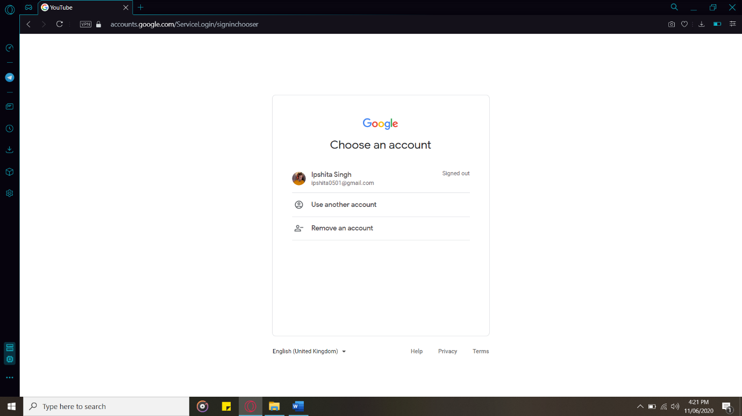

Settings/account page

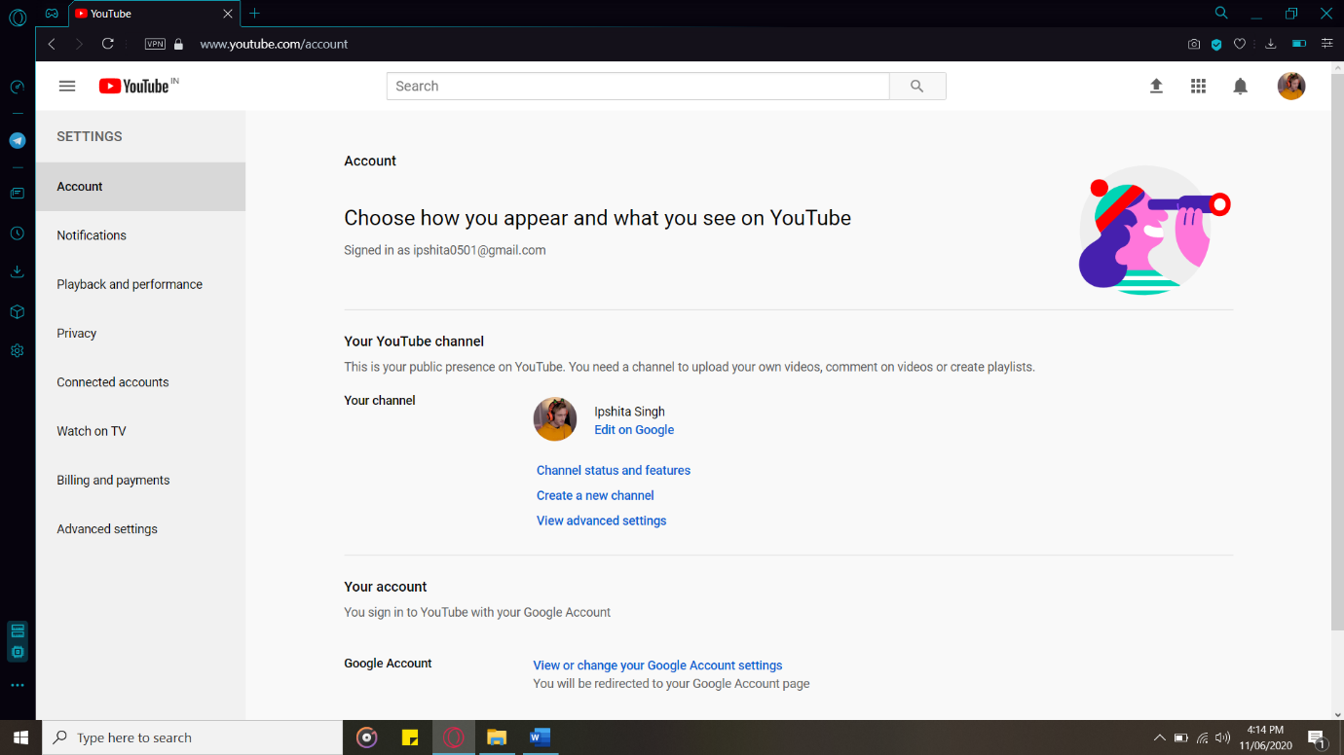

Upload(+its dashboard) page

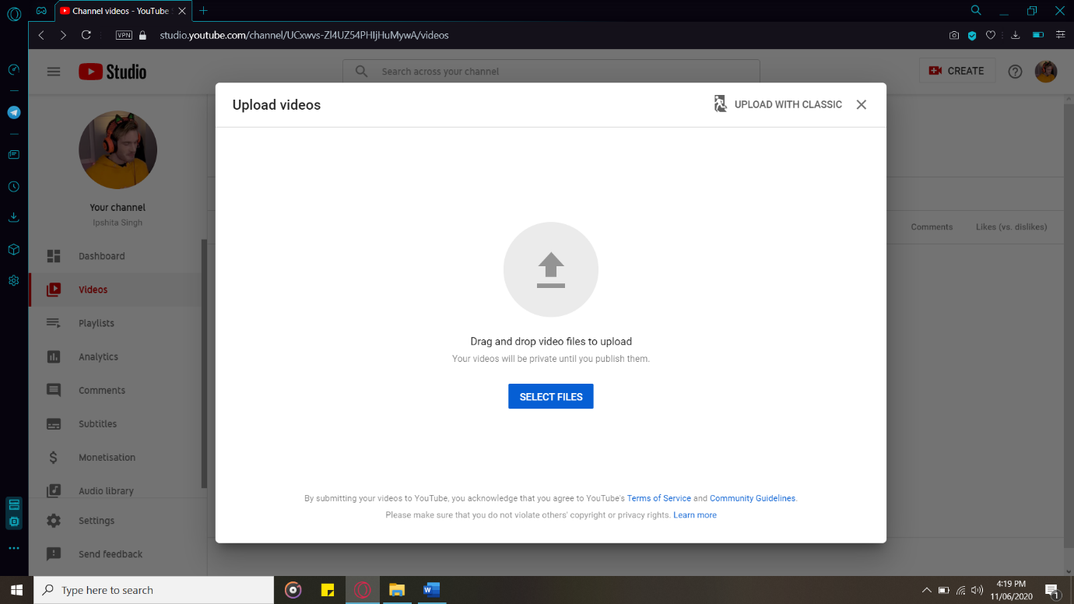

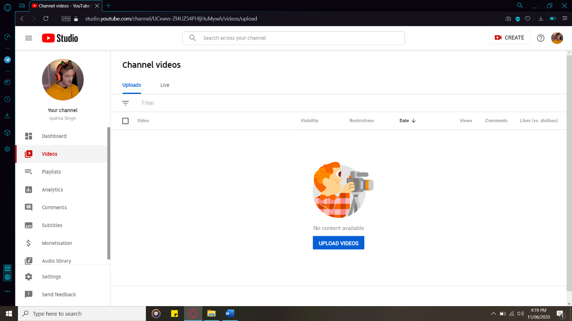

Home page – site before logging in

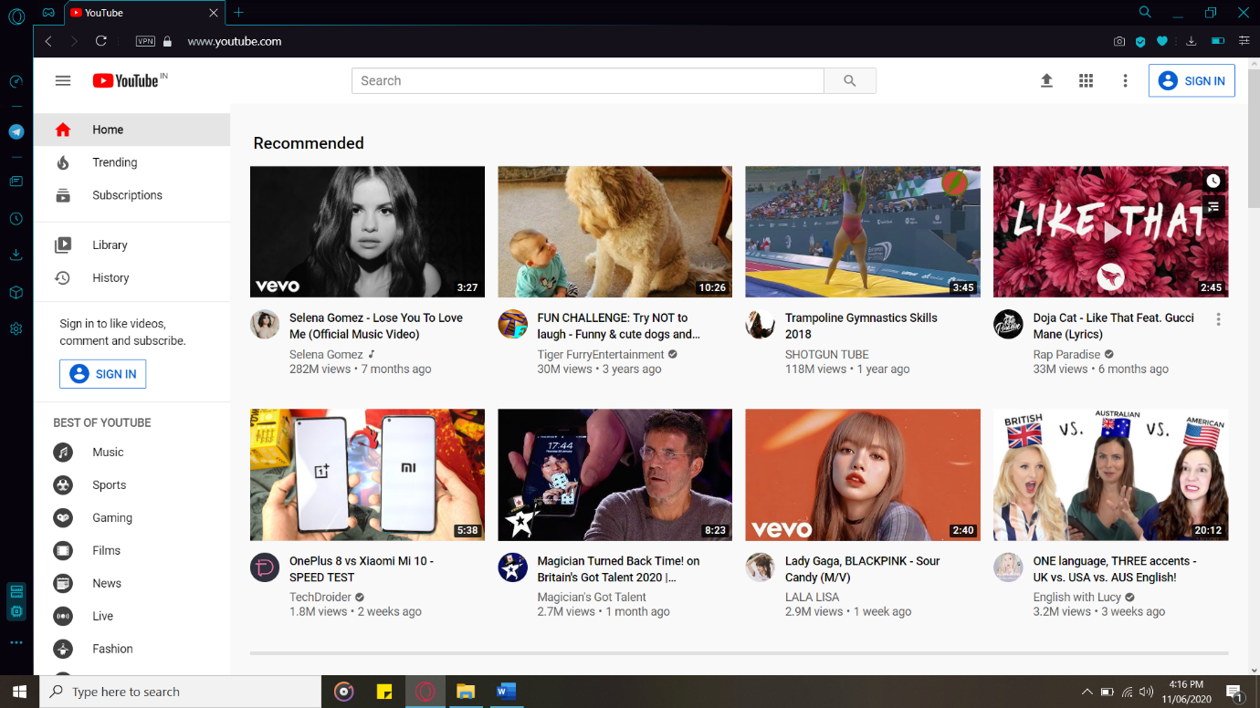

Explorer page – site after logging in

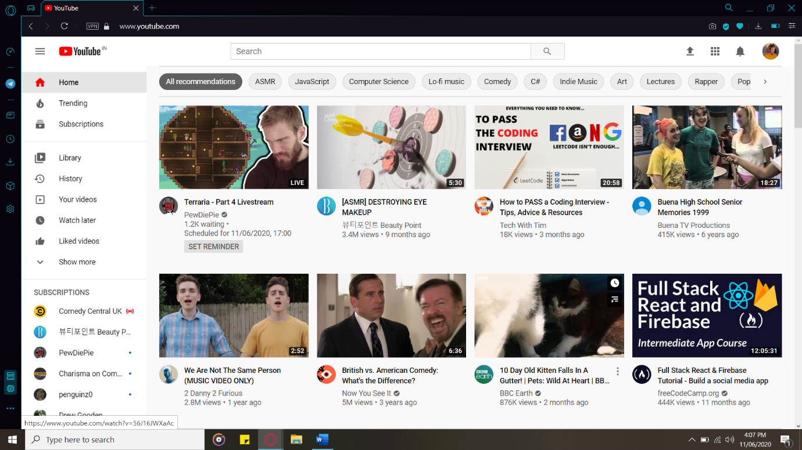

Video page – includes comments; likes/dislikes

