David Tyler and Andrew Hajj
Design Document
2/17/14
Phase 2 – UDP Server and Client
Required to run:
Python 2.7.x
Microsoft Windows or a modern version of linux
Contributions:
David Tyler – server code/GUI code
Andrew Hajj – client code

server.py
The UDP server is run via the server.py file. The syntax is:
python server.py [ip of machine] [port number to run on]
For example:
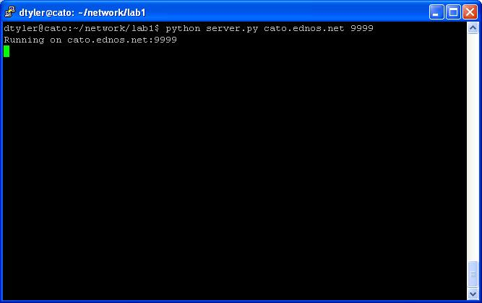

client.py
client.py is the module run as the UDP client process. It can send specified files to the host, as well as receive requested files.

The following are sample executions of the program:
Test 1: Send the file ‘sample.jpg’ from the client to the host.
To do this, the client script is run using the command ‘python client.py’. The address of the server and port are entered and so is the name of the file in the same directory as the script. The Send File button is then pressed. The following is a screenshot showing the Command Prompt on the client side. “sample.jpg saved!” was the message received from the host after the file was saved.
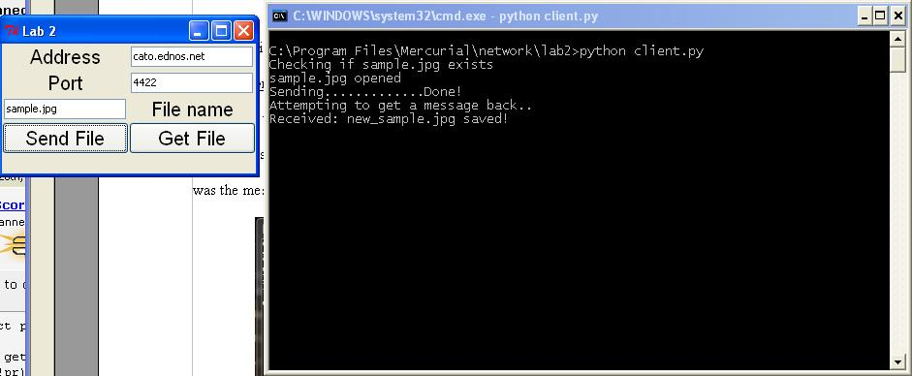
Test 2: Get file ‘sample.jpg’ from the server
To get ‘sample.jpg’ from the host, the client script is run using the command ‘python client.py’. The address of the server and port are entered and so is the name of the file in the same directory as the script. The Get File button is then pressed. The following is a screenshot showing the Command Prompt on the client side. “Successfully saved!” was the message received from the host after the file was saved (the client sent a message confirming the exchange was successful).

