David Tyler and Andrew Hajj
Design Document
2/2/14
Phase 1 – UDP Server and Client
Required to run:
Python 2.7.x
Microsoft Windows or a modern version of linux
Contributions:
David Tyler – server code
Andrew Hajj – client code

server.py
The UDP server is run via the server.py file. The syntax is:
python server.py [ip of machine] [port number to run on]
For example:
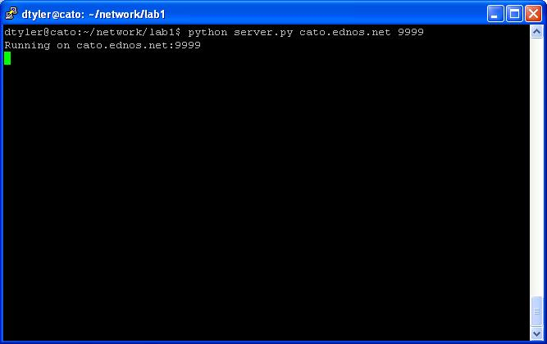

Client.py
Client.py is the module run as the UDP client process. It can send specified files to the host, as well as receive requested files.

The following are sample executions of the program:
Test 1: Send the file ‘sample.jpg’ from the client to the host.
To do this, the client script is run using the command ‘python Client.py send sample.jpg’. The following is a screenshot showing the Command Prompt on the client side. “sample.jpg saved!” was the message received from the host after the file was saved.
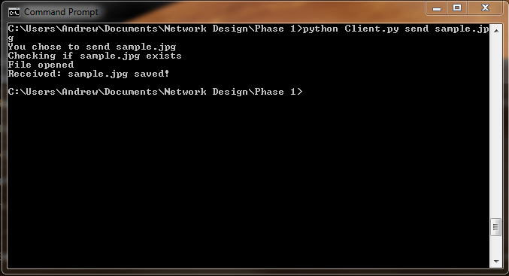

Test 2: Get file ‘Blackbox.png’ from the server
To get ‘Blackbox.png’ from the host, the client script is run using the command ‘python Client.py get Blackbox.jpg’. The following is a screenshot showing the Command Prompt on the client side. “Successfully saved!” was the message received from the host after the file was saved.

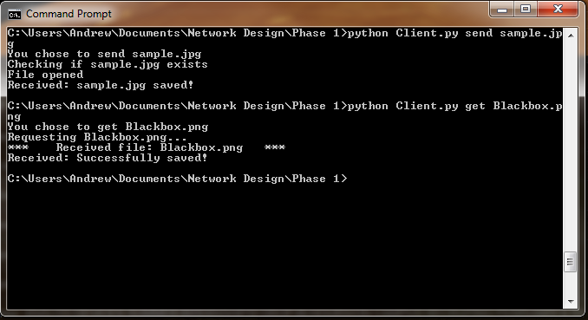

Test 3: Attempt to use an incorrect action
In this case, the command ‘python Client.py grab Blackbox.png’ was run. Since ‘grab’ is not a valid action, the program reports it to the user and lists all available actions. The following is a screenshot showing the Command Prompt on the client side.
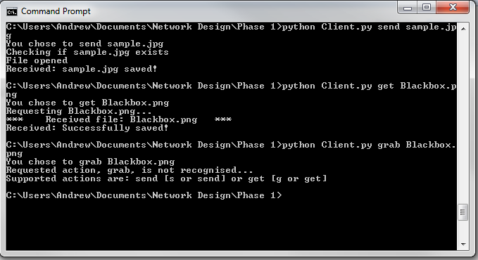

Test 4: Attempt to send a non-existing file (FakeFile.jpg)
For this test, the command ‘python Client.py send FakeFile.jpg’ was run but FakeFile.png does not exist on the client side. The program will attempt to find the file, and upon not finding it will let the user know. The following is a screenshot showing the Command Prompt on the client side.
