David Tyler and Andrew Hajj
Design Document
4/6/14
Phase 4 – RDT 3.0 over UDP with bit-errors
Required to run:
Python 2.7.x
Microsoft Windows or a modern version of linux
Contributions:
David Tyler – receiver code/GUI code
Andrew Hajj – sender code

Packet Break-down:
Each packet being sent from the sender to the receiver is 1024 bytes (or one kilobyte). The packet itself can be broken down into three segments; the packet sequence number (1 byte), data from the file (1021 bytes), and the checksum (2 bytes). Figure 1 below shows the breakdown of the packets.
(1 byte) (1021 bytes) (2 bytes)
Packet Sequ. | Data | Checksum

Figure 1: Packet length breakdown
Sending and Receiving files:
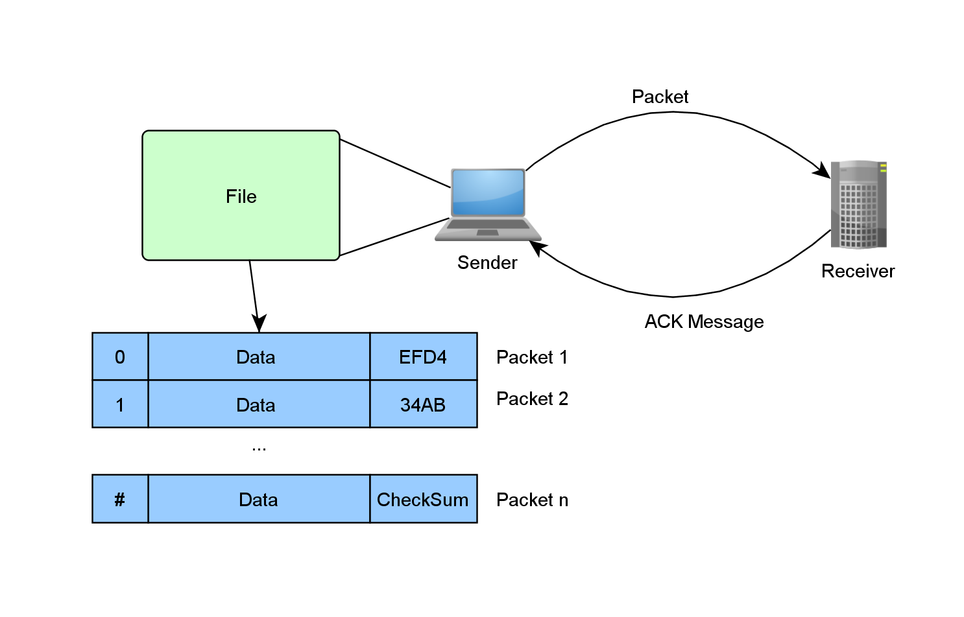
When a file is sent from the sender to the receiver, it gets broken down into 1021 bytes segments. When segment is created from the file, it gets a 1 byte Boolean packet sequence number attached to the beginning of it and generates a (crc16) checksum for the entire segment. After attaching the calculated checksum to the end of the segment, the sender is now ready to send the packet to the receiver. An illustration of this can be seen below in Figure 2.

Figure 2: Sender and Receiver
Upon receiving the packet, the receiver unpacks it and checks the packed checksum with a calculated checksum to see if there was any bit corruption. If there was bit corruption, or the packet sequence number was not the expected number, the receiver sends an acknowledgment message back to the sender saying that it received a packet of the opposite packet sequence number. The sender will then resend that same packet, as it is written to only send the next packet if it receives an acknowledgement saying that the receiver obtained the correct packet. IF there was no bit corruption, and the packet has the expected sequence number, the receiver sends an acknowledgement message saying that the expected sequence number was received. Figures 3 and 4 show the finite state machines of the sender and receiver.
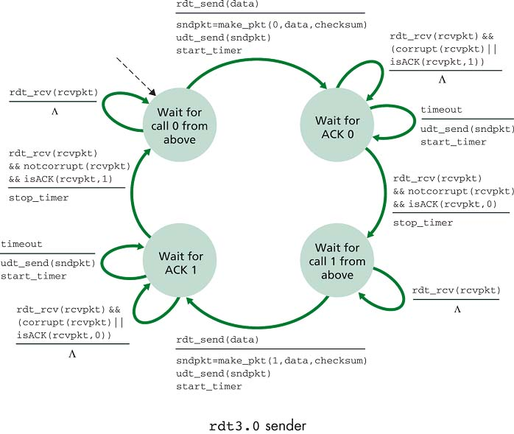

Figure 3: Finite State Machine for the Sender
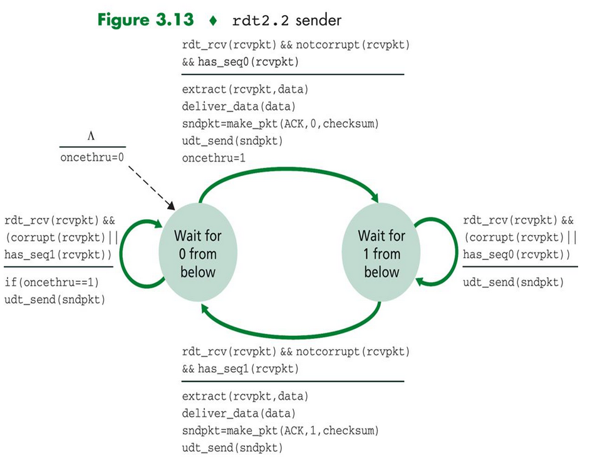

Figure 4: Finite State Machine for the Receiver
Calculating Checksum:
The checksums were calculated using the idea behind the Cyclic Redundancy Check (CRC 16) algorithm. The algorithm works as follows: it starts off by XORing each byte of the passed in data (starting with the first byte with 0xFFFF), while also shifts the value over by 1 in between each XOR. An additional detail is that it will XOR the whole thing by 0xA001 if the last bit pre-shift is 1. Once all the bytes are XORed and shifted, it swaps the first and last bytes and makes them the checksum. One can easily detect bit corruption using this algorithm, and the checksum itself is only two bytes long.

Intentional Corruption:
The data can intentionally be corrupted by checking either Option 2 or Option 3 in the GUI. If Option 2 is checked, the ACK packets are randomly corrupted (1 in 60 chance of corruption happening) on the sender side. If Option 3 is checked, data received on the receiving side is intentionally corrupted. In both cases the terminal on the sender side will state that there was corrupt data, and will resend the packet. With option 3, the terminal on the server side will display both the received and calculated checksums.

Intentional Packet Loss:
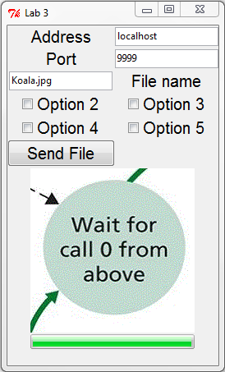
The packets can intentionally be dropped by checking either Option 4 or Option 5 in the GUI. If Option 4 is checked, the ACK packets are randomly dropped (1 in 60 chance of dropping happening) on the sender side. If Option 5 is checked, packets received on the receiving side are intentionally dropped. In both cases the terminal on the sender side will time out, and will resend the packet.

Option 2 -> <- Option 3
Option 4 -> <- Option 5

Receiver.py
The UDP server is run via the server.py file. The syntax is:
python server.py [ip of machine] [port number to run on]
For example:
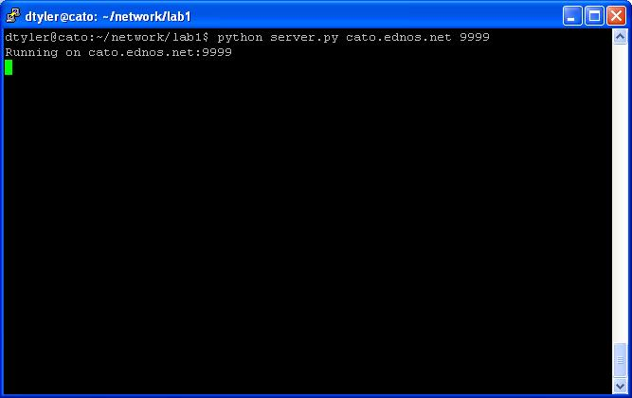

Sender.py
client.py is the module run as the UDP client process. It can send specified files to the host via the GUI. Sample GUI can be seen below:

Here is a present to make your day awesome:


