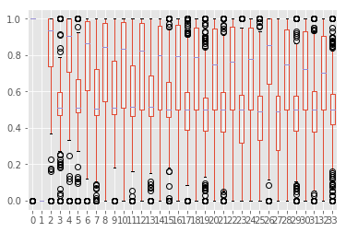Batchsize =10

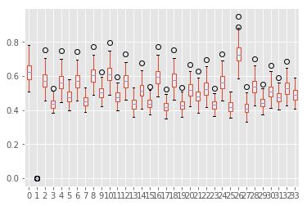

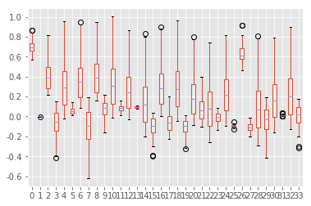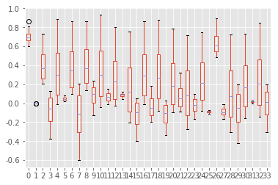

batchsize=2

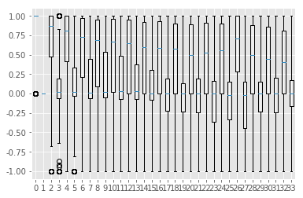

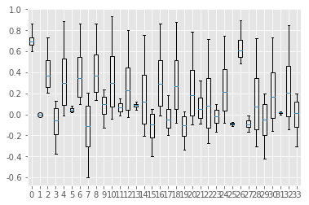

my_model_mean_test_F1 0.85699527745

my_model_mean_train_f1 0.901324834396

my_mean_F1 0.564902449149

my_mean_generation_F1 0.87690653766

my_mean_generation_gmean 0.898661850612

my_mean_generation_bagging_f1 0.859866828087

GNB_mean_F1 0.815870570108

GNB_mean_auc nan

GNB_mean_generation_F1 0.857243916242

batchsize=1





my_model_mean_test_F1 0.850355433048

my_model_mean_train_f1 0.896825396825

my_mean_F1 0.541840884358

my_mean_generation_F1 0.868918073796

my_mean_generation_gmean 0.897951111604

my_mean_generation_bagging_f1 0.854953593784

GNB_mean_F1 0.815870570108

GNB_mean_auc nan

GNB_mean_generation_F1 0.842407084785