Breastw

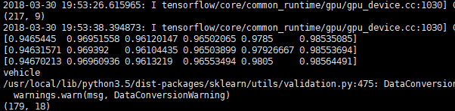

vehicle

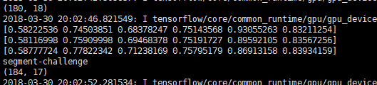

Segment-challenge

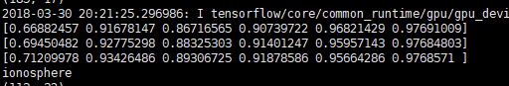

ionosphere

