UTS PW4

**Nama:M.Iqbal Aldeena**

**NIM:201401077 KOM B 2020**

**SS HTML:**

**Kalkulator biasa**

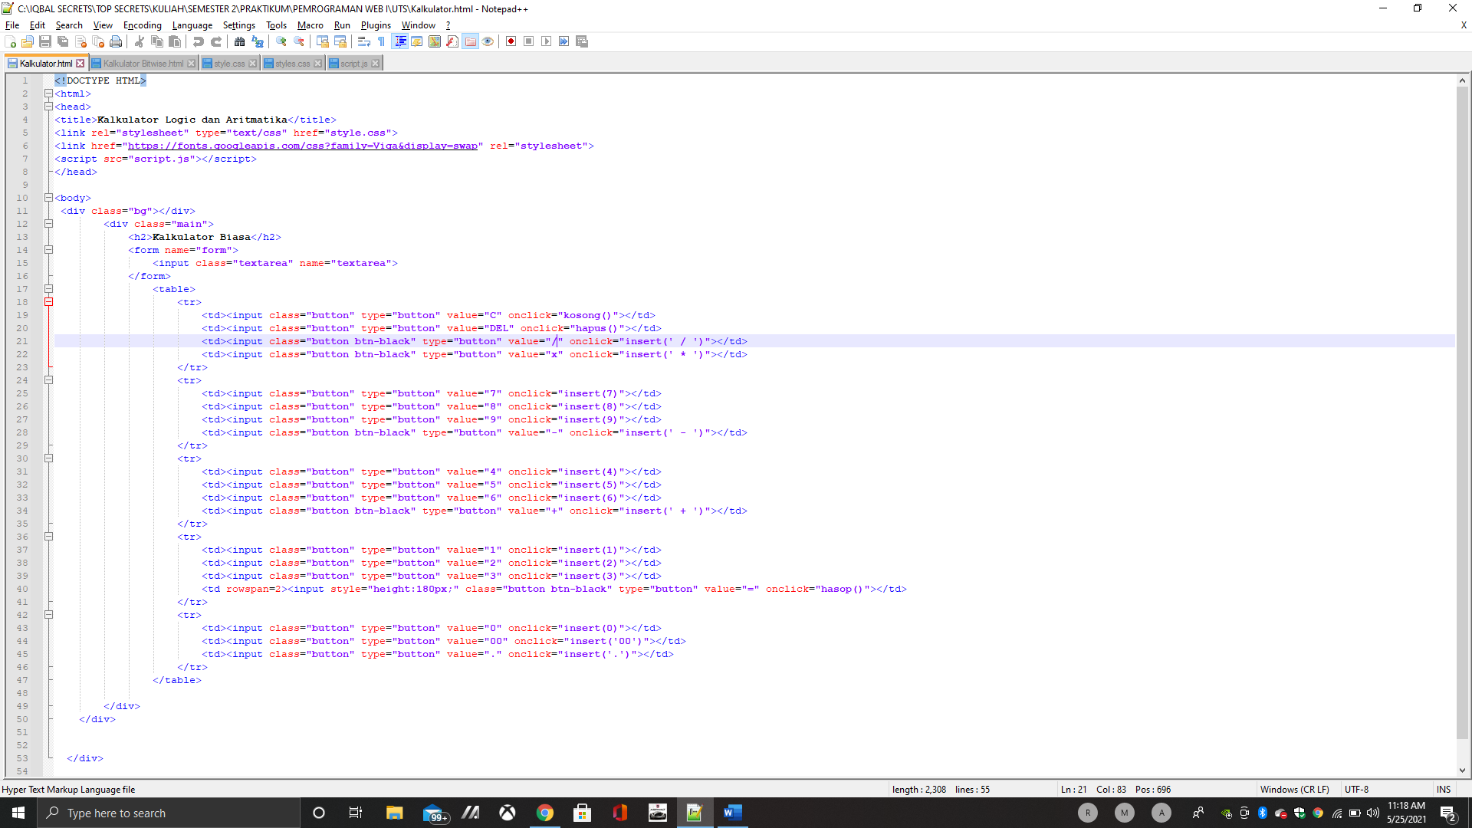

**Kalkulator Bitwise**

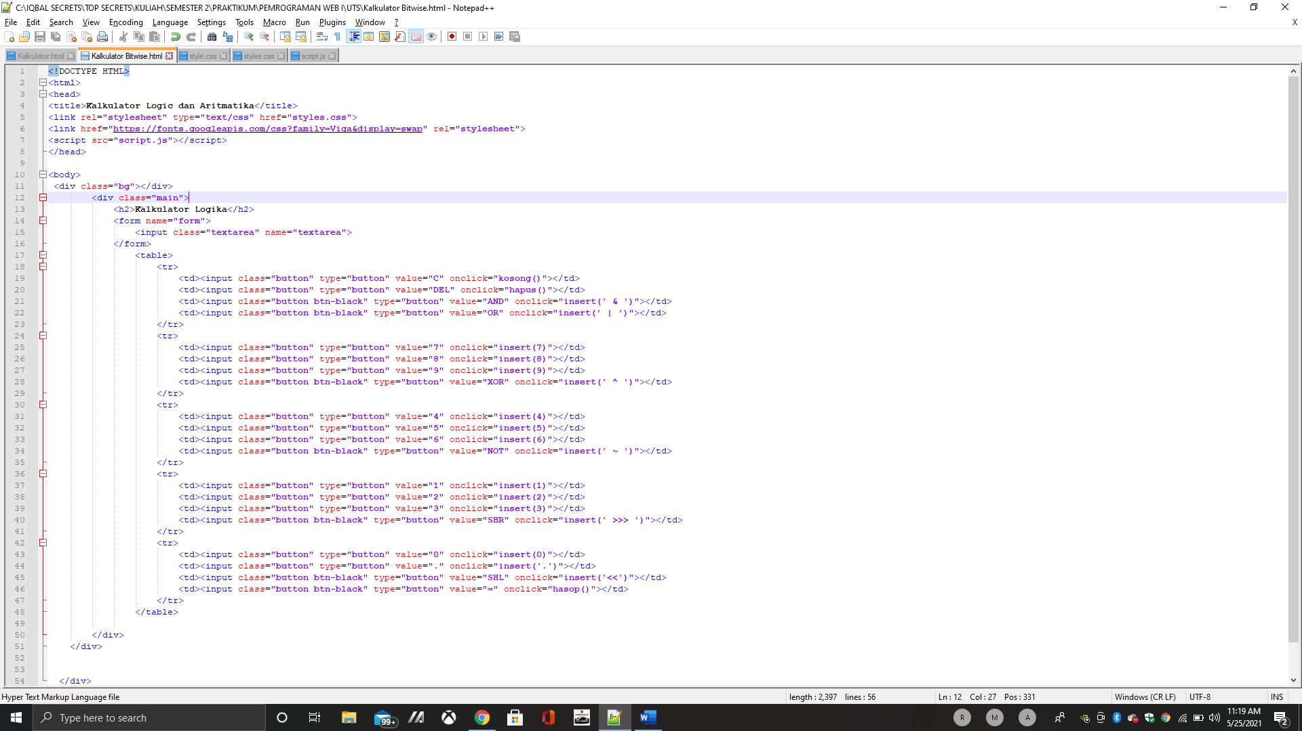

**CSS Biasa**

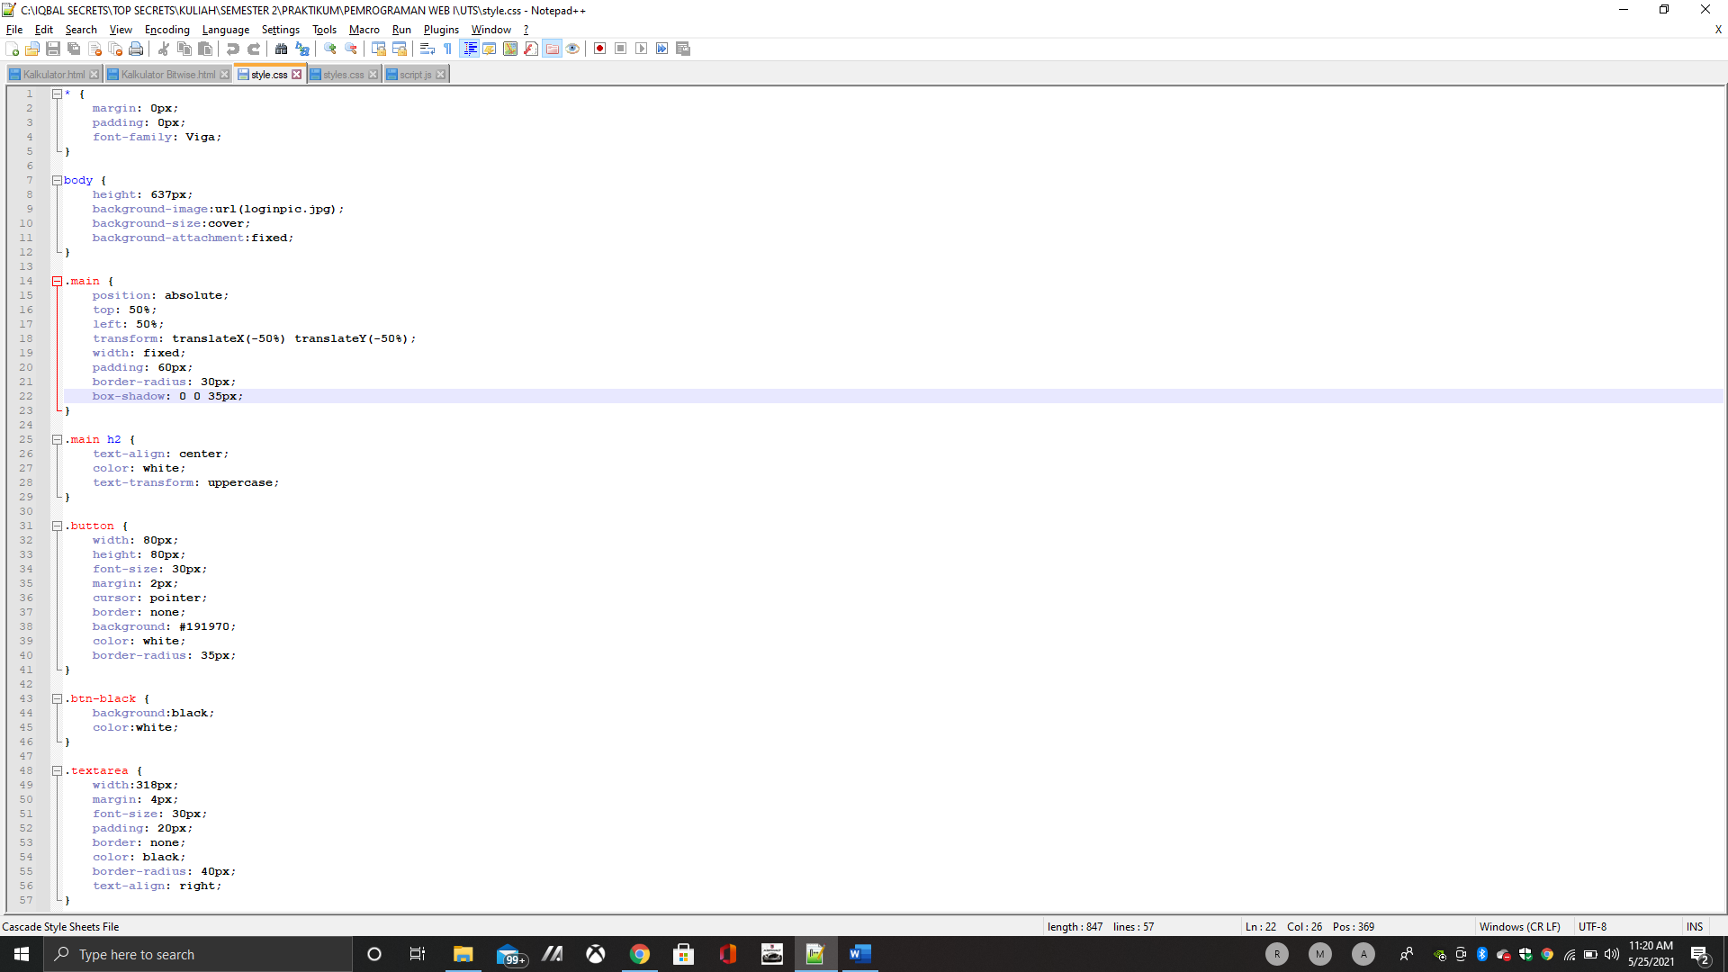

**CSS BITWISE**

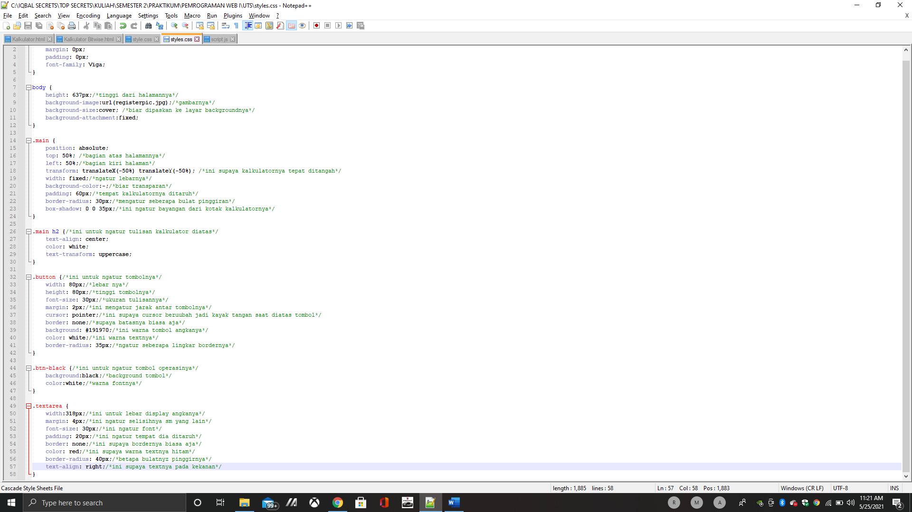

**Javascript**

