Assignment #3 – User Level Threading

(This report contains: source code, make-file code and necessary screenshots.)

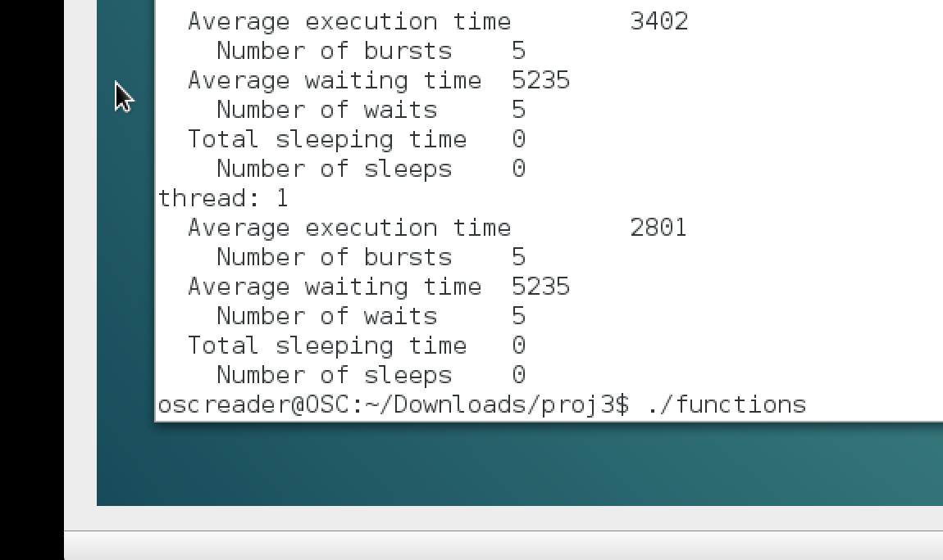**Screenshots:** 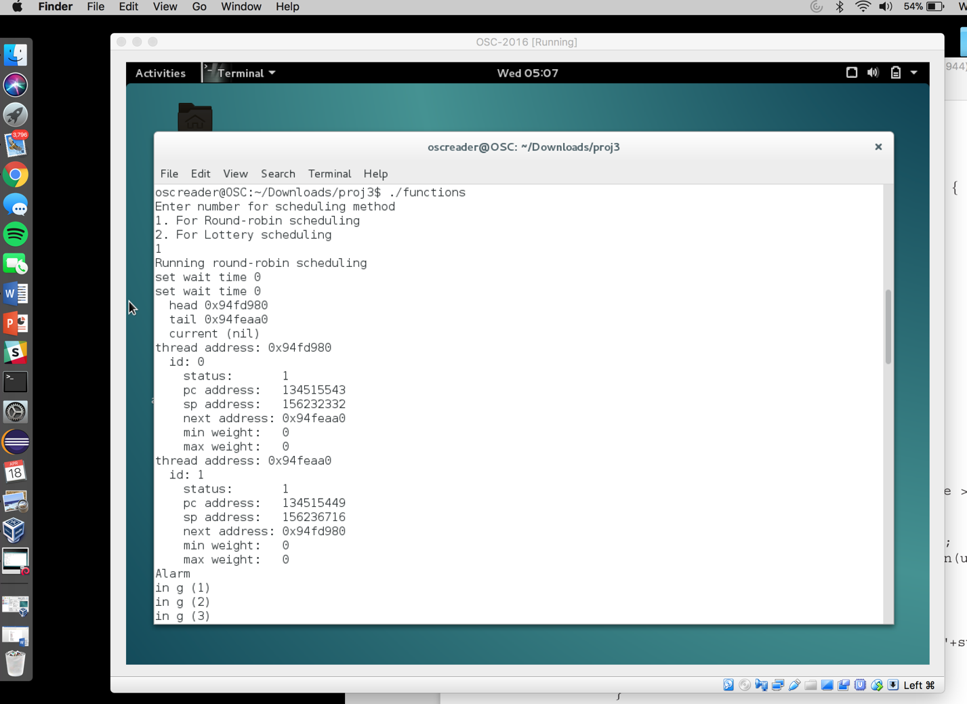

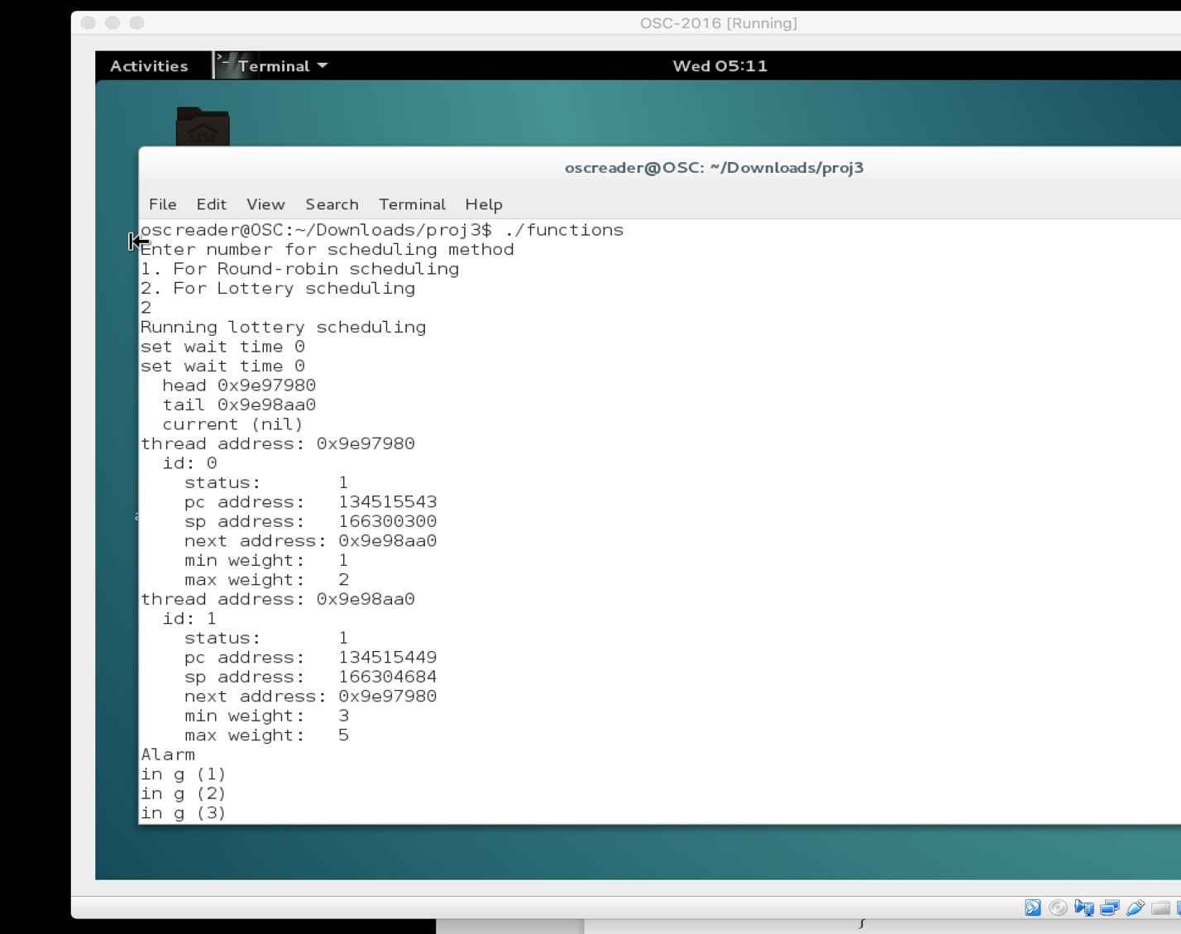

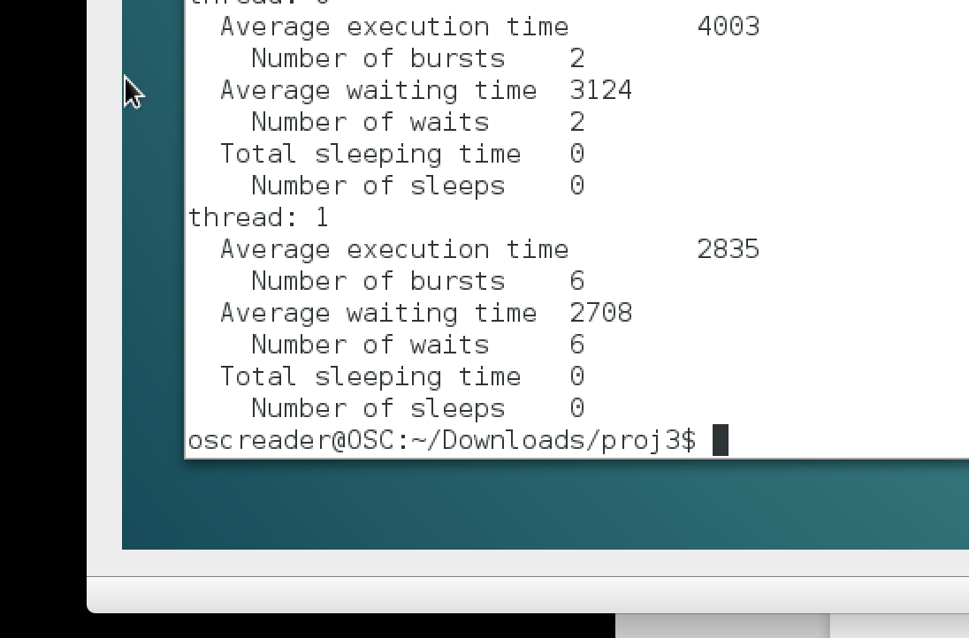

**source code:**

/**

* Assignment 3 - User Level Threading

* @author: Ali H. Iqbal

**/

#include <stdio.h>

#include <setjmp.h>

#include <signal.h>

#include <stdlib.h>

#include <string.h>

#include <unistd.h>

#include <sys/time.h>

#include <math.h>

#include <sys/timeb.h>

#include <setjmp.h>

#include <time.h>

// defined constants

#define JB_SP 6

#define JB_PC 7

#define SECOND 1000000

#define MAX_NO_OF_THREADS 100

#define STACK_SIZE 4096

#define STATUS_SLEEPING 0

#define STATUS_READY 1

#define STATUS_SUSPENDED 2

#define STATUS_RUNNING 3

#define TIME_QUANTUM 1*SECOND

static int run_time = 15000; /// max instructions for thread

static int curr_schedule = 1; // 1 for round robin, 2 for lottery scheduling

// global

static int num_of_threads = 0;

static int curr_thread_count = 0;

static int weight_total = 1;

struct timeb t_start, t_stop;

typedef unsigned long address_t;

//thread weight for lottery scheduling

typedef struct thread_weight

{

int min_weight;

int max_weight;

}thread_weight;

// thread sleeping time

typedef struct sleep_info

{

int start_sleeping;

int sleep_to;

struct timeb start_s;

int total;

}sleep_struct;

// thread waiting time

typedef struct wait_info

{

int start_waiting;

int stop_waiting;

struct timeb start_w, stop_w;

int total;

}wait_struct;

// thread control block

typedef struct TCB

{

address_t pc;

address_t sp;

thread_weight weight;

sleep_struct sleep_time;

wait_struct wait_time;

sigjmp_buf jbuf;

int thrd_id;

int thrd_status;

int num_bursts;

int num_waits;

int num_sleeps;

int exec_time;

struct TCB *next;

}TCB;

TCB *head_list = NULL;

TCB *tail_list = NULL;

TCB *curr_thread = NULL;

//functions

void appendList(TCB *new_tcb);

void dispatch(int sig);

void printList();

void yieldCPU(void);

void status(TCB *current);

void CleanUp();

void SleepThread(int sec);

int GetId();

void f( void );

void g( void );

int createThread (void (*f) (void));

TCB *findTcb(int random_number);

void go();

#ifdef __x86_64__

address_t tr_address(address_t addr)

{

address_t ret;

asm volatile("xor %%fs:0x30,%0\n"

"rol $0x11,%0\n"

: "=g" (ret)

: "0" (addr));

return ret;

}

#else

#define JB_SP 4

#define JB_PC 5

address_t tr_address(address_t addr)

{

address_t ret;

asm volatile("xor %%gs:0x18,%0\n"

"rol $0x9,%0\n"

: "=g" (ret)

: "0" (addr));

return ret;

}

#endif

//function used to get status of thread, accepts TCB thread pointer as parameter

void status(TCB *current)

{

int ex_avg;

int wait_avg;

int sleep_total;

printf("thread: %d\n", current->thrd_id);

if(current->num_bursts > 0)

{

ex_avg = (current->exec_time)/(current->num_bursts);

}

else

{

ex_avg = 0;

}

if(current->num_waits > 0)

{

wait_avg = (current->wait_time.total)/(current->num_waits);

}

else

{

wait_avg = 0;

}

if(current->num_sleeps > 0)

{

sleep_total = (current->sleep_time.total);

}

else

{

sleep_total = 0;

}

printf(" Average execution time\t%d\n", ex_avg);

printf(" Number of bursts\t%d\n", current->num_bursts);

printf(" Average waiting time\t%d\n", wait_avg);

printf(" Number of waits\t%d\n", current->num_waits);

printf(" Total sleeping time\t%d\n", sleep_total);

printf(" Number of sleeps\t%d\n", current->num_sleeps);

}

//function prints info, removes list and exits program

void CleanUp()

{

TCB *index = head_list;

int count = 0;

//suspend threads

while(count < num_of_threads)

{

index->thrd_status = STATUS_SUSPENDED;

status(index);

index = index->next;

count++;

}

index = head_list;

TCB *next;

while(index != tail_list)

{

next = index->next;

free(index);

index = next;

}

exit(0);

// exits

}

//function puts thread to sleep for given time

void SleepThread(int sec)

{

printf(" SLEEPING\n");

struct timeb temp_time;

ftime(&temp_time);

curr_thread->num_sleeps++;

curr_thread->sleep_time.start_s = temp_time;

curr_thread->sleep_time.sleep_to = temp_time.millitm + sec;

curr_thread->thrd_status = STATUS_SLEEPING;

yieldCPU();

}

//fuction to return thread id

int GetId()

{

return curr_thread->thrd_id;

}

// function handles thread context switching

void yieldCPU(void)

{

printf("switching threads\n");

ftime(&t_stop);//stop exectuting

curr_thread->exec_time += ( 1000.0 * (t_stop.time - t_start.time) + (t_stop.millitm - t_start.millitm));

// print thread info

printf(" Current Thread: %d\n", curr_thread->thrd_id);

printf(" Thread Status: %d\n", curr_thread->thrd_status);

printf("Execution Time: %d\n", curr_thread->exec_time);

usleep(2*SECOND);//pauses

raise(SIGVTALRM);

}

//function represents thread f

void f(void)

{

int i=0;

while(1)

{

++i;

printf("in f (%d)\n",i);

if (i % 3 == 0)

{

yieldCPU();

}

usleep(SECOND);

}

}

//function represents thread g

void g( void )

{

int i = 0;

while(1)

{

++i;

printf("in g (%d)\n",i);

if (i % 3 == 0)

{

yieldCPU();

}

usleep(SECOND);

}

}

//function create threads along with given arguments

int createThread (void (*f) (void))

{

TCB* curr_tcb = malloc(sizeof(TCB));

if(curr_tcb == NULL)

{

curr_tcb->thrd_id = -1;

num_of_threads++;

}

else

{

curr_tcb->thrd_id = curr_thread_count++;

curr_tcb->pc = (address_t)f;

curr_tcb->sp = (address_t)malloc(STACK_SIZE);

curr_tcb->sp = curr_tcb->sp + STACK_SIZE - sizeof(address_t);

curr_tcb->num_bursts = 0;

curr_tcb->num_waits = 0;

curr_tcb->num_sleeps = 0;

curr_tcb->exec_time = 0;

curr_tcb->sleep_time.sleep_to = 0;

curr_tcb->sleep_time.start_sleeping = 0;

curr_tcb->sleep_time.total = 0;

curr_tcb->wait_time.start_w.millitm = 0;

curr_tcb->wait_time.stop_w.millitm = 0;

curr_tcb->wait_time.total = 0;

printf("set wait time %d\n", curr_tcb->wait_time.total);

curr_tcb->next = NULL;

curr_tcb->weight.min_weight = 0;

curr_tcb->weight.max_weight = 0;

struct timeb temp_time;

ftime(&temp_time);

curr_tcb->wait_time.start_w = temp_time;

curr_tcb->thrd_status = STATUS_READY;

num_of_threads++;

// calculate weight for RR

if(curr_schedule == 2)

{

curr_tcb->weight.min_weight = weight_total;

int exponent = curr_tcb->thrd_id;

curr_tcb->weight.max_weight = weight_total + pow(2,exponent);

weight_total = curr_tcb->weight.max_weight;

weight_total++;

}

// threads exceeded

if(num_of_threads >= MAX_NO_OF_THREADS)

{

CleanUp();

}

}

sigsetjmp(curr_tcb->jbuf,1);

(curr_tcb->jbuf->__jmpbuf)[JB_SP] = tr_address(curr_tcb->sp);

(curr_tcb->jbuf->__jmpbuf)[JB_PC] = tr_address(curr_tcb->pc);

sigemptyset(&curr_tcb->jbuf->__saved_mask);

appendList(curr_tcb);

return curr_tcb->thrd_id;

}

// find thread with chosen "lottery ticket"

TCB *findTcb(int random_number)

{

TCB *index = head_list;

int count = 0;

while((count < num_of_threads))

{

if((random_number >= (index->weight.min_weight)) && (random_number <= (index->weight.max_weight)))

{

break;

}

index = index->next;

count++;

}

if(count == num_of_threads)

{

return NULL;

}

else

{

return index;

}

}

//function to check sleeping threads which will get woken up

void sleeping_threads()

{

TCB *index = head_list;

int count = 0;

while(count < num_of_threads)

{

struct timeb temp_time;

ftime(&temp_time);

if((index->thrd_status == STATUS_SLEEPING) && (temp_time.time > curr_thread->sleep_time.sleep_to))

{

curr_thread->thrd_status = STATUS_READY;

curr_thread->wait_time.start_w = temp_time;

curr_thread->sleep_time.sleep_to = 0;

curr_thread->sleep_time.total += ( 1000.0 * (temp_time.time - curr_thread->sleep_time.start_s.time ) + (temp_time.millitm - curr_thread->sleep_time.start_s.millitm));

}

index = index->next;

count++;

}

}

//function which runs thread scheduler and dispach a signal

void dispatch(int sig)

{

sleeping_threads();

printf("Alarm\n");

//Round-robin scheduling

if(curr_schedule == 1)

{

if(curr_thread == NULL)

{

curr_thread = head_list;

head_list->thrd_status = STATUS_RUNNING;

ftime(&t_start);

curr_thread->wait_time.stop_w = t_start;

curr_thread->wait_time.total += ( 1000.0 * (curr_thread->wait_time.stop_w.time - curr_thread->wait_time.start_w.time) + (curr_thread->wait_time.stop_w.millitm - curr_thread->wait_time.start_w.millitm));

siglongjmp(head_list->jbuf, 1);

}

else

{

if( (curr_thread->exec_time) > run_time )

{

CleanUp();

}

if(sigsetjmp(curr_thread->jbuf, 1) == 1)

{

ftime(&t_start);

return;

}

struct timeb temp_time;

ftime(&temp_time);

curr_thread->thrd_status = STATUS_READY;

curr_thread->wait_time.start_w = temp_time;

curr_thread = curr_thread->next;

while(curr_thread->thrd_status != STATUS_READY)

curr_thread= curr_thread->next;

curr_thread->thrd_status = STATUS_RUNNING;

ftime(&t_start);

curr_thread->wait_time.stop_w = t_start;

if(curr_thread->wait_time.stop_w.millitm != 0)

{

curr_thread->wait_time.total+= ( 1000.0 * (curr_thread->wait_time.stop_w.time - curr_thread->wait_time.start_w.time) + (curr_thread->wait_time.stop_w.millitm - curr_thread->wait_time.start_w.millitm));

curr_thread->num_waits++;

}

curr_thread->num_bursts++;

siglongjmp(curr_thread->jbuf, 1);

}

} // Lottery scheduling

else if (curr_schedule == 2)

{

if(curr_thread == NULL)

{

curr_thread = head_list;

head_list->thrd_status = STATUS_RUNNING;

ftime(&t_start);

curr_thread->wait_time.stop_w = t_start;

curr_thread->wait_time.total += ( 1000.0 * (curr_thread->wait_time.stop_w.time - curr_thread->wait_time.start_w.time) + (curr_thread->wait_time.stop_w.millitm - curr_thread->wait_time.start_w.millitm));

siglongjmp(head_list->jbuf, 1);

}

else

{

if( (curr_thread->exec_time) > run_time )

{

CleanUp();

}

if(sigsetjmp(curr_thread->jbuf, 1) == 1)

{

return;

}

curr_thread->thrd_status = STATUS_READY;

struct timeb start_wait_time;

ftime(&start_wait_time);

curr_thread->wait_time.start_w = start_wait_time;

int mod_value = weight_total - 1;

int chosen_number = ( rand() % mod_value )+ 1;

TCB *selected_thread = NULL;

do

{

selected_thread = findTcb(chosen_number);

chosen_number = ( rand() % mod_value ) + 1;

}while(selected_thread->thrd_status != STATUS_READY);

curr_thread = selected_thread;

ftime(&t_start);

curr_thread->wait_time.stop_w = t_start;

if(curr_thread->wait_time.stop_w.millitm != 0)

{

curr_thread->wait_time.total += ( 1000.0 * (curr_thread->wait_time.stop_w.time - curr_thread->wait_time.start_w.time) + (curr_thread->wait_time.stop_w.millitm - curr_thread->wait_time.start_w.millitm));

curr_thread->num_waits++;

}

curr_thread->thrd_status = STATUS_RUNNING;

curr_thread->num_bursts++;

siglongjmp(curr_thread->jbuf, 1);

}

}

}

//function to print the list

void printList()

{

TCB *index;

if(head_list == NULL)

{

printf("*Empty list \n");

}

printf(" head %p\n", head_list);

printf(" tail %p\n", tail_list);

printf(" current %p\n", curr_thread);

int i = 0;

for(index = head_list; i < num_of_threads; index = index->next)

{

printf("thread address: %p\n", index);

printf(" id: %d\n", index->thrd_id);

printf(" status: %d\n", index->thrd_status);

printf(" pc address: %lu\n", index->pc);

printf(" sp address: %lu\n", index->sp);

printf(" next address: %p\n", index->next);

printf(" min weight: %d\n", index->weight.min_weight);

printf(" max weight: %d\n", index->weight.max_weight);

i++;

}

}

//function add/append newly created thread

void appendList(TCB *new_tcb)

{

if( head_list == NULL)

{

head_list = new_tcb;

tail_list = new_tcb;

new_tcb->next = head_list;

}

else

{

TCB *index;

for( index = head_list; index != tail_list; index = index->next);

index->next = new_tcb;

tail_list = new_tcb;

new_tcb->next = head_list;

}

}

//function gets called by main, creates threads

void go()

{

signal(SIGVTALRM, dispatch);

srand(time(NULL));

struct itimerval tv;

tv.it_value.tv_sec = 2; //first timer

tv.it_value.tv_usec = 0;

tv.it_interval.tv_sec = 2; //all timers but first one

tv.it_interval.tv_usec = 0;

setitimer(ITIMER_VIRTUAL, &tv, NULL);

CreateThread(g);

CreateThread(f);

printList();

while(1);

}

//main function chooses scheduling method

//return int

int main()

{

printf("Enter number for scheduling method\n");

printf("1. For Round-robin scheduling\n");

printf("2. For Lottery scheduling\n");

scanf("%d",&curr_schedule);

if(curr_schedule == 1){

printf("Running round-robin scheduling\n");

} else if(curr_schedule == 2){

printf("Running lottery scheduling\n");

} else {

curr_schedule = 1;

printf("Running round-robin scheduling\n");

}

go();

return 0;

}

**make-file code:**

CC = gcc

SRC1 = demo.c

SRC2 = timer.c

SRC3 = functions.c

TRGT1 = demo

TRGT2 = timer

TRGT3 = functions

CFLAGS = -lm

all: T1 T2 T3

T1:

$(CC) $(SRC1) -o $(TRGT1)

T2:

$(CC) $(SRC2) -o $(TRGT2)

T3:

$(CC) $(SRC3) $(CFLAGS) -o $(TRGT3)

clean:

@rm $(TRGT1) $(TRGT2) $(TRGT3)