**Navbar e1 [vc_header]**



<nav class="navbar navbar-expand-md navbar-light bg-light sticky-top">

<div class="container-fluid">

<a class="navbar-brand" href="#">

<img class="img-fuild img" src="images/logo1.png">

</a>

<button class="navbar-toggler" type="button" data-toggle="collapse" data-target="#navbarResponsive" aria-expanded="true">

<span class="navbar-toggler-icon"></span>

</button>

<div class="navbar-collapse collapse show" id="navbarResponsive" style="">

<ul class="navbar-nav ml-auto">

<li class="nav-item active">

<a class="nav-link" href="index.html">Home</a>

</li>

<li class="nav-item">

<a class="nav-link" href="Internet.html">Internet</a>

</li>

<li class="nav-item">

<a class="nav-link" href="phone.html">Phone</a>

</li>

<li class="nav-item">

<a class="nav-link" href="Customer.html">Customer Service</a>

</li>

</ul>

</div>

</div>

<div class="cta-fixed">

<a class="nav-link" href="#"><button class="btn btn-primary btn-lg">

1-855-349-9312

</button></a>

</div>

</nav>

**[e_2 image=’image name’]**

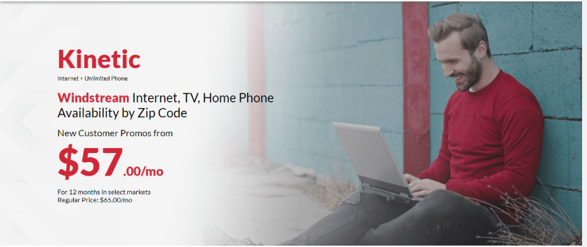

<div class="img" id="img">

<img src="images/001.png" alt="cover" width="100%" height="100%">

</div>

**[e_3 title=’’ sub_title=’’ text= , image=’’]**

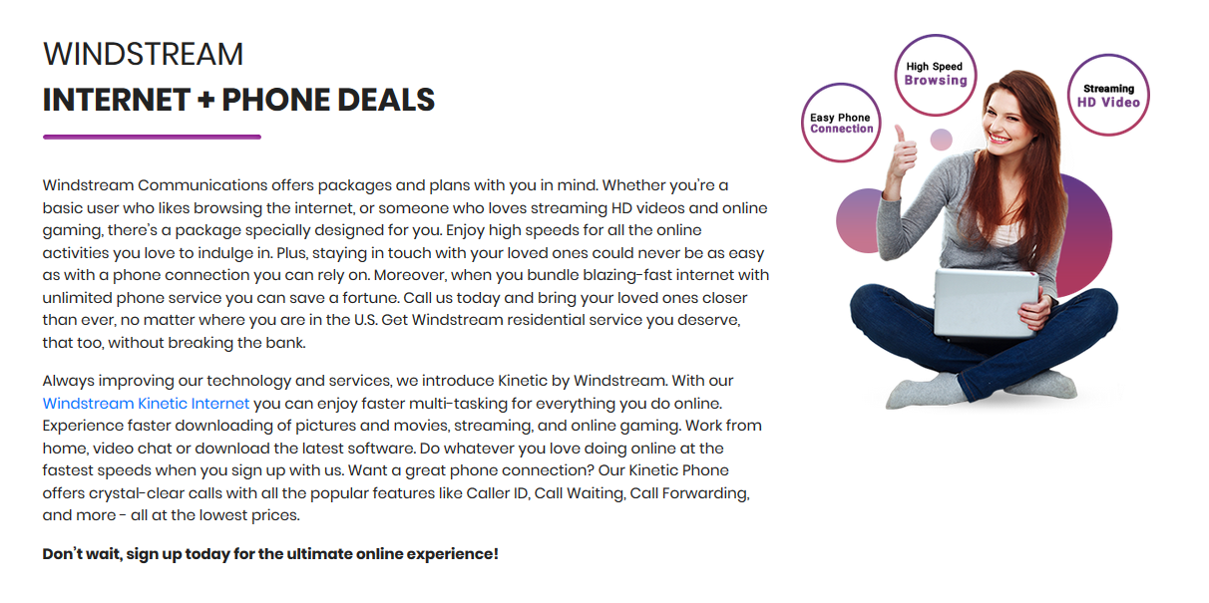

<div class="container" style="padding-top: 100px;">

<div class="row">

<div class="col-lg-8">

<h2>WINDSTREAM</h2>

<h2><b>INTERNET + PHONE DEALS</b></h2><hr class="space"><br><br>

<p style="font-size: 15px;">Windstream Communications offers packages and plans with you in mind. Whether you’re a basic user who likes browsing the internet, or someone who loves streaming HD videos and online gaming, there’s a package specially designed for you. Enjoy high speeds for all the online activities you love to indulge in. Plus, staying in touch with your loved ones could never be as easy as with a phone connection you can rely on. Moreover, when you bundle blazing-fast internet with unlimited phone service you can save a fortune. Call us today and bring your loved ones closer than ever, no matter where you are in the U.S. Get Windstream residential service you deserve, that too, without breaking the bank.</p>

<p style="font-size: 15px;">

Always improving our technology and services, we introduce Kinetic by Windstream. With our <a href="#">Windstream Kinetic Internet</a> you can enjoy faster multi-tasking for everything you do online. Experience faster downloading of pictures and movies, streaming, and online gaming. Work from home, video chat or download the latest software. Do whatever you love doing online at the fastest speeds when you sign up with us. Want a great phone connection? Our Kinetic Phone offers crystal-clear calls with all the popular features like Caller ID, Call Waiting, Call Forwarding, and more - all at the lowest prices.

</p>

<p style="font-size: 15px;">

<b>

Don’t wait, sign up today for the ultimate online experience!

</b>

</p>

</div>

<div class="col-lg-4">

<img class="img-fluid" src="images/02.png">

</div>

</div>

</div>

**[e_4 title_1= ‘’ title_2=’’ ]**



<div class="container" style="padding-top: 100px;">

<div class="row">

<div class="col-lg-12" align="center">

<h2 class="myh1">WINDSTREAM</h2>

<h2 class="myh2"><b>PACKAGES</b></h2>

<hr class="space01"><br> <br>

</div>

</div>

</div>

**[e_5 title= ‘’ sub_title= ‘’ text= , image= , button_title= , button_link= ]**

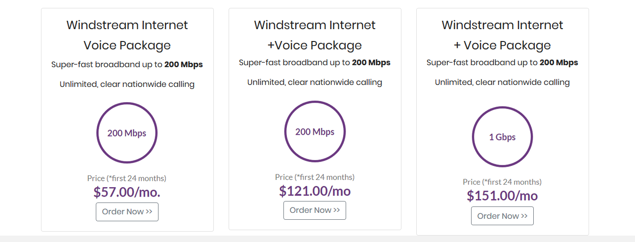

<div class="container carousel text-center">

<div class="row">

<div class="col-md-4">

<div class="card">

<div class="card-body">

<h4 class="card-title">Windstream Internet</h4>

<h4 class="card-title">Voice Package</h4>

<p class="card-text">Super-fast broadband up to <b> 200 Mbps</b></p>

<p>Unlimited, clear nationwide calling</p>

<img src="images/101.png" class="card-img-top">

<a href="#" class="btn btn-outline-secondary">Order Now &gt;&gt;</a>

</div>

</div>

</div>

<div class="col-md-4">

<div class="card">

<div class="card-body">

<h4 class="card-title">Windstream Internet</h4>

<h4> +Voice Package</h4>

<p class="card-text">Super-fast broadband up to <b> 200 Mbps</b></p>

<p>Unlimited, clear nationwide calling</p>

<img src="images/102.png" class="card-img-top">

<a href="#" class="btn btn-outline-secondary">Order Now &gt;&gt;</a>

</div>

</div>

</div>

<div class="col-md-4">

<div class="card">

<div class="card-body">

<h4 class="card-title">Windstream Internet</h4>

<h4>+ Voice Package</h4>

<p class="card-text">Super-fast broadband up to <b> 200 Mbps</b></p>

<p>Unlimited, clear nationwide calling</p>

<img src="images/103.png" class="card-img-top">

<a href="#" class="btn btn-outline-secondary">Order Now &gt;&gt;</a>

</div>

</div>

</div>

</div>

</div>

**[e_6 title= , sub_title= , text= , image= ]**

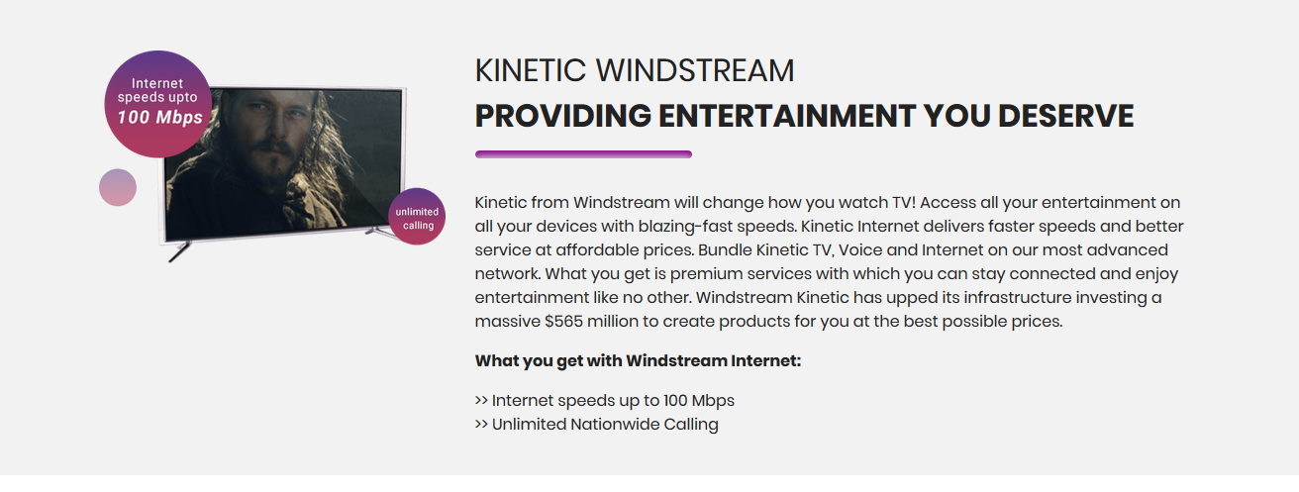

<section class="call-to" style="background-color: #f2f2f2;">

<div class="container" style="padding-top: 100px;">

<div class="row">

<div class="col-lg-4">

<img class="img-fluid" src="images/03.png">

</div>

<div class="col-lg-8">

<h2 align="left"> KINETIC WINDSTREAM</h2>

<h2><b>PROVIDING ENTERTAINMENT YOU DESERVE</b></h2>

<hr class="space02"><br><br>

<p>

Kinetic from Windstream will change how you watch TV! Access all your entertainment on all your devices with blazing-fast speeds. Kinetic Internet delivers faster speeds and better service at affordable prices. Bundle Kinetic TV, Voice and Internet on our most advanced network. What you get is premium services with which you can stay connected and enjoy entertainment like no other. Windstream Kinetic has upped its infrastructure investing a massive $565 million to create products for you at the best possible prices.

</p>

<p>

<b>What you get with Windstream Internet:</b>

</p>

<p>

&gt;&gt; Internet speeds up to 100 Mbps <br>

&gt;&gt; Unlimited Nationwide Calling

</p>

</div>

</div>

</div><br>

</section>

**[e_7 title= , sub_title= , text= ]**

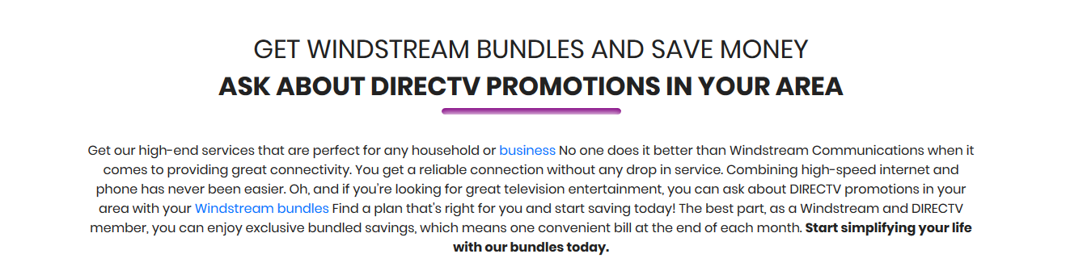

<section class="call-to-action" style="padding-top: 100px;">

<div class="container text-center">

<div class="row text-center">

<div class="col-lg-12">

<h2>GET WINDSTREAM BUNDLES AND SAVE MONEY</h2>

<h2><b>ASK ABOUT DIRECTV PROMOTIONS IN YOUR AREA</b></h2>

<hr class="space03"><br>

<p>

Get our high-end services that are perfect for any household or <a href="#">business</a> No one does it better than Windstream Communications when it comes to providing great connectivity. You get a reliable connection without any drop in service. Combining high-speed internet and phone has never been easier. Oh, and if you’re looking for great television entertainment, you can ask about DIRECTV promotions in your area with your <a href="#">Windstream bundles</a> Find a plan that's right for you and start saving today! The best part, as a Windstream and DIRECTV member, you can enjoy exclusive bundled savings, which means one convenient bill at the end of each month.

<b>Start simplifying your life with our bundles today.</b>

</p>

</div>

</div>

</div>

</section>

**[e_8 image=””, b_1= , b_2= , b_3= ]**

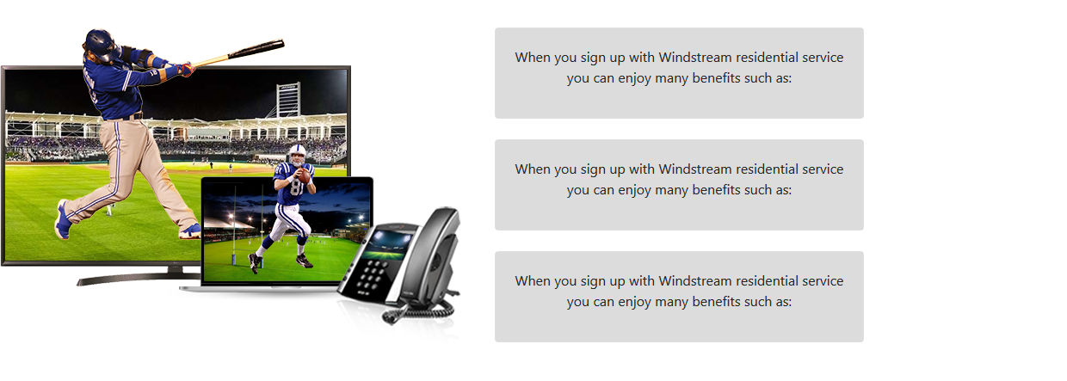

<div class="row mt-5">

<div class="col-lg-5">

<img class="img-fluid" src="images/04.png" align="center">

</div>

<div class="col-lg-4">

<div class="row-md-2">

<div class="card">

<div class="card-body active text-center" style="background-color: gainsboro;">

<p>

When you sign up with Windstream residential service you can enjoy many benefits such as:

</p>

</div>

</div>

</div><br>

<div class="row-md-4">

<div class="card">

<div class="card-body text-center" style="background-color: gainsboro;">

<p>

When you sign up with Windstream residential service you can enjoy many benefits such as:

</p>

</div>

</div>

</div><br>

<div class="row-md-4">

<div class="card">

<div class="card-body text-center" style="background-color: gainsboro;">

<p>

When you sign up with Windstream residential service you can enjoy many benefits such as:

</p>

</div>

</div>

</div>

</div>

</div>

**[e_9 title= , sub_title= , text= , image= , button_title= , button_link= ]**

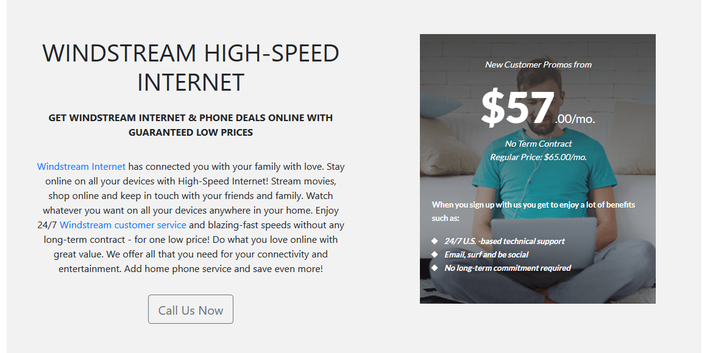

<section class="container cont text-center">

<div class="miniCont row mt-5" style="background-color: #f2f2f2;">

<div class="col-lg-6 my-auto" style="padding-top: 100px;">

<div class="row">

<div class="home-content col-lg-12" style="padding-left: 50px; padding-bottom: 50px;">

<h1 class="pb-3">WINDSTREAM HIGH-SPEED INTERNET</h1>

<p class="pb-3"><b>GET WINDSTREAM INTERNET &amp; PHONE DEALS ONLINE WITH GUARANTEED LOW PRICES</b></p>

<p class="pb-3"><a href="#">Windstream Internet</a> has connected you with your family with love. Stay online on all your devices with High-Speed Internet! Stream movies, shop online and keep in touch with your friends and family. Watch whatever you want on all your devices anywhere in your home.

Enjoy 24/7 <a href="#">Windstream customer service</a> and blazing-fast speeds without any long-term contract - for one low price! Do what you love online with great value. We offer all that you need for your connectivity and entertainment. Add home phone service and save even more!

</p>

<button class="btn btn-lg btn-outline-secondary">Call Us Now</button>

</div>

</div>

</div>

<div class="col-lg-6 mt-5 py-5 pl-5">

<img class="img-fluid" alt="" src="images/111.png">

</div>

</div>

</section>

**[e_10 title= , sub_title= , text= , image= , button_title= , button_link= ]**

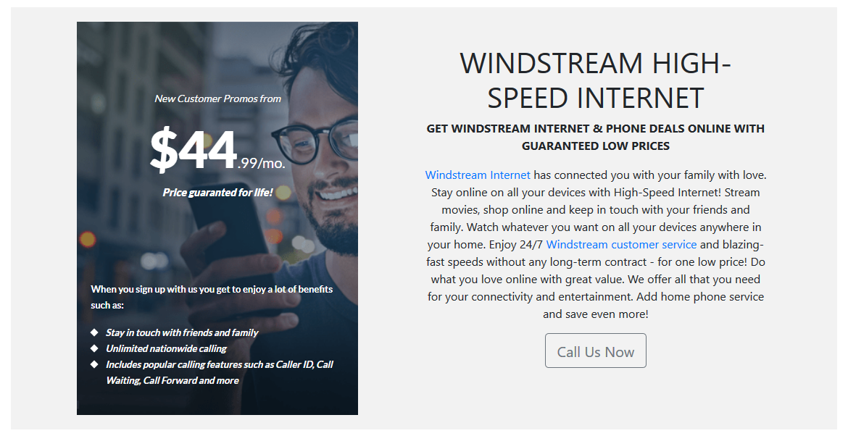

<section class="container cont1 text-center">

<div class="row mt-5 miniCont1">

<div class="col-lg-6" style="padding-top: 20px; padding-bottom: 20px;">

<img class="img-fluid" alt="" src="images/222.png">

</div>

<div class="col-lg-5" style="padding-top: 50px;">

<div class="row">

<div class="home-contentcol-lg-10">

<h1>WINDSTREAM HIGH-SPEED INTERNET</h1>

<p><b>GET WINDSTREAM INTERNET &amp; PHONE DEALS ONLINE WITH GUARANTEED LOW PRICES</b></p>

<p><a href="#">Windstream Internet</a> has connected you with your family with love. Stay online on all your devices with High-Speed Internet! Stream movies, shop online and keep in touch with your friends and family. Watch whatever you want on all your devices anywhere in your home.

Enjoy 24/7 <a href="#">Windstream customer service</a> and blazing-fast speeds without any long-term contract - for one low price! Do what you love online with great value. We offer all that you need for your connectivity and entertainment. Add home phone service and save even more!

</p>

<button class="btn btn-lg btn-outline-secondary">Call Us Now</button>

</div>

</div>

</div>

</div>

</section>

**[e_11 title= , text= , image=””]**

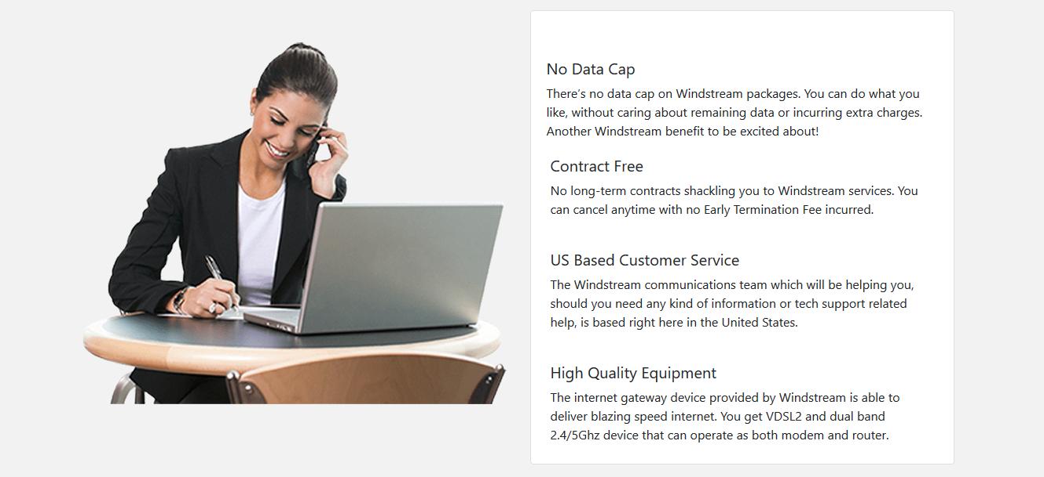

<section class="call-to-action mobile" style="padding-top:25px; background-color: #f2f2f2;">

<!-- new div started with table classes ended -->

<!-- first cards for div -->

<section class="container cont1">

<div class="row mt-5 miniCont1">

<div class="col-lg-6" style="padding-top: 40px;">

<img class="img-fluid" alt="" src="images/box.png">

</div>

<div class="col-lg-6">

<div class="card">

<div class="row-md-4" style="padding: 5px 5px 5px 5px;">

<div class="home-content col-lg-12" style="background-color: white;">

<p p="" class="card-body">

</p><h5 class="card-text">No Data Cap</h5>

<p class="card-text">There’s no data cap on Windstream packages. You can do what you like, without caring about remaining data or incurring extra charges. Another Windstream benefit to be excited about!

</p>

</div>

<div class="card-body">

<h5 class="card-text">Contract Free</h5>

<p class="card-text">No long-term contracts shackling you to Windstream services. You can cancel anytime with no Early Termination Fee incurred.</p>

</div>

<div class="card-body">

<h5 class="card-text">US Based Customer Service</h5>

<p class="card-text">The Windstream communications team which will be helping you, should you need any kind of information or tech support related help, is based right here in the United States.</p>

</div>

<div class="card-body">

<h5 class="card-text">High Quality Equipment</h5>

<p class="card-text">The internet gateway device provided by Windstream is able to deliver blazing speed internet. You get VDSL2 and dual band 2.4/5Ghz device that can operate as both modem and router.</p>

</div>

</div>

</div>

</div>

</div>

</section>

</section>

**[e_11 title= , text= , image=””]**

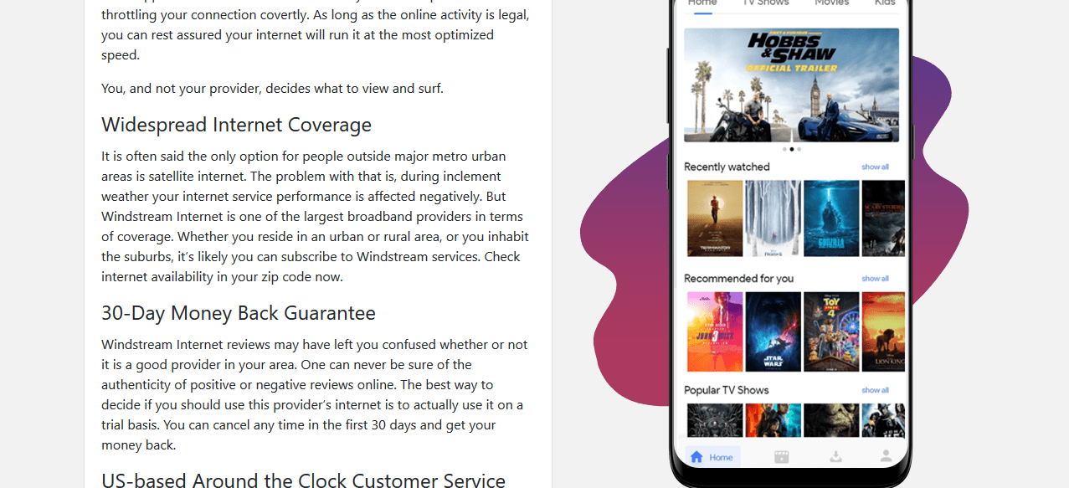

<div class="row" style="padding-left: 100px;padding-right: 100px; padding-bottom: 50px;">

<div class="col-lg-6" style="padding-top: 50px;">

<div class="card">

<div class="row-md-4">

<div class="card-body active">

<div class="row-lg-6">

<h4 class="card-title">Open, Free Internet Because This is America</h4>

<p class="card-text">People want to be free. Access to websites, applications, and all other online activities should be easily available to customers. That’s exactly what Windstream’s policy is regarding Net Neutrality. You’ll never find some apps are slower than others because your service provider is throttling your connection covertly. As long as the online activity is legal, you can rest assured your internet will run it at the most optimized speed.</p>

<p>You, and not your provider, decides what to view and surf.</p>

<h4 class="card-title">Widespread Internet Coverage</h4>

<p>It is often said the only option for people outside major metro urban areas is satellite internet. The problem with that is, during inclement weather your internet service performance is affected negatively. But Windstream Internet is one of the largest broadband providers in terms of coverage. Whether you reside in an urban or rural area, or you inhabit the suburbs, it’s likely you can subscribe to Windstream services. Check internet availability in your zip code now.</p>

<h4 class="card-title">30-Day Money Back Guarantee</h4>

<p>Windstream Internet reviews may have left you confused whether or not it is a good provider in your area. One can never be sure of the authenticity of positive or negative reviews online. The best way to decide if you should use this provider’s internet is to actually use it on a trial basis. You can cancel any time in the first 30 days and get your money back.</p>

<h4 class="card-title">US-based Around the Clock Customer Service</h4>

<p>The Customer Service team is located and trained here in the United States. Due to the local staff, you get better tech, billing, and general support. The support agents know all local regulations, corporate policies, taxes, latest promos, internet plans and bundles so they’re able to deliver accurate and the most updated information to you. They are also able to coordinate better with technicians and installation teams in your area for smooth home visits.</p>

</div>

</div>

</div>

</div>

</div>

<!-- new div started -->

<div class="col-lg-6" style="padding-top: 150px;">

<img class="img-fluid" src="img/mobile.png" align="center">

</div>

</div>

**[e_13 title= , list= ]**

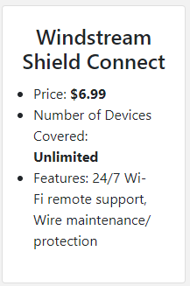

<div class="col-md-3">

<div class="card">

<div class="card-body">

<h4 class="card-title">Windstream Shield Connect</h4>

<ul class="col text-left">

<li>$list</li>

</ul>

<p></p>

</div>

</div>

</div>

**[e_14 title_1= , text_1= , title_2= , text_2= ]**

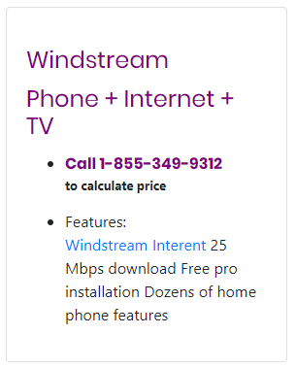

<div class="col-md-4">

<div class="card">

<div class="card-body">

<h4 class="card-title" style="color: purple; font-family: Poppins, sans-serif; text-align: left; padding-top: 20px;">Windstream</h4>

<h4 class="card-title" style="color: purple; font-family: Poppins, sans-serif; text-align: left;">Phone + Internet + TV</h4>

<ul align="left">

<li><a href="#" style="color: purple; font-family: poppins, Helvetica, sans-serif;"><b>Call 1-855-349-9312</b></a>

<p style="font-size: small;"><b>to calculate price</b></p></li>

<li>Features:

<p><a href="#">Windstream Interent</a> 25 Mbps download Free pro installation Dozens of home phone features</p></li>

</ul>

</div>

</div>

</div>

**[e_15 title= , statement= , num= , text= ]**

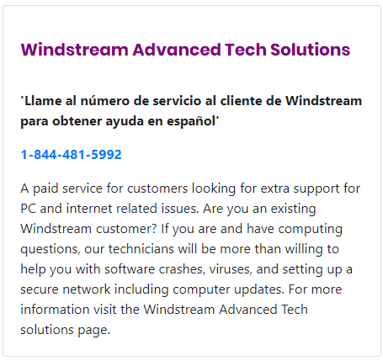

<div class="card">

<div class="card-body">

<h4 class="card-title" style="color: purple; font-family: Poppins, sans-serif; text-align: left; padding-top: 20px; font-size: 20px;"><b>Windstream Advanced Tech Solutions</b></h4><br>

<div align="left">

<p class="card-text"><b>'Llame al número de servicio al cliente de Windstream para obtener ayuda en español'</b></p>

<p><a href="#"><b>1-844-481-5992</b></a></p>

<p class="card-text">A paid service for customers looking for extra support for PC and internet related issues. Are you an existing Windstream customer? If you are and have computing questions, our technicians will be more than willing to help you with software crashes, viruses, and setting up a secure network including computer updates. For more information visit the Windstream Advanced Tech solutions page.</p>

</div>

</div>

</div>