**RESUME**

**OF**

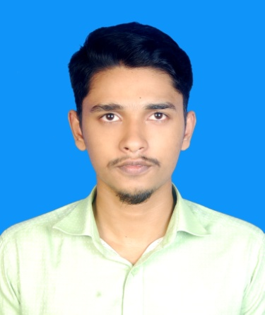**Md Miraz Hossain**

**Mailing Address**   
House No: 50, Bariabaha,

Chandra, Kaliakoir, Gazipur,

Dhaka

Cell: 01740659155, 01730647674

E-mail: mirazh661@gmail.com

**CAREER OBJECTIVE:**

Seeking a position that will allow me to apply, enhance my professional skills and take full advantage of my degree with hard work, sincerity and loyalty contributing to the growth of the organization allowing my career growth as far as possible.

**EDUCATIONAL QUALIFICATION:**

**Uttara University(UU):**

University : Uttara University

Department : Computer Science & Engineering (CSE)

Year : 1st Year Running

**Higher Secondary Certificate (HSC):**

Institute Name : Shafipur ideal public school and college

Group : Science

Result : 3.50 (Out of 5.00)

Board : Dhaka

Passing Year : 2018

**Secondary School Certificate (SSC):**

Institute Name : Baliadi M.L high school

Group : Science

Result : 4.44 (Out of 5.00)

Board : Dhaka

Passing Year : 2016

**COMPUTETR EXPERIENCE:**

Programming language (Python, C,C++,HTML,CSS,JavaScript), MS Word, MS Excel, Microsoft Office, Email, Internet Browsing.

**LANGUAGE EFFICIENCY:**

Excellent skill in communication both speaking and writing

(a) Bengali

(b) English

**PERSONAL INFORMATION:**

Name : Md Miraz Hossain

Father’s Name : Abdul Rashid

Mother’s Name : Mala Begum

Date of Birth : 06/11/1999

Permanent Address : Vill: Bariabaha,Post: Baliadi

P.S : Kaliakoir, Dist: Gazipur

Religion : Islam

Marital Status : Unmarried

Gender : Male

Blood Group : O (+ve)

NID : 4654273673

Nationality : Bangladeshi (by birth)

**DECLARATION:**

I hereby declare that my above information is correct and presented properly without any unfair means.

**Signature Date :**