Overview

This document contains the necessary information to build the Switch Adapted Water Gun with Collapsible Stand, a water gun that can be triggered via a switch and is supported by a stand that can be put together in pieces and be taken apart.

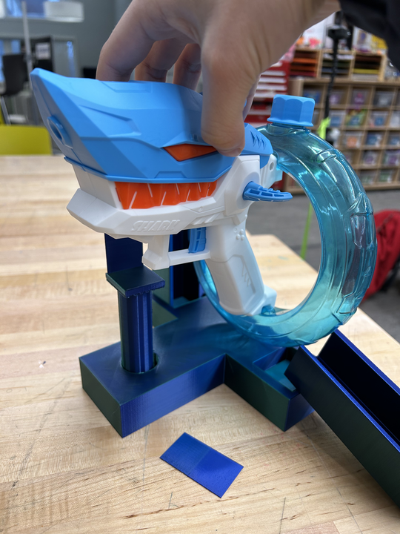
Printing Guide

This was originally printed on the Prusa MK4 using Prusa Slicer.
This device required supports on build plate only, 0.2mm STRUCTURAL, and 15% infill.

Printing Summary

Metrics
Total Print Time | 11 hours 42 minutes
Total Number of Components | 8 components
Typical Mass | 305.26 g
Typical Number of Print Setups | 5

The stand can also be separated into 3 files (4 prints) for reprinting.

File Name | Qty | Print Time | Mass (g) | Infill | Support | Layer Height | Notes
FullStand.stl | 1 | 9:44 | 239.22 | 15 | Y | 0.2 mm
Base.stl | 1 | 4:37 | 144.96 | 15 | N | 0.2 mm | part of FullStand
FrontSupport.stl | 1 | 1:46 | 28.85 | 15 | Y | 0.2 mm | part of FullStand
BackSupport.stl | 2 | 1:21 | 25.79 | 15 | N | 0.2 mm | part of FullStand
Interact_Switch_Base.stl | 1 | 0:50 | 17.85 | 15 | N | 0.2 mm
Interact_Switch_Insert.stl | 1 | 0:12 | 2.79 | 15 | N | 0.2 mm
ButtonCapInsert_0.3mm.stl | 1 | 0:03 | 0.74 | 15 | N | 0.2 mm | may need a different size
Interact_Switch_Cap_Plain.stl | 1 | 0:53 | 18.87 | 15 | Y | 0.2 mm | this print includes a customized switch

Post-Processing
Remove supports from the FrontSupport and ButtonCap. Inspect all pieces for print defects.

Examples of Quality Prints

 | Base.stl
 | FrontSupport.stl
 | BackSupport.stl
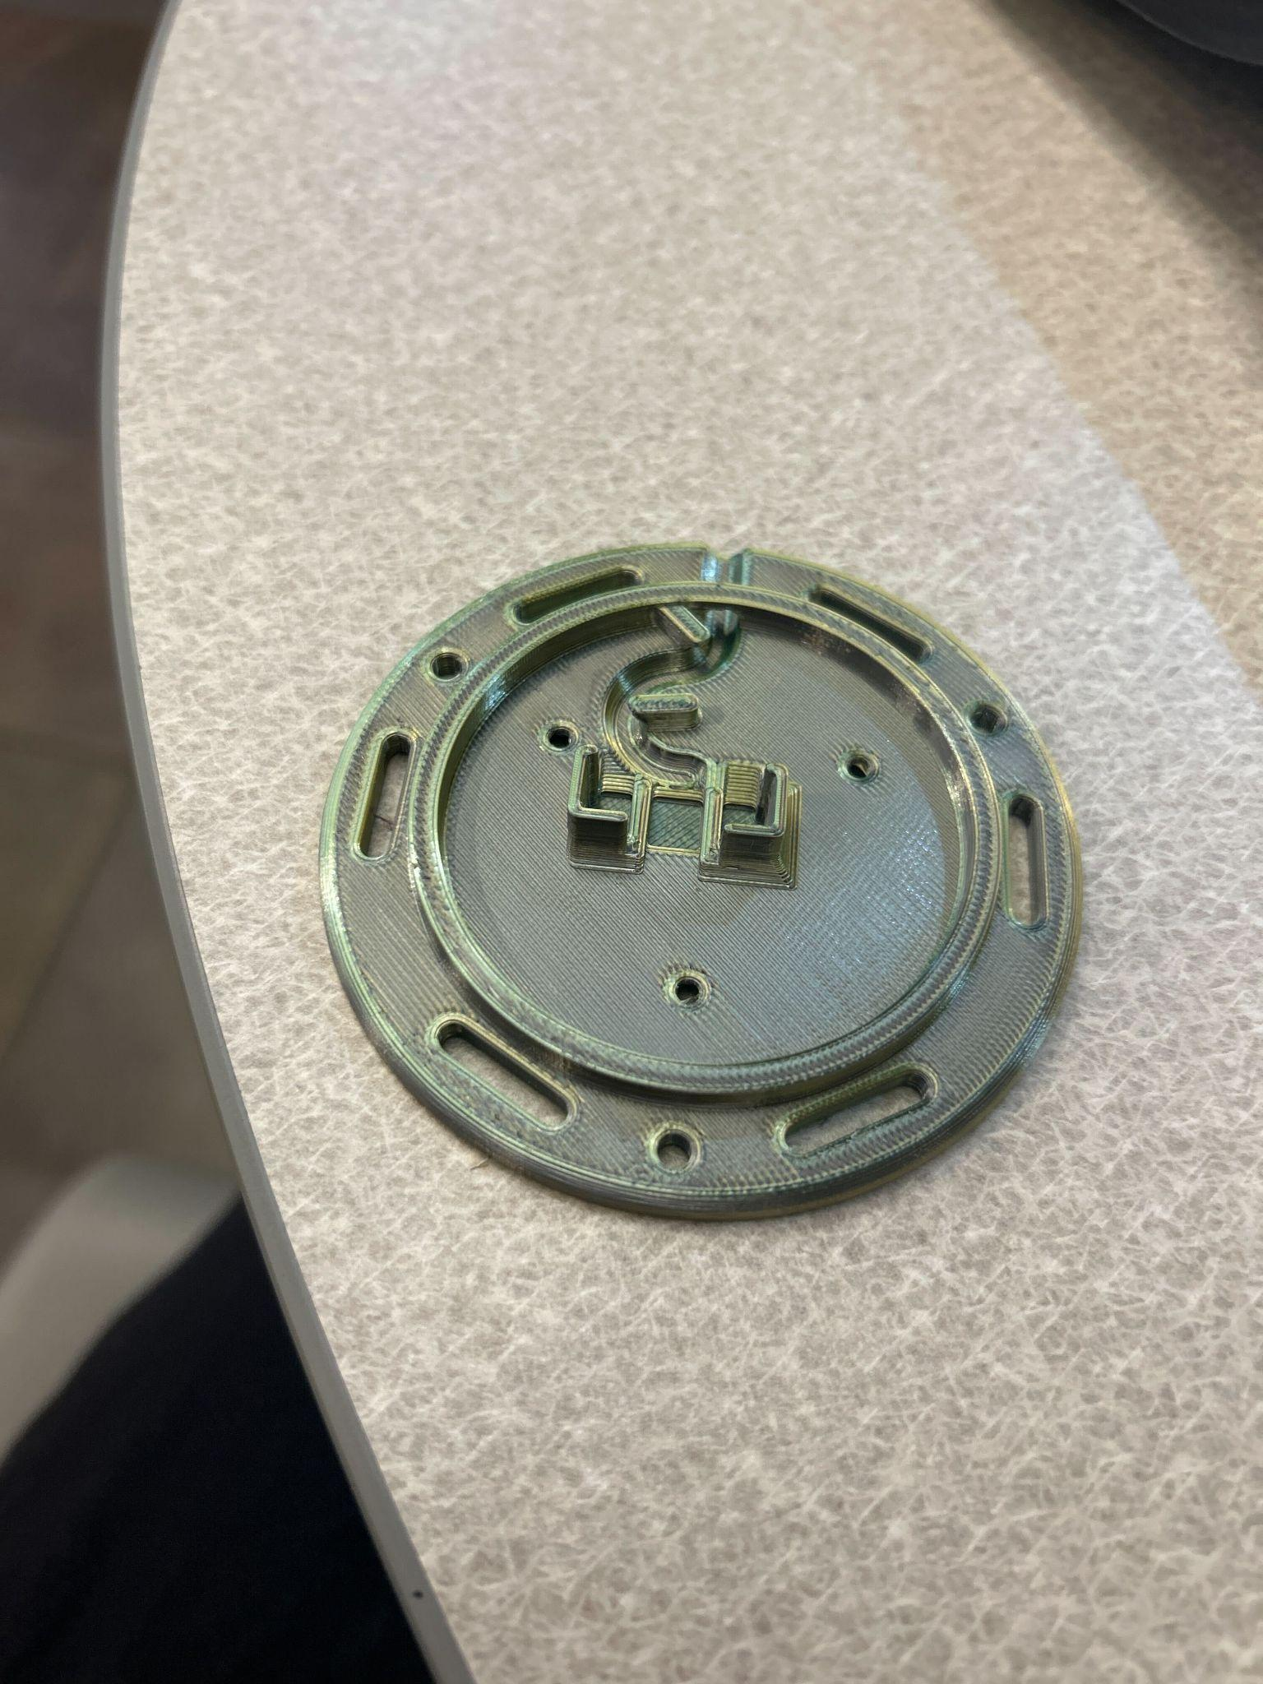 | Interact_Switch_Base.stl
 | Interact_Switch_Insert.stl
 | ButtonCapInsert_0.3mm.stl
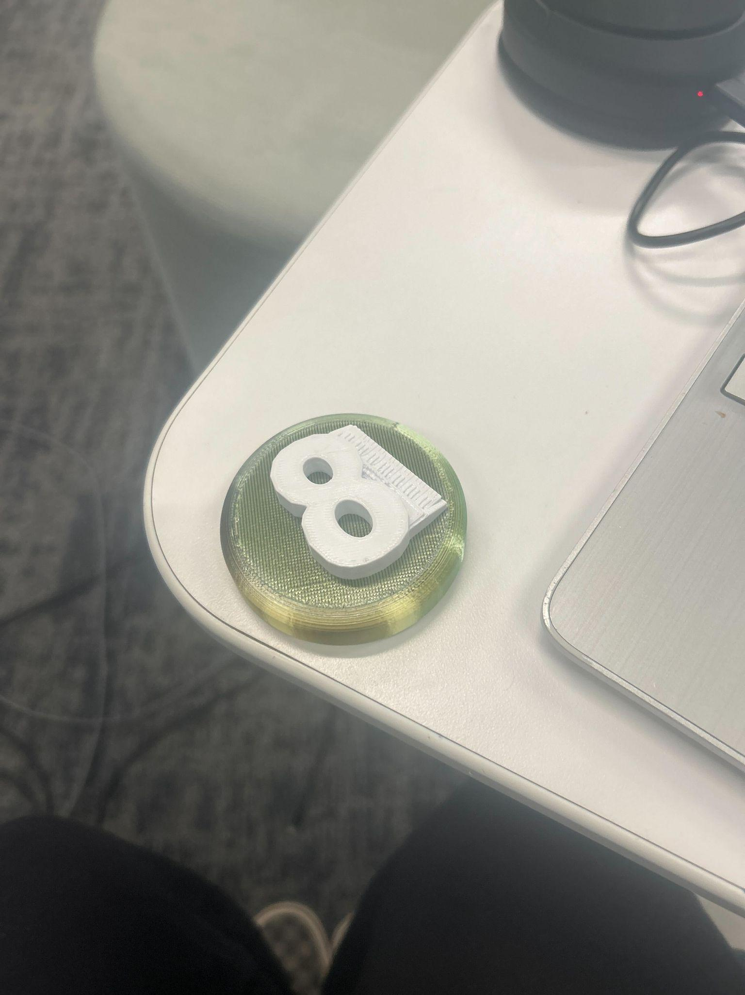 | Interact_Switch_Cap_Plain.stl

Assembly Guide
Part A: Disassembling the water gun
Required Components:
- Shark water gun
Required tools and Supplies:
- Screwdriver included in the box
Step A-01: Unscrew all the screws located on the gun’s surface by using the screwdriver included with the shark water gun.
Step A-02: Carefully remove all parts of the gun once the screws have been removed. Set these parts aside in a safe place, careful not to lose any of the screws.

Part B: Drilling a hole in the water gun
Required Components:
- Shark water gun
Required tools and Supplies:
- Screwdriver included in the box
- Electric drill
- Appropriate sized drill bit
- Soldering iron
- Solder
- Wire strippers
- Wire cutters
- Copper wire
- Sharpie
- Thick, wooden board
Required Personal Protective Equipment:
- Glasses
Step B-01: Take the white base of the water gun and mark a dot with a sharpie on the place that you will be drilling the hole for the socket. Make sure to leave enough surrounding space for the wires we will be putting on in a later step.
StepB-02: Once you are sure you have made enough space for the hole and it will be on a flat surface, hold the white base flat against a board.
StepB-03: Before handling the drill, place the glasses over your eyes to protect any debris from entering the eye socket.
StepB-03: Take the drill and apply pressure in the center of your mark and pull the trigger to create a hold in the base. Do this until you have fully pierced the white base of the water gun, then remove the drill by pressing on the trigger and pulling up.

Part C: Soldering the wires to the pre-existing wires in the water gun
Required Components:
- Shark water gun
Required tools and Supplies:
- Soldering iron
- Lead Solder
- Wire strippers
- Wire cutters
- Copper wire
Required Personal Protective Equipment:
- Glasses
Step C-01: Take about a four inch piece of twisted copper wire and strip off any protective coating that is around it.
Step C-02: Before beginning any soldering, place the protective glasses to protect any debris getting into the eyes.
Step C-03: To solder the copper wire to the existing wire, heat up the copper wire and apply the solder to the heated tip of the wire.
Step C-04: Quickly make contact to the pre-existing wire on the gun to solder the two pieces together.
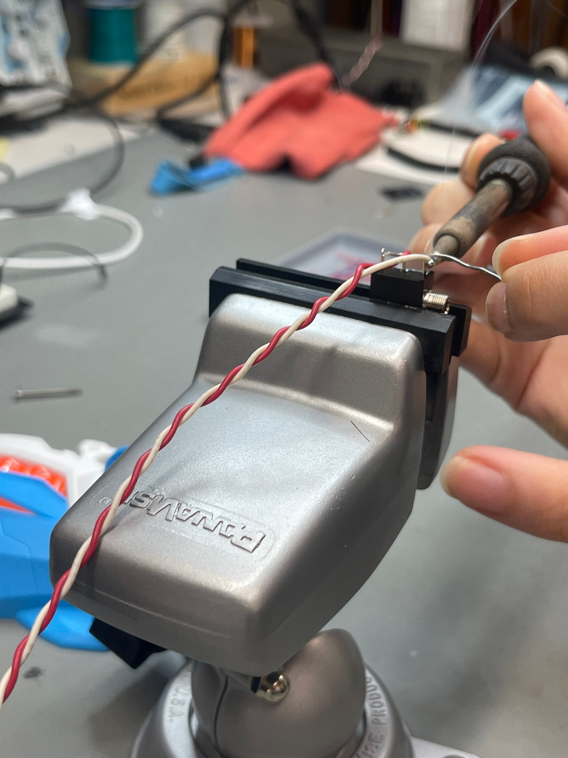
Step C-05: Following the same steps above on the opposite end of the copper wire, you will be soldering the copper wire to the jack.
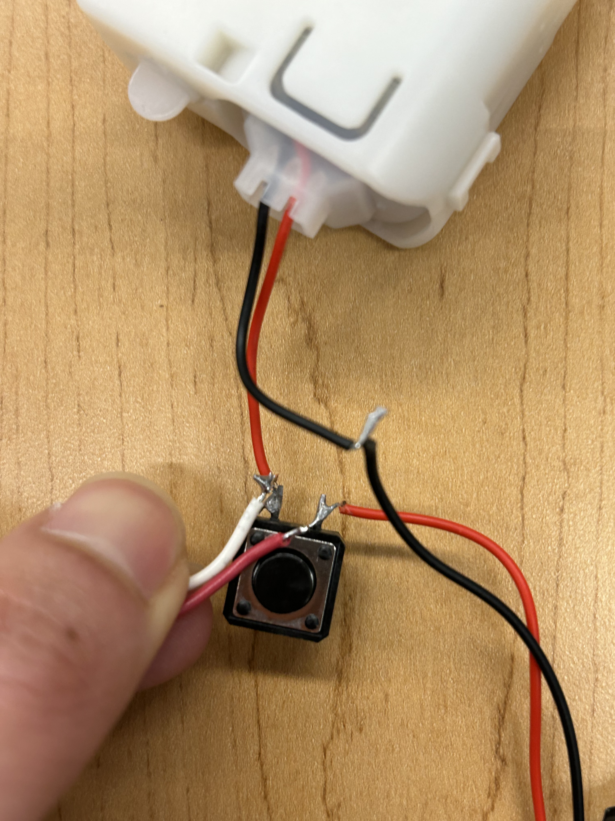
Step C-06: Fit the jack into the hole that was drilled into the white part of the gun earlier.
Step C-07: The gun can now be put together using the screwdriver and screws we used to take the gun apart in Step-A.

Part D: Adapting the switch
Required Components:
Required tools and Supplies:
- Screwdriver included in the box
- Electric drill
- Appropriate sized drill bit
- Soldering iron
- Solder
- Wire strippers
- Wire cutters
- Copper wire
- Sharpie
- Thick, wooden board
Required Personal Protective Equipment:
- Glasses
Step C-01: Take about a four inch piece of twisted copper wire and strip off any protective coating that is around it.
Step C-02: Before beginning any soldering, place the protective glasses to protect any debris getting into the eyes.
Step C-03: To solder the copper wire to the existing wire, heat up the copper wire and apply the solder to the heated tip of the wire.
Step C-04: Quickly make contact to the pre-existing wire on the gun to solder the two pieces together.
Step C-05: Following the same steps above on the opposite end of the copper wire, you will be soldering the copper wire to the jack.
Step C-06: Fit the jack into the hole that was drilled into the white part of the gun earlier.
Step C-07: The gun can now be put together using the screwdriver and screws we used to take the gun apart in Step-A.
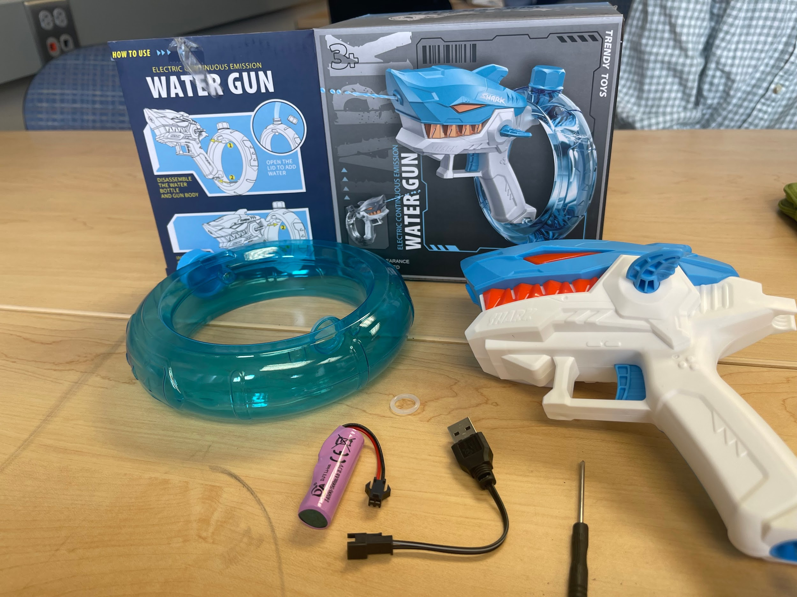

Part F: Assembling the switch
Required Components
1. 1x Switch Base (3D printed)
2. 1x Button Cap Holder (3D printed)
3. 1x Button Cap Insert (3D printed)
4. 1x Button Cap (3D printed)
5. 1x Omron SS-3GP limit switch
6. 1x 3.5 mm mono cable
7. 3x M2.5x12 or #4x 3-8” Pan Head screws (self threading)
Required Tools
• Soldering iron and solder
• Wire strippers
• Screw driver
• Safety glasses
Attribution
The Interact Switch design by Mike Turvey is used under CC-BY 4.0. Instructions adapted from Original Interact Switch Assembly Instructions by Mike Turvey, used under CC-BY 4.0. 1 2 3 4 5 6 7 V1.1 | AUGUST 2023 Interact Switch ASSEMBLY GUIDE © 2023 by Neil Squire / Makers Making Change. This work is licensed under the CC BY SA 4.0 License: http://creativecommons.org/licenses/by-sa/4.0 Files available at https://github.com/mwturvey/InteractSwitch
Assembly Instructions
Step 1 - Prep Cable
Cut off and discard one of the plugs from the mono audio cable. Use the wire strippers to carefully remove about 15 mm of the outer insulation from the end.
Step 2 - Prep Cable Wires Twist the copper strands together into a single wire. Use the wire strippers to remove roughly 5 mm of insulation from the other wire. (Note: Your cable may differ. If there are two wires with insulation, strip 5 mm from the end of each wire.)
Step 3 – Thread Cable into Switch Base
Thread the cable through the hole in the Switch Base. You will not be able to do this after you solder the limit switch onto the wire.
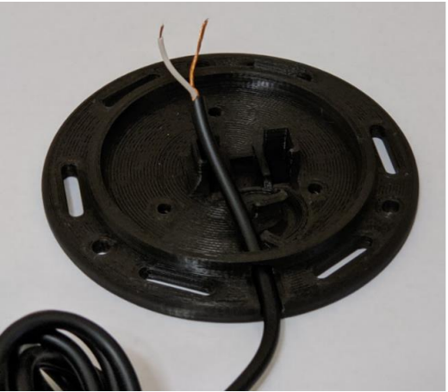
Step 4 – Solder Wires to Switch
Solder the wires into the switch in the position shown below. Note: Solder the two leads closest to the button on the switch. Test: plug your switch into a switch activated device and push the button on the limit switch
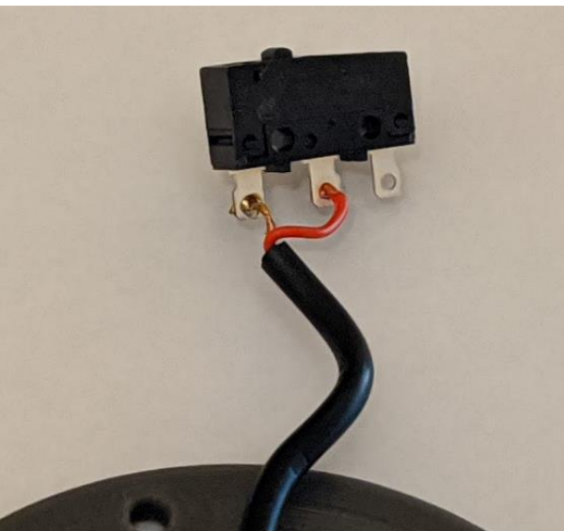
Step 5 – Position Switch in Base
Place the limit switch into the Switch Base as shown. For the orientation of the switch, when the cable is coming towards you, the button on the limit switch should be offset to the left. Make sure that no wires are stuck underneath, preventing the limit switch from going all the way down. Also push the cable in the slot as shown in the picture.
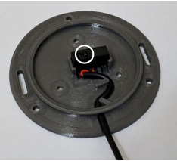
Step 6 – Assemble Button Cap
Turn the Button Cap over and insert the Button Cap Insert.
Step 7 – Finalize Button Cap Assembly
Insert the Button Cap Holder into the Button Cap Assembly. The orientation of the “open” side doesn’t matter. Note: for smoother switch action, sand the edges of the Button Cap Holder where it rubs on the switch. Check that the Insert is the right size. When placed on top of the base, it should be able to click the switch easily and not be overly wobbly.
Step 8 – Assemble Switch
Align the three posts of the Switch Cap Holder to the three holes in the Switch Base. Secure the Switch Cap Holder to the Switch Base using three screws. Note: Be careful not to over tighten the screws. Tighten them until you notice the resistance increases and the Switch Cap Holder is firmly against the Switch Base.

Testing
The last thing to do is test your switch. If this is your first switch, you’ll likely need to test it out and figure out the best size of Switch Cap Insert to use. The first thing I do to test a switch is to push it a lot. Tap it everywhere, repeatedly. Every time you push it, you should hear it click down and click as it goes back up. It should never stick. If you wiggle the top, it should move some, but it shouldn’t feel like it’s rattling around. Next, plug the switch into a switch activated device and make sure that it works.

Troubleshooting
Problem | Solution
The switch cap is too loose and rattles around easily. | Use a larger/ thicker Switch Cap Insert.
Switch doesn’t make any noise when pushed. | Use a smaller/ thinner Switch Cap Insert. An insert that is too big can cause the limit switch to be always depressed. When this is the case, you’ll often hear the limit switch “click” closed when you’re screwing everything together, but it won’t ever click open.
Switch sticks/ doesn’t always go back up. | Use a smaller/ thinner Switch Cap Insert. You may likely need just one size thinner.
Switch makes clicking noise, but the switch activated device isn’t activating | • Test the switch activated device with a switch known to work, just to make sure it’s working fine.  • Check that the plug is firmly plugged into the device  • The solder connection may be bad and need to be re-soldered.  • There may be an internal break in the wire, and you will need to replace it. This is a particularly common failure point for an older switch.

Part D: Assembling the water gun
Required Components:
- Adapted Shark water gun
- 3D Printed Base (4 pieces)
- Switch
Step D-01: Take the parts of the 3D printed base and stick them into the sockets that fit their shape, making sure to have the hollowed out part of the rectangular stands facing inwards.
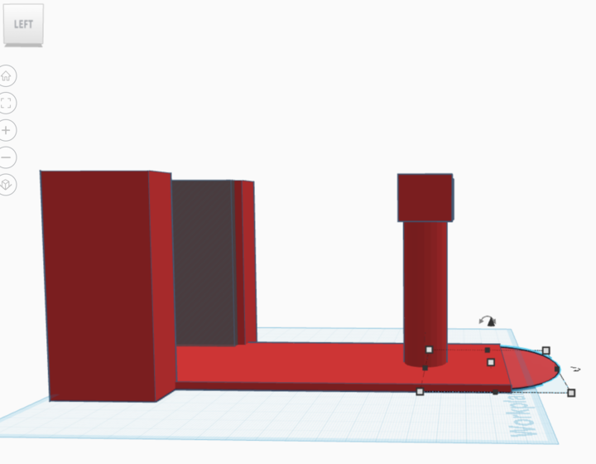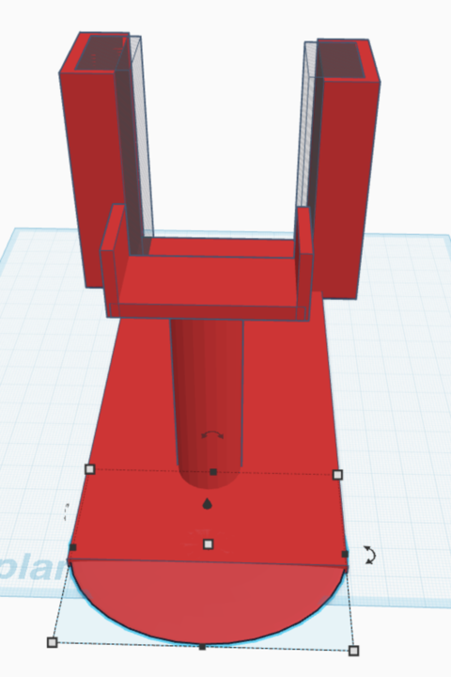
Step D-02: Place the gun on the stand, making sure to have the water tank fit inside the rectangular stands and the front end of the gun rest on top of the cylindrical stand.
Step D-03: Plug the switch into the jack that we made onto the gun and set the button flat on your workstation.
Step D-04: You are now able to activate your gun by clicking on the switch or pulling the trigger.

Testing
The last thing to do is test the water gun. Ensure that the port of the switch is fully inserted into the jack that you adapted on the jack. Before you fit the water gun onto the stand, fill the tank up with tap water. Once the gun is filled, place it onto the stand, making sure it fits snug. Either by holding the base in one hand or leaving it on top of a flat surface, take the button in the other hand and press down on it. This should trigger the gun to release water. Additionally, you can pull back the trigger to release water.

