Switch Adapted Water Gun with Collapsible Stand

USER GUIDE

Introduction
This is a switch adapted water gun that is compatible with 3.5mm switches. This device may be beneficial to someone with limited hand function that is interested in using a water gun.

Features

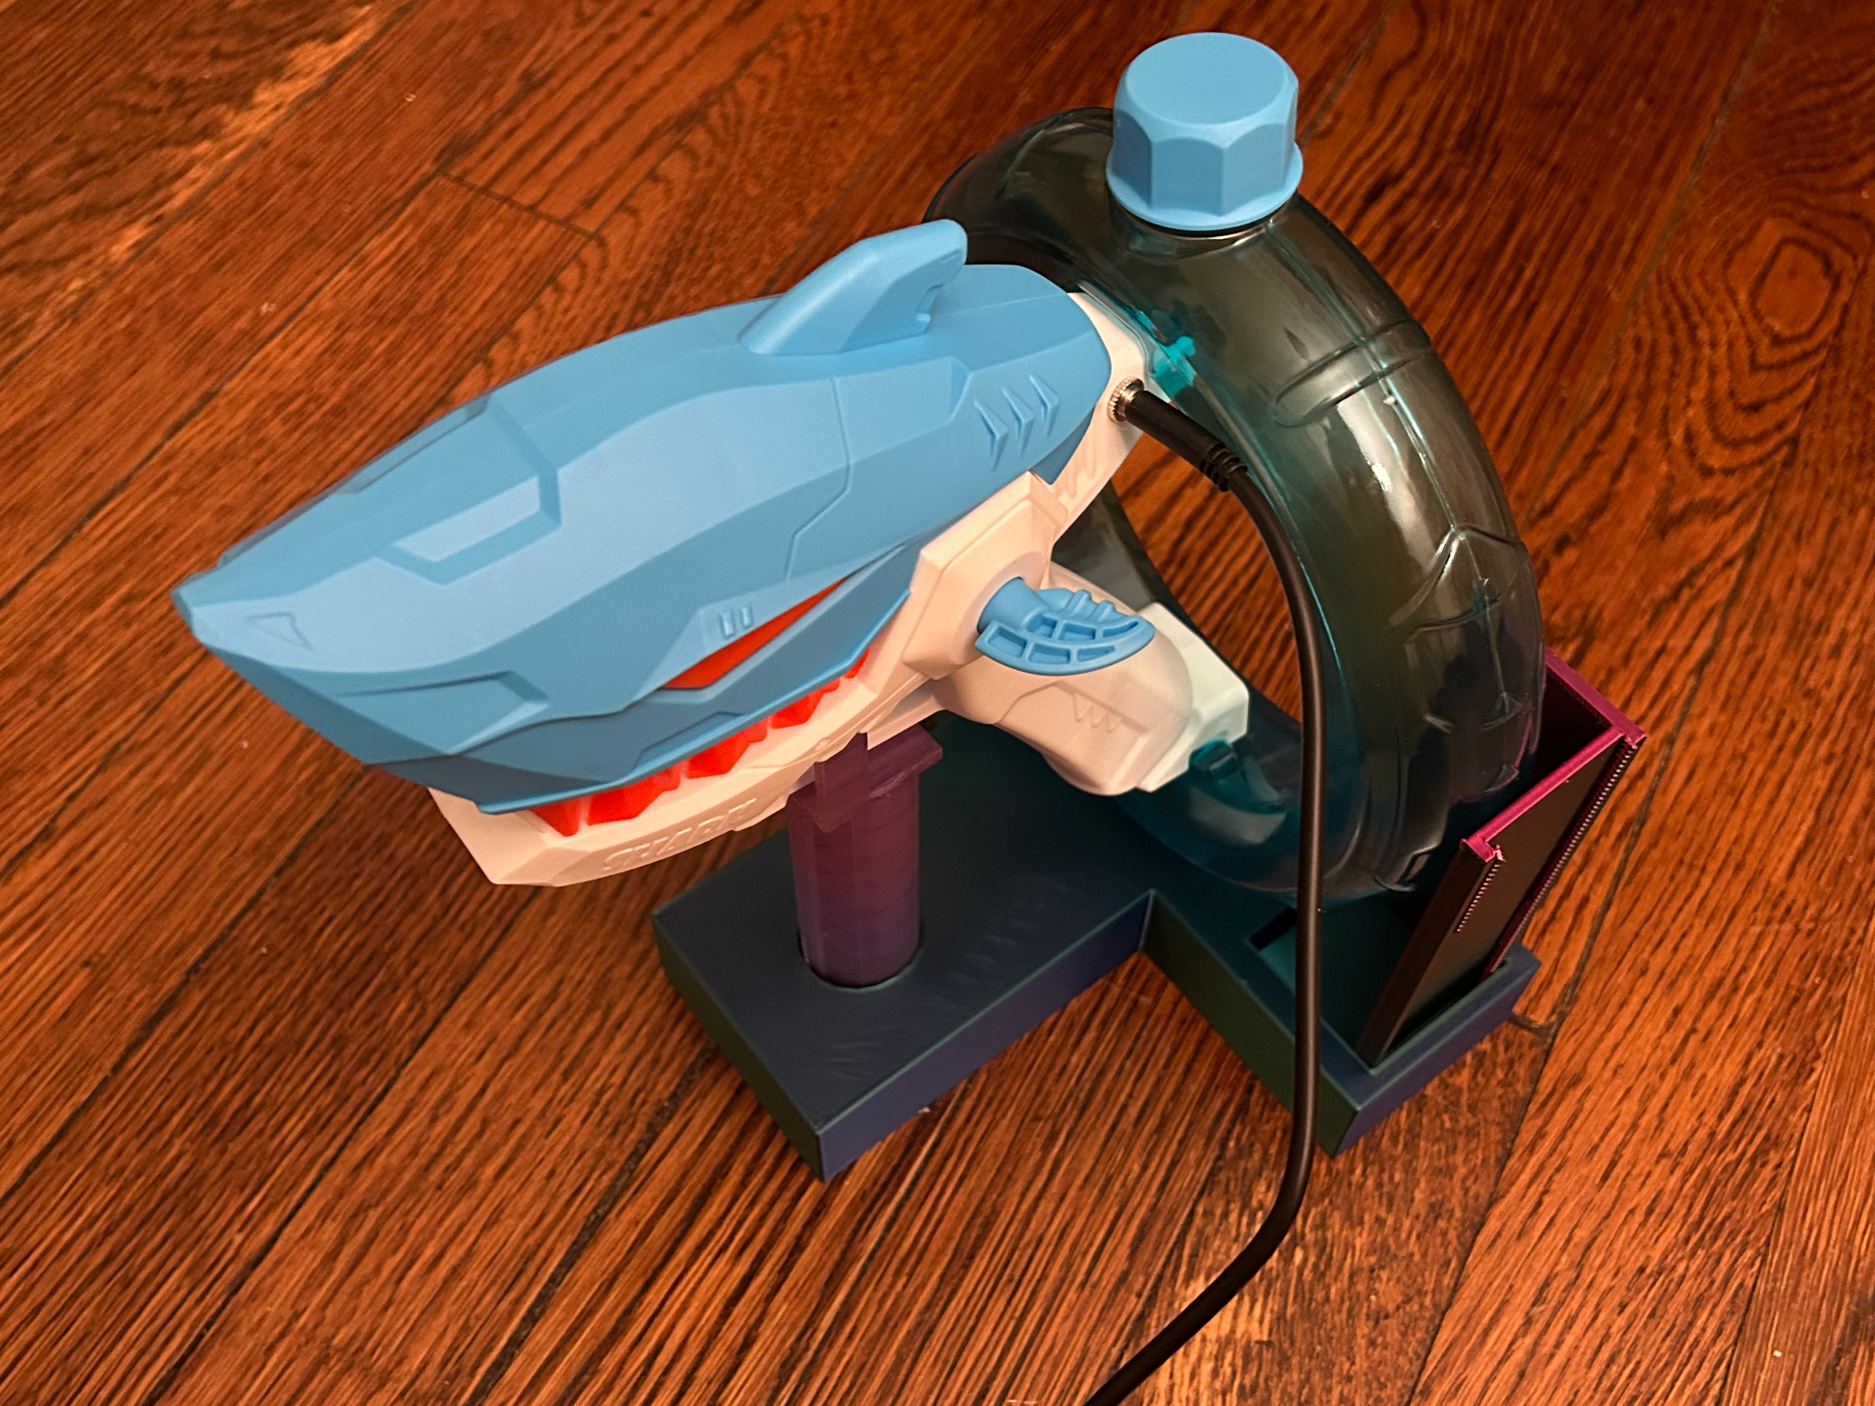
Water compartment
Battery component
Nozzle
3.5 mm. mono jack
3D printed stand

Usage
The Switch Adapted Water Gun with Collapsible Stand can be used by first filling it up with water. Next, plug in a 3.5mm switch into the back of the water gun. Once the switch is pressed, the water gun is activated.

Compatibility
The Switch Adapted Water Gun with Collapsible Stand should be compatible with any 3.5mm switch.

Specifications

Length (mm) | Width (mm) | Height (mm) | Mass (g)
193 | 87 | 130 | 480
*The mass given is the mass of the empty water gun.

Cleaning
The device can be wiped down with a damp cloth. When not in use, empty out the water compartment in the gun.

Switch Adapted Water Gun

USER QUICK GUIDE

Changing the Batteries
The batteries can be accessed by unscrewing all the screws located on the gun"s surface. Once they have been removed, open up the gun and access the white cylinder which contains the rechargeable batteries and the charging cable. The batteries can be charged with a usb. The battery shouldn't be charging for a prolonged time.

