
LLM COMPARISON REPORT
Llama 3.2 (3B) vs Qwen 2.5 (3B) results on different temperature, k-top and p-top

Aisha Anjum 2026-MS-AI-9
Iqra Aslam 2026-MS-AI-31
Rimsha Aamir 2026-MS-AI-20
Fatima Pir 2026-MS-AI-38

Performance evaluation across factual, reasoning, structured-output, uncertainty, creative, and instruction-following prompts

Benchmark scope | 10 prompts · 6 categories
Configuration combinations | 12 per prompt
Runs per model | 240
Total recorded runs | 480
Report date | 19 October 2026

Prepared from the supplied prompt set, benchmark script, model result CSV files, and comparison graphs.

Executive Summary
This report compares Llama 3.2 (3B) and Qwen 2.5 (3B) using the submitted benchmark outputs. Both models recorded 240 successful runs out of 240 (100% recorded success). Qwen 2.5 (3B) had a substantially lower average response time in this run: 1.12 seconds compared with 16.42 seconds for Llama 3.2 (3B), approximately 14.7× faster by mean latency. Llama produced longer responses on average, but response length alone does not establish correctness or quality.

Metric | Llama 3.2 (3B) | Qwen 2.5 (3B)
Runs | 240 | 240
Successful runs | 240 | 240
Failed runs | 0 | 0
Success rate | 100.0% | 100.0%
Mean response time | 16.42 s | 1.12 s
Median response time | 10.02 s | 0.76 s
Mean response length | 61.6 words | 35.8 words
Minimum response time | 0.39 s | 0.05 s
Maximum response time | 86.72 s | 42.72 s

Interpretation: the data strongly supports a latency advantage for Qwen in this specific setup. It does not, by itself, prove that either model is more accurate, safer, or better at following instructions; those outcomes require answer-level scoring.

Benchmark Design and Methodology
The supplied prompt.json contains 10 prompts across six categories: factual (2), reasoning (2), structured (2), uncertainty (1), creative (1), and instruction_following (2). The benchmark script varies temperature across 0.0, 0.5, and
1.0; top_k across 3 and 7; and top_p across 0.5 and 1.0. Each combination is run twice. This gives 3 × 2 × 2 × 2 = 24 runs per prompt and 240 runs per model for 10 prompts.
The supplied benchmark.py names Qwen 2.5 (3B) as its configured model; the CSV files contain results for both qwen2.5:3b and llama3.2. The report treats the CSV outputs as the recorded experimental results. Response time is the measured duration in each CSV; all reported averages are computed from those recorded values.

Main Findings
Latency: Qwen’s mean response time was 1.12 s versus 16.42 s for Llama, a difference of 15.30 s per recorded run on average. The median was 0.76 s for Qwen and 10.02 s for Llama, indicating the difference is not driven only by the mean.
Recorded completion: both CSVs show 240 successes and zero failed runs. This is the benchmark script’s recorded status, not an independent validation of answer correctness.
Response length: Llama averaged 61.6 words per response and Qwen 35.8 words. Longer output can be useful for explanation, but it may also be unnecessary verbosity; quality should be evaluated against the individual task requirements.
Timing outliers: the maximum recorded times were 86.72 s for Llama and 42.72 s for Qwen, much higher than their medians. Initial model loading, warm-up, hardware contention, or other runtime factors may affect timing; the CSV alone cannot identify the cause.

Graphical Results
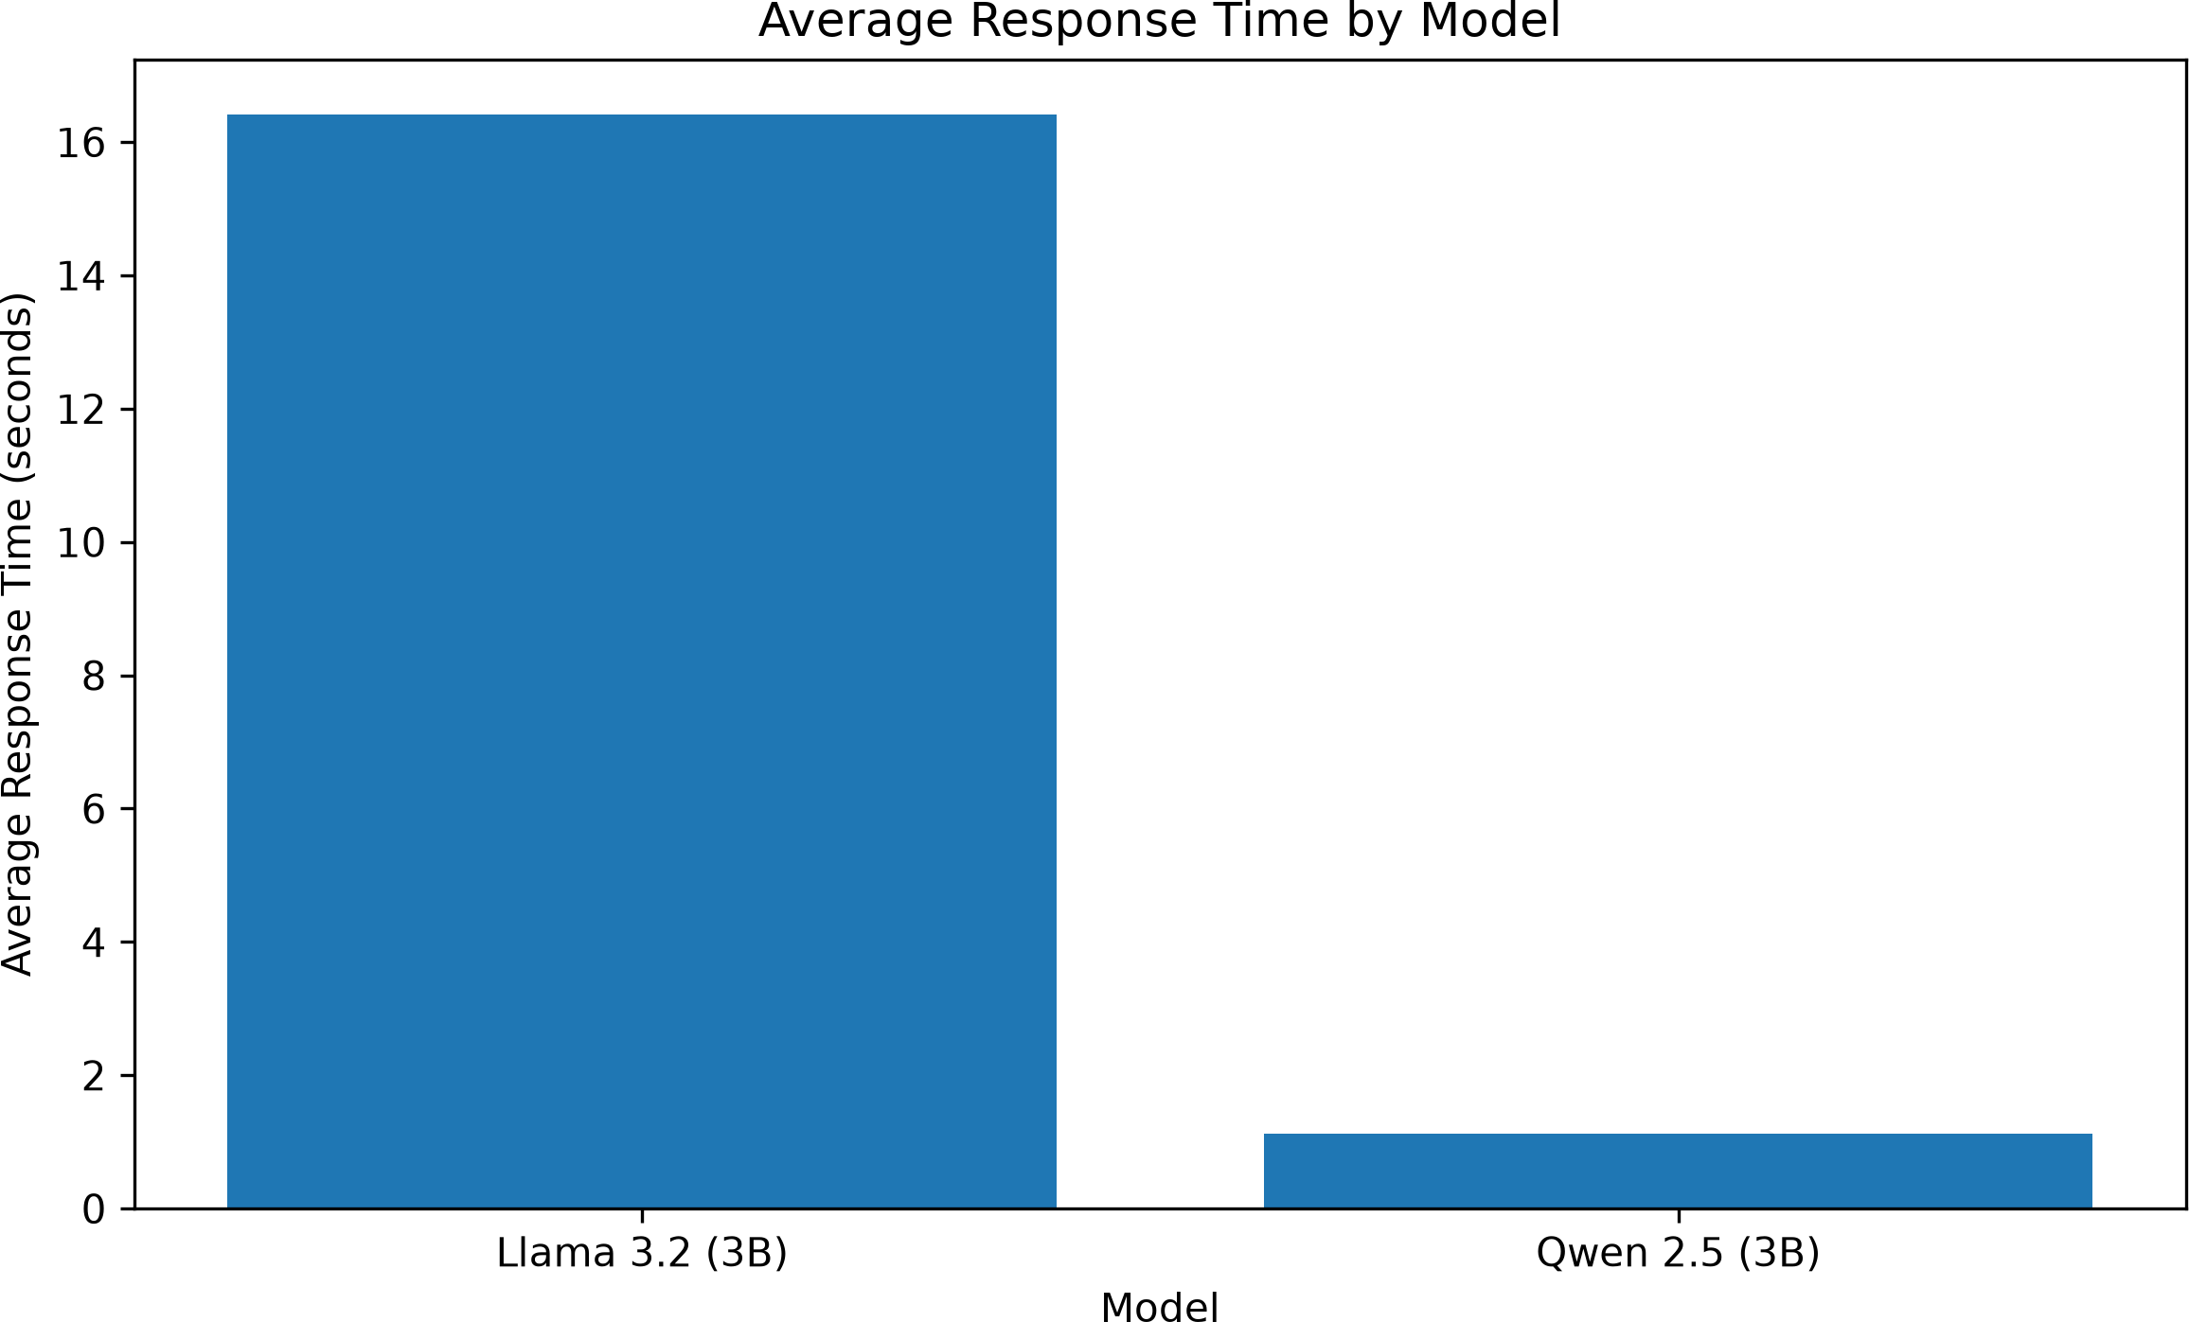

Figure 1. Average response time by model. Lower is faster.
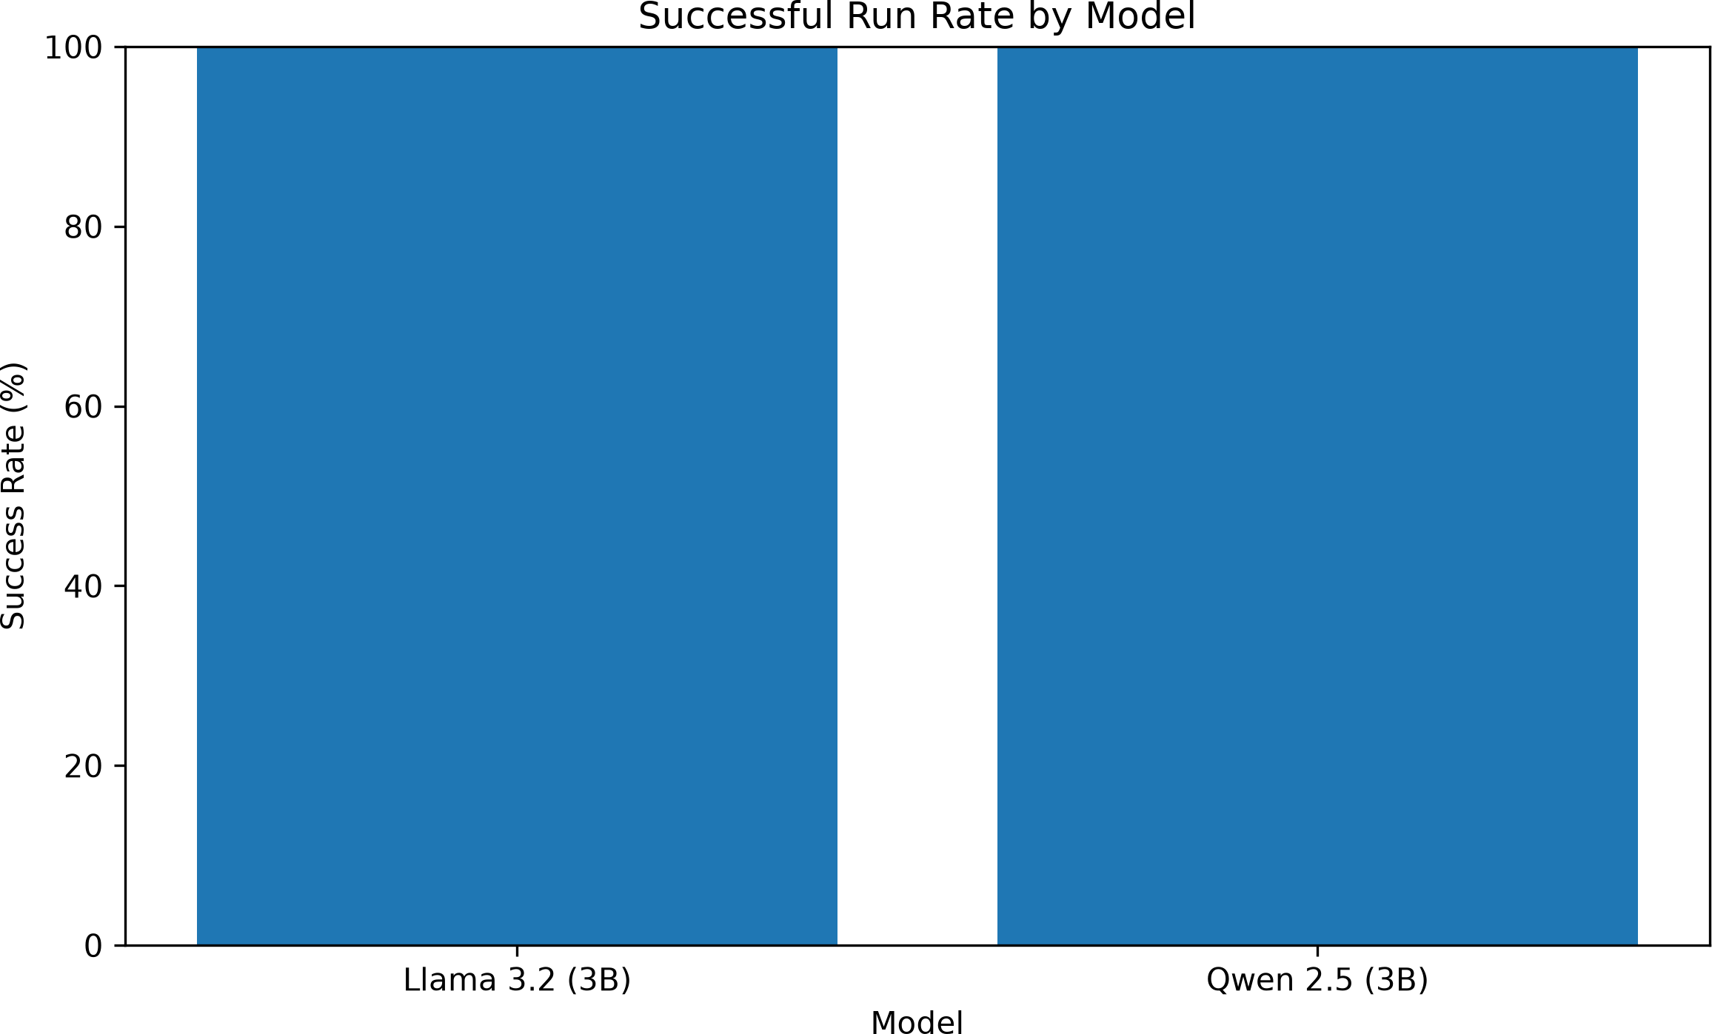

Figure 2. Recorded successful-run rate. Both models recorded 100%.

4. Graphical Results (continued)

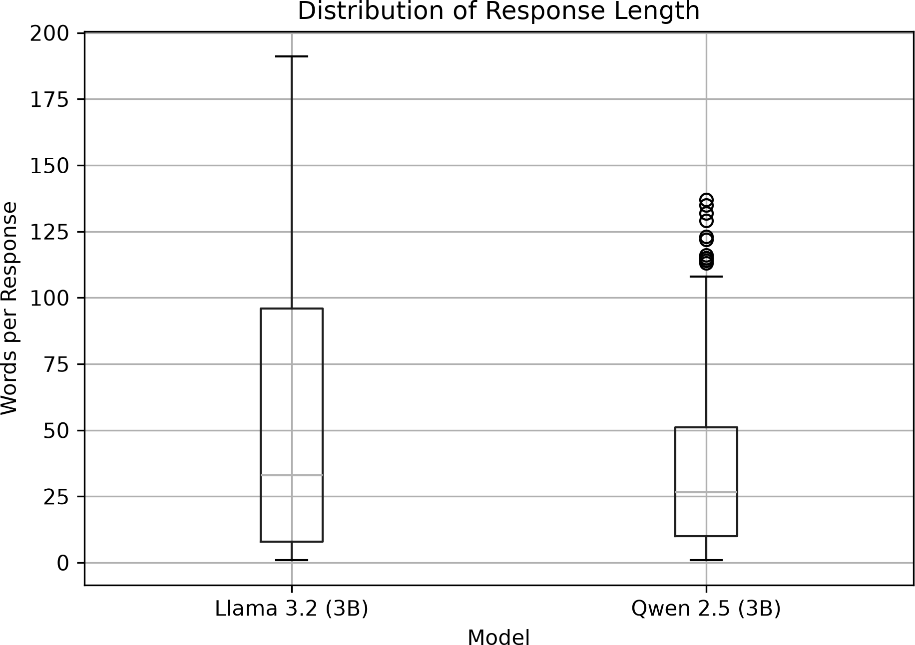

Figure 3. Distribution of response lengths in words.
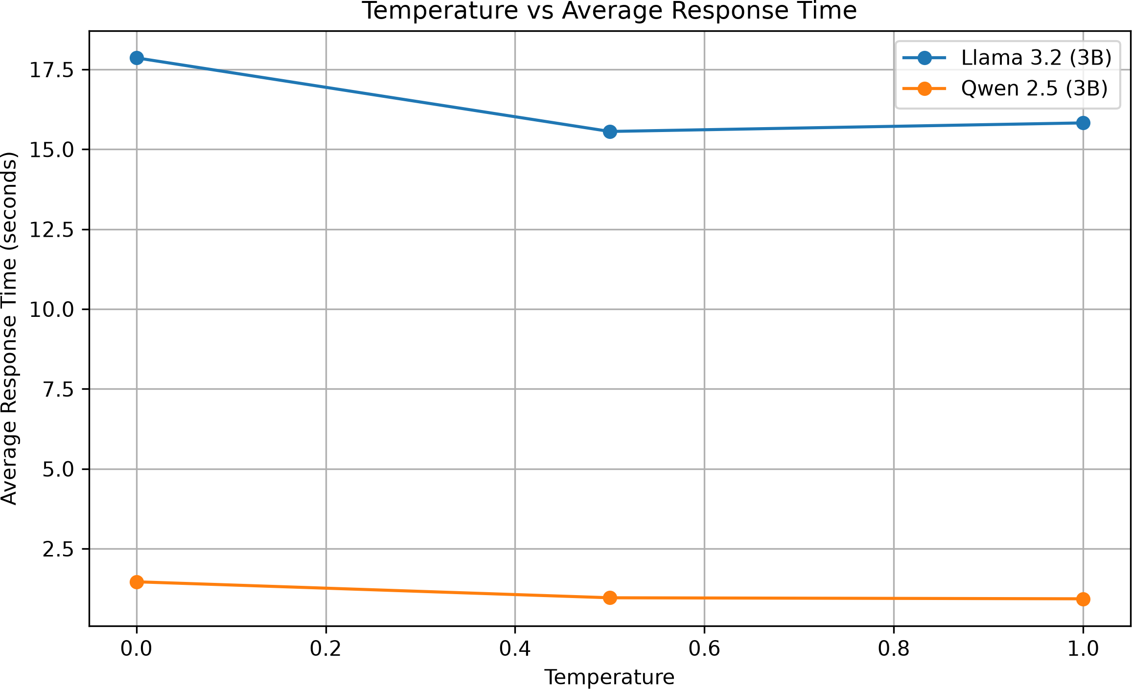

Figure 4. Temperature versus mean response time.

4. Graphical Results (continued)
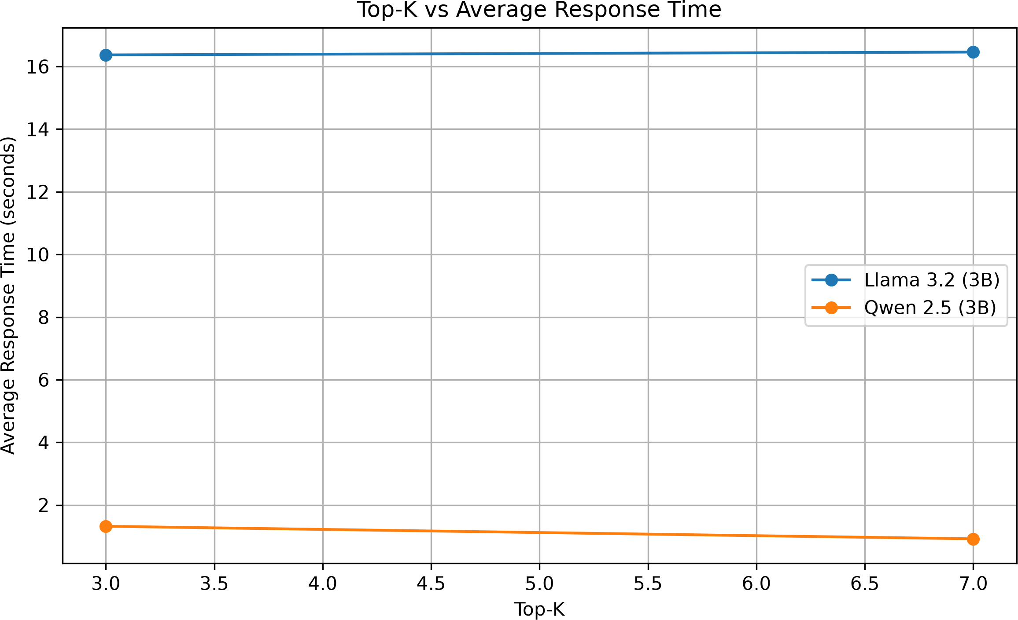
Figure 5. Top-k versus mean response time.
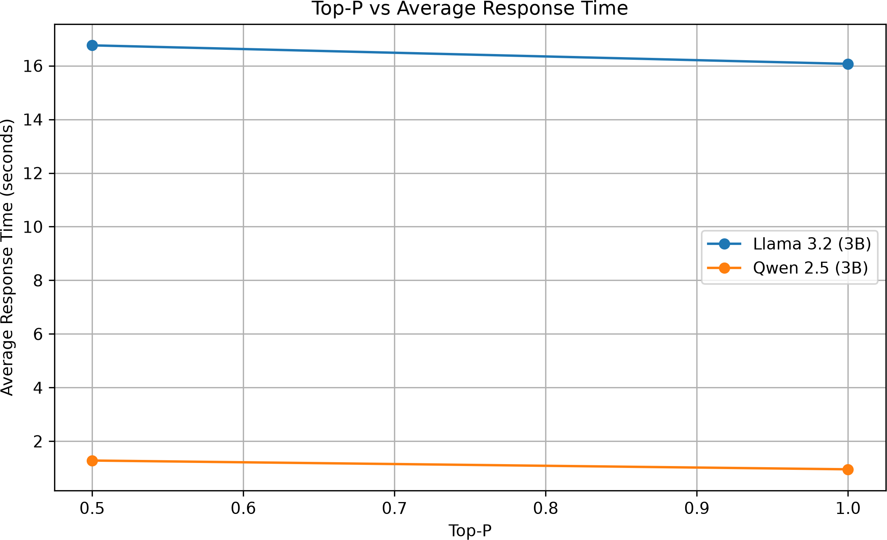

Figure 6. Top-p versus mean response time.

Graphical Results (continued)
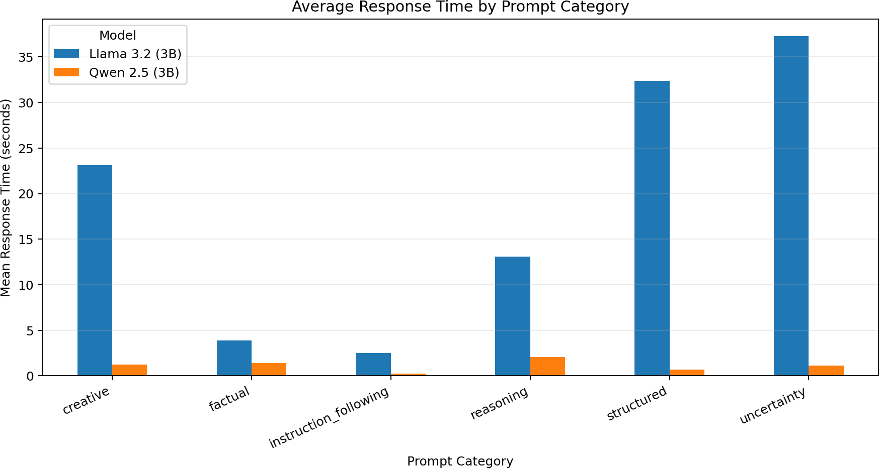
Figure 7. Average response time by prompt category. Category labels were mapped from prompt.json; this replaces the supplied plot whose category axis was labeled “unknown.”

Parameter-Level Analysis
The following figures summarize mean latency grouped by one sampling parameter at a time. Since other parameters and prompt types vary within each group, these are descriptive comparisons rather than causal estimates.
Mean response time by temperature (seconds)

Temperature | Llama 3.2 (3B) | Qwen 2.5 (3B)
0.0 | 17.86 s | 1.46 s
0.5 | 15.56 s | 0.96 s
1.0 | 15.83 s | 0.93 s

Mean response time by top_k (seconds)

Top-k | Llama 3.2 (3B) | Qwen 2.5 (3B)
3 | 16.37 s | 1.32 s
7 | 16.46 s | 0.92 s

Mean response time by top_p (seconds)

Top-p | Llama 3.2 (3B) | Qwen 2.5 (3B)
0.5 | 16.76 s | 1.28 s
1.0 | 16.07 s | 0.96 s

Prompt-Category Results
Category-level average response times are calculated by assigning each recorded prompt to its category in prompt.json, then averaging across all runs for that prompt category.

Category | Llama 3.2 (3B) | Qwen 2.5 (3B)
Creative | 23.15 s | 1.23 s
Factual | 3.89 s | 1.42 s
Instruction Following | 2.52 s | 0.26 s
Reasoning | 13.07 s | 2.06 s
Structured | 32.38 s | 0.68 s
Uncertainty | 37.31 s | 1.11 s

In the recorded results, Llama’s slowest category on average was uncertainty (37.31 s), followed by structured prompts (32.38 s) and creative prompts (23.15 s). Qwen’s highest category mean was reasoning (2.06 s), followed by factual (1.42 s) and creative (1.23 s). These values reflect latency only, not category accuracy.

Limitations and Validity Considerations
  - No ground-truth scoring: the CSVs record model responses and execution status, but no correctness, rubric, or human evaluation column. Accuracy and instruction compliance should not be inferred from success status.
  - Small prompt set: only 10 prompts are represented, with just one prompt each for uncertainty and creative tasks. Category-level conclusions for those categories are especially tentative.
  - Runtime dependence: latency can vary with hardware, model loading, quantization, local system load, and inference-server settings. These details were not established by the supplied files.
  - Response length: word count is a descriptive measure, not a quality metric. The box plot shows distribution and outliers but cannot tell whether answers are correct or appropriately detailed.
  - Parameter interactions: each parameter’s average is aggregated over other parameter values and prompt types. A controlled analysis would compare matched prompt/configuration pairs and consider warm-up separately.

Conclusions and Recommendations
For this benchmark run, Qwen 2.5 (3B) is the clear choice if the primary objective is lower response latency: its average recorded response time was about 14.7 times faster than Llama 3.2 (3B), while both achieved a 100% recorded success rate. Llama produced longer responses on average, which may or may not be beneficial depending on the task.
Recommended next steps:
- Score each response against an answer key or explicit rubric for factual correctness, reasoning, JSON validity, exact bullet/word counts, uncertainty handling, and yes/no compliance.
- Report quality scores alongside latency so model selection balances speed and usefulness.
- Repeat the experiment after separating model warm-up from timed runs, and report median and percentile latency as well as mean.
- Increase the number and diversity of prompts per category, especially creative and uncertainty tasks.
- Keep hardware, Ollama version, model tags, and runtime settings consistent and document them for reproducibility.

Appendix A. Prompt Set
The benchmark uses the following 10 prompts from the supplied prompt.json file. The category labels are retained as supplied.
- Factual — What is the capital city of Pakistan?

- Factual — How many days are there in a leap year?

- Reasoning — A notebook costs 100 rupees. What is the cost of 4 notebooks? Explain briefly.

- Reasoning — Find the next number in the sequence: 2, 4, 8, 16, . Explain the pattern.

- Structured — Return only valid JSON with keys name, age, and city. Use name Ali, age 22, and city Lahore.

- Structured — Return exactly three bullet points explaining the benefits of exercise.

- Uncertainty — What is the exact number of people currently inside the Eiffel Tower? If you do not have live data, say so.

- Creative — Write a short story about a robot that learns to paint, using no more than 100 words.

- Instruction Following — Answer only YES or NO: Is 17 a prime number?

- Instruction Following — Explain machine learning using exactly 20 words.

Appendix B. Source Files
This report was prepared from prompt.json, benchmark.py, lama_results.csv, qwen_results.csv, and the seven PNG plots contained in the uploaded Comparison graphs ZIP. The category-level graph was regenerated because the supplied category plot showed an “unknown” category label; the prompt categories were recovered from prompt.json.
All statistics in this report are computed from the supplied CSV records. No external answer-quality scoring was added.

Appendix B. Complete Benchmark Prompts
The complete prompt set below is reproduced from the supplied prompt.json file, preserving the original categories and wording.

Factual
What is the capital city of Pakistan?

Factual
How many days are there in a leap year?

Reasoning
A notebook costs 100 rupees. What is the cost of 4 notebooks? Explain briefly.

Reasoning
Find the next number in the sequence: 2, 4, 8, 16, . Explain the pattern.

Structured
Return only valid JSON with keys name, age, and city. Use name Ali, age 22, and city Lahore.

Structured
Return exactly three bullet points explaining the benefits of exercise.

Uncertainty
What is the exact number of people currently inside the Eiffel Tower? If you do not have live data, say so.

Creative
Write a short story about a robot that learns to paint, using no more than 100 words.

Instruction Following
Answer only YES or NO: Is 17 a prime number?

Instruction Following
Explain machine learning using exactly 20 words.

Appendix C. Benchmark Python Code
The following is the complete code from the supplied benchmark.py file. It loads prompts, evaluates the configured Ollama model across sampling settings, records run status and response time, and exports results to CSV.
import ollama import pandas as pd import time
import json

MODEL = "qwen2.5:3b" #when working with qwen
MODEL = "llama3.2" #When working with llama

# Load prompts from JSON file
with open("prompt.json", "r", encoding="utf-8") as file: prompt_data = json.load(file)

# Extract prompt text
prompts = [item["prompt"] for item in prompt_data]

temperatures = [0.0, 0.5, 1.0]
top_ks = [3, 7]
top_ps = [0.5, 1.0] results = []
for prompt in prompts:
for temperature in temperatures: for top_k in top_ks:
for top_p in top_ps:
for run in range(1, 3): try:
start = time.time()

response = ollama.chat( model=MODEL, messages=[
{"role": "user", "content": prompt}
],
options={
"temperature": temperature, "top_k": top_k,
"top_p": top_p
}
)

answer = response["message"]["content"] elapsed = round(time.time() - start, 2)

results.append({ "model": MODEL, "prompt": prompt,

"temperature": temperature, "top_k": top_k,
"top_p": top_p, "run": run, "response": answer,
"response_time_seconds": elapsed, "status": "success"
})

print(
f"Completed: T={temperature}, " f"Top-K={top_k}, Top-P={top_p}, " f"Run={run}"
)

except Exception as error: print("Error:", error)

results.append({ "model": MODEL, "prompt": prompt,
"temperature": temperature, "top_k": top_k,
"top_p": top_p, "run": run,
"response": str(error), "response_time_seconds": None, "status": "failed"
})

# Save all results to CSV df = pd.DataFrame(results)
df.to_csv("results.csv", index=False, encoding="utf-8-sig")

print("\nExperiment finished.") print("Results saved to results.csv") print("Total records:", len(df))
print("Successful runs:", (df["status"] == "success").sum())
print("Failed runs:", (df["status"] == "failed").sum())

Appendix D. Complete Matplotlib Comparison Python Code
The complete compare_results.py code used to load both model CSV files, calculate numerical summaries, generate Matplotlib graphs, and save the comparison report is included below.

from pathlib import Path
import re
import json
import ast
import pandas as pd
import matplotlib.pyplot as plt

# ==========================================
# 1. FILE PATHS AND OUTPUT FOLDER
# ==========================================

BASE_DIR = Path(__file__).resolve().parent

LLAMA_FILE = BASE_DIR / "lama_results.csv"
QWEN_FILE = BASE_DIR / "qwen_results.csv"

OUTPUT_DIR = BASE_DIR / "comparison_report"
PLOT_DIR = OUTPUT_DIR / "plots"

OUTPUT_DIR.mkdir(exist_ok=True)
PLOT_DIR.mkdir(exist_ok=True)

# ==========================================
# 2. LOAD AND CLEAN DATA
# ==========================================

def load_results(file_path, model_name):
if not file_path.exists():
raise FileNotFoundError(
f"File not found: {file_path}\n"
"Please check the CSV filename."
)

df = pd.read_csv(file_path, encoding="utf-8-sig")
df.columns = df.columns.str.strip().str.lower()

required = [
"temperature",
"top_k",
"top_p",
"response",
"response_time_seconds",
]

missing = [col for col in required if col not in df.columns]
if missing:
raise ValueError(
f"{file_path.name} is missing columns: {missing}\n"
f"Available columns: {list(df.columns)}"
)

# Standardize the model name for comparison
df["model"] = model_name

# Convert numeric columns safely
for col in [
"temperature",
"top_k",
"top_p",
"response_time_seconds",
]:
df[col] = pd.to_numeric(df[col], errors="coerce")

if "status" not in df.columns:
df["status"] = "unknown"

df["status"] = df["status"].fillna("unknown").astype(str).str.lower()

# Use the recorded status where available
df["success"] = df["status"].eq("success")

# Normalize response text
df["response"] = df["response"].fillna("").astype(str)

# Failed runs should not be treated as valid model answers
df["response_length_words"] = (
df["response"].str.split().str.len()
)

# Use prompt category if available
if "category" not in df.columns:
df["category"] = "unknown"

return df

llama = load_results(LLAMA_FILE, "Llama 3.2 (3B)")
qwen = load_results(QWEN_FILE, "Qwen 2.5 (3B)")

# Combine both datasets
data = pd.concat([llama, qwen], ignore_index=True)

data.to_csv(
OUTPUT_DIR / "combined_results.csv",
index=False,
encoding="utf-8-sig",
)

print("\n========== DATASET OVERVIEW ==========")
print("Total records:", len(data))
print("Models:", data["model"].unique().tolist())
print("\nRecords by model:")
print(data.groupby("model").size())

# ==========================================
# 3. NUMERICAL SUMMARY
# ==========================================

def success_rate(series):
known = series.isin(["success", "failed"])
if known.sum() == 0:
return float("nan")
return 100 * series[known].eq("success").mean()

summary_rows = []

for model_name, group in data.groupby("model", sort=False):
successful = group[group["success"]]

summary_rows.append({
"model": model_name,
"total_runs": len(group),
"successful_runs": int(group["success"].sum()),
"failed_runs": int(group["status"].eq("failed").sum()),
"success_rate_percent": success_rate(group["status"]),
"mean_response_time_seconds":
successful["response_time_seconds"].mean(),
"median_response_time_seconds":
successful["response_time_seconds"].median(),
"mean_response_words":
successful["response_length_words"].mean(),
})

summary = pd.DataFrame(summary_rows)

summary.to_csv(
OUTPUT_DIR / "model_summary.csv",
index=False,
encoding="utf-8-sig",
)

print("\n========== MODEL COMPARISON ==========")
print(summary.round(3).to_string(index=False))

# ==========================================
# 4. PARAMETER-WISE SUMMARY
# ==========================================

successful_data = data[data["success"]].copy()

parameter_summary = (
successful_data.groupby(
["model", "temperature", "top_k", "top_p"],
dropna=False,
)
.agg(
successful_runs=("response", "size"),
mean_response_time=("response_time_seconds", "mean"),
mean_response_words=("response_length_words", "mean"),
)
.reset_index()
)

parameter_summary.to_csv(
OUTPUT_DIR / "parameter_summary.csv",
index=False,
encoding="utf-8-sig",
)

print("\n========== PARAMETER SUMMARY ==========")
print(parameter_summary.round(3).to_string(index=False))

# ==========================================
# 5. GRAPH 1: AVERAGE RESPONSE TIME
# ==========================================

if summary["mean_response_time_seconds"].notna().any():
plot_data = summary.dropna(
subset=["mean_response_time_seconds"]
)

plt.figure(figsize=(8, 5))
plt.bar(
plot_data["model"],
plot_data["mean_response_time_seconds"],
)
plt.title("Average Response Time by Model")
plt.xlabel("Model")
plt.ylabel("Average Response Time (seconds)")
plt.tight_layout()
plt.savefig(PLOT_DIR / "01_average_response_time.png", dpi=300)
plt.close()

# ==========================================
# 6. GRAPH 2: SUCCESS RATE
# ==========================================

plot_data = summary.dropna(subset=["success_rate_percent"])

if not plot_data.empty:
plt.figure(figsize=(8, 5))
plt.bar(
plot_data["model"],
plot_data["success_rate_percent"],
)
plt.ylim(0, 100)
plt.title("Successful Run Rate by Model")
plt.xlabel("Model")
plt.ylabel("Success Rate (%)")
plt.tight_layout()
plt.savefig(PLOT_DIR / "02_success_rate.png", dpi=300)
plt.close()

# ==========================================
# 7. GRAPH 3: RESPONSE LENGTH
# ==========================================

if not successful_data.empty:
length_data = successful_data.dropna(
subset=["response_length_words"]
)

if not length_data.empty:
plt.figure(figsize=(8, 5))
length_data.boxplot(
column="response_length_words",
by="model",
)
plt.suptitle("")
plt.title("Distribution of Response Length")
plt.xlabel("Model")
plt.ylabel("Words per Response")
plt.tight_layout()
plt.savefig(PLOT_DIR / "03_response_length.png", dpi=300)
plt.close()

# ==========================================
# 8. GRAPH 4: TEMPERATURE EFFECT
# ==========================================

if not successful_data.empty:
temp_summary = (
successful_data.groupby(["model", "temperature"])
["response_time_seconds"]
.mean()
.reset_index()
)

plt.figure(figsize=(8, 5))

for model_name, group in temp_summary.groupby("model"):
plt.plot(
group["temperature"],
group["response_time_seconds"],
marker="o",
label=model_name,
)

plt.title("Temperature vs Average Response Time")
plt.xlabel("Temperature")
plt.ylabel("Average Response Time (seconds)")
plt.legend()
plt.grid(True)
plt.tight_layout()
plt.savefig(PLOT_DIR / "04_temperature_effect.png", dpi=300)
plt.close()

# ==========================================
# 9. GRAPH 5: TOP-K EFFECT
# ==========================================

if not successful_data.empty:
topk_summary = (
successful_data.groupby(["model", "top_k"])
["response_time_seconds"]
.mean()
.reset_index()
)

plt.figure(figsize=(8, 5))

for model_name, group in topk_summary.groupby("model"):
plt.plot(
group["top_k"],
group["response_time_seconds"],
marker="o",
label=model_name,
)

plt.title("Top-K vs Average Response Time")
plt.xlabel("Top-K")
plt.ylabel("Average Response Time (seconds)")
plt.legend()
plt.grid(True)
plt.tight_layout()
plt.savefig(PLOT_DIR / "05_top_k_effect.png", dpi=300)
plt.close()

# ==========================================
# 10. GRAPH 6: TOP-P EFFECT
# ==========================================

if not successful_data.empty:
topp_summary = (
successful_data.groupby(["model", "top_p"])
["response_time_seconds"]
.mean()
.reset_index()
)

plt.figure(figsize=(8, 5))

for model_name, group in topp_summary.groupby("model"):
plt.plot(
group["top_p"],
group["response_time_seconds"],
marker="o",
label=model_name,
)

plt.title("Top-P vs Average Response Time")
plt.xlabel("Top-P")
plt.ylabel("Average Response Time (seconds)")
plt.legend()
plt.grid(True)
plt.tight_layout()
plt.savefig(PLOT_DIR / "06_top_p_effect.png", dpi=300)
plt.close()

# ==========================================
# 11. GRAPH 7: RESPONSE TIME BY CATEGORY
# ==========================================

if not successful_data.empty:
category_data = (
successful_data.groupby(["category", "model"])
["response_time_seconds"]
.mean()
.unstack("model")
)

if not category_data.empty:
category_data.plot(kind="bar", figsize=(10, 6))
plt.title("Average Response Time by Prompt Category")
plt.xlabel("Prompt Category")
plt.ylabel("Average Response Time (seconds)")
plt.xticks(rotation=30, ha="right")
plt.tight_layout()
plt.savefig(
PLOT_DIR / "07_category_response_time.png",
dpi=300,
)
plt.close()

# ==========================================
# 12. GENERATE AUTOMATIC SUMMARY TEXT
# ==========================================

report_lines = [
"LLM BENCHMARKING: NUMERICAL SUMMARY",
"=" * 45,
f"Total combined records: {len(data)}",
"",
]

for _, row in summary.iterrows():
report_lines.extend([
f"Model: {row['model']}",
f"Total runs: {row['total_runs']}",
f"Successful runs: {row['successful_runs']}",
f"Failed runs: {row['failed_runs']}",
f"Success rate (%): {row['success_rate_percent']:.2f}"
if pd.notna(row["success_rate_percent"])
else "Success rate (%): unavailable",
f"Mean response time (s): "
f"{row['mean_response_time_seconds']:.3f}"
if pd.notna(row["mean_response_time_seconds"])
else "Mean response time: unavailable",
f"Mean response length (words): "
f"{row['mean_response_words']:.2f}"
if pd.notna(row["mean_response_words"])
else "Mean response length: unavailable",
"",
])

report_lines.extend([
"IMPORTANT LIMITATIONS",
"- Response length is not a measure of answer quality.",
"- Response time can depend on hardware and system load.",
"- Hallucination requires factual checking of the answers.",
"- Consistency requires comparing repeated answers.",
"- Formatting compliance requires task-specific validation.",
])

(OUTPUT_DIR / "numerical_report.txt").write_text(
"\n".join(report_lines),
encoding="utf-8",
)

print("\n========== FINISHED ==========")
print("Numerical summary saved to:", OUTPUT_DIR / "model_summary.csv")
print("Parameter summary saved to:", OUTPUT_DIR / "parameter_summary.csv")
print("Text report saved to:", OUTPUT_DIR / "numerical_report.txt")
print("Graphs saved in:", PLOT_DIR)

Appendix E. prompt.json
The JSON prompt dataset used for the benchmark is reproduced below, retaining the prompt categories and wording listed in the report.
[
{
"category": "factual",
"prompt": "What is the capital city of Pakistan?"
},
{
"category": "factual",
"prompt": "How many days are there in a leap year?"
},
{
"category": "reasoning",
"prompt": "A notebook costs 100 rupees. What is the cost of 4 notebooks? Explain briefly."
},
{
"category": "reasoning",
"prompt": "Find the next number in the sequence: 2, 4, 8, 16, . Explain the pattern."
},
{
"category": "structured",
"prompt": "Return only valid JSON with keys name, age, and city. Use name Ali, age 22, and city Lahore."
},
{
"category": "structured",
"prompt": "Return exactly three bullet points explaining the benefits of exercise."
},
{
"category": "uncertainty",
"prompt": "What is the exact number of people currently inside the Eiffel Tower? If you do not have live data, say so."
},
{
"category": "creative",
"prompt": "Write a short story about a robot that learns to paint, using no more than 100 words."
},
{
"category": "instruction_following",
"prompt": "Answer only YES or NO: Is 17 a prime number?"
},
{
"category": "instruction_following",
"prompt": "Explain machine learning using exactly 20 words."
}
]

