Startuplen
(Smart Analysis for Smarter Startups )

Team Name
Hack Hustle

(From Moradabad Institute of Technology, Moradabad – 244001 (U.P.) India)

 Team Members 
Ishika Gagneja,
Iqra Hussian,
Varsha Kumari,
Mahima Yadav

Idea Submission
For HACKATHON 4.0
Organised by Techedge cell under the guidance of Shri Ram Murti Smarak College of Engineering & Technology, Bareilly (U.P.) India
Under the problem statement
“Sustainable and Profitable Solutions for Startups”
which aligns with the key aspect
“Innovate for Impact: Tech Solutions for Advancing SDGs”
Table of content
1. Problem Description
a. Background
b. Present Obstacles
c. Impact
2. Proposed Solution
a. Overview
b. Key Features
c. 5 Unique Standout Points (USPs)
3. Proposed Technology
a. Technology Stack
4. Resources Required
a. Human Resources
b. Technical Resources
c. Other Resources
5. Budget
a. Hosting and Deployment
b. Miscellaneous Cost
c. Future Cost
6. Alignment with Hackathon Theme & SDGs and Impact

Problem Description
Background
In today’s fast-changing and highly competitive market, many startups and small businesses struggle to survive due to a lack of reliable market insights. Entrepreneurs often make decisions based on assumptions rather than data, leading to poor demand estimation, ineffective strategies, and financial losses.

Present Obstacles in Building a Successful Startup
- Lack of proper market research
- Poor understanding of customer needs
- Inaccurate demand forecasting
- Weak business strategy or planning
- Ineffective marketing and branding
- Rapidly changing market trends
- Delayed product-market fit
- Lack of mentorship or industry guidance
- Overdependence on assumptions instead of data

Proposed Solution

Overview:
Despite a booming ecosystem, 90% of startups fail due to "Strategic Blindness"—the inability to convert raw data into actionable growth. Early-stage founders frequently succumb to inefficient capital allocation and vanity metrics, lacking the 360-degree financial and operational oversight required for sustainability. Startup Analyzer bridges this gap by replacing gut-based intuition with a data-driven "Digital Co-Founder" to prevent premature failure.

Features:
- Reduction in Startup Failure Rates-Identifies strategic blind spots early, reducing failure risk through continuous data-driven performance monitoring.
- Improved Strategic Decision-Making-Enables founders to replace intuition with analytical insights for accurate, timely, and informed business decisions.
- Optimized Capital Utilization-Detects inefficient spending patterns and guides founders toward smarter resource allocation aligned with growth priorities.
- Enhanced Financial Visibility-Provides real-time financial insights, improving cash flow awareness, runway planning, and long-term sustainability control.
- Focus on Meaningful Growth Metrics-Prioritizes actionable KPIs over vanity metrics, ensuring founders focus on genuine business performance indicators.
- Early Risk Detection and Prevention-Predictive analytics highlight operational and financial risks early, enabling proactive corrective strategies before escalation.
- Investor Confidence and Credibility-Structured performance reporting enhances transparency, strengthening investor trust and improving funding communication outcomes.
- Scalable and Sustainable Growth Enablement-Aligns operational efficiency, financial discipline, and strategic planning to support scalable and sustainable startup growth.

Why Do Related Apps Fail?
In the market, similar tools fall into three categories:
Analytics dashboards
Business planning tools
Financial tracking software

- They Show Data, Not Decisions
Most platforms:
Display graphs and KPIs
Generate reports
But they do not:
Suggest clear next steps
Prioritize weaknesses
Calculate risk probability
Result: Founders see data but lack direction.
- Too Complex for Early-Stage Founders
Many tools are:
Enterprise-focused
Heavy in financial jargon
Complex to set up
Early-stage founders need simple validation support — not corporate dashboards.
Result: Complexity leads to low adoption and drop-offs.
- No Idea-Stage Support
Most platforms focus only on post-launch analytics.
They do not provide:
Idea validation scoring
Product–market fit readiness
Investor readiness assessment
Result: This is the biggest gap in the market.

Why Our Idea Is Strong
Startup Analyzer is not just an analytics tool — it is a decision intelligence platform.
- Idea-to-Growth Coverage
It integrates:
Idea validation
Business model clarity
Financial health scoring
Risk prediction
Strategic roadmap
Most competitors solve only one part.
You provide an integrated solution.
- Decision-Oriented Output
Instead of just showing data, it provides:
Weakness detection
Risk alerts
Priority recommendations
Structured action plans
This “decision intelligence layer” makes it unique.
- Focus on Early-Stage Founders
Target users:
College founders
Pre-seed startups
Idea-stage entrepreneurs
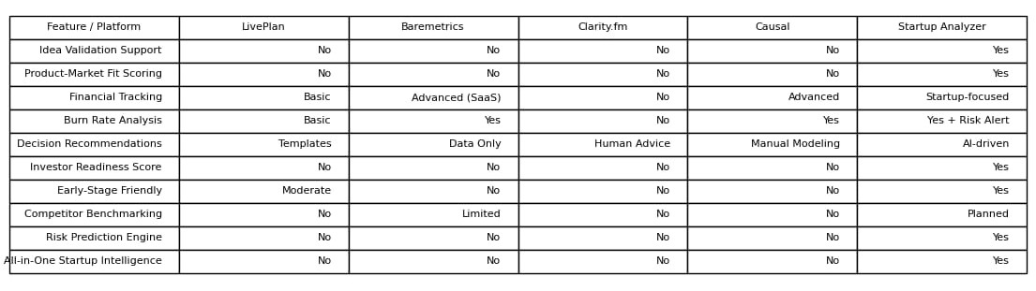
There is almost no simplified, intelligent platform built specifically for them.

Proposed Technology
Technology Stack
1. Frontend – ReactJS
- Provides a responsive web dashboard for startups and small business owners.
- Allows users to input business details such as industry, target audience, location, investment amount, and product/service description.
- Displays business viability score, market demand trends, competition level, risk index, and profit potential using interactive charts and visual cards.
2. Backend – Node.js
- Handles API requests, user authentication, and secure data processing.
- Connects frontend with AI/ML prediction modules.
- Integrates external data sources such as market trends, industry reports, and competitor data.
- Stores user inputs, business reports, and analytics in a MongoDB database for scalability and fast retrieval.

3.AI Intelligence Engine – Python
- Uses a Hybrid AI Architecture (Scoring + RAG + LLM)
- Computes Business Viability Score (0–100)
- Calculates Risk Index & Growth Potential
- Performs real-time market context retrieval (RAG)
- Analyzes industry trends & competition dynamically
- Uses LLM to generate:
  - Strengths & Weaknesses
  - Risk Factors
  - Profit Outlook
  - Strategic Recommendations
- NLP analyzes business description for clarity & uniqueness

4. Data & Trend Integration
- Collects and analyzes data from:
  - Industry reports
  - Search trends
  - Competitor presence
  - Market demand indicators
- Provides real-time trend insights and saturation analysis.

5. Recommendation & Optimization Engine
- Suggests:
  - Target market improvements
  - Pricing strategy adjustments
  - Differentiation strategies
  - Marketing channel recommendations
- Helps startups modify their plan before investment to increase profitability and reduce risk.

SDG Alignment and Impact

- SDG 8 – Decent Work and Economic Growth
- SDG 9 – Industry, Innovation and Infrastructure
- SDG 1 – No Poverty
- SDG 10 – Reduced Inequalities

END OF REPORT

A project report by Team Startuplen

(From Moradabad Institute of Technology, Moradabad – 244001 (U.P.) India)

