Obstacle detecting Autonomous Robot
Project report submitted to sir ASIF KHAN
Iqra Nadeem CMS-ID 023-20-0116
Shoba Rohra CMS-ID 023-20-0009
S
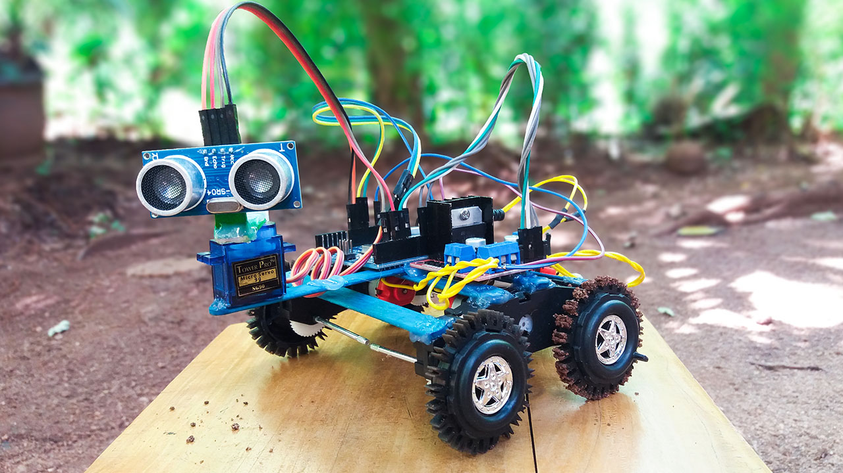

Abstract

The autonomous vehicle industry is expanding. According to studies, nine out of ten traffic accidents are caused by human error; if the safety of autonomous vehicles can be improved, they have the potential to save thousands of lives each year. However, obstacle-detecting autonomous robots can also be used in other situations, such as when the terrain is inaccessible to humans for a variety of reasons.
A self-navigating obstacle-detecting robot was created in this project. Ultrasonic sensors are used by the robot to detect and avoid obstacles. An algorithm for robot navigation was developed and implemented on the Arduino. Two servo motors were used to power the wheels. The robot had three wheels: two in the back for the servo motors and one in the front for the caster wheel.
This allowed differential drive to be implemented, allowing for quick and tight turns.
Tests revealed that the robot could successfully navigate a room with various obstacles placed out. Given the number of sensors used, the placement of the sensors worked well. If more sensors had been used, obstacle detection could have been improved. The tests also confirmed that ultrasonic sensors are effective for this type of application. Mechatronics, Autonomous Robot, Ultrasonic Sensors, Servo Motors, Arduino are some of the terms used in this paper.

Table of Contents
Table of Contents 4
Project Description 4
Introduction: 4
Background: 4
Purposes: 4
Scope: 4
Method: 5
Working of components: 5
Ultrasonic sensors 5
Servo motors 6
Micro controller: 6
Arduino: 6
Hardware list (with prices) 6
Test and Resulting: 10
Movement: 10
Navigation: 10
Sensor tests: 10
Obstacle test 11
Conclusion 11

Project Description

Introduction:
Autonomous vehicles can be used for a variety of purposes, and the industry is expanding. With autonomous vehicles come new challenges, the most important of which is safety. If the safety is adequate, autonomous vehicles could save thousands of lives each year. According to studies, nine out of ten traffic accidents are caused by human error. Other advantages of autonomous vehicles include increased energy efficiency and lower driving costs. This report describes the creation of an obstacle-detecting autonomous robot.

Background:
Autonomous robots can move freely and operate without the need for direct human supervision. They can make their own decisions based on what they perceive and are programmed to recognize. There are numerous applications for an obstacle-detecting autonomous robot. The technique, for example, can be used in automobiles. If the control system is fast enough, it can reduce the speed quickly and avoid accidents with moving obstacles. As traffic becomes more complex due to new situations, the demands on the control system and algorithms increase.
Autonomous robots can also be used in situations where humans would be dangerous or inappropriate.

Purposes:
The goal of this project was to create a robot capable of detecting obstacles in its path and avoiding them by turning in a different direction.

Scope:
The world was experiencing a major pandemic at the time this thesis was written.
No one was prepared when the pandemic struck in the middle of the project.
This presented a number of challenges because we were no longer permitted to be on campus and thus could not access the lab, which contained all of the necessary equipment and tools. Things we needed were shipped to us to help with this.

Method:
The research questions were developed as the first step in this project. The next step was to collect data on autonomous robots and obstacle detection.
This was accomplished by reading articles and researching previous year's projects on the subject. The components required for the prototype could be determined through a review of the literature. The prototype was then created. A design was created using the Autodesk Fusion program. Sensor axles and brackets were 3D printed. The bottom plate was created in Adobe Illustrator and laser cut out.
When the construction was finished, the algorithm was programmed using the Arduino software Integrated Development Environment (IDE).
To avoid collisions, the robot must be capable of all obstacles in its path.

Working of components:
Ultrasonic sensors:
Ultrasonic sensors are an excellent choice for measuring the distance between a moving object and any obstacles that may appear in its path. They are inexpensive but not very precise. When there is an object in front of them, ultrasonic sensors transmit pulses of ultrasonic sound-waves that propagate through the air and are reflected and received by the sensor. If an object is in front of the sensor, the sound-waves are reflected and returned to the receiver. One disadvantage is that if the object in front of the sensor is tilted relative to the sensor's transceiver, only a small portion of the sound-wave is reflected back to the sensor, resulting in the object not being detected. This may be possible.

l =tc/2

Where l denotes distance, t denotes time, and c denotes sound speed. It is divided by two because the time is measured from when the signal is transmitted from the sensor to when it is received, and the sound-waves have travelled the distance twice, back and forth, during that time. The value of the speed of sound makes the calculations less accurate. Because the speed of sound varies with temperature, using the same value all the time is not ideal. To improve this, a temperature sensor could be used to continuously update the value.

Servo motors:
Servo motors are straightforward electric motors that provide closed-loop position control. A signal, also known as Pulse Width Modulation, controls them (PWM).
PWM is a technique that employs digital control to generate a square wave, which is a signal that alternates between full on and full off. PWM produces analogue results using digital means. It simulates various voltages between full on and full off based on the amount of time the signal is on versus off. If the on-off pattern is repeated quickly enough, the signal appears to be a steady voltage. Control of linear or angular position, velocity, and acceleration is provided by the servo motor. They differ in their approaches.

Micro controller:

A microcontroller is a small computer that contains the majority of the necessary support chips. They are frequently embedded inside other devices and can thus control the product's features and actions. The microcontroller controls the device by receiving input and sending signals to various components. The microcontroller is made up of a microprocessor and primary memory that are linked by a system bus. The Central Processing Unit 6 is housed in the microprocessor.

Arduino:
The Arduino Uno microcontroller is used in this project. Arduino is a platform that is open source. The Arduino boards can be easily programmed using the Arduino IDE. The Arduino Uno is built around the microcontroller ATmega328P, which has 32 kB of flash memory. It has 14 digital I/O pins, six of which can be used as PWM outputs. To power the board, connect it to a computer via a USB cable or to an external power supply; the recommended voltage input is 7-12 V. It may become unstable if powered with less than 7 V, and more than 12 V may cause the voltage regulator to overheat and damage the board.

Hardware list (with prices)

Ultrasonic sensors
Push switch
Tilt sensors
Accelerometers
Gyroscope
Proximity sensors
Arduino
Servo motor

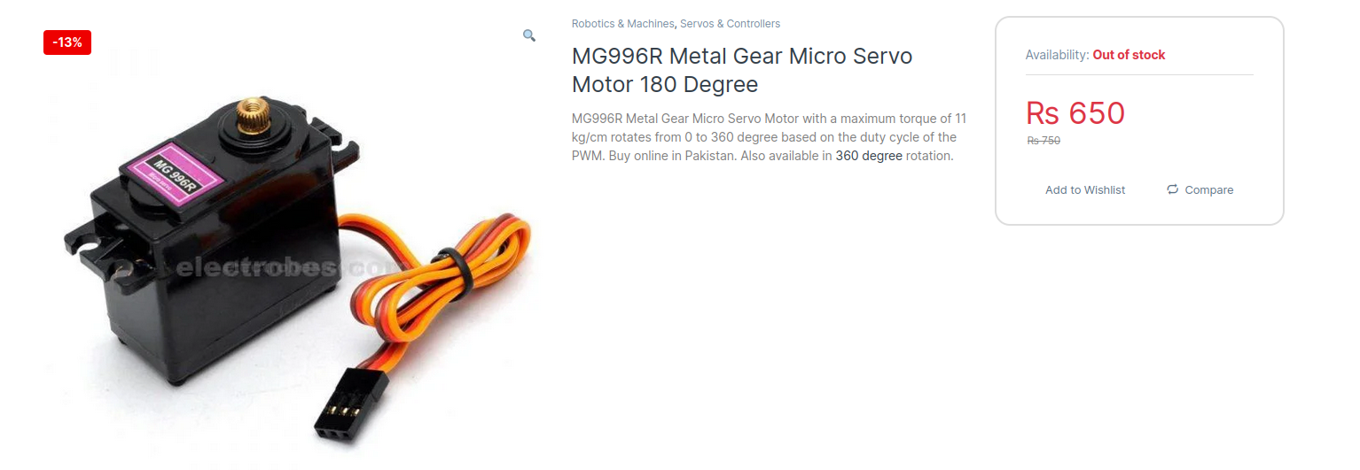
Servo motor

Ultrasonic sensor
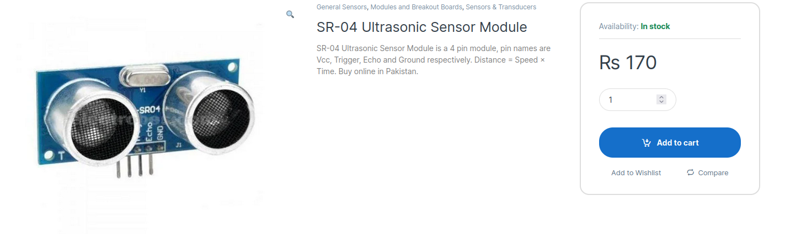

Tilt sensor
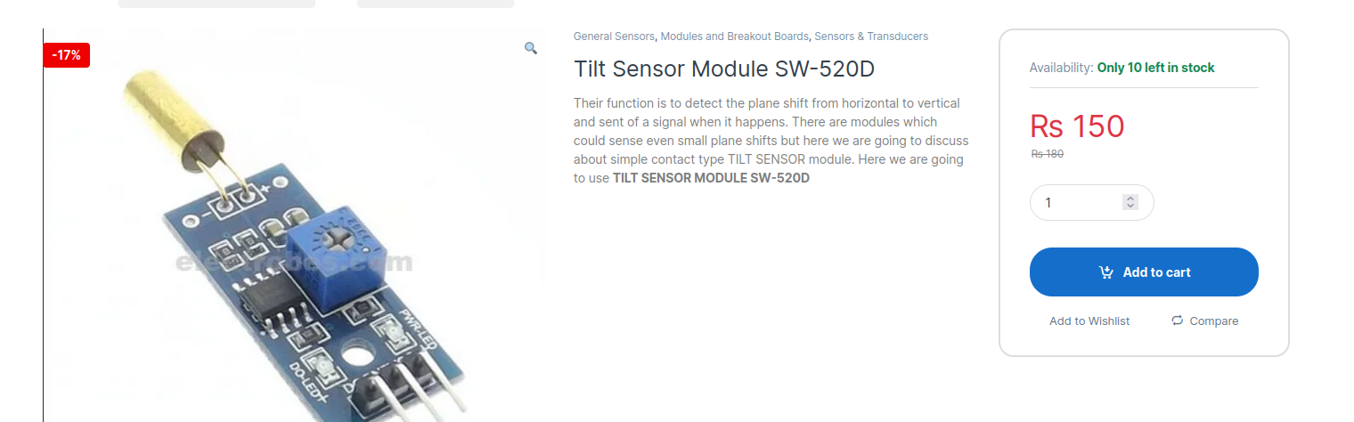

Accelerometer
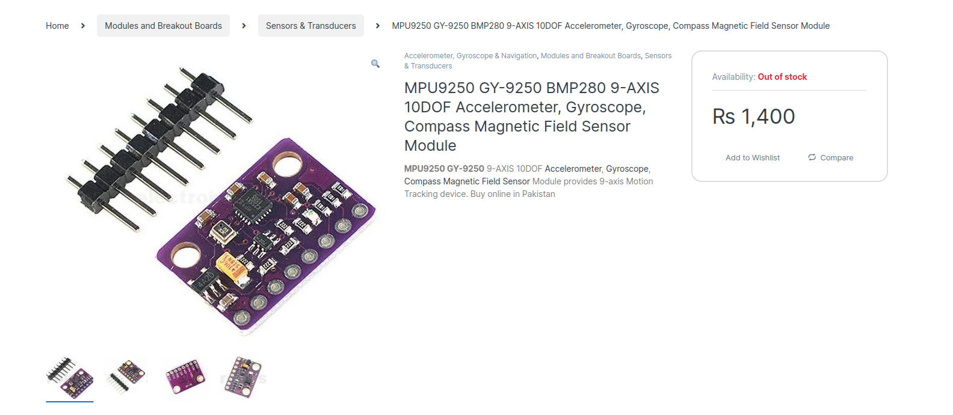

Proximity sensor

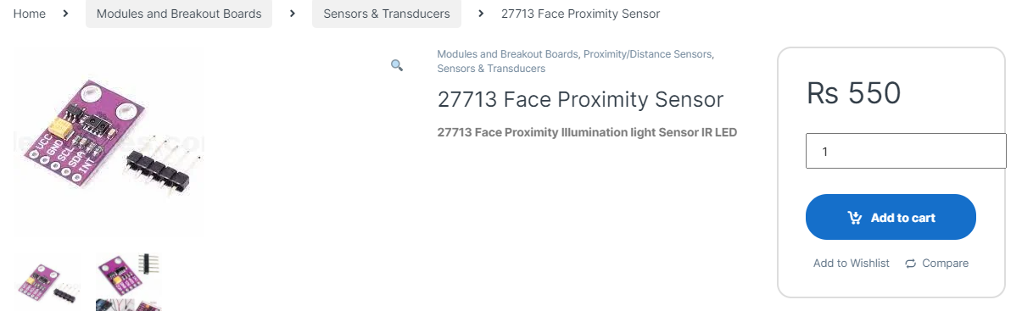

Push button
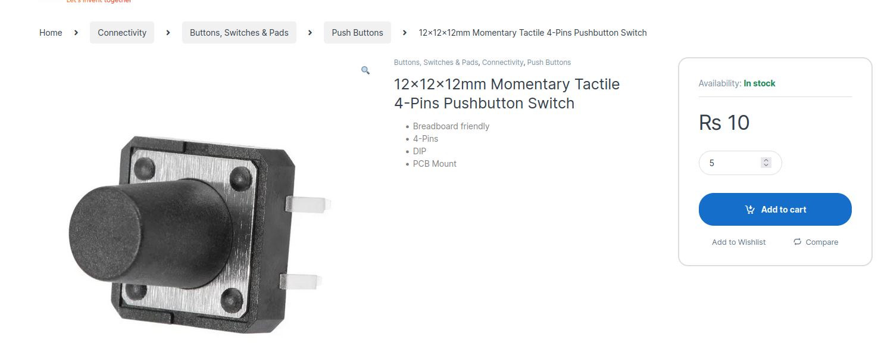

Arduino

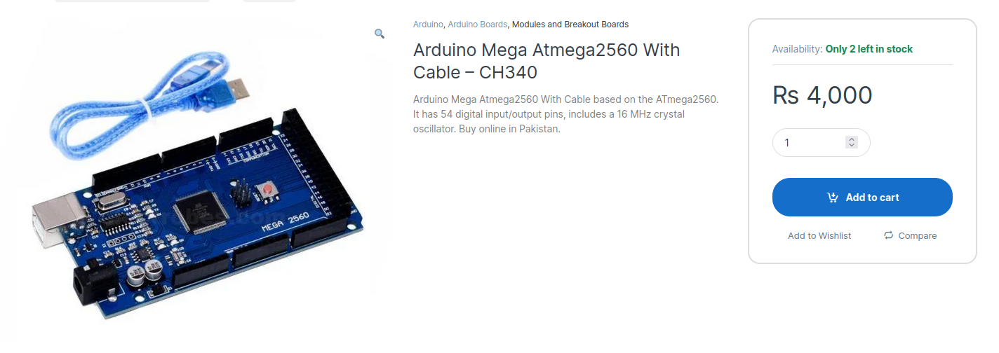

Circuit Diagram

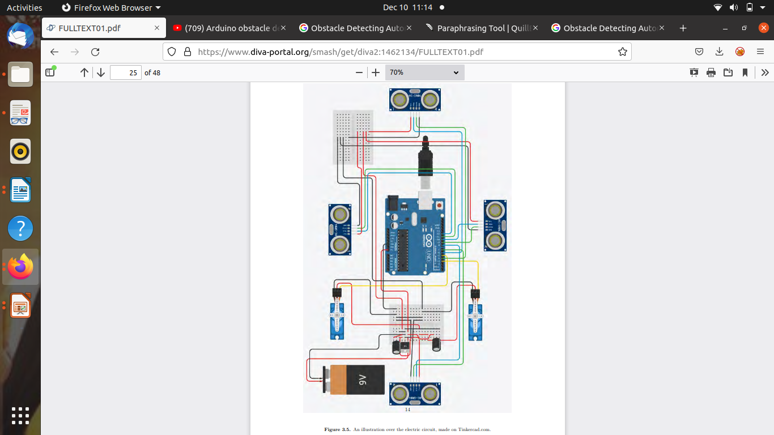

Link to buy hardware parts

https://electrobes.com/?s=proximity+sensor&product_cat=0&post_type=product

Test and Resulting:

Movement:

The sensors controlled the robot's movement by sending different values to the servos based on the distance to obstacles around the robot. As a result, tests were conducted to evaluate the robot's movement, with obstacles placed in front of it to ensure that it could turn as desired.

Navigation:
The robot was tested inside an environment with obstacles placed around it.
It was observed while driving to confirm that it worked as intended.
First, an object was placed in front of the robot to ensure that when it discovered the object, it turned right.
Then, to ensure that it turned left that time, an object was placed to the right.
When the code was adjusted so that these things worked, an obstacle to the left was added to see if the robot reversed.
Finally, obstacles were placed all around the robot to ensure that it came to a complete stop.
Following all of the testing, an obstacle course was constructed.
Minor changes were made to the code until the robot was operational.

Sensor tests:
Ultrasonic sensors were used in tests to determine how far away from the obstacles the robot should stop.
Tests were carried out to determine the accuracy of the sensors.
An obstacle was placed at a specific distance from the sensor, and the distance was measured with a ruler and compared to the sensor's specified distance.
The sensors can detect distances ranging from 2-400 cm, according to the manufacturer's specifications.

Obstacle test
Obstacles of varying shapes and sizes were placed in front of the robot to see what objects the sensors could detect.
The sensors were attached to the bottom plate, creating a 5 cm height difference between the ground and the center of the sensors.
This piqued my interest in investigating the sensors' ability to detect low-level obstacles in its path.
The test was started by placing an object 15 cm long and 16 cm tall in front of the robot.
The robot easily detected this obstacle. Figure 4.3 shows another object with dimensions of 4,5 cm x 5,5 cm that was placed in front of the construction and was easily discovered.
The robot was unable to detect an object with a height of 2.5 cm when tested.
Objects with heights of 3,5 cm, 4 cm, and finally 5 cm were tested to determine the lowest detectable height.

The results showed that the object with a height of 5 cm was the smallest obstacle that the sensors could detect. This test provided useful information about which obstacles to include in the obstacle course that was later built, as well as what improvements to the robot could have been made.

Conclusion
Following are the research questions that were investigated in this project and the answers to them:
• How should the robot navigate?
The robot can successfully navigate with the algorithm .
• How could the robot detect obstacles in its lane and what should it do when it Encounters them?
– What kind of sensors are needed?
– Where should the sensors be placed?
Ultrasonic sensors were chosen as the type of sensors. This is because they are good at detecting obstacles in relation to their cost. They are arranged in the following order: front, right, left, and back. This placement is the most profitable given the number of sensors available, but as it stands, the robot cannot detect all obstacles. This makes it impossible for only four sensors to detect all potential obstacles in the robot's path.

Complete Code:
#include <NewPing . h>
#include <Servo . h>
#def ine SONAR NUM 4 // Number o f s e n s o r s
#def ine MAX DISTANCE 300
// 0 : f r o n t , 1 : r i g h t , 2 : l e f t , 3 : back
NewPing s on a r [SONAR NUM] = { // Sensor o b j e c t a r r ay .
NewPing ( 5 , 1 3 , MAX DISTANCE) , // Each s e n s o r ’ s t r i g g e r p in , echo p in ,
NewPing ( 6 , 4 , MAX DISTANCE) , // and max d i s t a n c e t o p ing .
NewPing ( 1 2 , 1 1 , MAX DISTANCE) ,
NewPing ( 8 , 7 , MAX DISTANCE) ,
} ;
Servo l e f t s e r v o ; // Servo o b j e c t f o r each s e r v o
Servo r i g h t s e r v o ;
int d i s t a n c e f r o n t = 0 ; // I n i t i a l i s i n g v a r i a b l e s
int d i s t a n c e r i g h t = 0 ;
int d i s t a n c e l e f t = 0 ;
int di s t a n c e b a c k = 0 ;
int moving ;
int pos ;
void se t up ( ) {
S e r i a l . b e gi n ( 9 6 0 0 ) ;
l e f t s e r v o . a t t a c h ( 1 0 ) ; // A t tach s e r v o s t o p in 10 and 3
r i g h t s e r v o . a t t a c h ( 3 ) ;
}
//∗∗Robot movement f u n c t i o n s ∗∗
// The f u n c t i o n s r e c e i v e i n f o rm a t i o n ab o u t how many m icr o sec on d s
// t h e r o b o t s h o ul d d r i v e in t h a t d i r e c t i o n
// pwm s i g n a l s are s e n t t o t h e s e r v o s
int f o rw a rd ( int moving ){
l e f t s e r v o . w ri t eMi c r o s e c o n d s ( 1 3 0 0 ) ;
r i g h t s e r v o . w ri t eMi c r o s e c o n d s ( 1 7 0 0 ) ;
d el a y ( moving ) ;
return moving ;
}
int l e f t ( int moving ){
l e f t s e r v o . w ri t eMi c r o s e c o n d s ( 1 7 0 0 ) ;
r i g h t s e r v o . w ri t eMi c r o s e c o n d s ( 1 7 0 0 ) ;
d el a y ( moving ) ;
return moving ;
}
int r i g h t ( int moving ){
l e f t s e r v o . w ri t eMi c r o s e c o n d s ( 1 3 0 0 ) ;
r i g h t s e r v o . w ri t eMi c r o s e c o n d s ( 1 3 0 0 ) ;
d el a y ( moving ) ;
return moving ;
}
int r e v e r s e ( int moving ){
l e f t s e r v o . w ri t eMi c r o s e c o n d s ( 1 7 0 0 ) ;
r i g h t s e r v o . w ri t eMi c r o s e c o n d s ( 1 3 0 0 ) ;
d el a y ( moving ) ;
return moving ;
}
int s t o p s ( int moving ){
l e f t s e r v o . w ri t eMi c r o s e c o n d s ( 1 5 0 0 ) ;
r i g h t s e r v o . w ri t eMi c r o s e c o n d s ( 1 5 0 0 ) ;
d el a y ( moving ) ;
return moving ;
}
void l o o p ( ) {
// C a l c u l a t i n g and p r i n t i n g ou t t h e
// d i s t a n c e t o any o b s t a c l e in f r o n t o f t h e r o b o t
S e r i a l . p r i n t ( ” Di s t a n c e f r o n t : ” ) ;
S e r i a l . p r i n t ( s on a r [ 0 ] . ping cm ( ) ) ;
S e r i a l . p r i n t l n ( ”cm” ) ;
d i s t a n c e f r o n t = s on a r [ 0 ] . ping cm ( ) ;
// As l o n g as no o b s t a c l e has been d e t e c t e d in f r o n t
// o f t h e r o b o t i t s h o ul d keep moving f o rw a r d
while ( d i s t a n c e f r o n t > 1 5 ) {
pos = f o rw a rd ( 5 0 0 ) ;
d i s t a n c e f r o n t = s on a r [ 0 ] . ping cm ( ) ;
}
// I f an o b s t a c l e i s d e t e c t e d , t h e o t h e r s e n s o r s are c hecke d
// The r o b o t s t o p s f o r 300 ms
i f ( d i s t a n c e f r o n t < 1 5 ) {
pos = s t o p s ( 3 0 0 ) ;
d i s t a n c e r i g h t = s on a r [ 1 ] . ping cm ( ) ;
d i s t a n c e l e f t = s on a r [ 2 ] . ping cm ( ) ;
di s t a n c e b a c k = s on a r [ 3 ] . ping cm ( ) ;
S e r i a l . p r i n t ( ” Di s t a n c e r i g h t : ” ) ;
S e r i a l . p r i n t l n ( s on a r [ 1 ] . ping cm ( ) ) ;
S e r i a l . p r i n t ( ” Di s t a n c e l e f t : ” ) ;
S e r i a l . p r i n t l n ( s on a r [ 2 ] . ping cm ( ) ) ;
// I f t h e r e i s no o b s t a c l e t o t h e r i g h t
// The r o b o t t u r n s r i g h t
i f ( d i s t a n c e r i g h t > 15 && d i s t a n c e r i g h t != 0 ) {
pos = r i g h t ( 1 6 0 0 ) ;
d i s t a n c e f r o n t = s on a r [ 0 ] . ping cm ( ) ;
// I f t h e r e i s no o b s t a c l e in f r o n t o f i t now , i t
// d r i v e s f o rw a r d u n t i l an o b s t a c l e i s d e t e c t e d
while ( d i s t a n c e f r o n t > 1 5 ) {
pos = f o rw a rd ( 5 0 0 ) ;
d i s t a n c e f r o n t = s on a r [ 0 ] . ping cm ( ) ;
}
}
// Same t h i n g happes i f t h e r e i s an
// o b s t a c l e t o t h e r i g h t , i t j u s t t u r n s l e f t i n s t e a d
e l s e i f ( d i s t a n c e l e f t > 15 && d i s t a n c e l e f t != 0 ) {
pos = l e f t ( 1 6 0 0 ) ;
d i s t a n c e f r o n t = s on a r [ 0 ] . ping cm ( ) ;
while ( d i s t a n c e f r o n t > 1 5 ) {
pos = f o rw a rd ( 5 0 0 ) ;
d i s t a n c e f r o n t = s on a r [ 0 ] . ping cm ( ) ;
}
}
// I f t h e o nly f r e e way i s be h in d t h e r ob o t , i t w i l l r e v e r s e
e l s e i f ( di s t a n c e b a c k > 1 5 ) {
pos = r e v e r s e ( 2 0 0 0 ) ; // i t r e v e r s e s f o r 2 sec on d s
d i s t a n c e r i g h t = s on a r [ 1 ] . ping cm ( ) ;
d i s t a n c e l e f t = s on a r [ 2 ] . ping cm ( ) ;
// t hen t u rn r i g h t i f i t ’ s f r e e t h e r e
i f ( d i s t a n c e r i g h t > 1 5 ) {
pos = r i g h t ( 1 6 0 0 ) ;
d i s t a n c e f r o n t = s on a r [ 0 ] . ping cm ( ) ;
while ( d i s t a n c e f r o n t > 1 5 ) {
pos = f o rw a rd ( 5 0 0 ) ;
d i s t a n c e f r o n t = s on a r [ 0 ] . ping cm ( ) ;
}
}
// o t h e rw i s e i t t u r n s l e f t
e l s e i f ( d i s t a n c e l e f t > 1 5 ) {
pos = l e f t ( 1 6 0 0 ) ;
d i s t a n c e f r o n t = s on a r [ 0 ] . ping cm ( ) ;
while ( d i s t a n c e f r o n t > 1 5 ) {
pos = f o rw a rd ( 5 0 0 ) ;
d i s t a n c e f r o n t = s on a r [ 0 ] . ping cm ( ) ;
}
}
e l s e { // I f i t ’ s o b s t a c l e s eve ryw he re i t has t o s t o p
pos = s t o p s ( 3 0 0 0 ) ;
}
}
e l s e { // I f o b s t a c l e s are d e t e c t e d in e v e ry d i r e c t i o n
pos = s t o p s ( 3 0 0 0 ) ; // around t h e r ob o t , i t s t o p s
}
}
}

YouTube link of the project
https://youtu.be/yz9I-Kdh7v8

Detailed links
Link 1
https://www.researchgate.net/publication/304606238_obstacle_detection_and_avoidance_methods_for_autonomous_mobile_robot
Detailed link 2
https://www.researchgate.net/publication/343694073_An_Autonomous_Obstacle_Avoidance_Robot_Using_Ultrasonic_Sensor

