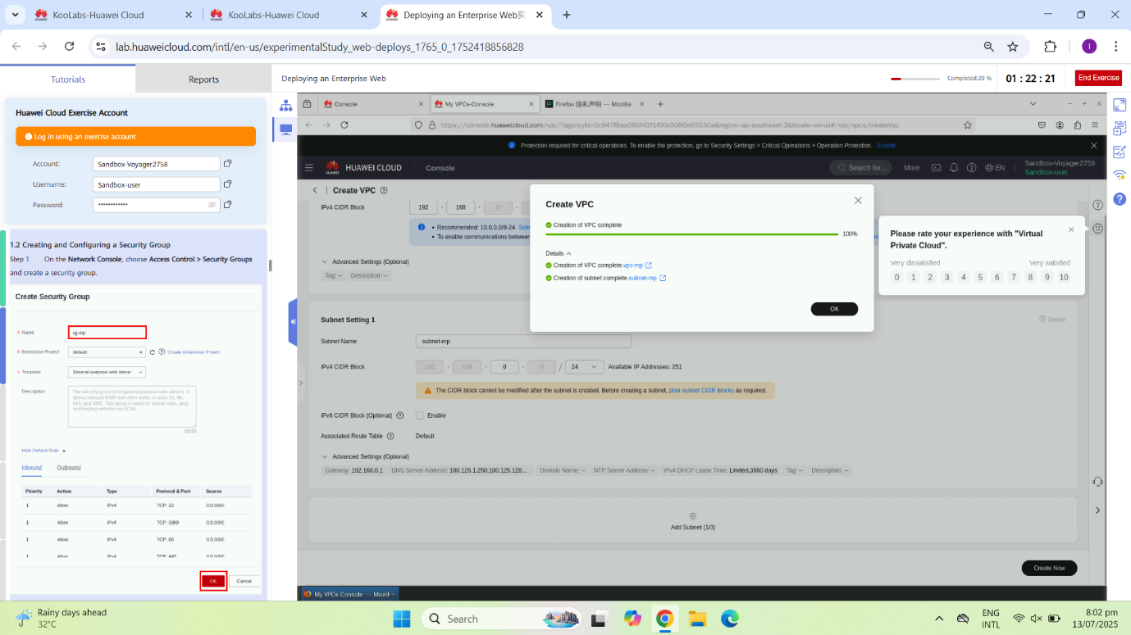

#### Created 1. VPC and Subnet Creation

Created a Virtual Private Cloud (VPC) named vpc-mp with an associated subnet subnet-mp for network isolation and resource grouping.

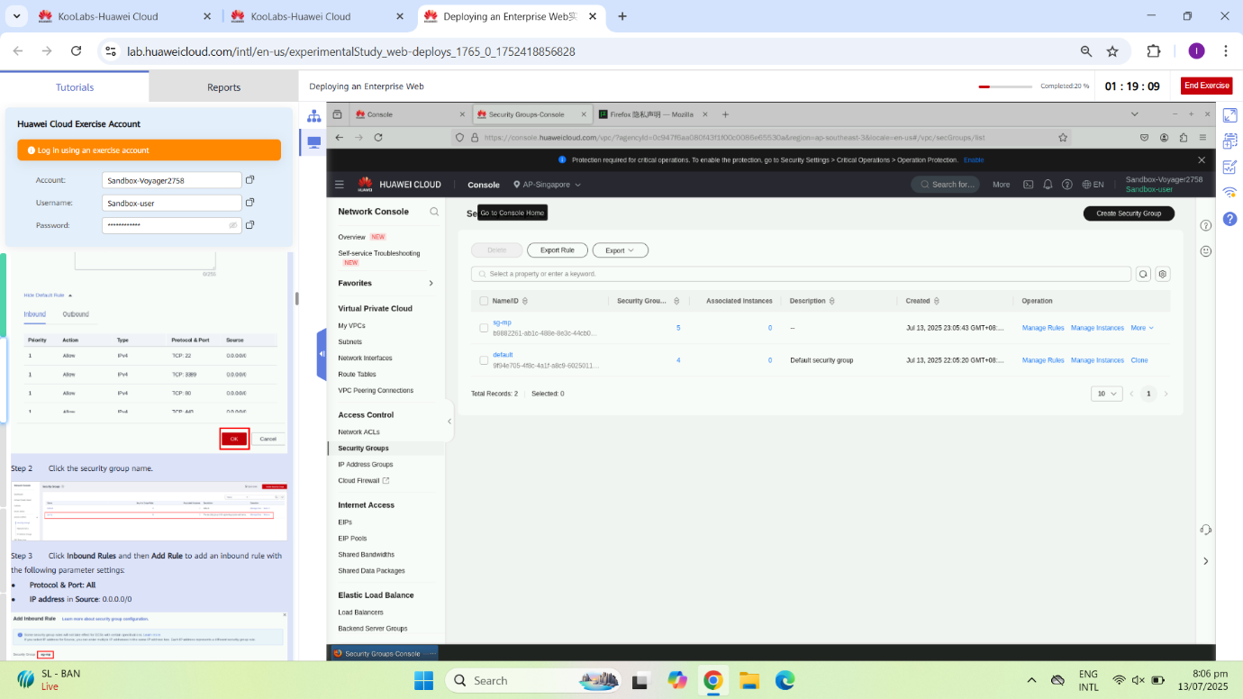

#### ****2. Security Group Setup****

Configured a security group sg-mp to allow HTTP (port 80), HTTPS (port 443), and MySQL (port 3306) access for the ECS and RDS instances.

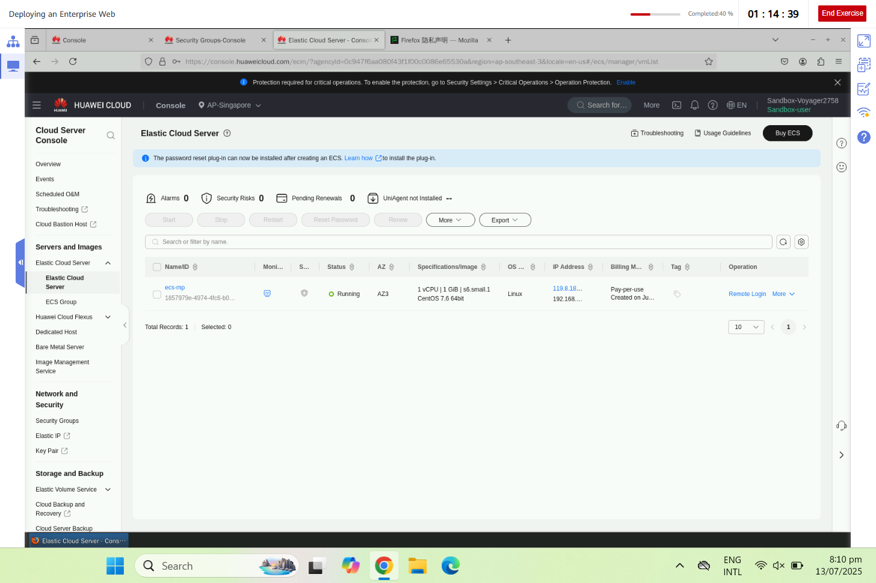

#### ****3. ECS Instance Creation****

Launched an ECS instance ecs-mp with CentOS 7.6, configured with 1 vCPU and 1GB RAM, and assigned an EIP for public acces

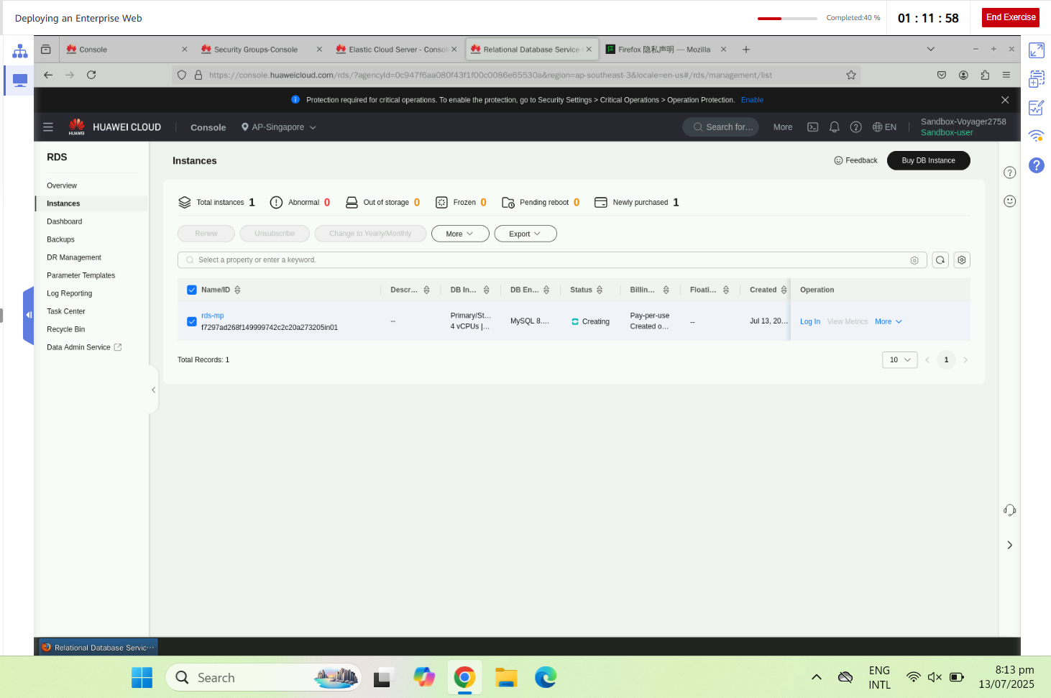

#### ****4. RDS MySQL Instance Creation****

Deployed an RDS instance running MySQL 8.0 with floating IP assigned, enabling backend database functionality for the WordPress application

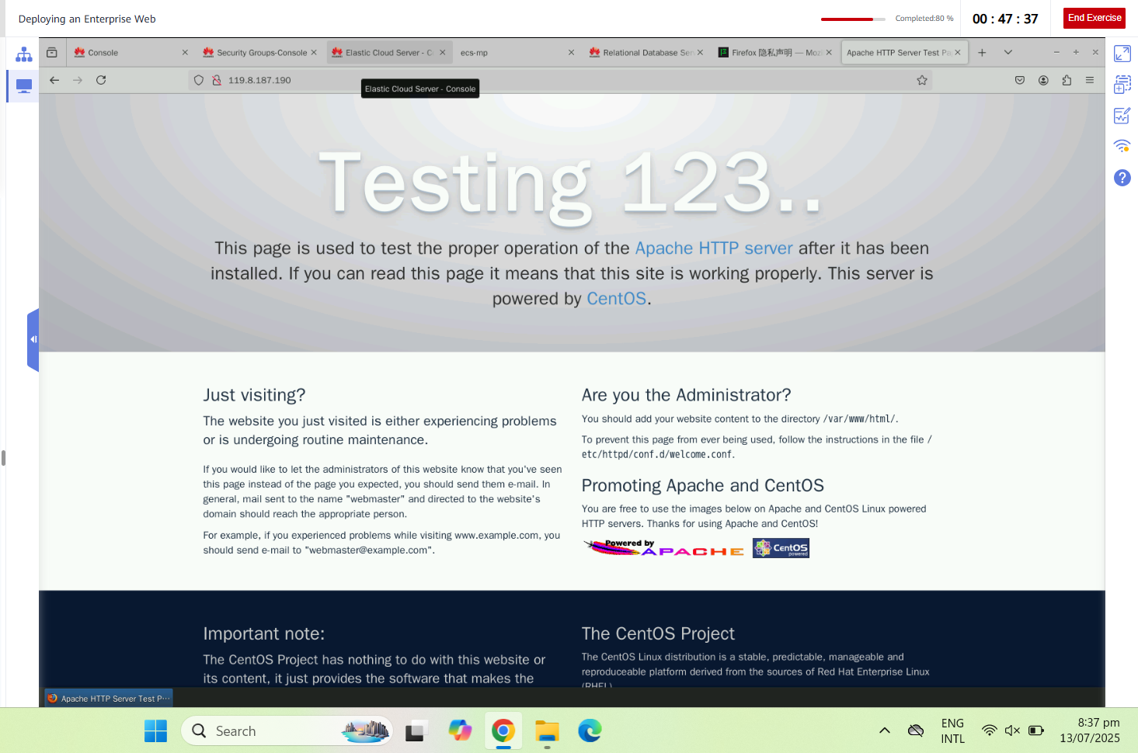

#### ****5. LAMP Stack Installation****

Installed Apache, PHP, and MySQL packages on the ECS to set up the LAMP environment required for WordPress.

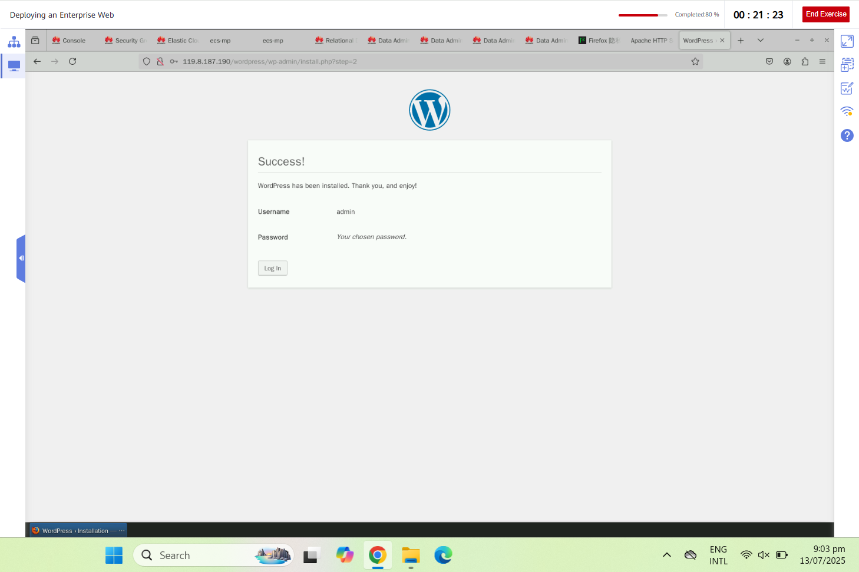

#### ****6. WordPress Setup Page****

Accessed the WordPress installation wizard via ECS public IP, confirming that the web server and PHP services are running correctly.

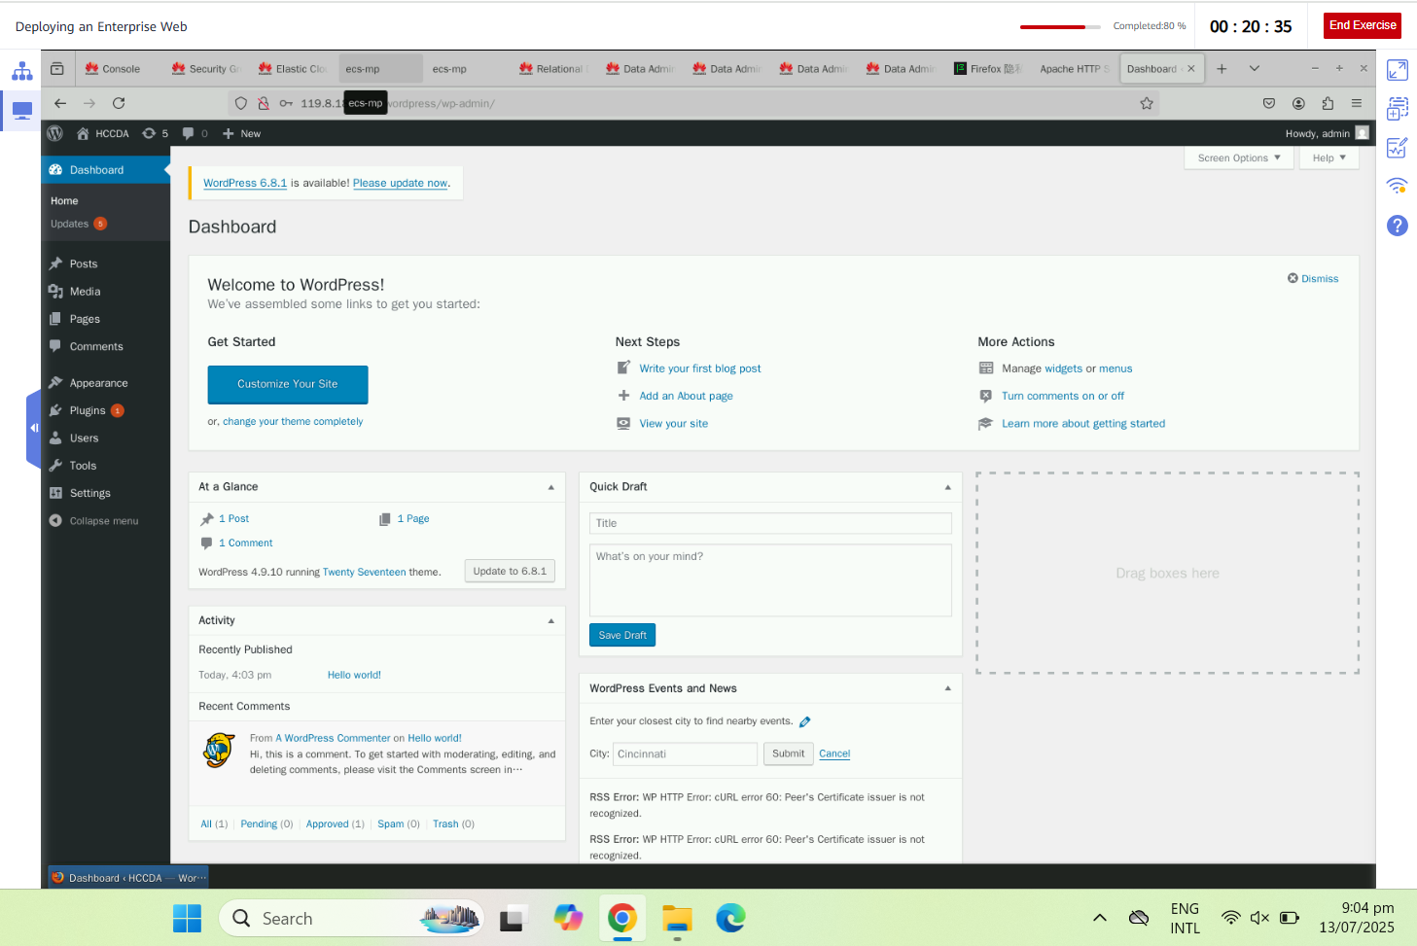

#### ****7. WordPress Installed and Running****

Successfully installed and configured WordPress. The site is now live and connected to the backend MySQL database.



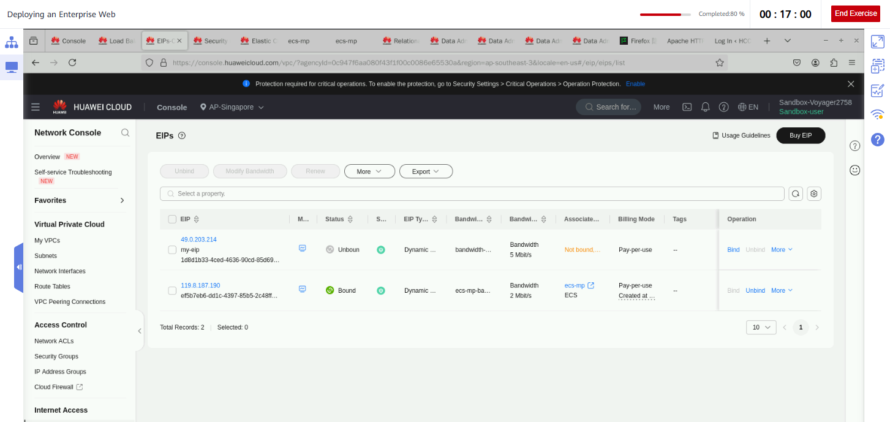

#### ****8. Elastic Load Balancer (Optional)****

Configured a shared ELB to distribute traffic across multiple ECS instances, improving web server availability and performance. Alongwith first we buied IP

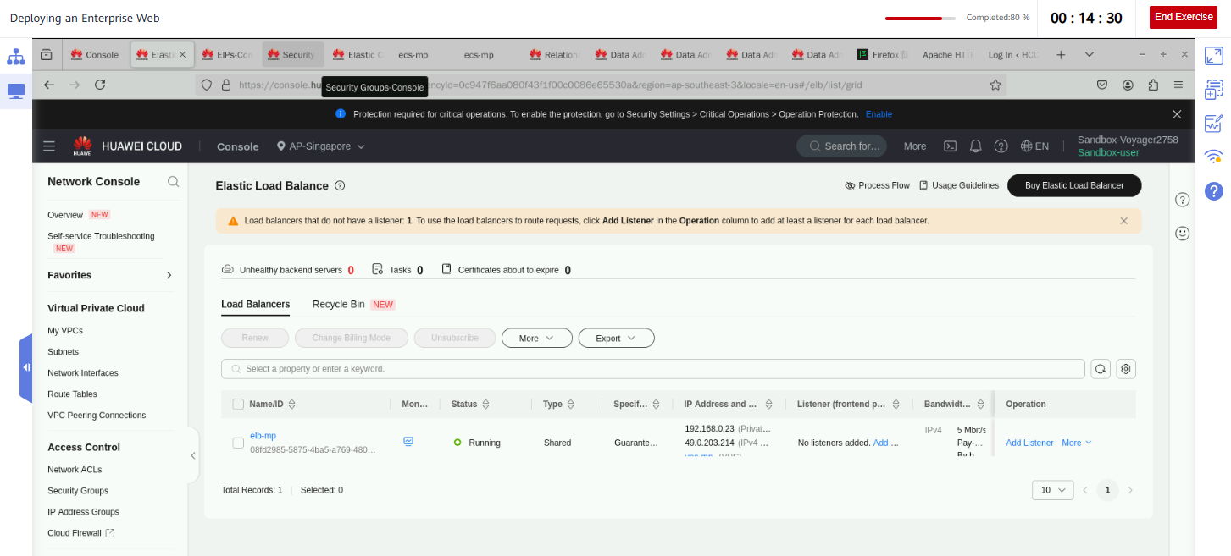

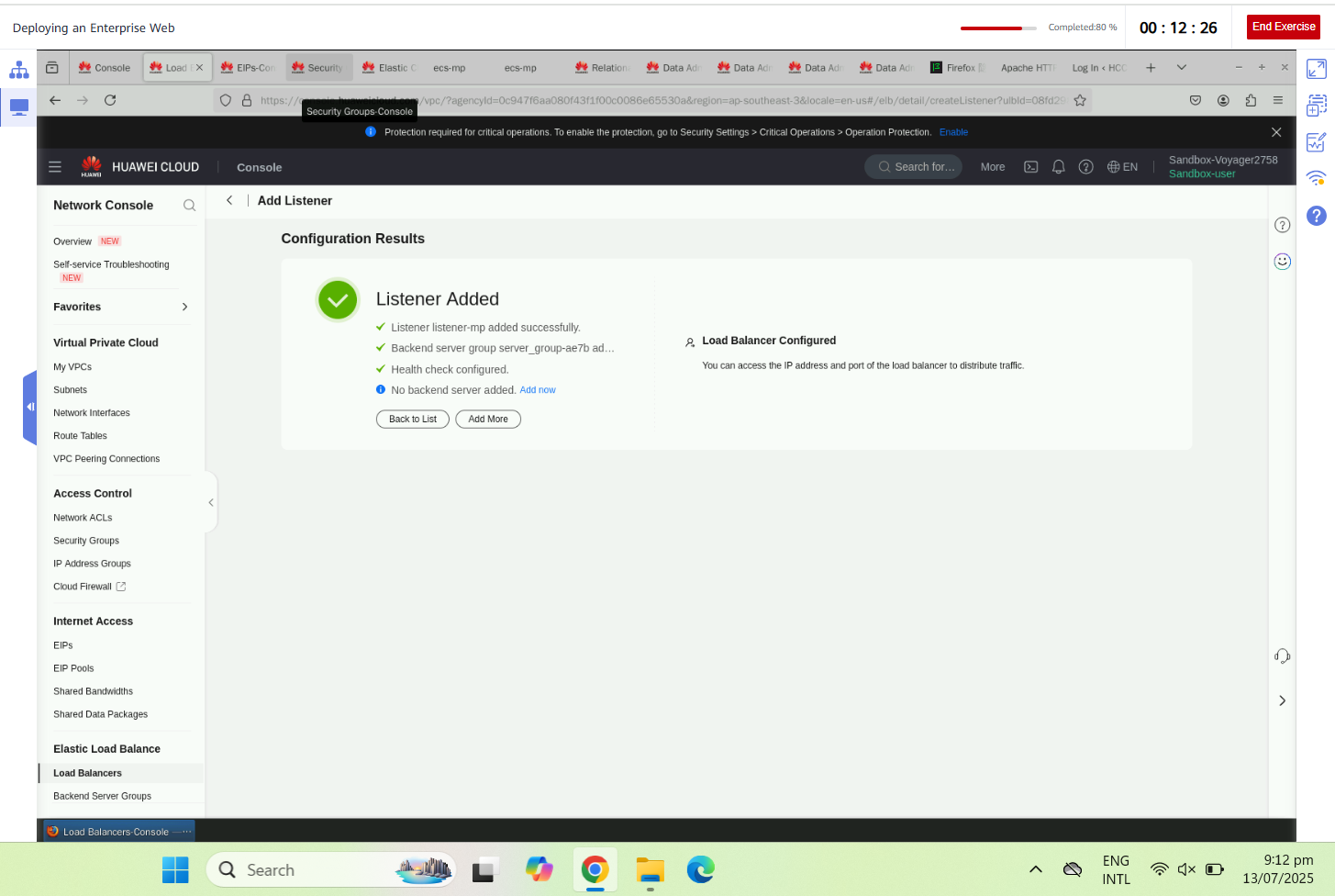

HERES OUR INTERPRISE WEB IS INSTALLED !!