# Final Report of Computation Intelligence

Authored by **SONG DAIWEI** 44161588-3

# Travelling Salesman Problem

Given a list of cities and the distances between each pair of cities, what is the shortest possible route that visits each city exactly once and returns to the origin city?

NP-hard problem in combinatorial optimization

TSP can be regard as a graph problem can can be modelled as an undirected weighted graph:

|  |  |  |
| --- | --- | --- |
| Cities | Paths | The path's distance |
| the graph's vertices | the graph's edges | the edge's weight |

It is a minimization problem starting and finishing at a specified vertex after having visited each other vertex exactly once.

Because the distance in Berlin52.tsp is coordinate distance, so it is a symmetric problem.

And I try to improve the algorithms, so I will introduce some improvement in GA and ACO Algorithm.

## GA

Genetic Algorithm (GA) is a metaheuristic inspired by the process of natural selection that belongs to the larger class of evolutionary algorithms (EA). Genetic algorithms are commonly used to generate high-quality solutions to optimization and search problems by relying on bio-inspired operators such as mutation, crossover and selection.

### Flow chart

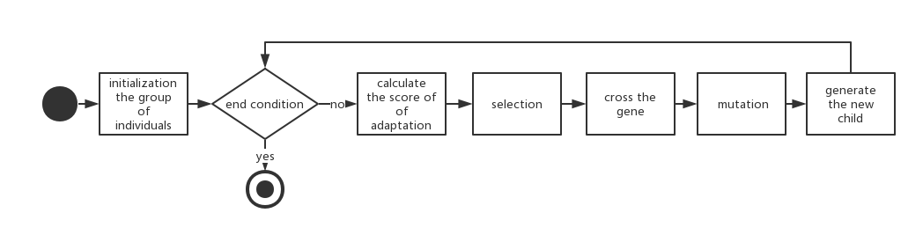

### Result

1000 iterations 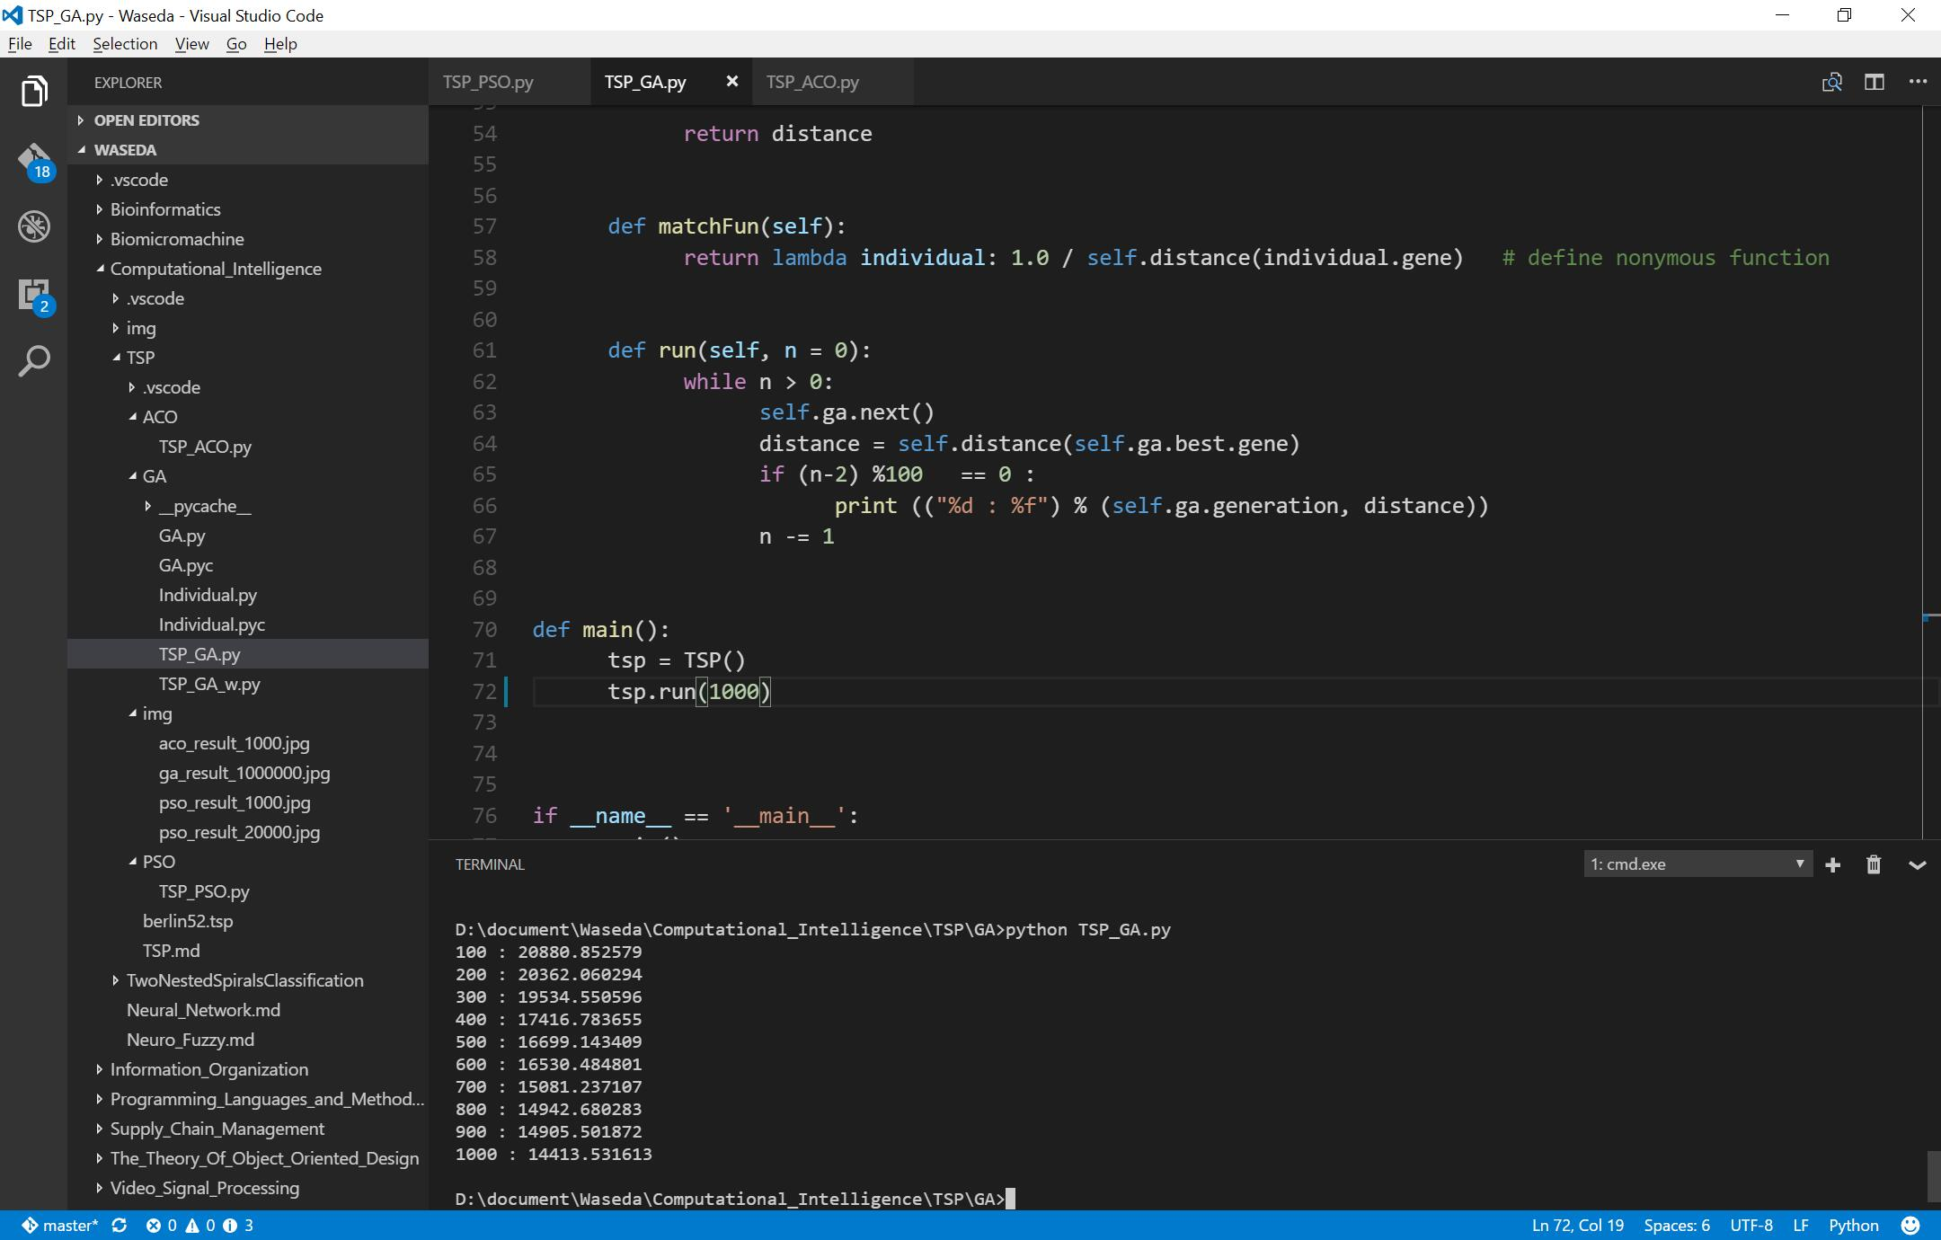

1000000 iterations with the same rate in GA expression. 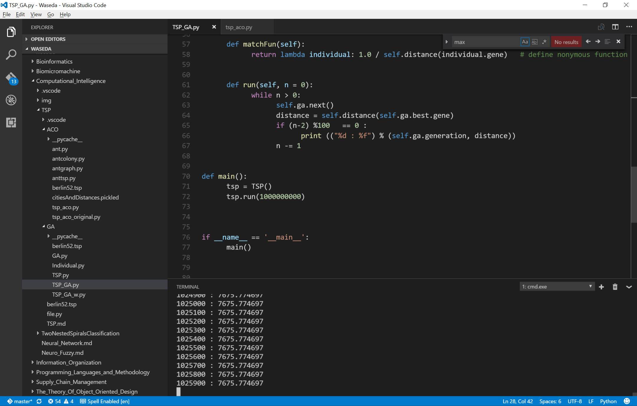

So we can find that the rate of descent is really slow. especially campared with other algorithms.

### Improvement

In order to know the parameters' efficiency in the expression, especially in the crossRate and mutationRate, I calculate the crossRate from 0-0.5 stepped by 0.1, mutationRate from 0-0.5 stepped by 0.05, iterations times is 10000, and show the temporary result of each 100 iterations.

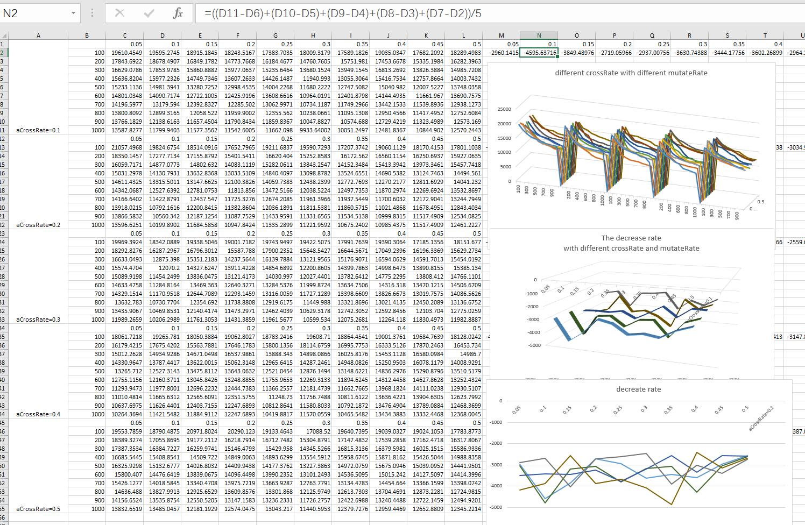

And the calculate the decreate rate of each state, with considering 10 results, using the method of successive minus. 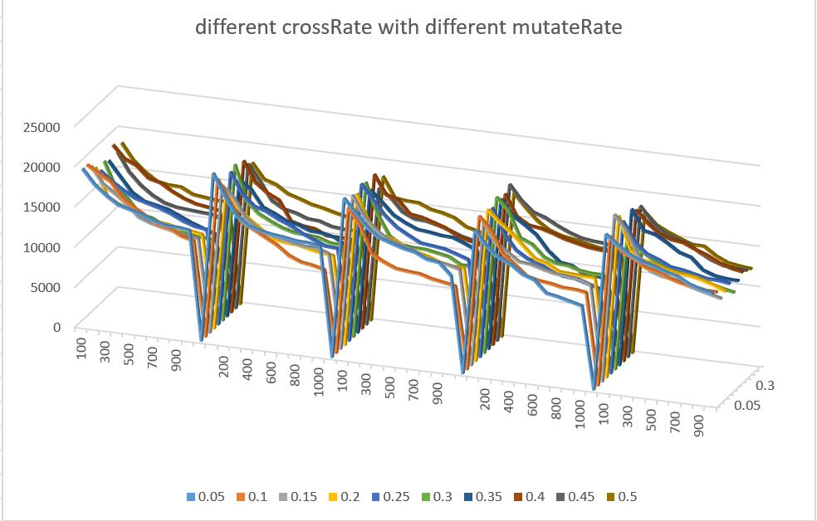 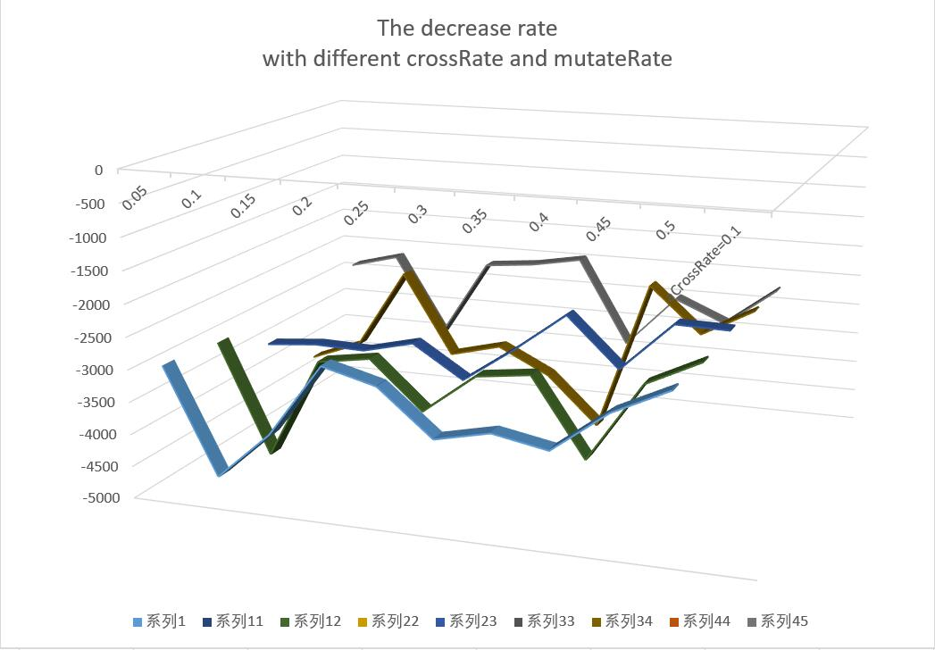

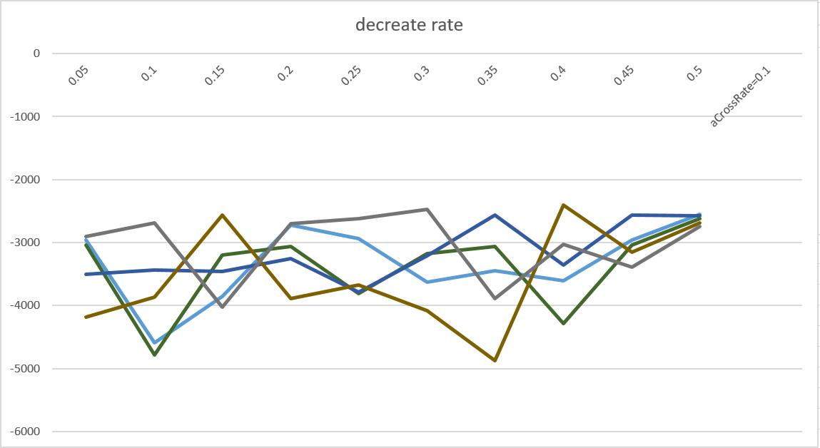

### Conclusion

So we can find that the parameter in expression of GA, if you want to steepest descent to the final result, maybe you can choose crossRate as 0.4 and mutationRate as 0.35.

## ACO

Ants of some species (initially) wander randomly, and upon finding food return to their colony while laying down pheromone trails. If other ants find such a path, they are likely not to keep travelling at random, but instead to follow the trail, returning and reinforcing it if they eventually find food.

Over time, however, the pheromone trail starts to evaporate, thus reducing its attractive strength. The more time it takes for an ant to travel down the path and back again, the more time the pheromones have to evaporate. A short path, by comparison, gets marched over more frequently, and thus the pheromone density becomes higher on shorter paths than longer ones. Pheromone evaporation also has the advantage of avoiding the convergence to a locally optimal solution. If there were no evaporation at all, the paths chosen by the first ants would tend to be excessively attractive to the following ones. In that case, the exploration of the solution space would be constrained. The influence of pheromone evaporation in real ant systems is unclear, but it is very important in artificial systems.

The overall result is that when one ant finds a good (i.e., short) path from the colony to a food source, other ants are more likely to follow that path, and positive feedback eventually leads to all the ants following a single path. The idea of the ant colony algorithm is to mimic this behavior with "simulated ants" walking around the graph representing the problem to solve.

The probability of ants moving from position i to position j at time t is expressed as follows:

### Pseudo Code

procedure ACO_MetaHeuristic  
 while(not_termination)  
 generateSolutions()  
 daemonActions()  
 pheromoneUpdate()  
 end while  
 end procedure

### Improvement

* Use greedy algorithm to initialize the ACO of TSP.
* Greedy algorithm is an algorithmic paradigm that follows the problem solving heuristic of making the locally optimal choice at each stage[1] with the hope of finding a global optimum. In many problems, a greedy strategy does not in general produce an optimal solution, but nonetheless a greedy heuristic may yield locally optimal solutions that approximate a global optimal solution in a reasonable time.
* Rotate the matrix of cities to avoid to fail into the local optimization.

### Result

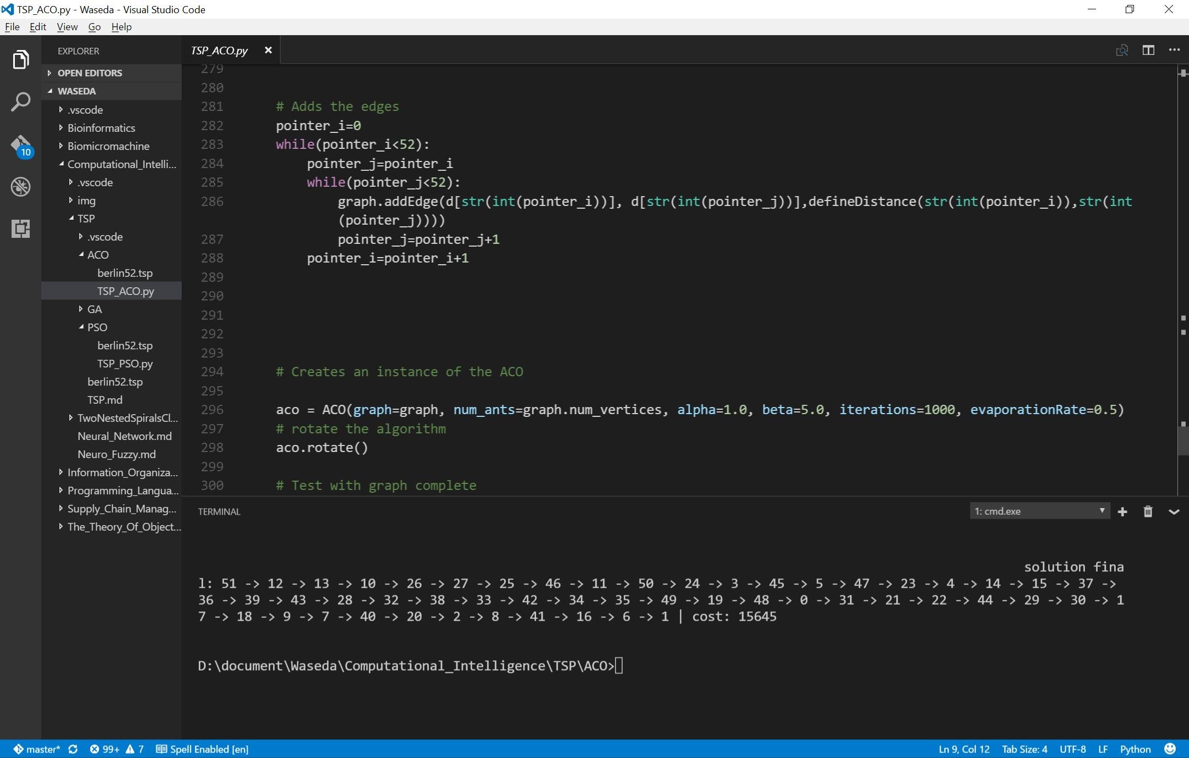

## PSO

A basic variant of the PSO algorithm works by having a population (called a swarm) of candidate solutions (called particles). These particles are moved around in the search-space according to a few simple formulae.

The movements of the particles are guided by their own best known position in the search-space as well as the entire swarm's best known position. When improved positions are being discovered these will then come to guide the movements of the swarm. The process is repeated and by doing so it is hoped, but not guaranteed, that a satisfactory solution will eventually be discovered.

Formally, let f: ℝn → ℝ be the cost function which must be minimized. The function takes a candidate solution as argument in the form of a vector of real numbers and produces a real number as output which indicates the objective function value of the given candidate solution. The gradient of f is not known. The goal is to find a solution a for which f(a) ≤ f(b) for all b in the search-space, which would mean a is the global minimum. Maximization can be performed by considering the function h = -f instead.

Let S be the number of particles in the swarm, each having a position xi ∈ ℝn in the search-space and a velocity vi ∈ ℝn. Let pi be the best known position of particle i and let g be the best known position of the entire swarm. A basic PSO algorithm is then:

### Pseudo Code

for each particle i = 1, ..., S do  
 Initialize the particle's position with a uniformly distributed random vector: xi ~ U(blo, bup)  
 Initialize the particle's best known position to its initial position: pi ← xi  
 if f(pi) < f(g) then  
 update the swarm's best known position: g ← pi  
 Initialize the particle's velocity: vi ~ U(-|bup-blo|, |bup-blo|)  
while a termination criterion is not met do:  
 for each particle i = 1, ..., S do  
 for each dimension d = 1, ..., n do  
 Pick random numbers: rp, rg ~ U(0,1)  
 Update the particle's velocity: vi,d ← ω vi,d + φp rp (pi,d-xi,d) + φg rg (gd-xi,d)  
 Update the particle's position: xi ← xi + vi  
 if f(xi) < f(pi) then  
 Update the particle's best known position: pi ← xi  
 if f(pi) < f(g) then  
 Update the swarm's best known position: g ← pi

### Result

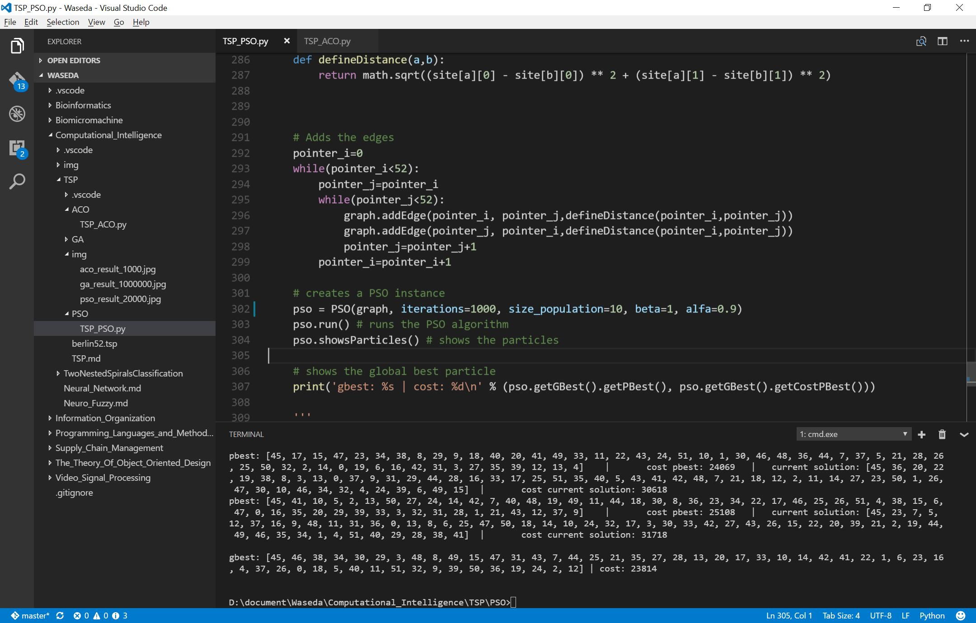

### Conclusion

We can find that the PSO is the slowest descent to the result, and it cost too much time than others.

However, the individuals and the ability of computation are different among GA, ACO and PSO, so it is hard to compare their efficiency. Maybe we can calculate the first time gap of the first big descent, but unfortunately, I use Python, which is hard to draw down the graph about the gap for me.

# Reference

<https://en.wikipedia.org/wiki/Genetic_algorithm>

<https://en.wikipedia.org/wiki/Ant_colony_optimization_algorithms>

<https://en.wikipedia.org/wiki/Particle_swarm_optimization>

# Appendix - Source Code in TSP

## GA

import random  
import math  
from numpy import *  
class Individual(object):  
 """class of Individual"""  
 def __init__(self, aGene = None):  
 self.gene = aGene  
 self.score = SCORE_NONE  
  
class GA(object):  
 """class of GA"""  
 def __init__(self, aCrossRate, aMutationRage, aIndividualCount, aGeneLenght, aMatchFun = lambda individual : 1):  
 self.crossRate = aCrossRate  
 self.mutationRate = aMutationRage  
 self.individualCount = aIndividualCount  
 self.geneLenght = aGeneLenght  
 self.matchFun = aMatchFun # adaptation function  
 self.population = [] # population  
 self.best = None # elitist selection  
 self.generation = 1  
 self.crossCount = 0  
 self.mutationCount = 0  
 self.bounds = 0.0 # sum of adaptation to calculate the probability when selection  
  
 self.initPopulation()  
  
  
 def initPopulation(self):  
 """initial the population"""  
 self.population = []  
 for i in range(self.individualCount):  
 gene = [ x for x in range(self.geneLenght) ]   
 random.shuffle(gene)  
 individual = Individual(gene)  
 self.population.append(individual)  
  
  
 def judge(self):  
 """judge to calculate the adaptation of each individual"""  
 self.bounds = 0.0  
 self.best = self.population[0]  
 for individual in self.population:  
 individual.score = self.matchFun(individual)  
 self.bounds += individual.score  
 if self.best.score < individual.score:  
 self.best = individual  
  
  
 def cross(self, parent1, parent2):  
 """cross"""  
 index1 = random.randint(0, self.geneLenght - 1)  
 index2 = random.randint(index1, self.geneLenght - 1)  
 tempGene = parent2.gene[index1:index2] # cross the pieces of genes  
 newGene = []  
 p1len = 0  
 for g in parent1.gene:  
 if p1len == index1:  
 newGene.extend(tempGene) # insert the pieces of genes  
 p1len += 1  
 if g not in tempGene:  
 newGene.append(g)  
 p1len += 1  
 self.crossCount += 1  
 return newGene  
  
  
 def mutation(self, gene):  
 """mutation of gene"""  
 index1 = random.randint(0, self.geneLenght - 1)  
 index2 = random.randint(0, self.geneLenght - 1)  
  
 newGene = gene[:] # generate a new sequence of gene in order not to infect the father population when it mutates # Yvon-Shong   
 newGene[index1], newGene[index2] = newGene[index2], newGene[index1] # swap  
 self.mutationCount += 1  
 return newGene  
  
  
 def getOne(self):  
 """select one Individual"""  
 r = random.uniform(0, self.bounds) # generate a real number, the threhold of evolution  
 for individual in self.population:  
 r -= individual.score  
 if r <= 0:  
 return individual  
  
 raise Exception("Wrong selection", self.bounds)  
  
  
 def newChild(self):  
 """generate the child"""  
 parent1 = self.getOne()  
   
  
 # cross by the probability  
 rate1 = random.random()  
 if rate1 < self.crossRate:  
 # cross  
 parent2 = self.getOne()  
 gene = self.cross(parent1, parent2)  
 else:  
 gene = parent1.gene  
  
 # mutate by the probability  
 rate2 = random.random()  
 if rate2 < self.mutationRate:  
 gene = self.mutation(gene)  
  
 return Individual(gene)  
  
  
 def next(self):  
 """generate the next generation"""  
 self.judge()  
 newPopulation = []  
 newPopulation.append(self.best) # elitist selection, choose the best ONE to add to the next generation  
 while len(newPopulation) < self.individualCount:  
 newPopulation.append(self.newChild())  
 self.population = newPopulation  
 self.generation += 1  
  
class TSP(object):  
 def __init__(self, aIndividualCount = 100,):  
 self.initCitys()  
 self.individualCount = aIndividualCount  
 self.ga = GA(aCrossRate = 0.7,   
 aMutationRage = 0.05,   
 aIndividualCount = self.individualCount,   
 aGeneLenght = len(self.citys),   
 aMatchFun = self.matchFun())  
  
  
 def initCitys(self):  
 self.citys = []  
 # import the data set of TSP  
 a = loadtxt('../berlin52.tsp')   
 self.citys = a[:,1:]  
   
   
   
   
 def distance(self, order):  
 distance = 0.0  
 for i in range(-1, len(self.citys) - 1): # -1 ???  
 index1, index2 = order[i], order[i + 1]  
 city1, city2 = self.citys[index1], self.citys[index2]  
 distance += math.sqrt((city1[0] - city2[0]) ** 2 + (city1[1] - city2[1]) ** 2)  
   
 return distance  
  
  
 def matchFun(self):  
 return lambda individual: 1.0 / self.distance(individual.gene) # define nonymous function  
  
  
 def run(self, n = 0):  
 while n > 0:  
 self.ga.next()  
 distance = self.distance(self.ga.best.gene)  
 if (n-2) %100 == 0 :  
 print (("%d : %f") % (self.ga.generation, distance))  
 n -= 1  
  
  
def main():  
 tsp = TSP()  
 tsp.run(1000)  
   
  
  
if __name__ == '__main__':  
 main()

## ACO

import random, math  
from numpy import *  
import math  
# class to present an edge  
class Edge:  
  
 def __init__(self, origin, destination, cost):  
 self.origin = origin  
 self.destination = destination  
 self.cost = cost  
 self.pheromone = None  
  
 def getOrigin(self):  
 return self.origin  
  
 def getDestination(self):  
 return self.destination  
  
 def getCost(self):  
 return self.cost  
  
 def getPheromone(self):  
 return self.pheromone  
  
 def setPheromone(self, pheromone):  
 self.pheromone = pheromone  
  
  
  
class Graph:  
  
 def __init__(self, num_vertices):  
 self.num_vertices = num_vertices # The number of vertices of the graph  
 self.edges = {} # The dictionary of the edges  
 self.neighbors = {} # The dictionary of all the neighbors of each vertex  
  
  
 def addEdge(self, origin, destination, cost):  
 edge = Edge(origin=origin, destination=destination, cost=cost)  
 self.edges[(origin, destination)] = edge  
 if origin not in self.neighbors:  
 self.neighbors[origin] = [destination]  
 else:  
 self.neighbors[origin].append(destination)  
   
 edge_symmetry = Edge(origin=destination, destination=origin, cost=cost) # add the symmetric path with the same cost  
 self.edges[(destination,origin)] = edge_symmetry  
 if destination not in self.neighbors:  
 self.neighbors[destination] = [origin]  
 else:  
 self.neighbors[destination].append(origin)  
   
  
  
 def getCostEdge(self, origin, destination):  
 return self.edges[(origin, destination)].getCost()  
  
 def getPheromoneEdge(self, origin, destination):  
 return self.edges[(origin, destination)].getPheromone()  
  
 def setPheromoneEdge(self, origin, destination, pheromone):  
 self.edges[(origin, destination)].setPheromone(pheromone)  
  
 def getCostPath(self, path):  
 cost = 0  
 for i in range(self.num_vertices - 1):  
 cost += self.getCostEdge(path[i], path[i+1])  
 # Add the final cost  
 cost += self.getCostEdge(path[-1], path[0])  
 return cost  
  
  
class GraphComplete(Graph):  
 # Generates a graph complete  
 def generate(self):  
 for i in range(0, self.num_vertices):  
 for j in range(0, self.num_vertices):  
 if i != j:  
 peso = random.randint(1, 10)  
 self.addEdge(i, j, peso)  
  
  
  
class Ant:  
  
 def __init__(self, city):  
 self.city = city  
 self.solution = []  
 self.cost = None  
  
 def getCity(self):  
 return self.city  
  
 def setCity(self, city):  
 self.city = city  
  
 def getSolution(self):  
 return self.solution  
  
 def setSolution(self, solution, cost):  
 # update the solution  
 if not self.cost:  
 self.solution = solution[:]  
 self.cost = cost  
 else:  
 if cost < self.cost:  
 self.solution = solution[:]  
 self.cost = cost  
  
 def getCostSolution(self):  
 return self.cost  
  
  
class ACO:  
  
 def __init__(self, graph, num_ants, alpha=1.0, beta=5.0, iterations=10, evaporationRate=0.5):  
 self.graph = graph  
 self.num_ants = num_ants  
 self.alpha = alpha # The importance of the pheromone  
 self.beta = beta # The importance of the heuristic information  
 self.iterations = iterations # The amount of iterations  
 self.evaporationRate = evaporationRate # The rate of evaporation  
 self.ants = [] # The list of ants  
  
 list_citys = [city for city in range(0, self.graph.num_vertices)]  
 # Creates the ants by putting each one in a city.  
 for k in range(self.num_ants):  
 city_ant = random.choice(list_citys)  
 list_citys.remove(city_ant)  
 self.ants.append(Ant(city=city_ant))  
 if not list_citys:  
 list_citys = [city for city in range(0, self.graph.num_vertices)]  
  
  
 # Calculates the greedy cost to use in the pheromone initialization  
 cost_greedy = 0.0 # cost greedy  
 vertice_initial = random.randint(0, graph.num_vertices-1) # Selects a random vertex  
 vertice_current = vertice_initial  
 visited = [vertice_current] # The list of visited  
 while True:  
 neighbors = self.graph.neighbors[vertice_current][:]  
 costs, option = [], {}  
 for neighbor in neighbors:  
 if neighbor not in visited:  
 cost = self.graph.getCostEdge(vertice_current, neighbor)  
 option[cost] = neighbor  
 costs.append(cost)  
 if len(visited) == self.graph.num_vertices:  
 break  
 min_cost = min(costs) # Get the lowest cost list.  
 cost_greedy += min_cost # Add the cost to the total  
 vertice_current = option[min_cost] # Updates the current vertex  
 visited.append(vertice_current) # Marks the current as a visited vertex  
  
 # Add the cost of the last visited of the cost_ greedy  
 cost_greedy += self.graph.getCostEdge(visited[-1], vertice_initial)  
  
 # Initializes the pheromone of all edges  
 for key_edge in self.graph.edges:  
 pheromone = 1.0 / (self.graph.num_vertices * cost_greedy)  
 self.graph.setPheromoneEdge(key_edge[0], key_edge[1], pheromone)  
  
  
 def rotate(self):  
  
 for it in range(self.iterations):  
  
 # List of lists of the city 's visited by each ant.  
 citys_visited = []  
 for k in range(self.num_ants):  
 # Add the city of origin of each ant.  
 citys = [self.ants[k].getCity()]  
 citys_visited.append(citys)  
  
 # For each ant builds a solution.  
 for k in range(self.num_ants):  
 for i in range(0, self.graph.num_vertices-1):  
 # Get all the neighbors that have not been visited  
 citys_not_visited = list(set(self.graph.neighbors[self.ants[k].getCity()]) - set(citys_visited[k]))  
   
 # The sum of the number of city 's not visited by ant "k"  
 # Will be used in the calculation of the likelihood  
 somatorio = 0.0  
 for city in citys_not_visited:  
 # Calculates the pheromone  
 pheromone = self.graph.getPheromoneEdge(self.ants[k].getCity(), city)  
 # Obtains the distance  
 distance = self.graph.getCostEdge(self.ants[k].getCity(), city)  
 # Add in the sum  
 somatorio += (math.pow(pheromone, self.alpha) * math.pow(1.0 / distance, self.beta))  
  
 # probabilities f choosing a path  
 probabilities = {}  
  
 for city in citys_not_visited:  
 # Calculates the pheromone  
 pheromone = self.graph.getPheromoneEdge(self.ants[k].getCity(), city)  
 # Obtains the distance  
 distance = self.graph.getCostEdge(self.ants[k].getCity(), city)  
 # Obtains the probability  
 probability = (math.pow(pheromone, self.alpha) * math.pow(1.0 / distance, self.beta)) / (somatorio if somatorio > 0 else 1)  
 # Add to the list of probabilities  
 probabilities[city] = probability  
 # print(probabilities)  
  
 # Obtains the chosen city   
 city_chosen = max(probabilities, key=probabilities.get)   
  
 # Adds the chosen city to the list of citys visited by ant "K"  
 citys_visited[k].append(city_chosen)  
  
 # Updates the solution found by the ant.  
 self.ants[k].setSolution(citys_visited[k], self.graph.getCostPath(citys_visited[k]))  
  
 # updates the amount of pheromone   
 for edge in self.graph.edges:  
 # The sum of the pheromones of the edge  
 somatorio_pheromone = 0.0  
 # For each ant "K"  
 for k in range(self.num_ants):  
 edges_ant = []  
 # It generates all the edges travelled by the ant "K"  
 for j in range(self.graph.num_vertices - 1):#changed  
 edges_ant.append((citys_visited[k][j], citys_visited[k][j+1]))  
 # Add the last edge  
 edges_ant.append((citys_visited[k][-1], citys_visited[k][0]))  
 # Check whether the edge is part of the path of the ant "K"  
 if edge in edges_ant:  
 somatorio_pheromone += (1.0 / self.graph.getCostPath(citys_visited[k]))  
 # Calculates the new pheromone  
 novo_pheromone = (1.0 - self.evaporationRate) * self.graph.getPheromoneEdge(edge[0], edge[1]) + somatorio_pheromone  
 # The arrow of the new pheromone edge  
 self.graph.setPheromoneEdge(edge[0], edge[1], novo_pheromone)  
  
  
 # Through to get the solutions of the ants  
 solution, cost = None, None  
 for k in range(self.num_ants):  
 if not solution:  
 solution = self.ants[k].getSolution()[:]  
 cost = self.ants[k].getCostSolution()  
 else:  
 aux_cost = self.ants[k].getCostSolution()  
 if aux_cost < cost:  
 solution = self.ants[k].getSolution()[:]  
 cost = aux_cost  
 print('solution final: %s | cost: %d\n' % (' -> '.join(str(i) for i in solution), cost))  
  
  
if __name__ == "__main__":  
 #song daiwei  
 # Creates a graph and the number of vertices  
 graph = Graph(num_vertices = 52)  
  
  
 berlin52 = loadtxt('../berlin52.tsp')   
 site={}  
 count_0=0  
 while(count_0<52):  
 site[str(int(count_0))]=[berlin52[count_0][1],berlin52[count_0][2]]  
 count_0=count_0+1  
  
 d={}  
 count_1=0  
 while(count_1<52):  
 d[str(int(count_1))]=count_1  
 count_1=count_1+1  
  
 def defineDistance(a,b):  
 return math.sqrt((site[a][0] - site[b][0]) ** 2 + (site[a][1] - site[b][1]) ** 2)  
  
   
  
 # Adds the edges  
 pointer_i=0  
 while(pointer_i<52):  
 pointer_j=pointer_i  
 while(pointer_j<52):  
 graph.addEdge(d[str(int(pointer_i))], d[str(int(pointer_j))],defineDistance(str(int(pointer_i)),str(int(pointer_j))))  
 pointer_j=pointer_j+1  
 pointer_i=pointer_i+1  
  
  
 # Creates an instance of the ACO  
   
 aco = ACO(graph=graph, num_ants=graph.num_vertices, alpha=1.0, beta=5.0, iterations=1000, evaporationRate=0.5)  
 # rotate the algorithm  
 aco.rotate()

## PSO

# class that represents a graph  
class Graph:  
  
 def __init__(self, amount_vertices):  
 self.edges = {} # dictionary of edges  
 self.vertices = set() # set of vertices  
 self.amount_vertices = amount_vertices # amount of vertices  
  
  
 # adds a edge linking "src" in "dest" with a "cost"  
 def addEdge(self, src, dest, cost = 0):  
 # checks if the edge already exists  
 if not self.existsEdge(src, dest):  
 self.edges[(src, dest)] = cost  
 self.vertices.add(src)  
 self.vertices.add(dest)  
  
  
 # checks if exists a edge linking "src" in "dest"  
 def existsEdge(self, src, dest):  
 return (True if (src, dest) in self.edges else False)  
  
  
 # shows all the links of the graph  
 def showGraph(self):  
 print('Showing the graph:\n')  
 for edge in self.edges:  
 print('%d linked in %d with cost %d' % (edge[0], edge[1], self.edges[edge]))  
  
 # returns total cost of the path  
 def getCostPath(self, path):  
   
 total_cost = 0  
 for i in range(self.amount_vertices - 1):  
 total_cost += self.edges[(path[i], path[i+1])]  
  
 # add cost of the last edge  
 total_cost += self.edges[(path[self.amount_vertices - 1], path[0])]  
 return total_cost  
  
  
 # gets random unique paths - returns a list of lists of paths  
 def getRandomPaths(self, max_size):  
  
 random_paths, list_vertices = [], list(self.vertices)  
  
 initial_vertice = random.choice(list_vertices)  
 if initial_vertice not in list_vertices:  
 print('Error: initial vertice %d not exists!' % initial_vertice)  
 sys.exit(1)  
  
 list_vertices.remove(initial_vertice)  
 list_vertices.insert(0, initial_vertice)  
  
 for i in range(max_size):  
 list_temp = list_vertices[1:]  
 random.shuffle(list_temp)  
 list_temp.insert(0, initial_vertice)  
  
 if list_temp not in random_paths:  
 random_paths.append(list_temp)  
  
 return random_paths  
  
  
# class that represents a complete graph  
class CompleteGraph(Graph):  
  
 # generates a complete graph  
 def generates(self):  
 for i in range(self.amount_vertices):  
 for j in range(self.amount_vertices):  
 if i != j:  
 weight = random.randint(1, 10)  
 self.addEdge(i, j, weight)  
  
  
# class that represents a particle  
class Particle:  
  
 def __init__(self, solution, cost):  
  
 # current solution  
 self.solution = solution  
  
 # best solution (fitness) it has achieved so far  
 self.pbest = solution  
  
 # set costs  
 self.cost_current_solution = cost  
 self.cost_pbest_solution = cost  
  
 # velocity of a particle is a sequence of 4-tuple  
 # (1, 2, 1, 'beta') means SO(1,2), prabability 1 and compares with "beta"  
 self.velocity = []  
  
 # set pbest  
 def setPBest(self, new_pbest):  
 self.pbest = new_pbest  
  
 # returns the pbest  
 def getPBest(self):  
 return self.pbest  
  
 # set the new velocity (sequence of swap operators)  
 def setVelocity(self, new_velocity):  
 self.velocity = new_velocity  
  
 # returns the velocity (sequence of swap operators)  
 def getVelocity(self):  
 return self.velocity  
  
 # set solution  
 def setCurrentSolution(self, solution):  
 self.solution = solution  
  
 # gets solution  
 def getCurrentSolution(self):  
 return self.solution  
  
 # set cost pbest solution  
 def setCostPBest(self, cost):  
 self.cost_pbest_solution = cost  
  
 # gets cost pbest solution  
 def getCostPBest(self):  
 return self.cost_pbest_solution  
  
 # set cost current solution  
 def setCostCurrentSolution(self, cost):  
 self.cost_current_solution = cost  
  
 # gets cost current solution  
 def getCostCurrentSolution(self):  
 return self.cost_current_solution  
  
 # removes all elements of the list velocity  
 def clearVelocity(self):  
 del self.velocity[:]  
  
  
# PSO algorithm  
class PSO:  
  
 def __init__(self, graph, iterations, size_population, beta=1, alfa=1):  
 self.graph = graph # the graph  
 self.iterations = iterations # max of iterations  
 self.size_population = size_population # size population  
 self.particles = [] # list of particles  
 self.beta = beta # the probability that all swap operators in swap sequence (gbest - x(t-1))  
 self.alfa = alfa # the probability that all swap operators in swap sequence (pbest - x(t-1))  
  
 # initialized with a group of random particles (solutions)  
 solutions = self.graph.getRandomPaths(self.size_population)  
  
 # checks if exists any solution  
 if not solutions:  
 print('Initial population empty! Try run the algorithm again...')  
 sys.exit(1)  
  
 # creates the particles and initialization of swap sequences in all the particles  
 for solution in solutions:  
 # creates a new particle  
 particle = Particle(solution=solution, cost=graph.getCostPath(solution))  
 # add the particle  
 self.particles.append(particle)  
  
 # updates "size_population"  
 self.size_population = len(self.particles)  
  
  
 # set gbest (best particle of the population)  
 def setGBest(self, new_gbest):  
 self.gbest = new_gbest  
  
 # returns gbest (best particle of the population)  
 def getGBest(self):  
 return self.gbest  
  
  
 # shows the info of the particles  
 def showsParticles(self):  
  
 print('Showing particles...\n')  
 for particle in self.particles:  
 print('pbest: %s\t|\tcost pbest: %d\t|\tcurrent solution: %s\t|\tcost current solution: %d' \  
 % (str(particle.getPBest()), particle.getCostPBest(), str(particle.getCurrentSolution()),  
 particle.getCostCurrentSolution()))  
 print('')  
  
  
 def run(self):  
  
 # for each time step (iteration)  
 for t in range(self.iterations):  
  
 # updates gbest (best particle of the population)  
 self.gbest = min(self.particles, key=attrgetter('cost_pbest_solution'))  
  
 # for each particle in the swarm  
 for particle in self.particles:  
  
 particle.clearVelocity() # cleans the speed of the particle  
 temp_velocity = []  
 solution_gbest = self.gbest.getPBest() # gets solution of the gbest  
 solution_pbest = particle.getPBest()[:] # copy of the pbest solution  
 solution_particle = particle.getCurrentSolution()[:] # gets copy of the current solution of the particle  
  
 # generates all swap operators to calculate (pbest - x(t-1))  
 for i in range(self.graph.amount_vertices):  
 if solution_particle[i] != solution_pbest[i]:  
 # generates swap operator  
 swap_operator = (i, solution_pbest.index(solution_particle[i]), self.alfa)  
  
 # append swap operator in the list of velocity  
 temp_velocity.append(swap_operator)  
  
 # makes the swap  
 aux = solution_pbest[swap_operator[0]]  
 solution_pbest[swap_operator[0]] = solution_pbest[swap_operator[1]]  
 solution_pbest[swap_operator[1]] = aux  
  
 # generates all swap operators to calculate (gbest - x(t-1))  
 for i in range(self.graph.amount_vertices):  
 if solution_particle[i] != solution_gbest[i]:  
 # generates swap operator  
 swap_operator = (i, solution_gbest.index(solution_particle[i]), self.beta)  
  
 # append swap operator in the list of velocity  
 temp_velocity.append(swap_operator)  
  
 # makes the swap  
 aux = solution_gbest[swap_operator[0]]  
 solution_gbest[swap_operator[0]] = solution_gbest[swap_operator[1]]  
 solution_gbest[swap_operator[1]] = aux  
  
   
 # updates velocity  
 particle.setVelocity(temp_velocity)  
  
 # generates new solution for particle  
 for swap_operator in temp_velocity:  
 if random.random() <= swap_operator[2]:  
 # makes the swap  
 aux = solution_particle[swap_operator[0]]  
 solution_particle[swap_operator[0]] = solution_particle[swap_operator[1]]  
 solution_particle[swap_operator[1]] = aux  
   
 # updates the current solution  
 particle.setCurrentSolution(solution_particle)  
 # gets cost of the current solution  
 cost_current_solution = self.graph.getCostPath(solution_particle)  
 # updates the cost of the current solution  
 particle.setCostCurrentSolution(cost_current_solution)  
  
 # checks if current solution is pbest solution  
 if cost_current_solution < particle.getCostPBest():  
 particle.setPBest(solution_particle)  
 particle.setCostPBest(cost_current_solution)  
   
  
if __name__ == "__main__":  
 #song daiwei  
 # creates the Graph instance  
  
 graph = Graph(amount_vertices=52)  
  
 # This graph is in the folder "images" of the repository.  
   
 berlin52 = loadtxt('../berlin52.tsp')   
 site=berlin52[:,1:]  
  
  
 def defineDistance(a,b):  
 return math.sqrt((site[a][0] - site[b][0]) ** 2 + (site[a][1] - site[b][1]) ** 2)  
  
   
  
 # Adds the edges  
 pointer_i=0  
 while(pointer_i<52):  
 pointer_j=pointer_i  
 while(pointer_j<52):  
 graph.addEdge(pointer_i, pointer_j,defineDistance(pointer_i,pointer_j))  
 graph.addEdge(pointer_j, pointer_i,defineDistance(pointer_i,pointer_j))  
 pointer_j=pointer_j+1  
 pointer_i=pointer_i+1  
   
 # creates a PSO instance  
 pso = PSO(graph, iterations=1000, size_population=10, beta=1, alfa=0.9)  
 pso.run() # runs the PSO algorithm  
 pso.showsParticles() # shows the particles  
  
 # shows the global best particle  
 print('gbest: %s | cost: %d\n' % (pso.getGBest().getPBest(), pso.getGBest().getCostPBest()))