|  |  |
| --- | --- |
| **Course Name: Operating Systems** | **Course Code: CMPE-331L** |
| **Assignment Type:** Lab | **Dated: 08-09-2022** |
| **Semester:** 5th | **Session:** 2020-2024 |
| **Lab #:** 1 | **CLOs to be covered:** 1 |
| **Lab Title:** *Process Intro* | **Teacher Name: Darakhshan Abdul Ghaffar** |

**Name: Iqra Muzaffar Registration number: 2020-CE-45**

**Date: ………………………………………………………. Signatures:……………………………………………………**

# Lab Evaluation:

|  |  |  |  |  |  |  |
| --- | --- | --- | --- | --- | --- | --- |
| **CLO1** | Implement programs to create new processes that communicate with each other through signals | | | | | |
| **Levels (Marks)** | **Level1** | **Level2** | **Level3** | **Level4** | **Level5** | **Level6** |
| Cognitive (5) |  |  |  |  |  |  |
| **Total** | | | | | | **/5** |

|  |  |  |  |
| --- | --- | --- | --- |
| **Rubrics for Current Lab (Optional):** | | | |
| **Scale** | **Marks** | **Level** | **Rubric** |
| **Excellent** | **5** | L1 | Run the code snippet, have concepts and explained output on the terminal. |
| **Very Good** | **4** | L2 | Run the code snippet, have concepts but couldn’t explain output on terminal. |
| **Good** | **3** | L3 | Run the code snippet and understands how the code works. |
| **Basic** | **2** | L4 | Run the code snippet but have weak understanding. |
| **Barely** | **1** | L5 | Run the code snippet but have no understanding. |
| **Acceptable** |
| **Not** | **0** | L6 | Lab missed or implemented none of the task |
| **Acceptable** |

LAB DETAILS:

**Lab Goals/Objectives:**

* To understand how a process states change as a program runs

# Lab Evaluation:

In this question, we will understand the hardware configuration of your working machine using the /proc file system.

1. Run command more /proc/cpuinfo and explain the following terms: processor and cores. Use the command lscpu to verify your definitions. You may want to understand the concept of CPU hyper threading at a high level before attempting this question.

* The processor is the electronic chip located in the computer which comprises commands to make logic, and arithmetic control and output or input variation
* The core is the executing unit placed in the processor which receives and follows the instruction.

A computer can have 1 or more processors and a processor can have 1 or more cores. Acentral processing unit

CPU, can have multiple core units, those cores are a processor by itself, capable of execute a program but

it is self contained on the same chip. So basically, a CPU can have multiple cores each of

them capable to run one thread or more at the same time.

***Run command: more /proc/cpuinfo***

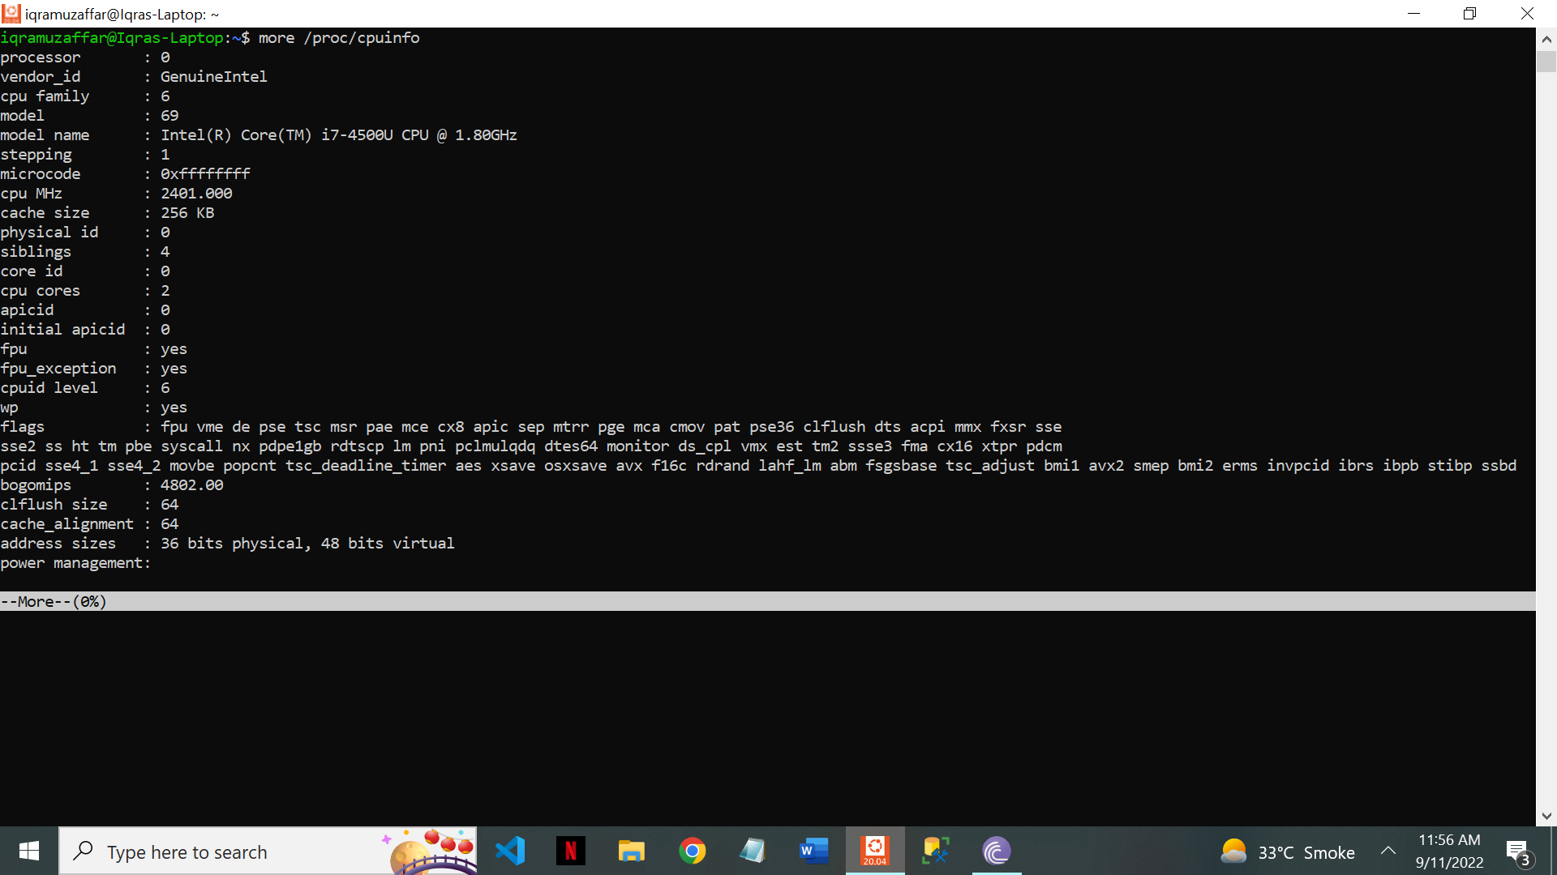

***Verified by command: lscpu***

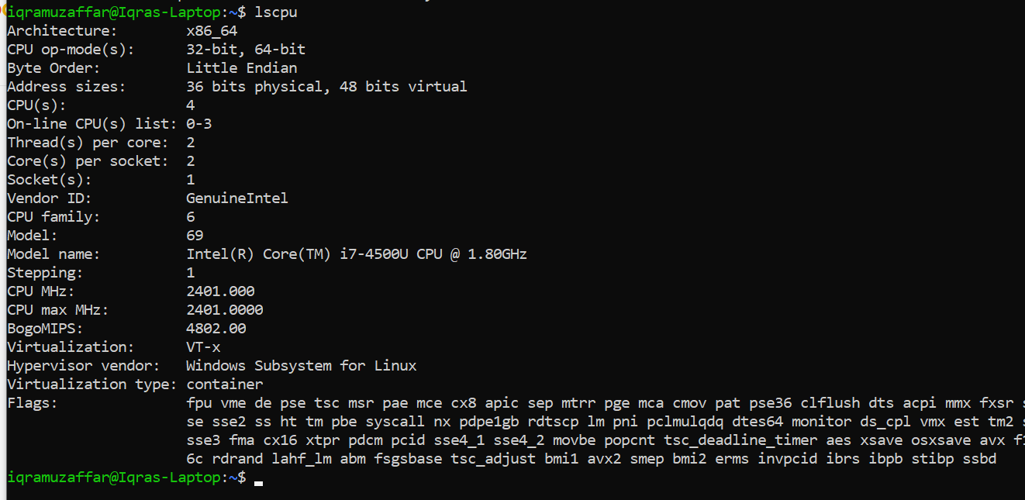

1. How many cores does your machine have?

My machine has 2 cores

1. How many processors does your machine have?

My machine has 1 processor that is;

Intel(R) Core(TM) i7-4500U CPU @ 1.80GHz 2.40 GHz

1. What is the frequency of each processor?

CPU MHZ: 2401.00

CPU MAX MHZ: 2401.000

1. What is the architecture of your CPU?

Architecture is ; x86_64

1. How much physical memory does your system have?

7894896 kbs

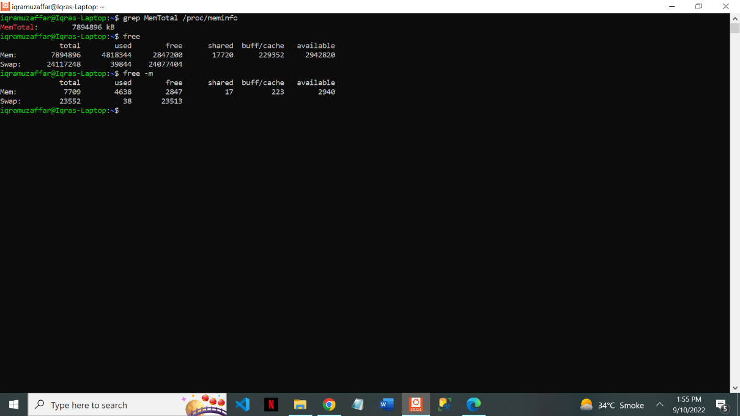

1. How much of this memory is free?

Free memory is 2847200 kbs

1. What is total number of number of forks and context switches since the system booted up?

Forks are 185

Context Switches are 96709

**University Of Engineering and Technology, Lahore Computer Engineering Department**