MindHx
Zapier Integration — Diagram & Setup Instructions
This document explains how to connect MindHx to Zapier so that a screening event — for example, a check-in landing in the "elevated" risk band — can automatically trigger an action in another tool: a Slack alert, a Google Sheets log row, an email, or an SMS. MindHx does not ship a dedicated Zapier app in the Zapier marketplace; this guide uses Zapier's built-in "Webhooks by Zapier" feature, which works with any REST backend and requires no Zapier developer account or app review.

1. Integration Diagram
The diagram below shows the full flow: MindHx's backend evaluates a trigger condition on a screening result, and — only when that condition is met — sends a small, privacy-safe payload to a Zapier webhook, which then runs whichever action steps the Zap is configured with.
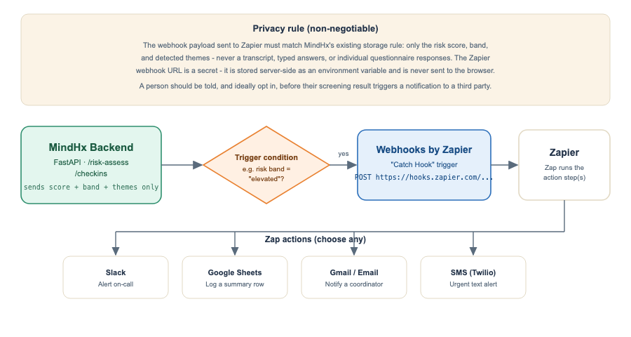
Figure 1 — MindHx → Webhooks by Zapier → Zap action flow

2. Privacy Rule (Non-Negotiable)
This integration must follow the same data-minimization rule as the rest of MindHx: the payload sent to Zapier may only ever contain the risk score, the risk band, and detected themes — never a transcript, typed free-text answers, or individual questionnaire item responses. The Zapier webhook URL is a secret and must be stored as a server-side environment variable; it must never be embedded in frontend code or sent to the browser, since anyone who obtained it could inject fabricated data into your Zap.
Recommendation: if this notifies a real person or team about someone's mental-health signal, the person being screened should be informed that this happens, and ideally opt in explicitly, consistent with MindHx's existing "optional, never silent" data-handling philosophy.

3. Prerequisites
- A Zapier account (the free plan supports Webhooks by Zapier).
- Access to the MindHx backend's deployment environment, to add one new environment variable.
- Whichever destination app you want to notify already connected in Zapier (Slack, Google Sheets, Gmail, Twilio, etc.).

4. Step-by-Step Setup

Step 1 — Create the Zap and get a webhook URL
- In Zapier, click Create Zap.
- For the trigger app, search for and select "Webhooks by Zapier".
- Choose the event "Catch Hook", then click Continue.
- Zapier generates a unique webhook URL, e.g. https://hooks.zapier.com/hooks/catch/xxxxx/yyyyy/ — copy it.

Step 2 — Store the webhook URL as a backend secret
Add the URL to the MindHx backend's environment configuration (never to the frontend's NEXT_PUBLIC_ variables, since those are exposed in the browser bundle):
ZAPIER_WEBHOOK_URL=https://hooks.zapier.com/hooks/catch/xxxxx/yyyyy/

Step 3 — Send the webhook from the backend on the trigger condition
Add a small, optional call in the backend's check-in or risk-assessment flow that fires only when the configured condition is met (for example, band == "elevated"). This keeps the integration entirely opt-in and off by default when ZAPIER_WEBHOOK_URL is not set:
import os
import httpx
async def notify_zapier(band: str, risk_score: float, themes: list[str]) -> None:
webhook_url = os.getenv("ZAPIER_WEBHOOK_URL")
if not webhook_url or band != "elevated":
return
payload = {"band": band, "risk_score": round(risk_score, 2), "themes": themes}
async with httpx.AsyncClient(timeout=5) as client:
try:
await client.post(webhook_url, json=payload)
except httpx.HTTPError:
pass # never let a notification failure block the user's own result
Call this function after a check-in's band is computed, alongside the existing response — it should never block or fail the request back to the user if the webhook call itself fails.

Step 4 — Test the trigger in Zapier
- Back in Zapier, click Test trigger while a real (or manually curled) POST request hits your webhook URL.
- Zapier will show the sample payload it received (band, risk_score, themes) — confirm no unexpected fields are present.

Step 5 — Add an action step
Choose what should happen when the webhook fires. Common options:
- Slack — "Send Channel Message", posting the band and themes to a private #mindhx-alerts channel.
- Google Sheets — "Create Spreadsheet Row", logging band, score, themes, and a timestamp for later review.
- Gmail / Outlook — "Send Email", notifying a designated coordinator.
- Twilio — "Send SMS", for an urgent text alert to an on-call number.

Step 6 — Publish and monitor
- Turn the Zap on.
- Watch Zapier's Zap History for the first few real events to confirm payloads look correct.
- Periodically review who has access to the destination channel/sheet/inbox, since it will contain real (if minimal) screening signals.

5. Sample Webhook Payload
{
"band": "elevated",
"risk_score": 0.72,
"themes": ["anxiety", "hardship"]
}
Nothing beyond these three fields should ever be included — no transcript, no typed text, no individual PHQ-9/GAD-7/K10 item answers, and no personally identifying information unless a signed-in user has explicitly consented to that being shared for this purpose.

6. Summary
Webhooks by Zapier gives MindHx a no-code path to automation without building or maintaining a dedicated Zapier app: a small, guarded backend function decides when to notify, Zapier decides what to do about it. This keeps MindHx's existing privacy and safety commitments intact while making its screening signal actionable in whatever tools a team already uses day to day.

