Software Requirement

Specifications

For

Library Management System



Prepared By :-

Sara Safdar (801)

Nimra Ejaz (828)

Iqra Rehman (833)

Institution: Post Graduate College, Jhang

Date: 25-June-2020

Table of Contents

**1. Introduction**

**1.1** Purpose

**1.2** Document Conventions

**1.3** Intended Audience and Reading Suggestions

**1.4** Project Scope

**1.5** References

**2. Overall Description**

**2.1** Product Perspective

**2.2** Product Features

**2.3** User Classes and characteristics

**2.4** Operating Environment

**2.5** Design and Implementation Constraint

**2.6** Assumption Dependencies

**3. System Features**

**3.1** Functional Requirements

**4. External interface requirements**

**4.1** User interfaces

**4.2** Hardware interfaces

**4.3** Software interfaces

**4.4** Communication interfaces

**5. Non-functional requirements**

**5.1** Performance Requirements

**5.2** Security requirements

**5.3** Software quality attributes

1. Introduction

1.1 **Purpose**

The purpose of this document is to build a library management system that design to help users to maintain and organize library. The main purpose of this project is to maintain the easy circulation system using computers. After computerized system is implemented less human force will be required to maintain the library.

**1.2 Document Conventions**

Entire Document should be justified:

**Convention for main title**

Font-size: 18

Font-style: Arial rounded MT

**Convention for subtitle**

Font-size: 12

Font-style: Bahnschrift

**Convention for body**

Font-size: 12

Font-style: Calibri

**Acronym**

SQL: Structured Query Language

OS: Operating System

ERD: Entity Relationship Diagram

**1.3 Intended audience and reading suggestions**

This project is a prototype for the library management system and it is restricted within the college. This project is useful for a librarian and as well as students.

**1.4 Project Scope**

The proposed library management system is to manage all the process involved in a library in the most effective ways. It will be a helpful product in an effective way as it will reduce the tiresome workload for the members of library. Library management system can be used by any existing or new library to manage its books, insertion and monitoring. It is especially useful for any educational institute where modification in the content can be done easily according to the requirements.

**1.5 References**

* <https://krazytech.com/projects>
* <https://www.slideshare.net/>
* <https://www.academia.edu/>

2. Overall Description

**2.1 Product Perspective**

The library management system can be used by libraries to improve efficiency of librarians and user. The librarian can keep the books record updated all the time so that the members get the updated information all the time. It’s a stand-alone product and does not depend upon the availability of any other product. The system will have an administrator/librarian who has full-fledged rights with regards to performing all actions related to control and management of library database. The system provides books record and information to members and helps them decide on the book to borrow from the library. The librarian can keep the books record updated all the time so that the members get the updated information all the time.

**2.2 Product Features**

This software is capable of managing book issues, return, fine etc. The member status of issue, return is maintained in the library database. The member details can be fetched by librarian as and when required. The valid members are also allowed to view their account information.

**2.3 User Classes and characteristics**

**We have 2 level of users:**

1)The librarian will be acting as the controller and he will have all the privileges of an administrator.

2) Students who will be access the library.

**The librarian should have the following characteristics:**

1. Add books and their information of the books to the database.
2. Edit the information of the existing books.
3. A librarian can issue a book to the student.
4. Can access all the accounts of the student.
5. Can take the book returned from the student.
6. Can view the list of books.
7. Can issue a new book to student and also update the details when student return book.

**The members should have the following characteristics:**

1. Student can register yourself.
2. Can view the book issued to him.
3. Can view the history of books issued to him previously.
4. Can search for a particular book.
5. Can view the list of books.

**2.4 Operating Environment**

Operating for the library database is as listed below:

1. Operating system: windows 32/64 bit
2. Database: SQL
3. Platform: .net (C#)

**2.5 Design and implementation constraints**

The design and implementation constraint are:

1. The system Database used should be an open-source technology.
2. The SQL database must be attached to the system
3. RAM usage should not exceed 1024 MB.

**2.6 Assumption Dependencies**

The specific hardware and software due to which the product will be run. This system will be written for users with a basic understanding of how computer works. Users with less computer experience may have a harder time. The information of all the user must be stored in database that is accessible by the library system. Device is connected to the internet to run this.

3**.** System Features

Functional Requirements

* 1. Register

First the user will have to register/ signup.

* 1. Login

Input: user enter the email and password to login.

Output: if credentials are matches to stored database the user will be able to use the features of library

* 1. Librarian Functions
     1. Update Book Details

Input: Enter detail of books such as names, author, Publisher etc.

Output: Confirmation message display.

* + 1. Remove Books

Input: Enter the name of ISBN, title of book.

Output: update the list of books available and display confirmation message.

* + 1. IssueBooks

state: Search the book user wants to issue.

Input: click the book user wants

Output: confirmation message for issuance of book.

* + 1. Fine Information

Input: check information about Fine

Output: Inform the user using email/phone number about fine.

* 1. Student Functionality
     1. Search

Input: Enter the book title, author to search

Output: if book available it can be shown.

* + 1. Return

Input: Return the book to the librarian.

Output: The issued list will be updated and the return book will be listed out.

4.External interfaces requirements

**4.1 User Requirements**

Frontend Software: C# WPF (visual studio 2019)

Backend software: Oracle SQL Developer

**4.2 Hardware interfaces**

Processor: Intel(R) Core™ i5-5200 U CPU 2.20 GHz

RAM: 256 MB

Keyboard, Mouse, Monitor

**4.3 Software interfaces**

|  |  |
| --- | --- |
| **Software used** | **Description** |
| Operating System | We have chosen window OS for its best support and user-friendliness |
| Database | To save the library record we have chosen SQL developer |
| C# .net | To implement the project we have chosen C# .net for its more interactive support |

**4.5 Communication interfaces**

We are using forms for retrieving, adding, updating, deleting records.

5.Nonfunctional Requirements

**5.1 Performance Requirements**

**ERD**

The E-R Diagram constitute a technique for representing the logical structure of a database in a pictorial manner. It is used to describe the element of a system and their relationship.

**Entities:** An entity is a person, place, thing or event for which data is collected and maintained.

**Attributes:** Characteristics of an entity.

**Relationships:** Logical connection between different entities.

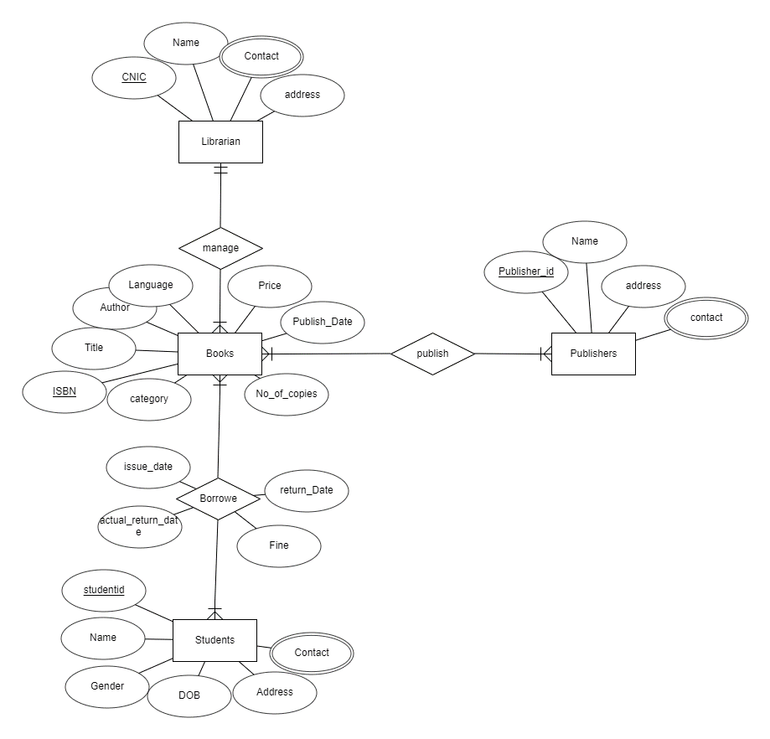

Entity Relationship Diagram

**5.2 Security Requirements**

**Security requirements are as follows:**

1. System will use secure database.
2. Student can just read information but they can’t modify or edit anything except their personal and some other information.
3. There should be separate account for a admin and member such that no member can access database.
4. user authentication and validation of members using their unique member id.
5. Proper accountability which include not allowing a member to see other member account.
   1. **Software Quality Attributes**

* **Maintainability**: The quality of database is maintained in such a way so that it can be very user friendly for all the user of the database.
* **Reliability:** The system does its works more accuracy like user registration to the system, user validation and authorization, book search, issue operation and updating the database by synchronizing between database and application.

**Thank you**