TRACER Forensic Report

CASE-9BB67E5F — testi
Status: Open
Case created: 2026-08-13 19:38 UTC · Report generated: 2026-08-13 19:41 UTC
Total Evidence | Clean | Adversarial
1 | 1 | 0

scaled_pexels-eberhard-grossgasteiger-1612371.jpg
SHA-256: 8c658ce8a4cbebbe6668aecd2ed7115ce784850ace70e80fd8a33d6c580d0b4d
Uploaded: 2026-08-13 19:38 UTC
Verdict: CLEAN (95.3% confidence)
Attribution method: gradient_saliency
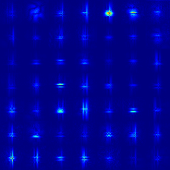
This image was classified as CLEAN with 95.3% confidence (high confidence).
- This verdict is based on attention-entropy anomaly scoring: the attention pattern closely matched what the detector learned to expect from clean, unmanipulated images.
- Attribution (gradient_saliency) shows the most forensically significant pixels are tightly concentrated in a small region (0.1% of the image above threshold).

This report was generated automatically by TRACER. Verdicts are produced by an automated detector (Module 5's offline evaluation measured 86% binary accuracy, 0.95 AUC on its test set) and are not a substitute for expert human review. Treat every verdict below as an investigative lead, not a final determination.

