

assignement no.1

Submitted to: Muhammad Yousaf Submitted by: Iqra Fakhar Roll no: p17-6148 section: CS(B)



September 14, 2018

*Command prompt commands list*

*1:Cd*

*This is used to change the folder, display the name of current dictionary.*

*Example:*

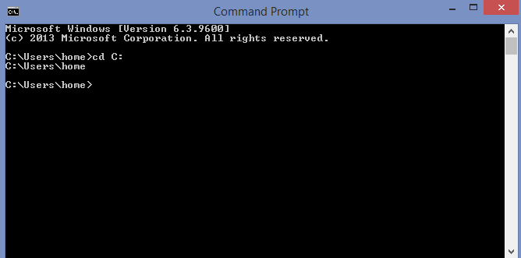

*2:Mkdir*

Creates a folder like if we want to make another folder of any name.

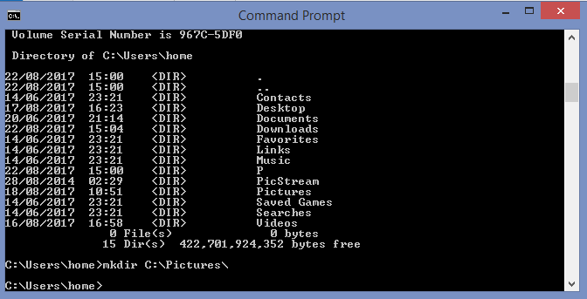Example:

*3:Dir*

*Display the list of folder files and subfolders.*

*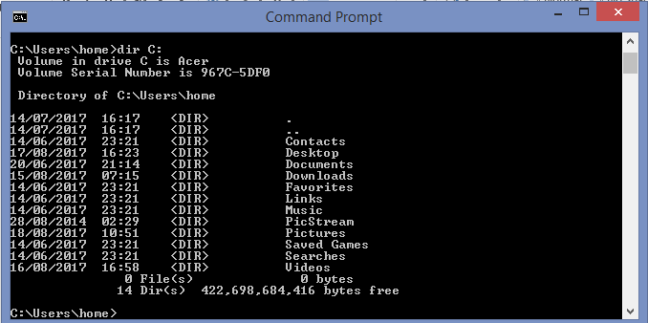Example:*

*4:copy*

*This copies one file to another file even from one**drive to another drive .Like from C drive to D drive.*

*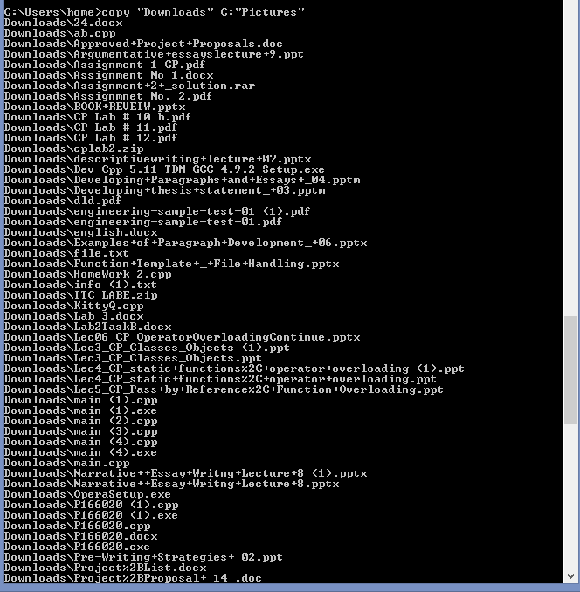 Example:*

*5:Rename*

*Changes the name of the file*

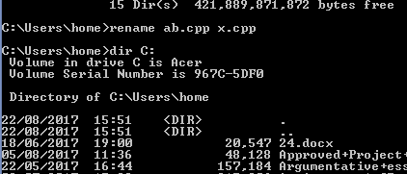*Example:*

*6:del*

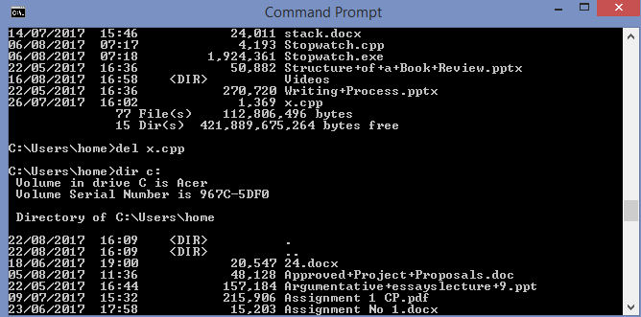*Used to delete a file*

*7:Cls clear screen*

*To clear the command screen*

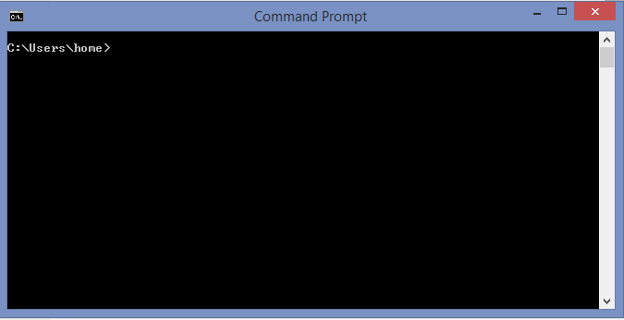

*8:shutdown -l*

*****To logoff from any account in your computer.*

*Example:*

*9:Before shutdown*

*Print a message before shutting down*

**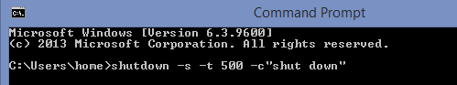***Example:*

*10:shutdown –s*

*To shutdown the computer/power off.*

*****Example:*

*11:shutdown –r*

*To restart*

*****Example:*

*12:exit*

*To exit from the prompt*

*Example:*

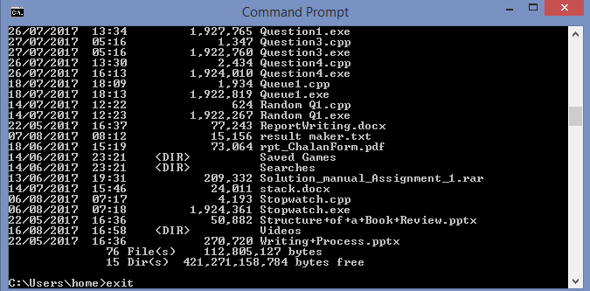

*13:shutdown –s –t*

*For the timmer to shut down PC.*

**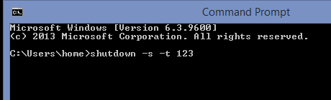***Example:*

*14:shutdown –s +h/-h*

*To hide and show data/file*

**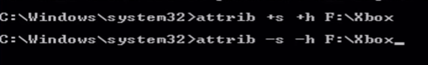***Example:*

*15:netsh waln show profiles*

*To find the wifi password.*

**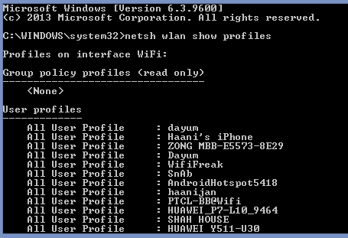***Example:*

*16:Time*

Shows the time

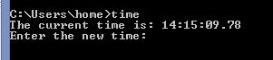Example:

*17:Tree*

*Show the working folder in tree form.*

*Example:*

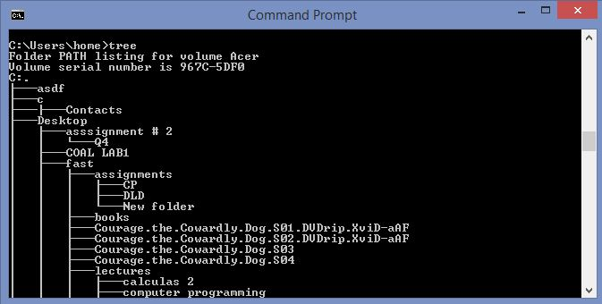

*18:Date*

*Show the date.*

*Example:*

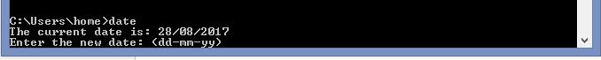

*19:tasklist*

*Show the task running.*

*Example:*

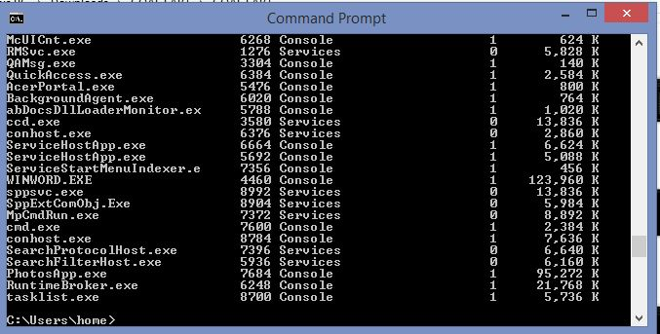

*21:Set*

*Displays, sets or rename variables*

*Example:*

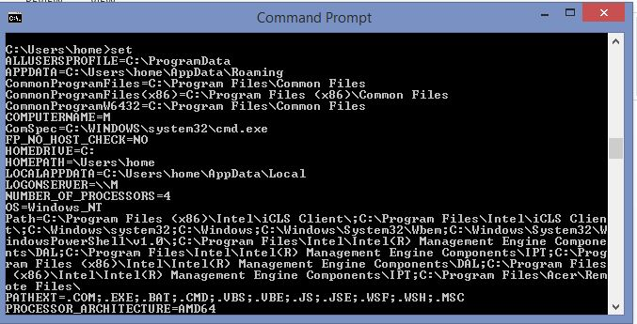

*22:Version*

*Displays the version of the window*

*Example:*

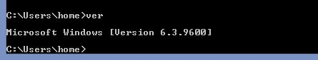

*23:Color*

*Changes the background color*

*Example:*

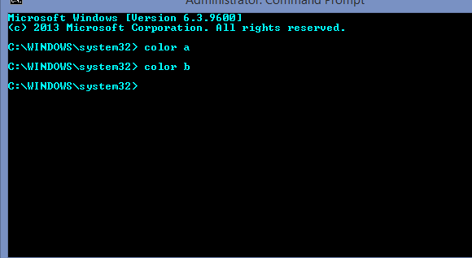

*24:Path*

Displays the files of executable files

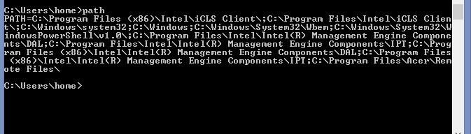Example:

*25:Mode*

*Configure a system device or can also be used to show the lines and rows and columns in the printing material.*

*Example:*

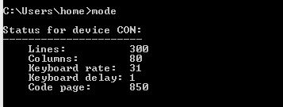

*26:Start*

*Starts another page of command prompt.*

*Example:*

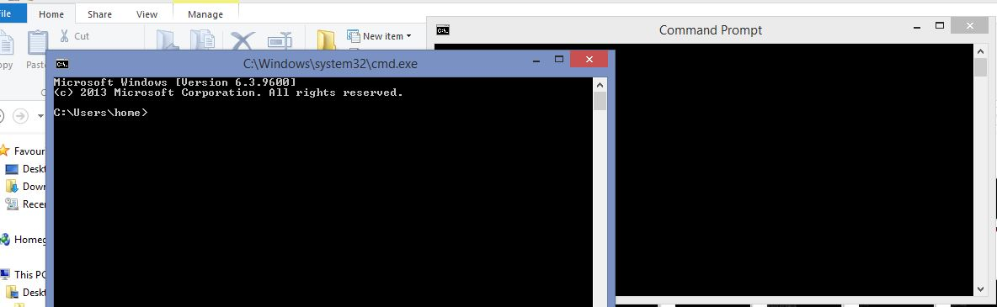 *27:SC*

*Used communicate with the service control manager*

*Example:*

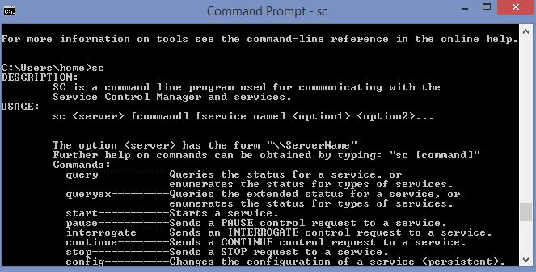

*28:Help*

*Shows the commands prompt list.*

*Example:*

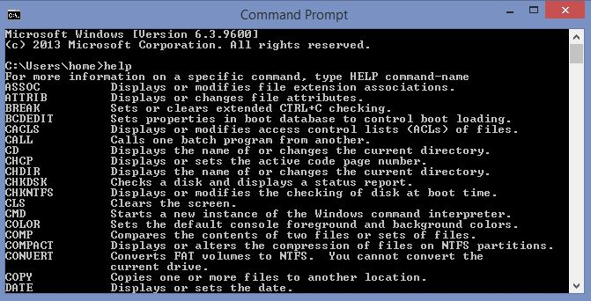

*29: chcp*

*Shows the active mode page number*

*Example:*

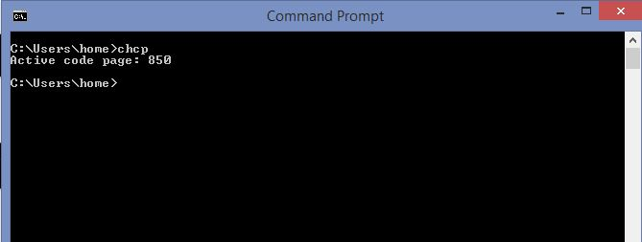

*30: ping*

*The ping commad is used to check the ability of the source computer to reach a specific destination*.

Example:

