SalesBuddy AI
Retail Sales Analytics Assistant

Project Report
Developed using Python, Streamlit, SQLite, and Pandas.

This document provides a comprehensive explanation of the design, development, features, and working of the SalesBuddy AI application. The system demonstrates how data analytics tools can be combined with natural language interaction to create an intelligent retail analytics assistant.

1. Introduction
Retail businesses generate massive amounts of data every day. Each transaction, product purchase, promotional activity, and customer interaction contributes to a growing dataset that holds valuable insights about the business.
However, extracting meaningful insights from large datasets is often difficult without specialized technical knowledge. Many business users depend on analysts to generate reports or dashboards, which slows down decision making.
SalesBuddy AI aims to simplify the process of data analysis by allowing users to interact with sales data using natural language queries. Instead of writing SQL queries manually, users can simply ask questions such as "total sales", "top product", or "sales by month".
The system interprets these questions, executes appropriate database queries, and returns the results through tables, charts, and business insights.
2. Problem Statement
Retail organizations rely heavily on sales data to understand their business performance. However,analyzing this data requires technical skills such as SQL querying, data cleaning, and dashboarddevelopment.
Many small businesses do not have dedicated data analysts, which means decision-makers oftenstruggle to obtain insights from raw sales data.
Some of the common challenges include difficulty querying large datasets, lack of easy-to-use analytics tools, and the time required to generate meaningful reports.
The goal of this project is to create a simple and intuitive system that allows users to analyze sales data quickly without needing technical knowledge of databases or programming.

3. Project Objectives
The main objective of this project is to build an intelligent retail analytics assistant that enables users to explore sales data interactively.
The system should allow users to ask questions related to sales performance and instantly receive results in the form of tables and charts.
Another objective is to design a visually appealing dashboard that provides key performance indicators such as total sales, number of orders, and average sales value.
The system should also support additional analytical features such as product performance analysis and promotion impact analysis.

4. Technologies Used
Python is used as the main programming language because of its simplicity and strong ecosystem of data analytics libraries.
Streamlit is used to build the web-based user interface. Streamlit allows developers to quickly create interactive dashboards using Python code.
SQLite is used as the database system to store sales transaction data. SQLite is lightweight, fast, and does not require complex installation.
Pandas is used for data manipulation and analysis. It allows efficient handling of tabular data retrieved from the database.
The combination of these technologies makes it possible to build a complete analytics system with minimalcomplexity.

5. System Architecture
The system follows a simple architecture that connects the user interface to the database through Python logic.
First, the user enters a question through the Streamlit interface. This question is processed by the application logic which determines the appropriate SQL query to execute.
The SQL query is then executed against the SQLite database containing sales transaction records.
The results returned from the database are converted into Pandas dataframes and displayed using tables and visual charts.
Finally, business insights are generated to provide meaningful interpretation of the results.

6. Key Features
- Feature Description
- KPI Dashboard Displays total sales, total orders, and average sales.
- Suggested Questions Predefined buttons help users explore data quickly.
- Natural Language Queries Users can type simple questions about sales.
- Product Dashboard Shows top products based on sales revenue.
- Promotion Analysis Analyzes impact of promotional offers on sales.
- Charts and Visualizations Line charts and bar charts visualize trends.
- Chat History Stores user queries and responses.
- Download Report Allows downloading chat history as CSV file.

7. Results and Analysis
The system successfully retrieves data from the database and presents it through interactive
visualizations.
Monthly sales trends are displayed using line charts which help identify seasonal patterns in sales performance.
Top product charts highlight the most successful products based on revenue or number of units sold.
Promotion analysis charts reveal whether promotional offers have a positive impact on overall sales performance.
These visual insights enable business users to quickly understand important trends without analyzing raw data manually.

8. Advantages of the System
- The system provides a simple interface for exploring complex datasets.
- Users do not need to write SQL queries manually which makes the system accessible to non-technical users.
- Interactive charts help visualize trends and patterns in sales data.
- The application is lightweight and can run locally without requiring advanced infrastructure.
- It can also be extended easily with additional analytics features.

9. Conclusion
SalesBuddy AI demonstrates how modern analytics tools can simplify data exploration and
decision-making for retail businesses.
By integrating Streamlit dashboards with SQL databases, the system provides a powerful yet
easy-to-use analytics platform.
The ability to query data using natural language significantly reduces the complexity of traditional data analysis workflows.
This project highlights the potential of combining data analytics, visualization, and conversational interfaces in business applications.

10. Future Enhancements
Future versions of the system could integrate advanced AI models to interpret more complex user questions.
Machine learning algorithms could be used to predict future sales trends and demand patterns.
The system could also be connected to cloud databases and deployed as a fully scalable web
application.
Additional features such as customer segmentation, recommendation systems, and automated reporting could further enhance the platform.

11. Implementation
The SalesBuddy AI system was implemented using Python and the Streamlit framework. The application connects to a SQLite database containing retail sales transaction data. Users interact with the system through a web-based interface where they can enter natural language queries. The system processes the query, maps it to a corresponding SQL command, retrieves the relevant data from the database, and displays the results through tables, charts, and insights
11. Application Screenshots

Main Dashboard
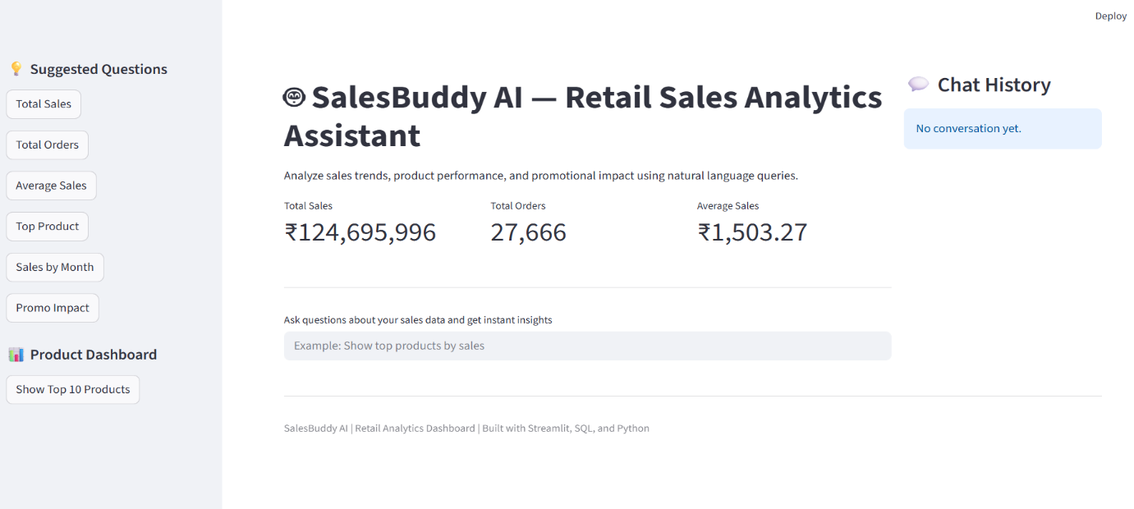

Natural Language Query Result

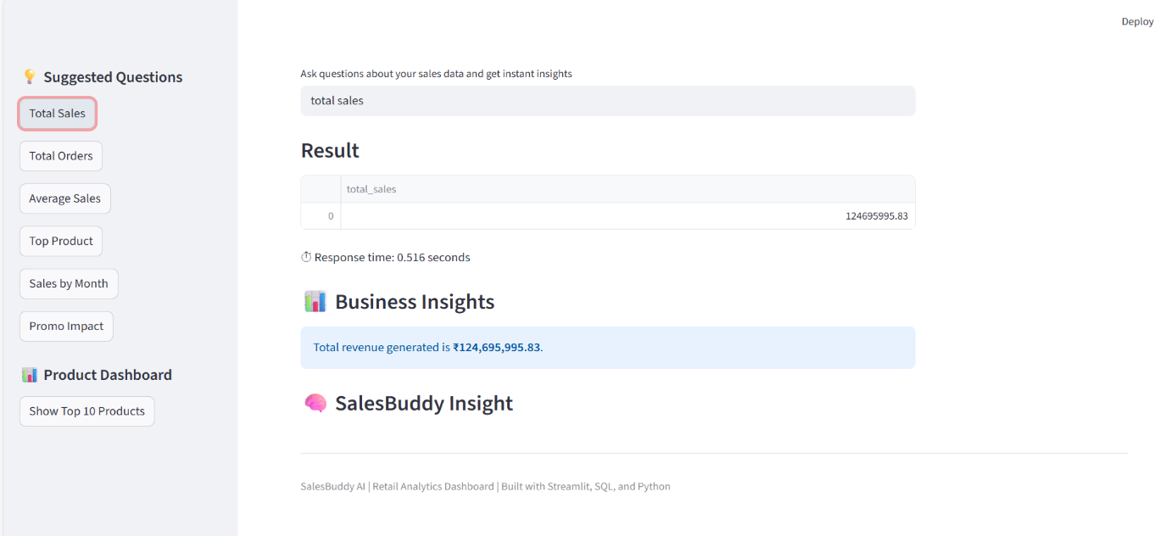

Monthly Sales Chart
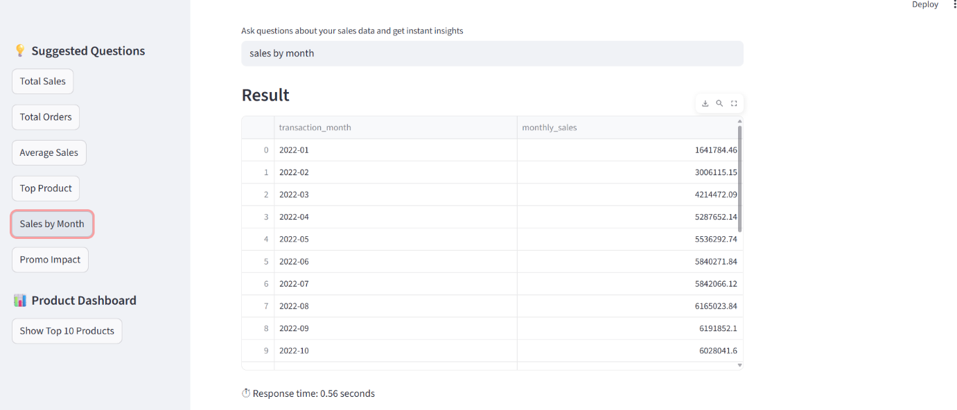
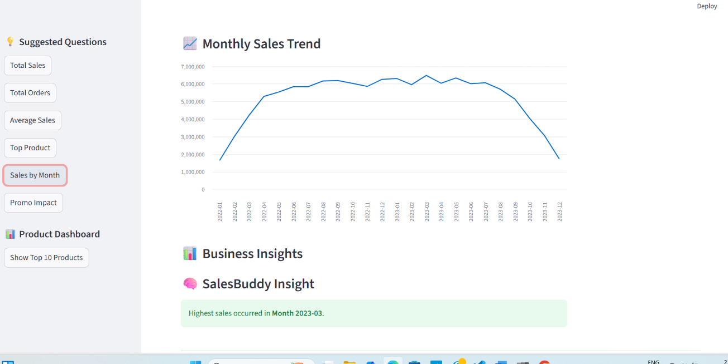

Top Product Chart
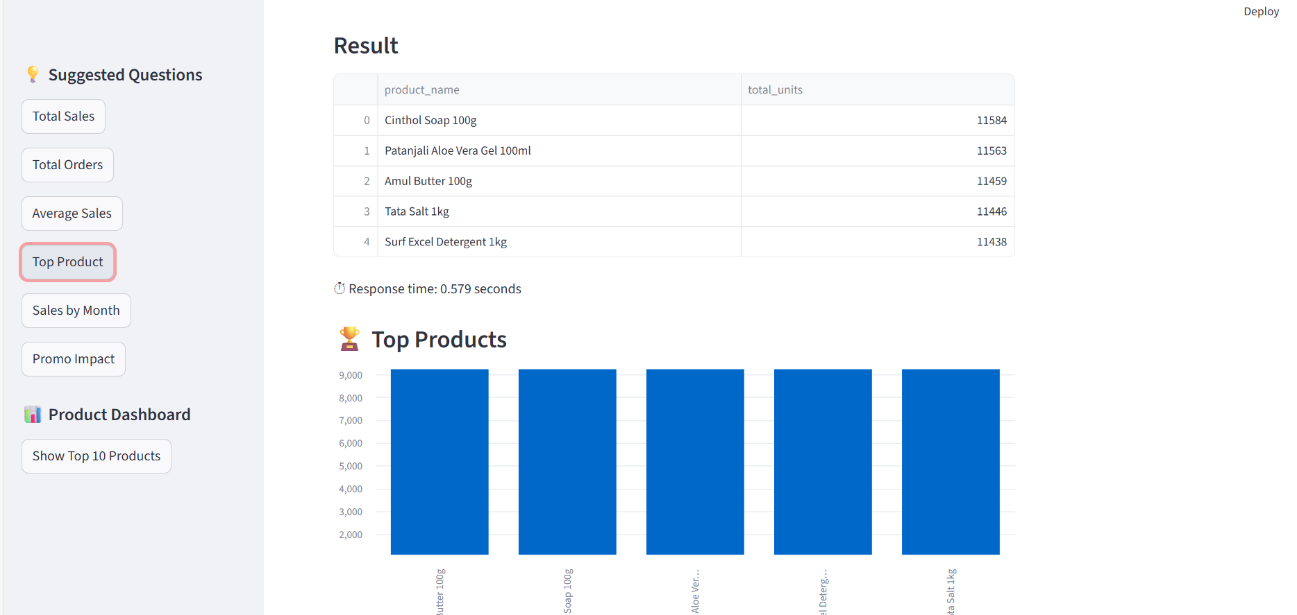
Promotion Impact Chart
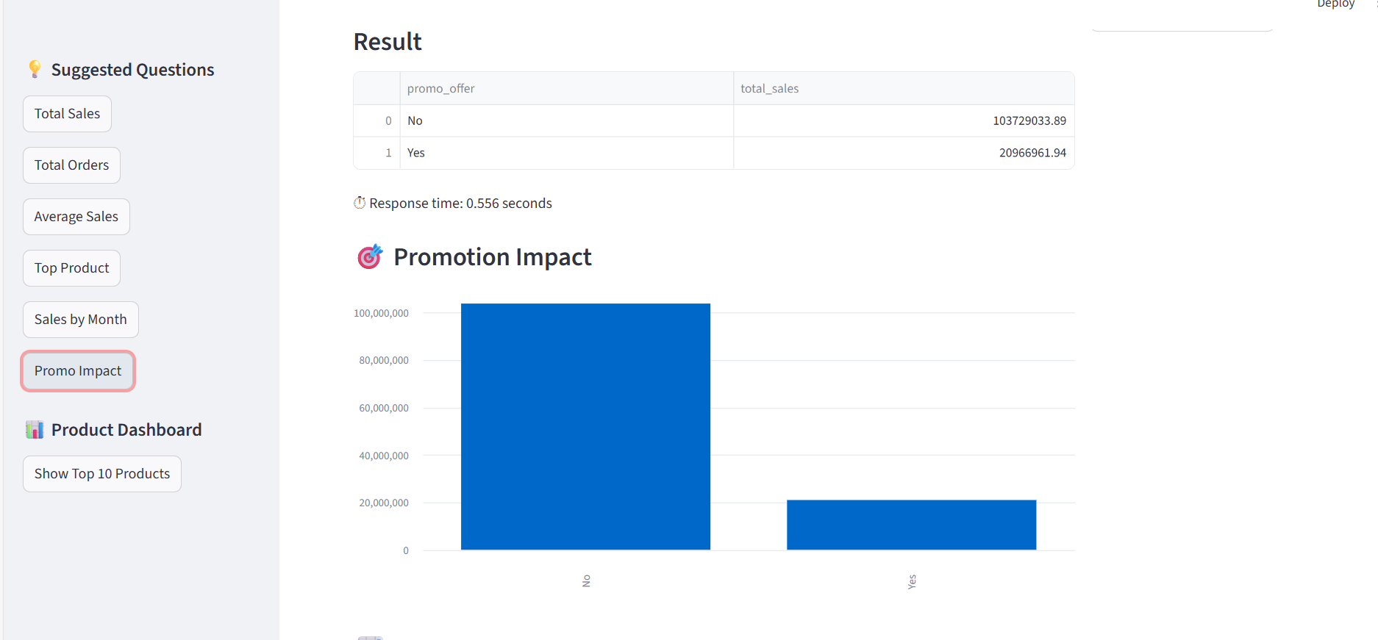

Show top 10 products
