“Naujeños Craftify: An E-commerce Platform for Naujeños Crafts and Souvenirs”

An

Application Development Project

Presented to the Faculty of

**Mindoro State University Calapan City Campus**

Masipit, Calapan City

Oriental Mindoro

In Partial Fulfillment

of the Requirements for the Degree

Bachelor of Science in Information Technology

by:

**Leemart M.Macatangay**

**Ira May B.Baldonado**

<*Date*>

**TABLE OF CONTENTS**

**LIST OF FIGURES**

**LIST OF TABLES**

**LIST OF APPENDICES**

**CHAPTER I**

**INTRODUCTION**

**Project Context**

In today's advanced technological landscape, the use of digital tools has revolutionized various aspects of business, particularly through the emergence of e-commerce platforms facilitating buying and selling goods online. At the same time, the implementation of digital promotional strategies has become a trend, enhancing product visibility and market presence. However, amidst this digital trend, it's notable that some businesses persist in employing manual selling methods, which pose significant challenges in effectively marketing and selling their products compared to those using e-commerce and digital promotions.

In line with this, in the town of Naujan, people take pride in their unique culture and the exceptional skills of the Mangyan tribe's craftsmen. Despite the incredible craftsmanship, the products created by these talented individuals struggle to reach a wider audience beyond local markets. This limitation arises from the traditional manual selling methods still prevalent in the community, making it difficult for these craftsmen to compete with businesses that have embraced the convenience and reach of online platforms. One key issue faced by Naujan’s craftsmen is the persistence of outdated methods of selling products manually. Many local businesses in Naujan still rely on traditional approaches, which involve face-to-face transactions and limited exposure. Additionally, the craftsmen and sellers in Naujan face difficulties in managing their inventory efficiently. The lack of an organized system to track product availability leads to missed opportunities and challenges in meeting the diverse demands of the market in a timely manner. This not only hinders economic growth for the talented artisans but also restricts the potential for their unique creations to be appreciated by a more extensive and diverse customer base.

The economic implications of these challenges are profound, as the local craftsmen miss out on opportunities to expand their reach and improve their financial standing. Moreover, the town itself loses out on the chance to showcase its cultural richness and artistic heritage to a global audience.

In the past twenty years, e-commerce has become increasingly important for businesses of all types. Making customers happy is crucial for a business's success, and having a user-friendly website plays a key role in achieving this. A well-designed website allows customers to easily communicate with the company and shop without any hassle (Almtiri et al., 2022). Ramhidani et al. (2020), emphasize the pivotal role of technology in empowering the products and selling it to more people online. In a study by Qurtubi (2022), it was found that using digital technology doesn't just impact them but also affects many other areas, especially businesses to reach global markets, promote products, and communicate with customers faster. Recognizing these issues, Naujeños Craftify emerges as a solution to these pressing challenges. By providing a centralized E-commerce and Promotional Platform, this project aims to break the environmental barriers, empower craftsmen economically, and create a cultural bridge that connects Naujan's crafts with audience or buyers. The implementation of an efficient Inventory Management System is poised to organize production, reduce wastage, and enhance the overall competitiveness of Naujan's crafts in the market.

## Objectives of the Study

The general objective of the study is to design and develop an e-commerce and promotional platform for Naujeños crafts and souvenirs.

**Specifically, it aimed to:**

* platform to showcase and promote local products of Naujan;
* implement an inventory management design and develop a user-friendly e-commerce with integration of online payment and customer feedback;
* develop a web-based promotional system that ensures real-time tracking of product availability develop report features that offer insights into daily, weekly, and monthly sales within the POS system;

**Scope and Limitation of the Study**

This project entitled “Naujeños Craftify: An E-commerce Platforms for Naujeños Crafts and Souvenirs” is an e-commerce platform designed for Naujan, Oriental Mindoro. It focuses on crafts and souvenirs from the Naujan, emphasizing their unique craftsmanship and cultural significance. In response to the needs of the Naujan Municipal Tourism Office, the system is designed for administrators, staff, and customers with distinct features. Administrative access is to add, update, delete, view local crafts and souvenirs, oversee all transactions, manage stock, encode purchases, manage users, and generate reports. Additionally, administrators can visualize real-time inventory status, review customer feedback, and update the product menu. For staff, functionalities will include adding, viewing,deleting, updating stock, encoding purchases, and generating reports. On the other hand, customers will experience a user- friendly interface that allows them to create accounts, log in, select items, view, and modify their chosen products. The system also supports data analytics that is helpful in gaining insights into sales data to identify best-selling products and know customer preferences.

The system can be used as a promotional platform, but it may not support live-streaming features for promoting new products or showcasing special promotions. The system supports online payment, but it does not offer real-time tracking of their orders. Also, it is delimited to be used by the Naujan Tourism Office for selling their local crafts and souvenirs and promoting those products.

## Definition of Terms

The following are the definitions of the words used on the study.

1. **Naujeños Craftify.** It is a centralized e-commerce platform for showcasing and promoting crafts and souvenirs from Naujan.
2. **E-Commerce.** It is a short term for electronic commerce, and it refers to the buying and selling of crafts and souvenirs over the internet.
3. **Promotional Platform.** It is a centralized means of promoting crafts of Naujeños.
4. **Inventory Management System.** It is a feature of the system that can be used by the staff and admin to track, organize, and manage the stock of products.
5. **Cultural Bridge**. A concept or initiative that helps connect different cultures by showcasing their traditions, art, and heritage. In this project, it refers to connecting the crafts of Naujan to a wider audience, creating an understanding and appreciation of local culture.
6. **Sales Reports**. A feature in an e-commerce or inventory system that generates summaries of sales activity over specific periods (daily, weekly, monthly). These reports provide insights into performance and help businesses make informed decisions.
7. **Crafts and Souvenirs**. Handmade products typically crafted by local artisans, often reflecting the culture, traditions, and craftsmanship of a particular region or community. Souvenirs are usually purchased as mementos from a specific location.
8. **Customer Feedback**: Information provided by customers regarding their experience with a product or service. Feedback can be in the form of reviews, ratings, or comments and is valuable for improving products, services, and customer satisfaction.
9. **Real-Time Tracking**: The ability to monitor and track the status of an event, such as product availability or order delivery, as it happens. It provides up-to-date

information to users and businesses, enhancing the customer experience.

**10. Digital Promotional Strategies**: Techniques and methods used online to market and promote products, services, or brands. These strategies may include social media marketing, search engine optimization (SEO), email campaigns, and online advertisements, which enhance product visibility and attract customers.

**CHAPTER II**

**REQUIREMENTS SPECIFICATION**

**Hardware and Software Requirements**

The backend of the **Naujeños Craftify** platform will handle all business logic, user authentication, order processing, and communication with the database. The selected technologies are:

* **Node.js**:
  + A JavaScript runtime built on Chrome's V8 JavaScript engine that allows for the development of scalable and high-performance web applications.
  + **Node.js** is an ideal choice for the platform due to its event-driven, non-blocking I/O model, making it well-suited for handling multiple simultaneous requests, which is essential for e-commerce platforms.
* **Express.js**:
  + A minimal and flexible Node.js web application framework that provides a robust set of features for building web and mobile applications.
  + **Express** will be used for routing, middleware support, and managing HTTP requests, making the backend development more efficient and streamlined.
* **MongoDB**:
  + A NoSQL database that stores data in a flexible, JSON-like format, making it ideal for handling unstructured and large-scale data.
  + **MongoDB** will store product details, customer data, order information, reviews, and other dynamic content. It offers flexibility to scale and adapt as the platform grows.
  + It will be used in place of traditional relational databases, offering faster write operations and flexible schema designs.

**Functional Requirements**

These specify the core functions that the platform needs to perform for users and administrators.

1. **User Registration & Authentication**
   * Users can register with an email address (name, age, email, contact no., gender).
   * Provide secure login and password recovery options.
2. **Inventory Management (Admin)**
   * Administrators can add, edit, and remove products.
3. **Product Catalogue**
   * Display products with descriptions, images, pricing, and availability.
   * Include categories for different types of crafts (e.g., woodwork, textiles, jewelry).
4. **Product Search and Filter**
   * Allow users to search for products by name.
5. **Shopping Cart**
   * Users can add, remove, or update items in their cart.
   * Display the total cost and estimated shipping costs.
6. **Payment Processing**
   * User shall pay through COD upon delivery.
7. **Order Management**
   * Users can view their order history.
   * Send order confirmation and shipping updates via email.
8. **Customer Reviews and Ratings**
   * Users can leave reviews and ratings for products they have purchased.
9. **Sales Reports** 
   * Track sales performance and inventory movement.
10. **User Profile Management**
    * Users can update personal details, manage addresses, and view their order history.

**Non-Functional Requirement**

These requirements define system qualities and constraints that enhance user experience and maintain system performance.

**1. Performance**

The system should handle up to a high volume of concurrent users without lag.

Response time for page loads and actions (e.g., adding to cart) should be minimal.

**2. Scalability**

The platform should be scalable to accommodate growth in users, products, and order volume.

**3. Security**

Ensure secure user authentication and data encryption.

Protect against data breaches, ensuring safe transactions and secure storage of sensitive information.

**4. Availability and Reliability**

Ensure a high uptime (e.g., 99.9%) to provide uninterrupted access to users.Implement backup systems to prevent data loss.

**5. Usability and Accessibility**

Ensure the platform is easy to navigate and intuitive for users of all backgrounds.

Make the platform accessible, compliant with standards (e.g., WCAG), and mobile-responsive.

**6. Data Privacy**

Comply with data privacy regulations (e.g., GDPR) to ensure user data is protected and managed responsibly.

**7. Maintainability**

Code should be modular and well-documented to facilitate updates and bug fixes.

Ensure support for adding new features and integrations.

**8. Localization**

Support multiple languages and currencies to cater to an international customer base.

**9. Analytics Accuracy**

Ensure data analytics tools provide accurate and real-time insights.Regularly verify data integrity and analytics calculations.

**10. SEO Optimization**

Optimize the website for search engines to increase visibility and organic traffic.

**Security Requirement**

**1.Data Encryption**

* **SSL/TLS Encryption**:
  + All communication between users and the platform must be encrypted using **SSL/TLS** protocols. This ensures that any data exchanged between users and the server (e.g., login credentials, payment information) is securely transmitted over the internet, preventing eavesdropping and man-in-the-middle attacks.
  + SSL certificates should be implemented for the entire website, especially for sensitive pages like login, payment, and registration.
* **Encryption of Sensitive Data**:
  + Sensitive data, including user passwords and payment details, should be encrypted using strong encryption methods (e.g., **bcrypt** for password hashing and encryption for payment-related data).

### **2. User Authentication and Authorization**

* **Strong Password Policies**:
  + The platform should enforce strong password policies for both customers and administrators, such as a minimum length of 8 characters, a combination of uppercase and lowercase letters, numbers, and special characters.
* **Multi-Factor Authentication (MFA)**:
  + Implement **Multi-Factor Authentication (MFA)** for both administrative users and customers during the login process to add an extra layer of security.
  + Users should be required to verify their identity using a second factor (e.g., a code sent via email or SMS) in addition to their password.
* **Session Management**:
  + Implement **session expiration** and **inactivity timeouts** to prevent unauthorized access if a user remains inactive for too long.

**Cultural Requirement**

**Naujeños Craftify** is designed to promote the local crafts and cultural heritage of **Naujan, Oriental Mindoro**, it is important that the platform respects and celebrates the unique traditions, values, and identities of the local communities, particularly the **Mangyan tribe**. The platform must ensure that it aligns with cultural sensitivities while highlighting the significance of the products offered.

### **1. Authentic Representation of Local Culture**

* **Visual Design & Aesthetics**:
  + The website’s design should incorporate elements that reflect **Naujan’s culture** and the **Mangyan tribe’s traditional crafts**. This includes using
  + **local art**, **tribal patterns**, **colors,** and symbols that represent the community’s identity.
  + Include high-quality images and content that authentically represent the **craftsmanship** and **traditions** of the Mangyan artisans, making sure that these visuals resonate with the culture of Naujan and do not misappropriate or distort traditional elements.
* **Cultural Significance of Products**:
  + Each product should include a **description** explaining its **cultural significance**. For example, if a craft item has a symbolic meaning or is tied to specific ceremonies or traditions, the platform should explain this to consumers.
  + Promote the **stories behind the products,** ensuring that the crafts are not just seen as products for sale, but as part of a rich cultural heritage. This could include information about how the crafts are made, the traditions they represent, and the history of the artisans.

### **2. Community Empowerment and Support**

* **Fair Compensation and Ethical Business Practices**:
  + The platform should ensure that local artisans receive **fair compensation** for their work. The pricing of items should be transparent, with a clear breakdown of how the profits are distributed. This is particularly important for local communities that may be vulnerable to exploitation.
  + Support ethical business practices that do not take advantage of the artisans, especially when working with indigenous communities like the Mangyan.
* **Supporting Local Artisans**:
  + **Highlight the artisans** themselves on the platform. Include profiles or interviews with the craftsmen and women who create the products, allowing consumers to connect with the people behind the goods.
  + Provide opportunities for artisans to showcase their work, ensuring that they have **full control** over the representation of their crafts.

**Chapter III**

**Design and Development Methodologies**

**System Design**

The design and development of the "Naujeños Craftify" e-commerce platform focuses on creating a user-friendly, scalable, and secure system to promote and sell the unique crafts of Naujan. The platform’s architecture is divided into key layers: a responsive frontend for an engaging user experience, a robust backend for handling orders, inventory, and payments, and a flexible database layer to store essential data. The system is designed with a user-centered approach, ensuring that artisans, customers, and administrators have seamless interactions. By utilizing modern technologies like React.js, Node.js, and MongoDB, the platform aims to support the growth of local businesses and enhance the visibility of Naujan’s cultural heritage. Agile development practices ensure that the platform evolves with user needs, and rigorous testing ensures a secure and efficient experience for all users. Ultimately, "Naujeños Craftify" aims to empower local artisans and provide customers with a reliable, enjoyable shopping experience, contributing to the local economy and the preservation of traditional crafts.

"Naujeños Craftify" aims to bridge the gap between local artisans and a global market, creating a platform that not only facilitates the growth of Naujan’s economy but also showcases the rich cultural heritage of the Mangyan tribe. By leveraging modern technology and design best practices, the platform creates an inclusive, user-friendly space for artisans and customers alike, contributing to the sustainability and visibility of Naujan’s unique craftsmanship.

Database Design

**Architectural Diagram/ Block Diagram**

This diagram illustrates the workflow of an e-commerce platform, highlighting the roles and processes: Admin manages inventory, sales, reports, and assigns tasks to staff. Staff handles product management and order processing. Users authenticate, browse products, add to cart, and make payments. Data flows into the database, ensuring updates for inventory, orders, and payments. Core processes include managing products, orders, payments, and generating reports. The system ensures seamless integration, secure transactions, and efficient management of operations.

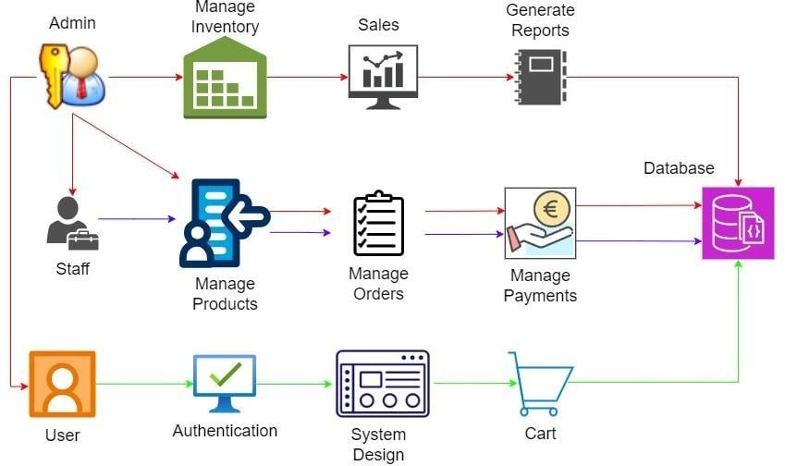

Figure 1: System Architecture “Naujeños Craftify: An E-commerce Platform for Naujeños Crafts and Souvenirs”

System architecture refers to the structural design and organization of a system, encompassing both its hardware and software components. It defines how various subsystems interact and work together to achieve the system's overall objectives. The architecture outlines the key components, such as databases, servers, user interfaces, and APIs, and establishes how they communicate through interfaces, protocols, and data flows. It organizes these components into layers, such as presentation, business logic, and data access, to separate concerns and improve maintainability. A good system architecture also considers the technology stack,

specifying the tools and frameworks used, including programming languages, databases, and cloud platforms. It ensures scalability, allowing the system to handle increased load by either adding more resources or upgrading existing ones, and addresses performance optimization to ensure the system operates efficiently under varying conditions. Additionally, the architecture includes measures for security, such as encryption and authentication, as well as fault tolerance, ensuring the system can continue functioning despite hardware or software failures. Finally, it outlines deployment strategies, whether on-premises, in the cloud, or in a hybrid setup, and provides a plan for maintenance and monitoring to keep the system running smoothly. In summary, system architecture serves as a blueprint, ensuring all components are integrated effectively to meet the system's functional and non-functional requirements.

DFD Level 0

UML Use-case Diagram

**Sample Mock-up**

This user interface showcases the product addition page of "Naujeños Craftify," a specialized e-commerce platform designed to promote and sell handcrafted goods and souvenirs from Naujan. The platform aims to empower local artisans by providing a digital storefront for their unique creations.

***Registration Form***

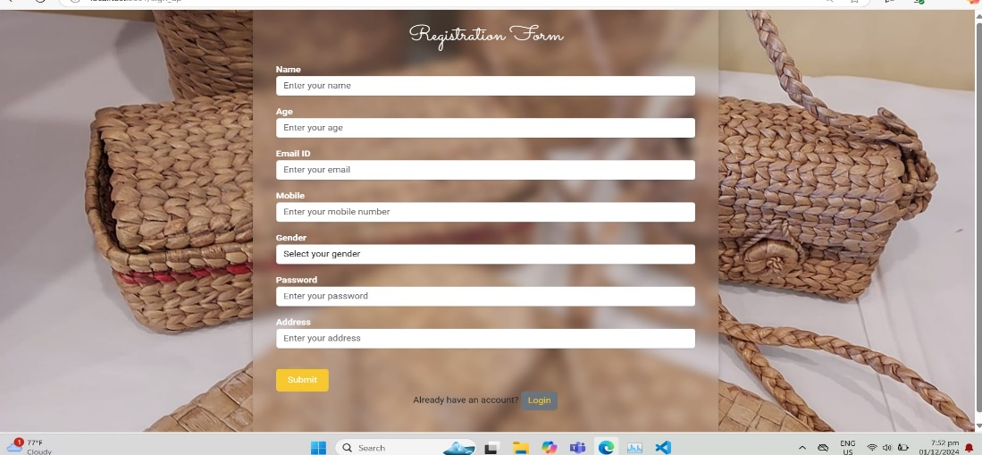

***HandCrafted Baskets***

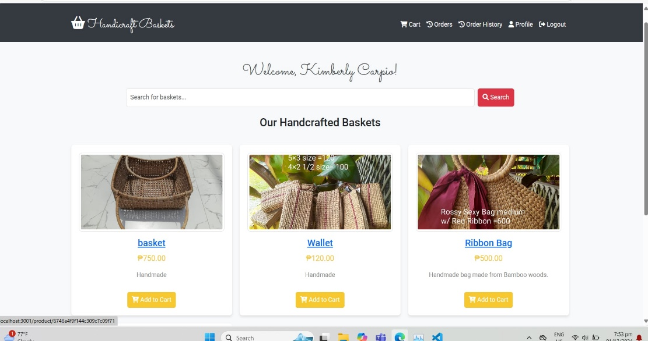

***Delivered Orders***

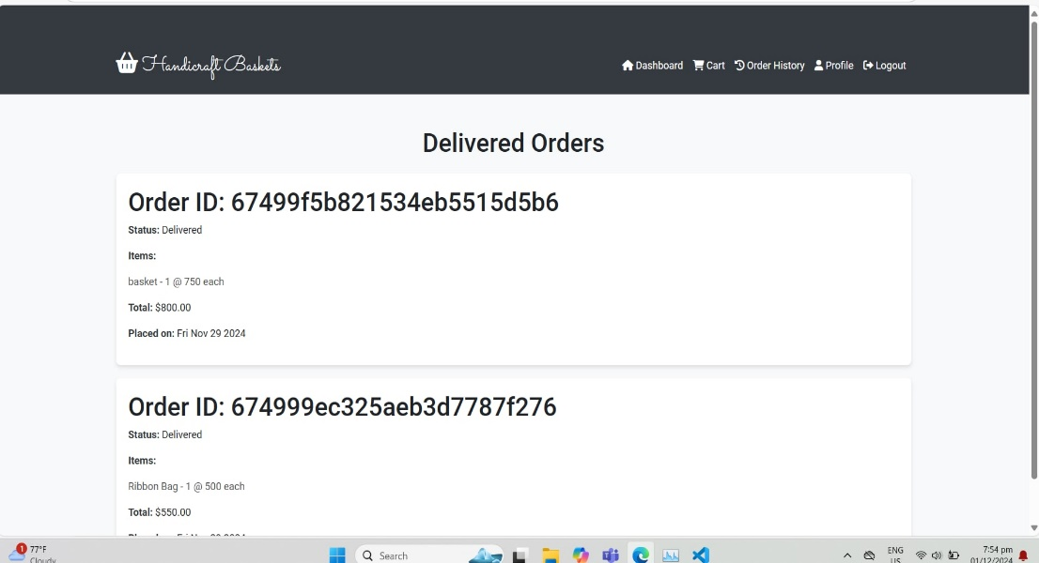

***Order Summary***

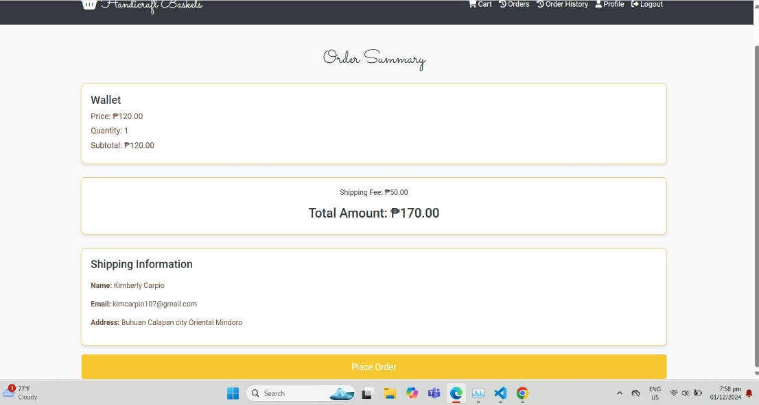

***Admin Dasboard***

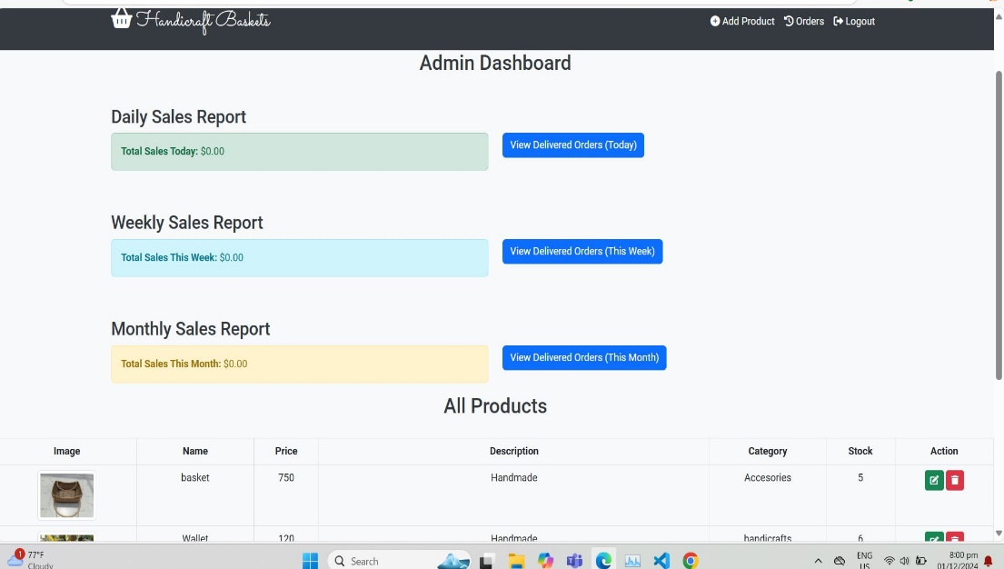

***Customer Orders***

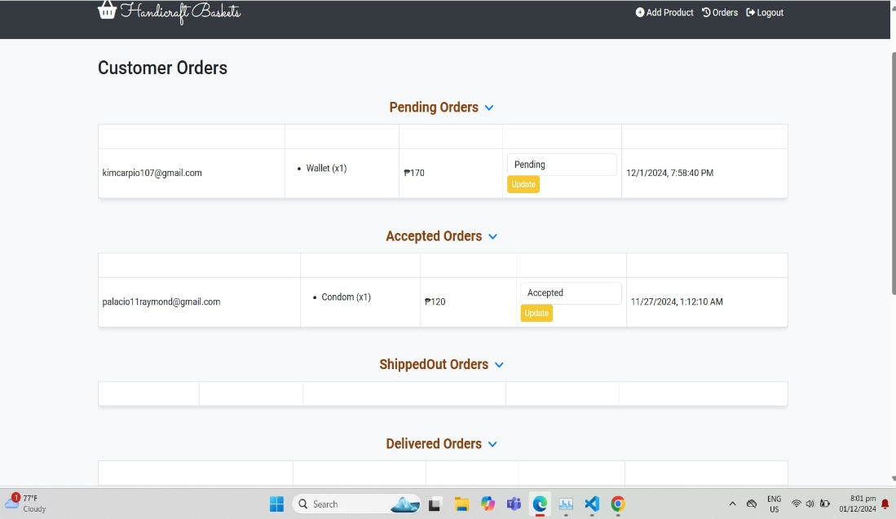

***Add Product***

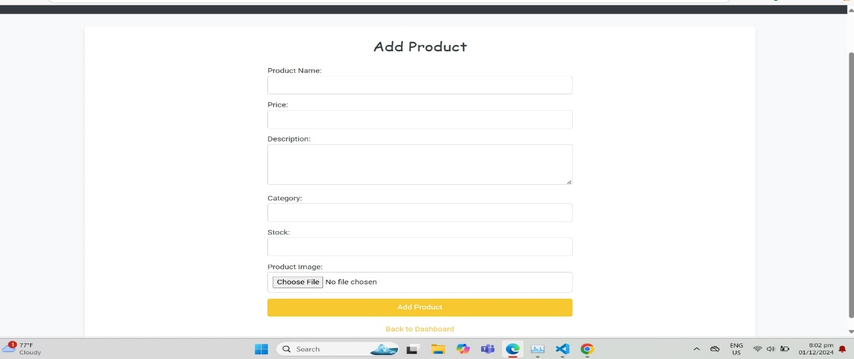

**(Name of your chosen methodology)**

**(Phases of your chosen method)**

**Testing**

To make sure of the usefulness and effectiveness of the study, an evaluation was presented and given to different respondents by having a random sampling selection. The questionnaires include questions for the functionality, performance, compatibility, usability, reliability, security, maintainability, and portability of the system. This phase aims to test the user acceptance and performance of the system. Criteria were based form ISO 25010 Quality Model that was evaluated by 100 respondents.

Also, Unified Theory of Acceptance and Use of Technology (UTAUT) was utilized for the user acceptance and performance of the system.

Below is the list of the actual criteria which are used in the evaluation of the project.

4 – Very Acceptable 3 - Acceptable

2- Not Acceptable 1- Very Not Acceptable

**ISO 25010 Evaluation**

|  |  |  |  |  |
| --- | --- | --- | --- | --- |
| **1. Functional Suitability** | **4** | **3** | **2** | **1** |
| 1.1 The system achieves its expected output. | |  |  |  |
| 1.2 The system is well structured according to the needs of the user. | |  |  |  |
| 1.3 The system is running according to its uses and functions. | |  |  |  |

|  |  |  |  |  |
| --- | --- | --- | --- | --- |
| **2. Performance Efficiency** | **4** | **3** | **2** | **1** |
| 2.1 The system is responsive to the users' command. | |  |  |  |
| 2.2 The system can be used by many users across different platforms without interference. | |  |  |  |
| 2.3 The system can make the users work faster and easier. | |  |  |  |

1. **Compatibility 4 3 2 1** 
   1. The system can be easily installed on any smartphone, laptop, or desktop.
   2. The system is accessible on any smartphone e, laptop, or desktop.
   3. The system generates effective result of data.

|  |  |  |  |  |
| --- | --- | --- | --- | --- |
| **4. Usability** | **4** | **3** | **2** | **1** |
| 4.1 The system meets the needs of the target users | |  |  |  |
| 4.2 The system is easy to understand, operate and control by the end-users. | |  |  |  |
| 4.3 The system user interface is intuitive and satisfies user interaction. | |  |  |  |

|  |  |  |  |  |
| --- | --- | --- | --- | --- |
| **5. Reliability** | **4** | **3** | **2** | **1** |
| 5.1 The system operates properly and reliably. | |  |  |  |
| 5.2 The system facilitates recovery procedure in the event of system failure. | |  |  |  |
| 5.3 The system can operate reliably even in the presence of software faults. | |  |  |  |

|  |  |  |  |  |
| --- | --- | --- | --- | --- |
| **6. Security** | **4** | **3** | **2** | **1** |
| 6.1 The system can be accessed only by the authorized users. | |  |  |  |
| 6.2 The system is secured and protected in terms of data transmission. | |  |  |  |
| 6.3 The system has user-limited access based on roles and responsibilities. | |  |  |  |

|  |  |  |  |  |
| --- | --- | --- | --- | --- |
| **7. Maintainability** | **4** | **3** | **2** | **1** |
| 7.1 The system is easy to install and maintain. | |  |  |  |
| 7.2 The system can be easily modified for the improvement of the system. | |  |  |  |
| 7.3 The system can be modified without compromising the existing system’s quality. | |  |  |  |

|  |  |  |  |  |
| --- | --- | --- | --- | --- |
| **8. Portability** | **4** | **3** | **2** | **1** |
| 8.1 The system can be adapted seamlessly across various hardware setups. | |  |  |  |
| 8.2 The system can be transferred to another location conveniently. | |  |  |  |
| 8.3 The system can be easily deployed across different environments. | |  |  |  |

**Respondents Profile**

**Likert Scale**

|  |  |  |
| --- | --- | --- |
| **Scale** | **Statistical Limit** | **Verbal Interpretation** |
| 4 | 3.50 – 4.00 | Very Acceptable |
| 3 | 2.50 – 3.49 | Acceptable |
| 2 | 1.50 – 2.49 | Not Acceptable |
| 1 | 1.00 – 1.49 | Very Not Acceptable |

Table 7 shows the basics of how the rating of the system was rated. Four (4) is the highest score and one (1) is the lowest.

**Evaluation Instrument**

In this section, we present the evaluation instrument used to assess the **Naujeños Craftify** e-commerce platform. The purpose of this instrument is to evaluate how well the platform performs across various critical aspects such as functional suitability, performance efficiency, compatibility, usability, reliability, security, maintainability, and portability. These aspects are essential for determining the effectiveness and user satisfaction with the system.

The evaluation process utilizes a **Likert Scale**, where the rating values range from 1 to 4, corresponding to the following interpretations:

* **4** represents *Very Acceptable*,
* **3** represents *Acceptable*,
* **2** represents *Not Acceptable*, and
* **1** represents *Very Not Acceptable*.

Each category includes specific criteria to measure how well the system performs in relation to user expectations and technical requirements. Below is the detailed **Evaluation Instrument** used for assessing the **Naujeños Craftify** platform.

**CHAPTER IV**

**DEVELOPMENT, TESTING AND EVALUATION RESULT**

**Presentation of the System Output**

**Testing Results**

**ISO 25010 Evaluation Result**

**CHAPTER V**

**CONCLUSION AND RECOMMENDATION**

**Conclusion**

The *Naujeños Craftify* e-commerce platform has been designed and developed to serve as a digital marketplace dedicated to promoting and selling authentic Naujeños crafts and souvenirs. This project was driven by the goal of providing a user-friendly, scalable, and secure platform for artisans and customers alike. After completing the system design and development process, the following key points summarize the achievements and outcomes:

1.Successful Integration of E-Commerce Features the platform includes key e-commerce functionalities such as user registration, product browsing, shopping cart, secure payment processing, order management, and inventory tracking. This provides users with an efficient and enjoyable online shopping experience for local crafts.

2.User-Centered Design the platform has been designed with the end-users in mind, ensuring a seamless browsing and purchasing process. Features like responsive design, easy

navigation, and a visually appealing product display contribute to the platform's overall usability.

3.Scalability and Performance the system is built on a scalable architecture, ensuring that as the platform grows and more users and products are added, it will remain responsive and functional. Cloud-based hosting, load balancing, and caching mechanisms are implemented to support high traffic volumes.

4.Secure and Reliable Transactions the integration of reliable payment gateways such as PayPal and Stripe ensures secure payment processing, while encryption standards and secure authentication mechanisms protect user data and transactions.

5.Enhanced Visibility for Naujeños Crafts by creating a dedicated space for Naujeños artisans to showcase their products, *Naujeños Craftify* contributes to the preservation and promotion of local culture. The platform provides a global audience for crafts and souvenirs that reflect the rich traditions and artistry of the Naujeños community.

**Recommendation**

While the platform has successfully met its objectives, there are several areas where further enhancements and improvements could be made. The following recommendations aim to expand the platform's functionality, increase user engagement, and improve its sustainability in the long term:

**1. Develop a Mobile Application** although the website is mobile-responsive, developing a dedicated mobile application for iOS and Android could provide users with a more convenient and optimized shopping experience. A mobile app would also enable features like push notifications for promotions and order updates, as well as greater integration with mobile payment systems.

**2. Expand Payment Options** to cater to a broader audience, especially in local and international markets, it is recommended to integrate additional payment methods,

**3.Multilingual and Multicurrency Support** introducing multilingual capabilities would help make the platform more inclusive, especially for customers who speak different languages. Additionally, implementing multicurrency support would facilitate international transactions and attract a global customer base, expanding the platform’s reach beyond local markets.

**4. Personalization Features:**offering personalized products, such as custom engravings or made-to-order crafts, could enhance customer satisfaction and drive sales. A "personalize your craft" feature would allow users to create unique items, adding value to the product offerings and increasing customer loyalty.

**5. Customer Reviews and Ratings System** integrating a customer review and rating system would help build trust with potential buyers. Positive reviews can serve as testimonials, improving the platform's credibility. It also provides valuable feedback to artisans on product quality and customer preferences.

**6. SEO and Digital Marketing Strategies** to improve the platform's visibility and attract more traffic, a comprehensive SEO strategy should be implemented. Optimizing product pages, using relevant keywords, and creating high-quality content will help the platform rank higher in search engine results. Additionally, digital marketing campaigns on social media platforms can be leveraged to drive awareness and engage with a larger audience.

**7. Sustainability and Ethical Sourcing Initiatives a**s sustainability becomes increasingly important to consumers, the platform can promote ethical sourcing by featuring eco-friendly or locally sourced materials used in the products. This could be a unique selling proposition (USP) that appeals to environmentally conscious customers.

**8. Collaboration with Local Communities and Artisans** tofurther enhance the cultural value of the platform, partnerships with local artisan communities, cultural events, or festivals can help promote the platform and create opportunities for artisans. Hosting online showcases or events that feature crafts or live demonstrations can increase engagement and visibility.

**REFERENCES**

Tufail, M., & Kim, K. M. (2019). Sustainable and ICT-Enabled development in developing areas: An E- Heritage E-Commerce service for handicraft marketing. Journal of Physics,989,012009.https://doi.org/10.1088/17426596/989/1/012009

Escaith,H.(2021).Technology, E- commerce and Handicrafts:When traditional creators meet 21st Century business models.ResearchGate. [https://www.researchgate.net/publicat](http://www.researchgate.net/publicat) ion/356931583_Technology_Ecommerce_and_Handicrafts_When_traditi onal_creators_meet_21st_Century_busin ess_models

Rahmidani, Rose & Armiati, Armiati & Syukhri, Syukhri & Susanti, Dessi. (2020). Development Strategy of Embroidery Product Market Based on WEB E-Commerce in West Sumatra. 10.2991/aebmr.k.200305.149.

Ivanova, M. G. (2020, October 1). Online distribution channels of Bulgarian wood crafts and artwork microenterprises.https://papers.ssrn. com/sol3/papers.cfm?abstract_id=37029 14

Kawa, A., Business, P., Wałęsiak, M., & Polska, P. G. (2019). Marketplace as a key factor in e-commerce value networks. LogForum, 15(4), 521–529. https://doi.org/10.17270/j.log.2019.3 51

Warlina,L.,&Habibi, I. (2019). Analysis E-commerce handicraft of Website-Based.IOP Conference Series, 662(3),032050.[https://doi.org/10.1088](https://doi.org/10.1088/1757-899x/662/3/032050)

[/1757-899x/662/3/032050](https://doi.org/10.1088/1757-899x/662/3/032050)

Hasan, M.R., Daryanto, Y., Roy, T.C. and Feng, Y. (2020), "Inventory management with online payment and preorder discounts", Industrial Management & Data Systems, Vol. 120 No.11, pp.2001-2023. https://doi.org/10.1108/IMDS-05-2020-

0314

**APPENDICES**

**Sample Accomplished ISO 25010 Evaluation Form**

**Picture During Development, Testing & Evaluation**