KIET Group of Institutions, Ghaziabad
Electronics and Communication Engineering



Control System Lab Report

Submitted to: Mr Vipin Verma and Dr. Himanshu Chaudhary

(2023-24)

Submitted By: Ira Nafees
Course: Btech
Branch: ECE
Semester: 6th
Sec: B
Roll No: 2100290310072

INDEX
Experiment Number | Aim of experiment | Page number
2 | Determine transpose, inverse value of given matrix | 3-4
3 | Plot pole zero configuration in s-plane for given transfer function | 5-6
4 | Determine the transfer function for the closed loop system in the block diagram representation. | 7-9
5 | Determine the time response of the given system subjected to any arbitrary input. | 10-11
6 | Plot unit step response of the given transfer function and find delay time, rise time, peak time, peak time, peak overshoot and settling time. | 12-13
7 | Determine the steady state error of a given transfer function | 14-15
8 | Plot root locus of a given transfer function, locate closed loop pole for the different value of K | 16-17
9 | Plot Bode plot of given transfer function. Also determine gain and phase margins | 18-19
10 | Plot Nyquist plot for given transfer function. Also determine the relative stability by measuring gain and phase margin. | 20-21
Experiment – 2

OBJECTIVE: Determine transpose, inverse value of given matrix.

SOFTWARE REQUIRED: MATLAB

PROGRAM:

TRANSPOSE OF MATRIX

clc;

clear all;

close all;

A=[231;451;231]

B = transpose(A)

INVERSE OF MATRIX

clc;

clear all;

A=[12;34]

B = det(A)

for i = 1:2

for j = 1:2

- (i, j) = ((-1) ^ (i+ j)) *(A(3-i,3-j)); E (i, j) = transpose(D(i,j))

I (i, j) = (E (i, j)/B); C=I'

end

end

WORKSPACE:
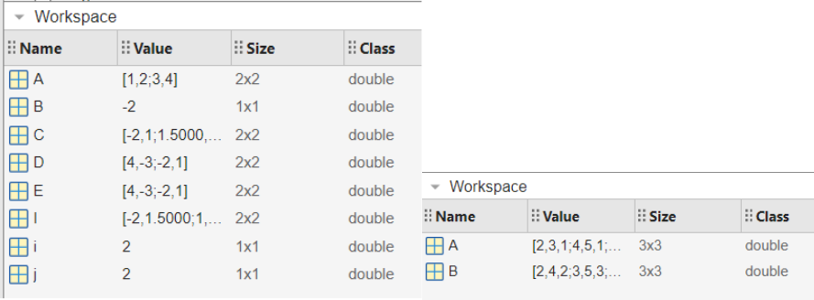
COMMAND WINDOW:

A=1 2

- 4

B=-2 E = 4 C=-2

E = 4 | -3
C = -2.0000
1.5000
E = 4 | -3
-2 | 0
C = -2.0000 |  | 1.0000
1.5000 |  | 0
E = 4 | -3
-2 | 1
C = -2.0000 |  | 1.0000
1.5000 |  | -0.5000
A = 2 | 3 | 1
4 | 5 | 1
2 | 3 | 1
B = 2 | 4 | 2
3 | 5 | 3
1 | 1 | 1

Experiment – 3

OBJECTIVE: PLOT POLE-ZERO CONFIGURATION IN S-PLANE FOR THE GIVEN TRANSFER FUNCTION USING MATLAB

SOFTWARE REQUIRED: MATLAB

PROGRAM:

clc;

clear all;

H = tf ([3 2 1 2 1], [6 6 2 6 2 1])

Y = zpk (1, [-2, -3], 6)

subplot (2,1,1);

pzmap (H);

grid on;

subplot (2,1,2);

pzmap(Y);

WORKSPACE:
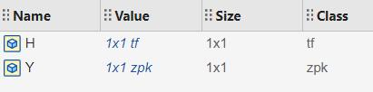

COMMAND WINDOW:

H = 3 s^4 + 2 s^3 + s^2 + 2 s + 1

---------------------------------------

6 s^5 + 6 s^4 + 2 s^3 + 6 s^2 + 2 s + 1

Continuous-time transfer function.

Y = 6 (s-1)

-----------

(s+2) (s+3)

Continuous-time zero/pole/gain model.

FIGURE:
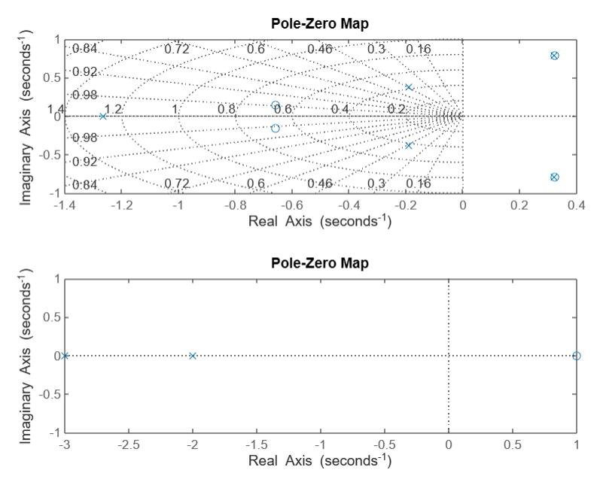
Experiment – 4

OBJECTIVE: Determine the transfer function for the closed loop system in the block diagram representation.

SOFTWARE REQUIRED: MATLAB

PROGRAM:

clc;

close all;

clear all;

%for system1

G1 = tf ([1 0], [1 1])

H1 = tf ([1], [1 0])

G2 = tf ([1 4], [1 3 1])

H2 = tf ([1 0], [1 2])

F1 = feedback (G1, H1)

F2 = feedback (G2, H2)

A = series (F1, F2)

H = tf ([1 0], [1 3])

F3 = feedback (A, H)

f =F3(step);

WORKSPACE:
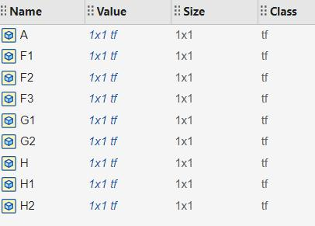
COMMAND WINDOW:

G1 = s

-----

s + 1

Continuous-time transfer function.

H1=1

-

s

Continuous-time transfer function.

G2 = s + 4

-------------

s^2 + 3 s + 1

Continuous-time transfer function.

H2 = s

-----

s + 2

Continuous-time transfer function.

F1 = s^2

---------

s^2 + 2 s

Continuous-time transfer function.

F2 = s^2 + 6 s + 8

----------------------

s^3 + 6 s^2 + 11 s + 2

Continuous-time transfer function.

A = s^4 + 6 s^3 + 8 s^2

-----------------------------------

s^5 + 8 s^4 + 23 s^3 + 24 s^2 + 4 s

Continuous-time transfer function.
H = s

-----

s + 3

Continuous-time transfer function.

F3 = s^5 + 9 s^4 + 26 s^3 + 24 s^2

-----------------------------------------------

s^6 + 12 s^5 + 53 s^4 + 101 s^3 + 76 s^2 + 12 s Continuous-time transfer function.

num = 0 -0.1022 0.0316 0.1934 -0.1795 0.1620

den = 1.0000 6.2190 50.6538 222.7866 359.5180 162.7478

FIGURE:
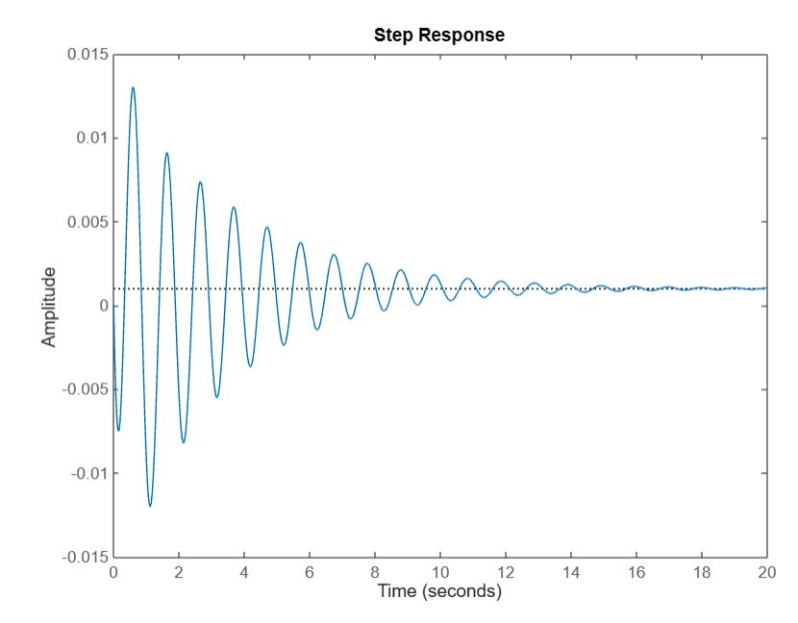
Experiment – 5

OBJECTIVE: Determine the time response of the given system subjected to any arbitrary input.

SOFTWARE REQUIRED: MATLAB

PROGRAM:

clc;

close all;

clear all;

h1 = tf ([9], [1 6 9])

t = linspace (1,15,50);

%step response

Subplot (3,2,1)

step(h1)

%impulse response

Subplot (3,2,2)

impulse(h1)

%sinusoidal

- =sin(t);

%ramp

s=2*t;

%parabolic q = 5*(t.^2); subplot (3,2,3); lsim (h1, r, t); subplot (3,2,4); lsim (h1, s, t); subplot (3,2,5); lsim (h1, q, t);
WINDOWSPACE:
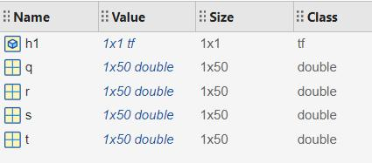

COMMAND WINDOW:

h1 =

9
-------------

s^2 + 6 s + 9
Continuous-time transfer function.

FIGURE:
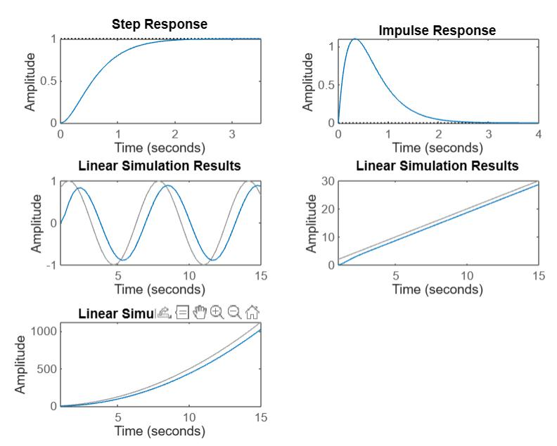

Experiment – 6

OBJECTIVE: Plot unit step response of the given transfer function and find delay time, rise time, peak time, peak time, peak overshoot and settling time.

SOFTWARE REQUIRED: MATLAB

PROGRAM:

clc

clear all

close all

g = tf ([25], [1 6 25])

wn = 5

zt = 6/(wn*2)

wd = wn*sqrt(1-(zt*zt))

tp =pi/wd

mp =exp((-1*zt*pi)/sqrt(1-(zt*zt)))

po = (2*pi)/wd

st = 4/(zt*wn)

a = acos(zt);

rt = (pi-a)/wd

t = 0:0.01:10;

[y, t] = step(g);

Plot (t, y)

WINDOWSPACE:
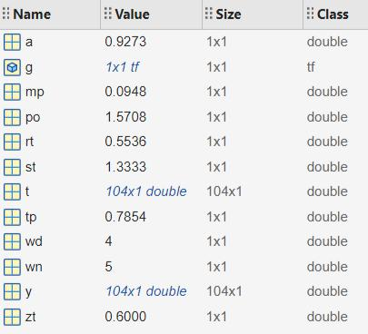
COMMAND WINDOW:

g = 25

--------------

s^2 + 6 s + 25

Continuous-time transfer function.

wn = 5

zt = 0.6000

wd = 4

tp = 0.7854

mp = 0.0948

po = 1.5708

st = 1.3333

rt = 0.5536

FIGURE:
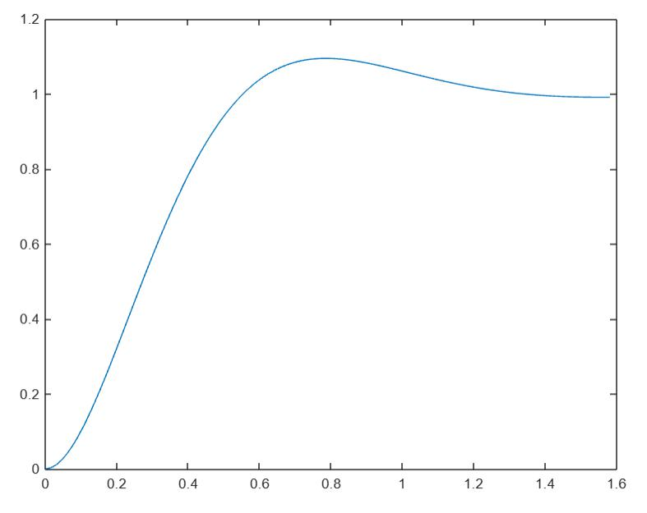
Experiment – 7

OBJECTIVE: Determine the steady state error of a given transfer function.

SOFTWARE REQUIRED: MATLAB

PROGRAM:

clc

close all

clear all

g = tf ([4], [1 3 4])

a = step(g);

[y, t] = step(g);

i=length(y)

z = y(i)

c = y(end)

sserror = abs(1-c)

WINDOWSPACE:
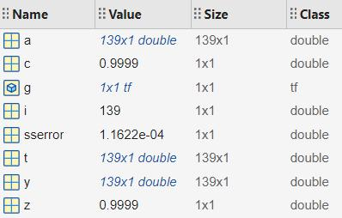

COMMAND WINDOW:

g = 4

-------------

s^2 + 3 s + 4

Continuous-time transfer function.

i = 139

z = 0.9999

c = 0.9999

sserror = 1.1622e-04

Experiment – 8

OBJECTIVE: Plot root locus of a given transfer function, locate closed loop pole for the different value of K

SOFTWARE REQUIRED: MATLAB

PROGRAM:

clc

close all

g = tf ([1 3 5], [1 5 8 4]);

w = linspace(1,1000,1000);

for i = 1:1:1000

mag(i) = 2/sqrt(25+w(i).^2);

magdb(i) = 20*log(mag(i));

phase(i) = -atan(w(i)/5);

end

subplot(2,2,1)

semilogx(w,magdb)

subplot(2,2,2)

semilogx(w,phase)

subplot(2,2,3)

bodeplot(g)

COMMAND WINDOW:

g =

s^2 + 3 s + 5

---------------------

s^3 + 5 s^2 + 8 s + 4

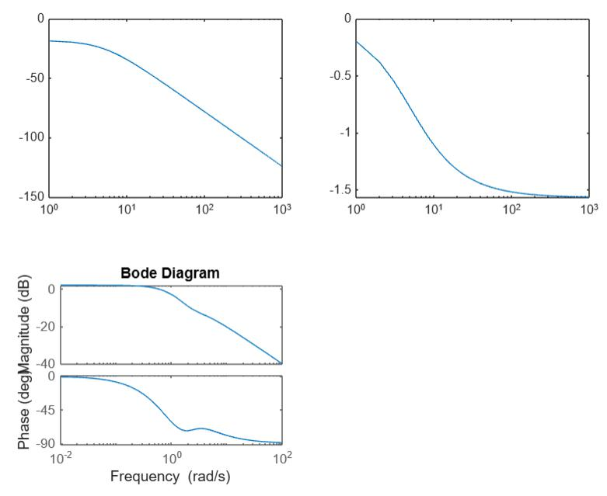
Continuous-time transfer function.

FIGURE:
Experiment – 9

OBJECTIVE: Plot Bode plot of given transfer function. Also determine gain and phase margins

SOFTWARE REQUIRED: MATLAB

PROGRAM:

clc;
clear all;
close all;
w = linspace(0,1000,1000);
for i=1:1:1000
mag(i) = 20/ (w(i)* (sqrt(4+(w(i)*w(i)))) *(sqrt(25+(w(i)*w(i)))));
magdb(i) = 20*log(mag(i));
phase(i) = ((-atan(w(i)/5)-atan(w(i)/2))*180/pi) -90 ;

end
gh = tf(20,[1 7 10 0])

[pm,gm,wcg,wcp] = margin(gh)
margin(gh)

subplot(2,1,1)
semilogx(w,magdb)
subplot(2,1,2)
semilogx(w,phase)

COMMAND WINDOW:
gh =
20
------------------
s^3 + 7 s^2 + 10 s
Continuous-time transfer function.
Model Properties
pm =
3.5000
gm =
35.7873
wcg =
3.1623
wcp =
1.5224

FIGURE: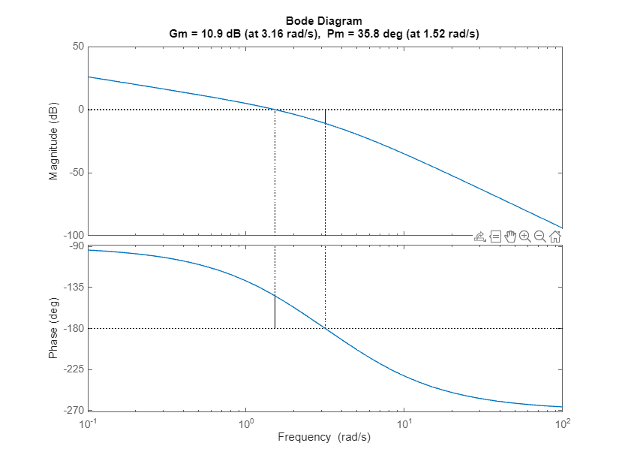

Experiment – 10

OBJECTIVE: Plot Nyquist plot for given transfer function. Also determine the relative stability by measuring gain and phase margin.

SOFTWARE REQUIRED: MATLAB

PROGRAM:

gshs1 = tf([2],[1 4]) % order 1
figure
subplot(2,2,1)
nyquist(gshs1);
gshs2 = tf([4], [1 6 8]) %order 2
subplot(2,2,2)
nyquist(gshs2);
gshs3 = tf([2],[1 4 2 6]) % order 3
subplot(2,2,3)
nyquist(gshs3);
gshs4 = tf([4],[1 4 0]) % order 2 type 1
[R,I,w] = nyquist(gshs4);
Mag = abs(R+I*i);
Phi = angle(R+I*i);
for j=1:1:length(R)
mag1(j) = Mag(j);
phi1(j) = Phi(j);
end
subplot(2,2,4)
nyquist(gshs4)
figure
polar(phi1,mag1)

FIGURE:

