**Iryna Tyshchenko**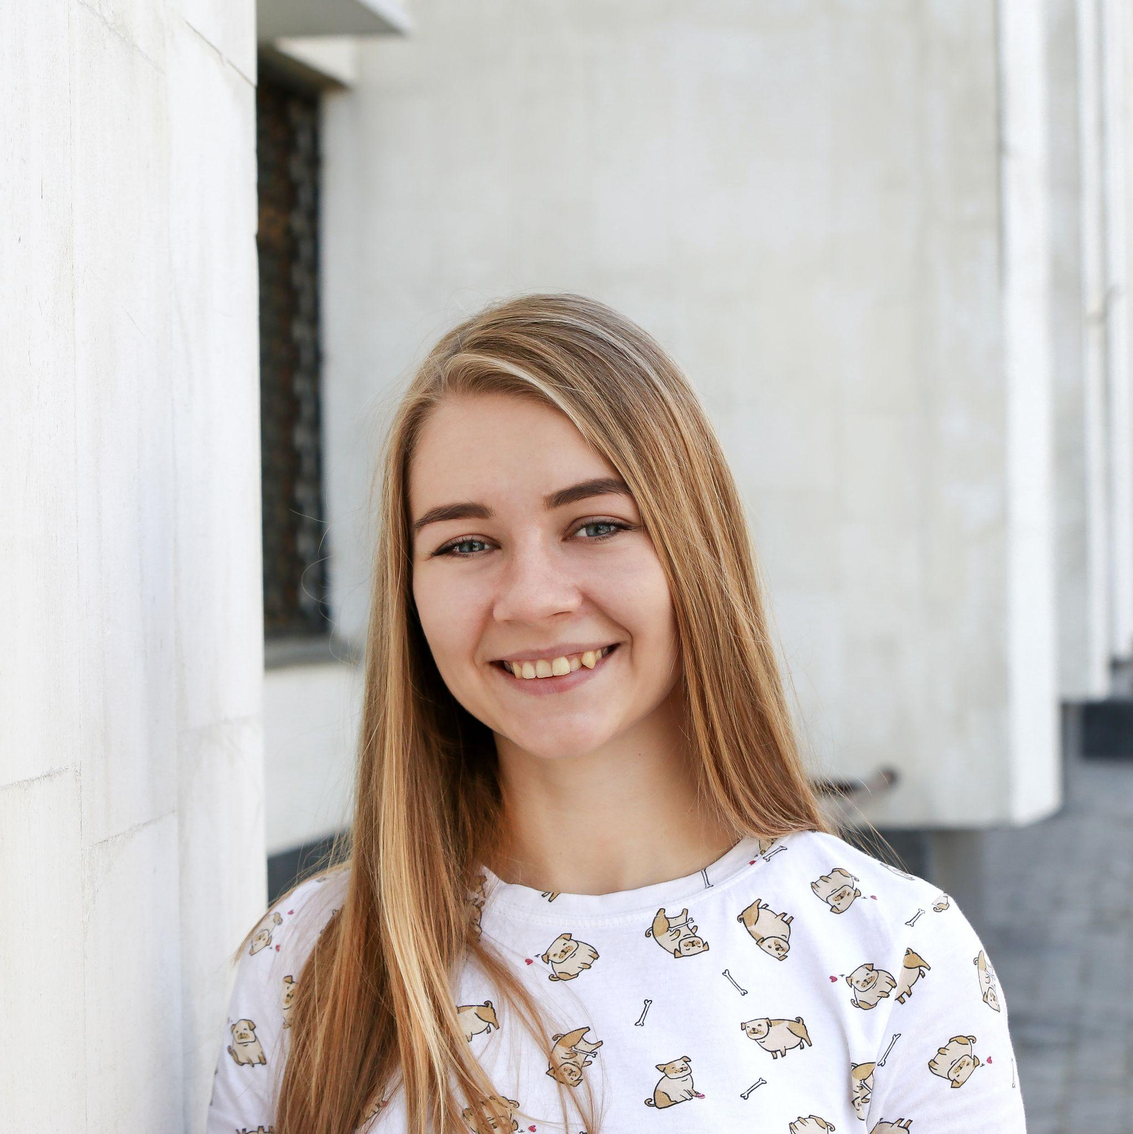

**QA Engineer  
  
Contact info:**City: Chernihiv

Email: ikvasha92@gmail.com

Mobile phone: 0632087954

**Summary**Has a good understanding of QC processes, requirements, testing types, and methodology.

Has good communication and organization skills, positive and responsible person.

I am a self-motivated person that interested in QA and the IT community in general. I can pick up new skills and knowledge quickly and efficiently  
**Technical Skills  
RDBMS/ Databases servers**My SQL  
**Operating Systems**Microsoft Windows 7/10  
MacOS  
Have experience with Linux (ubuntu)  
  
**Tools and Technologies**  
Technical Documentation/ SRS  
XML  
JSON  
MySQL  
Selenium IDE  
Git  
SourseTre  
Fiddler Everywhere  
HTML/CSS  
Rest API   
Postman  
experience working with bug reports

experience with creating a test plan

experience with creating test cases

experience with creating check-lists

**Other**Agile  
SCRUM  
Kanban  
Waterfall  
  
**Experience:**

* GeekHub Project Med Helper: March 2021- May 2021;
* GeekHub: October 2020 - May 2021;
* QATestLab: February 2020 – March 2020;

**Languages:**

* English – Pre-intermediate