El Cerrito–Kensington Fire Incident Analysis

Ira Sharenow

July 28, 2025

## Introduction

This report analyzes data from the El Cerrito Fire Department. I obtained the data via a Public Records Act request from the California Fire Department.

The data is for the years 2017-2024.

I analyzed data where the fire department was under the auspices of the El Cerrito Fire Department. There are two fire stations located in El Cerrito. The Kensington Fire Station is under contract with El Cerrito, so that data was also included.  
<https://el-cerrito.org/133/Fire-Department>

**Important note about the data.**  
For most of the data, I only counted an incident number one time. So if several fire stations went to an incident or a single fire station brought several pieces of equipment, I still only counted that as one incident.  
Except for the last few figures, only incidents in El Cerrito and Kensington were counted.  
The last few figures count the work of each fire station. Finally, every row of data is counted in some of the final tables. This will be noted in the comments associated with those figures.  
It is also important to note that until the last few figures, I only counted data where an actual street address was provided. So if the address was given as “San Pablo Avenue” or “I-80”, it was not counted. This removed over 10% of the data. For policy decisions, I do not believe the deleted data makes a difference. That data is included in some of the final tables.  
El Cerrito changed its fire department numbering. Station 71 became 51. Station 72 became 52. Station 65 became 55. I used the current numbering throughout the report.

This report was created using the *R Markdown language in RStudio.* The maps are from *Google Maps.*

## Main Takeaways

* Station 51 has about four times the workload of each of the other stations
* Building fires represent a very small portion of the workload
* Emergency Medical Services is the largest segment of the workload.
* The year to year workload varies by a very significant amount
* Seasonal variation was not significantly different
* There were statistically signficant differences for response times based on region – El Cerrito West, El Cerrito East, Kensington

### Part 1: Incident Counts

The heat map shows shows where the incidents occurred by frequency. The area around the Del Norte BART Station has a great number of incidents. The area around the El Cerrito Plaza BART Station also had a significant number of incidents.

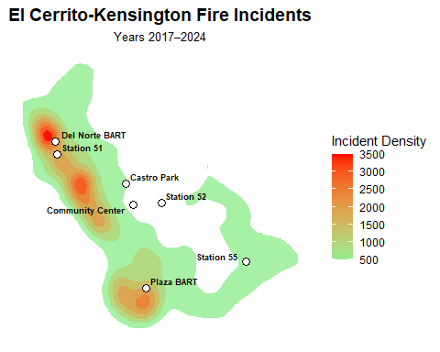

The heat map shows shows where the Emergency Medical Services (EMS, 321) incidents occurred by frequency. The area around the Del Norte BART Station has a great number of incidents. The area around the El Cerrito Plaza BART Station also had a significant number of incidents.

The 321 incidents are a point of emphasis throughout this report. 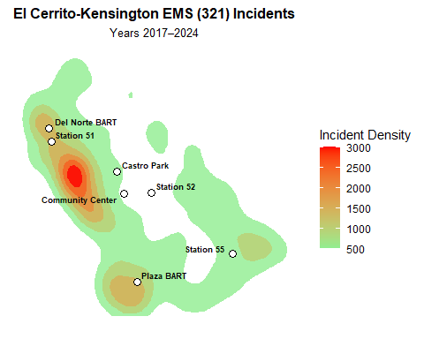

This table is a simple count of the number of incidents that occurred in El Cerrito or Kensington from 2017-2024 that were handled by the three fire stations. About 35% of the calls were EMD (321).

Table 1AE. Total and EMS (Code 321) Incidents (2017–2024)

| **All Incidents** | **EMS Incidents** | **Percent EMS** |
| --- | --- | --- |
| 20,743 | 7,151 | 34.5% |

This table breaks down the incidents on an East-West basis The split divide is approximately Richmond Street. Richmond Street and everything west is the West group. East of Richmond Street is in the East group.

Table 1A_EW. Incident Counts by Richmond Street East–West Region

| **East–West Region** | **All Incidents** | **EMS Incidents** | **Percent EMS** |
| --- | --- | --- | --- |
| East | 12,021 | 4,428 | 36.8% |
| West | 8,722 | 2,723 | 31.2% |

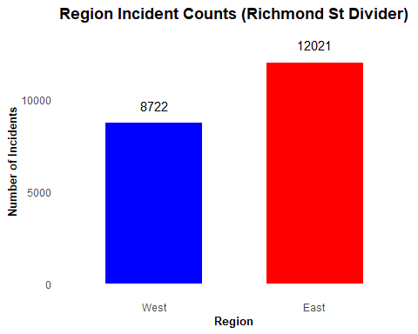

The annual count shows the signfiant variability from year to year. The Covid pandemic was declared in March 2020 and ended in May 2023.

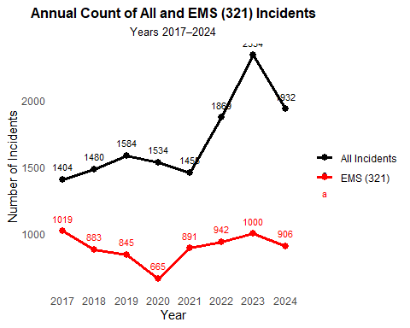

The monthly count of incidents shows that the count peaks in December and January and diminishes during May, June, and July.

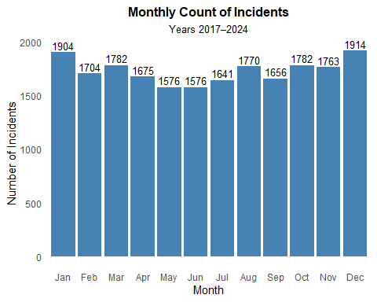

This chart and the next one show that a large number of incidents occur near the two BART stations. We first saw this with the heat maps. Now we see the numbers.

Table 4A. Fire Incidents Within 500 Feet of Key Locations (2017–2024)

| **Location** | **Incident Count (within 500 ft)** |
| --- | --- |
| Plaza BART | 426 |
| Del Norte BART | 892 |
| Castro Park Pickleball | 126 |
| El Cerrito Community Center | 51 |

Table 4AE. All and EMS (321) Incidents Within 500 Feet of Key Locations (2017–2024)

| **Location** | **All Incidents** | **EMS (321) Incidents** | **Percent EMS** |
| --- | --- | --- | --- |
| Plaza BART | 426 | 130 | 30.5% |
| Del Norte BART | 892 | 234 | 26.2% |
| Castro Park Pickleball | 126 | 66 | 52.4% |
| El Cerrito Community Center | 51 | 13 | 25.5% |

### Part 2: Response Times

Now the report moves from counts to resphis had a signficant effect on the mean but very little effect on the median.

Both the median and the mean tell the same story. Responses are faster to the west of Richmond Street than to the east. I discussed this with a fire captain who said the reason was the terrain. West of Richmond Street is mostly flat and laid out in a grid. East of Richmond Street is very hilly.

Table E2-321. EMS (Code 321) First Response Times by East–West Region

| **Side** | **Incident Count** | **Mean Response Time (min)** | **Median Response Time (min)** |
| --- | --- | --- | --- |
| Total | 6,810 | 6.7 | 6.4 |
| East | 4,220 | 7.2 | 6.9 |
| West | 2,590 | 5.9 | 5.6 |

Table E2-CITY. First Response Times by City and Incident Type

| **City** | **Incident Type** | **Incident Count** | **Mean Response Time (min)** | **Median Response Time (min)** |
| --- | --- | --- | --- | --- |
| El Cerrito | All Incidents | 13,284 | 7.3 | 6.6 |
| Kensington | All Incidents | 2,593 | 8.4 | 7.6 |
| El Cerrito | EMS (321) | 5,516 | 6.5 | 6.2 |
| Kensington | EMS (321) | 1,294 | 7.7 | 7.3 |

The histogram clearly shows that the West region receives faster response times.

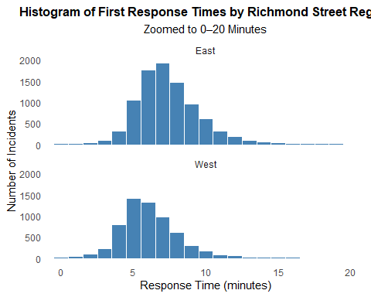

El Cerrito receives faster response times than Kensington.

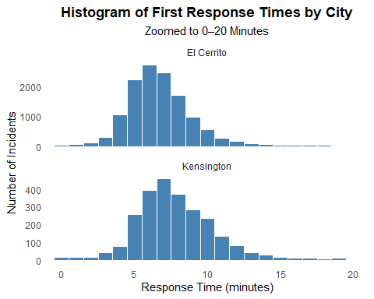

The boxplot continues to tell the same story with respect to response times. El Cerrito West receives the fastest response times. Then El Cerrito East. Then Kensington.

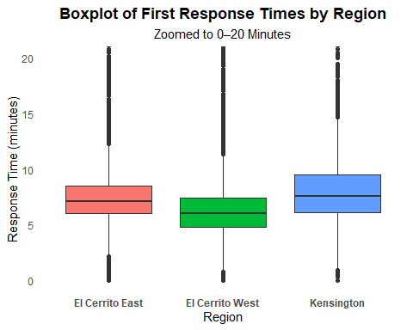

### Part 3: Station Level Data

Now the counts include every station that participated in an incident.

The first tables counts the number of incidents that each station participated in.  
The Station 51 count far exceeds the count of the other two stations. The EMS percentage of incidents also varies signficantly.

Table E3. Incident Counts by Station (2017–2024)

| **Station** | **All Incidents** | **321 Incidents** | **% 321** |
| --- | --- | --- | --- |
| 51 | 14,523 | 4,323 | 29.8% |
| 52 | 3,650 | 1,268 | 34.7% |
| 55 | 4,785 | 1,931 | 40.4% |

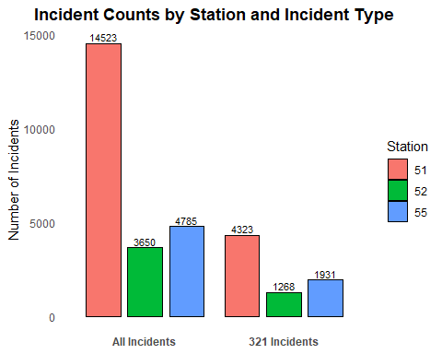

Table E3_REGIONS. Station Incident Counts by Region (With Totals)

| **Station** | **EC East** | **EC West** | **Kensington** | **Total** |
| --- | --- | --- | --- | --- |
| 51 | 5,734 | 6,988 | 140 | 12,862 |
| 52 | 1,670 | 1,570 | 195 | 3,435 |
| 55 | 1,586 | 164 | 2,888 | 4,638 |
| Total | 8,990 | 8,722 | 3,223 | 20,935 |

The total times on job now looks at every row of data, *all activity by the three stations is now included* so a station might have several pieces of equipment particpating in an incident. Every piece of equipment was counted. The time starts when the call center receives the call and ends when the last workers leave.

Table E5. Total Time on Job by Station and Year (Hours)

| YEAR | 51 | 52 | 55 | Row_Total |
| --- | --- | --- | --- | --- |
| 2017 | 1,676 | 377 | 535 | 2,587 |
| 2018 | 2,603 | 483 | 717 | 3,804 |
| 2019 | 2,372 | 595 | 746 | 3,713 |
| 2020 | 1,466 | 345 | 511 | 2,322 |
| 2021 | 1,368 | 398 | 731 | 2,498 |
| 2022 | 1,938 | 464 | 746 | 3,148 |
| 2023 | 4,018 | 715 | 1,016 | 5,749 |
| 2024 | 2,678 | 669 | 783 | 4,129 |
| Total | 18,120 | 4,045 | 5,785 | 27,950 |

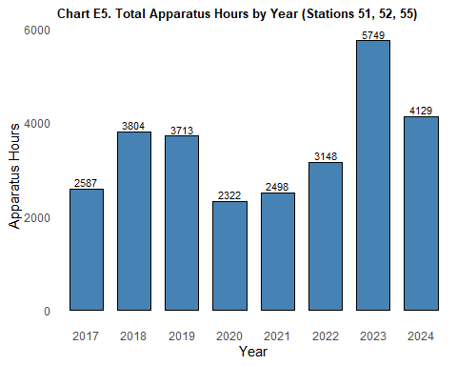

This table shows the activity of the El Cerrito-Kensington Fire Department by city. Interestingly, the spent more hours in Richmond than in Kensington. El Cerrito has a mutual aid agreement with Richmond.

Table E6. Total Apparatus Hours by City and Year (2017–2024)

| INCIDENT_CITY_CLEAN | 2017 | 2018 | 2019 | 2020 | 2021 | 2022 | 2023 | 2024 | RowTotal |
| --- | --- | --- | --- | --- | --- | --- | --- | --- | --- |
| El Cerrito | 2,230 | 3,316 | 3,241 | 1,920 | 2,001 | 2,686 | 5,024 | 3,611 | 24,029 |
| Richmond | 428 | 417 | 512 | 654 | 690 | 515 | 511 | 541 | 4,268 |
| Kensington | 359 | 492 | 468 | 404 | 499 | 468 | 721 | 518 | 3,929 |
| San Pablo | 43 | 72 | 70 | 140 | 103 | 118 | 86 | 148 | 780 |
| Idylwild | 0 | 732 | 0 | 0 | 0 | 0 | 0 | 0 | 732 |
| Shasta | 0 | 424 | 0 | 0 | 0 | 0 | 0 | 0 | 424 |
| Yreka | 0 | 0 | 0 | 0 | 0 | 0 | 0 | 198 | 198 |
| Orinda | 25 | 17 | 17 | 62 | 26 | 12 | 3 | 25 | 187 |
| Mariposa | 164 | 0 | 0 | 0 | 0 | 0 | 0 | 0 | 164 |
| Pinole | 5 | 19 | 48 | 8 | 47 | 8 | 2 | 9 | 146 |
| **Undefined | 14 | 16 | 6 | 2 | 11 | 12 | 21 | 47 | 129 |
| El Sobrante | 2 | 6 | 9 | 20 | 34 | 7 | 0 | 43 | 121 |
| East Richmond Height | 16 | 21 | 16 | 12 | 22 | 0 | 3 | 13 | 103 |
| Berkeley | 11 | 1 | 11 | 26 | 10 | 11 | 6 | 20 | 96 |
| Hercules | 1 | 17 | 5 | 22 | 13 | 25 | 6 | 0 | 89 |
| Rodeo | 9 | 1 | 0 | 52 | 7 | 1 | 5 | 7 | 82 |
| Crockett | 0 | 0 | 39 | 35 | 0 | 0 | 1 | 0 | 75 |
| Martinez | 0 | 0 | 13 | 1 | 0 | 11 | 1 | 0 | 26 |
| Albany | 2 | 0 | 2 | 2 | 1 | 12 | 1 | 0 | 20 |
| Oakley | 0 | 0 | 16 | 0 | 0 | 0 | 2 | 2 | 20 |
| Contra Costa County | 1 | 4 | 3 | 2 | 5 | 0 | 1 | 0 | 16 |
| Brentwood | 2 | 0 | 0 | 0 | 6 | 0 | 0 | 2 | 10 |
| Antioch | 2 | 0 | 1 | 2 | 1 | 0 | 2 | 0 | 8 |
| Moraga | 0 | 0 | 3 | 2 | 2 | 1 | 0 | 0 | 8 |
| Moraga-Orinda | 1 | 0 | 0 | 0 | 0 | 7 | 0 | 0 | 8 |
| Fairfield | 0 | 7 | 0 | 0 | 0 | 0 | 0 | 0 | 7 |
| Oakland | 0 | 0 | 0 | 0 | 3 | 0 | 0 | 4 | 7 |
| Vallejo | 4 | 0 | 3 | 0 | 0 | 0 | 0 | 0 | 7 |
| Ebrp | 0 | 0 | 5 | 0 | 0 | 0 | 0 | 0 | 5 |
| Suisun City | 0 | 0 | 0 | 4 | 0 | 0 | 0 | 0 | 4 |
| Briones | 0 | 0 | 0 | 0 | 2 | 1 | 0 | 0 | 3 |
| Concord | 0 | 0 | 0 | 0 | 0 | 0 | 3 | 0 | 3 |
| Pacifica | 0 | 0 | 0 | 0 | 0 | 0 | 3 | 0 | 3 |
| Walnut Creek | 0 | 1 | 2 | 0 | 0 | 0 | 0 | 0 | 3 |
| Danville | 0 | 0 | 2 | 0 | 0 | 0 | 0 | 0 | 2 |
| Pittsburg | 0 | 0 | 0 | 2 | 0 | 0 | 0 | 0 | 2 |
| Vacaville | 0 | 0 | 0 | 2 | 0 | 0 | 0 | 0 | 2 |
| Alamo | 0 | 0 | 0 | 0 | 0 | 0 | 1 | 0 | 1 |
| Canyon | 0 | 0 | 0 | 0 | 0 | 0 | 0 | 1 | 1 |
| Clayton | 0 | 0 | 0 | 0 | 0 | 0 | 1 | 0 | 1 |
| Daly City | 0 | 0 | 0 | 0 | 0 | 1 | 0 | 0 | 1 |
| Lafayette | 0 | 0 | 0 | 0 | 0 | 0 | 1 | 0 | 1 |
| Morago | 0 | 0 | 0 | 0 | 1 | 0 | 0 | 0 | 1 |
| San Mateo | 0 | 0 | 0 | 0 | 0 | 1 | 0 | 0 | 1 |
| Santa Rosa | 0 | 0 | 0 | 1 | 0 | 0 | 0 | 0 | 1 |
| Tilden Park (Orinda) | 0 | 0 | 1 | 0 | 0 | 0 | 0 | 0 | 1 |
| Tilden Regional Park | 0 | 1 | 0 | 0 | 0 | 0 | 0 | 0 | 1 |
| Pleasant Hill | 0 | 0 | 0 | 0 | 0 | 0 | 0 | 0 | 0 |
| San Pablo Ave | 0 | 0 | 0 | 0 | 0 | 0 | 0 | 0 | 0 |
| Tilden Park | 0 | 0 | 0 | 0 | 0 | 0 | 0 | 0 | 0 |
| Total | 3,319 | 5,564 | 4,493 | 3,375 | 3,484 | 3,897 | 6,405 | 5,189 | 35,726 |

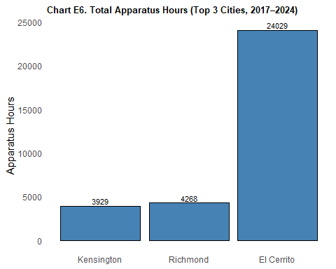

This table clearly shows that the EMS (321) calls is the leading type of calls.

Table E7. Total Apparatus Hours by Incident Type and Year (2017–2024)

| INCIDENT_TYPE | 2017 | 2018 | 2019 | 2020 | 2021 | 2022 | 2023 | 2024 | RowTotal |
| --- | --- | --- | --- | --- | --- | --- | --- | --- | --- |
| 321 EMS call, excluding vehicl | 1,222 | 1,908 | 1,785 | 891 | 1,208 | 1,427 | 1,890 | 1,703 | 12,034 |
| 500 Service call, other | 7 | 253 | 904 | 609 | 502 | 515 | 577 | 660 | 4,027 |
| 900 Special incident type, oth | 0 | 1 | 9 | 0 | 2 | 354 | 2,275 | 524 | 3,165 |
| 611 Dispatched & canceled enro | 327 | 481 | 413 | 319 | 319 | 297 | 361 | 427 | 2,944 |
| 111 Building fire | 154 | 222 | 200 | 549 | 382 | 319 | 219 | 499 | 2,544 |
| 311 Medical assist, assist EMS | 588 | 701 | 196 | 35 | 43 | 30 | 100 | 24 | 1,717 |
| 141 Forest, woods, or wildland | 13 | 1,156 | 16 | 15 | 0 | 0 | 0 | 7 | 1,207 |
| 322 Vehicle accident with inju | 137 | 152 | 106 | 111 | 155 | 129 | 135 | 152 | 1,077 |
| 142 Brush, or brush and grass | 223 | 38 | 26 | 73 | 48 | 38 | 69 | 44 | 559 |
| 571 Cover assignment, standby, | 6 | 1 | 2 | 10 | 0 | 0 | 1 | 351 | 371 |
| 444 Power line down | 49 | 5 | 30 | 25 | 29 | 9 | 35 | 115 | 297 |
| 554 Assist invalid | 9 | 7 | 33 | 35 | 44 | 69 | 53 | 47 | 297 |
| 550 Public service assistance, | 54 | 54 | 43 | 27 | 29 | 22 | 30 | 24 | 283 |
| 400 Hazardous conditions – No | 43 | 19 | 26 | 13 | 42 | 16 | 43 | 61 | 263 |
| 324 Motor vehicle accident wit | 16 | 35 | 36 | 17 | 55 | 27 | 34 | 12 | 232 |
| 743 Smoke detector activation, | 25 | 52 | 34 | 18 | 32 | 27 | 25 | 15 | 228 |
| 651 Smoke scare, odor of smoke | 36 | 33 | 26 | 37 | 25 | 18 | 12 | 18 | 205 |
| 140 Natural vegetation fire, o | 2 | 0 | 26 | 93 | 12 | 56 | 8 | 3 | 200 |
| 150 Outside rubbish fire, othe | 3 | 8 | 9 | 15 | 49 | 39 | 29 | 38 | 190 |
| 118 Trash or rubbish fire in a | 4 | 33 | 25 | 27 | 16 | 14 | 22 | 35 | 176 |
| 131 Passenger vehicle fire | 7 | 9 | 9 | 28 | 29 | 42 | 39 | 13 | 176 |
| 700 False alarms & false calls | 16 | 14 | 33 | 14 | 21 | 25 | 29 | 21 | 173 |
| 323 Motor vehicle/pedestrian a | 23 | 32 | 25 | 9 | 17 | 5 | 19 | 36 | 166 |
| 622 No accident found at dispa | 8 | 16 | 16 | 21 | 16 | 22 | 26 | 25 | 150 |
| 412 Gas leak (natural gas or L | 16 | 13 | 29 | 12 | 19 | 16 | 30 | 11 | 146 |
| 151 Outside rubbish, trash, or | 4 | 8 | 11 | 30 | 45 | 20 | 19 | 8 | 145 |
| 113 Cooking fire, confined to | 11 | 15 | 20 | 26 | 16 | 16 | 22 | 17 | 143 |
| 733 Smoke detector activation | 15 | 17 | 28 | 14 | 18 | 21 | 16 | 14 | 143 |
| 735 Alarm system activation du | 20 | 7 | 2 | 11 | 18 | 20 | 19 | 30 | 127 |
| 520 Water problem, other | 14 | 11 | 17 | 9 | 11 | 39 | 18 | 7 | 126 |
| 553 Public service, not govern | 14 | 9 | 11 | 16 | 17 | 20 | 22 | 9 | 118 |
| 440 Electrical wiring/equipmen | 8 | 7 | 28 | 24 | 20 | 11 | 10 | 6 | 114 |
| 740 Unintentional system/detec | 13 | 9 | 24 | 15 | 9 | 17 | 14 | 10 | 111 |
| 143 Grass fire, includes fire | 22 | 13 | 45 | 2 | 2 | 10 | 6 | 0 | 100 |
| 600 Good intent call, other | 38 | 13 | 16 | 8 | 9 | 6 | 7 | 3 | 100 |
| 381 Rescue or EMS standby, haz | 15 | 30 | 6 | 26 | 6 | 2 | 4 | 9 | 98 |
| 522 Water or steam leak, inclu | 21 | 9 | 11 | 2 | 7 | 14 | 15 | 11 | 90 |
| 100 Fire, other | 7 | 17 | 15 | 7 | 3 | 20 | 12 | 4 | 85 |
| 445 Arcing, shorted electrical | 8 | 4 | 9 | 7 | 5 | 3 | 29 | 17 | 82 |
| 551 Assist police or other gov | 11 | 10 | 14 | 6 | 8 | 20 | 6 | 5 | 80 |
| 745 Alarm system activation, n | 8 | 10 | 10 | 10 | 8 | 6 | 12 | 10 | 74 |
| 160 Special outside fire, othe | 1 | 0 | 31 | 0 | 21 | 1 | 3 | 6 | 63 |
| 320 Emergency medical service | 0 | 1 | 0 | 0 | 2 | 0 | 1 | 59 | 63 |
| 552 Police matter | 9 | 4 | 9 | 4 | 4 | 16 | 5 | 4 | 55 |
| 744 Detector activation, no fi | 5 | 5 | 2 | 12 | 8 | 6 | 15 | 2 | 55 |
| 353 Removal of victim(s) from | 1 | 1 | 11 | 0 | 10 | 13 | 2 | 6 | 44 |
| 352 Extrication of victim(s) f | 0 | 10 | 0 | 22 | 3 | 5 | 2 | 0 | 42 |
| 112 Fires in structure other t | 0 | 0 | 0 | 25 | 0 | 10 | 2 | 3 | 40 |
| 114 Chimney of flue fire, conf | 8 | 10 | 1 | 1 | 2 | 15 | 0 | 3 | 40 |
| 132 Road freight or transport | 0 | 2 | 10 | 1 | 22 | 4 | 0 | 0 | 39 |
| 300 Rescue and EMS incidents, | 0 | 0 | 4 | 0 | 13 | 8 | 9 | 5 | 39 |
| 746 Carbon monoxide detector a | 3 | 5 | 10 | 5 | 4 | 0 | 5 | 7 | 39 |
| 161 Outside storage fire on re | 0 | 0 | 0 | 15 | 22 | 0 | 0 | 0 | 37 |
| 162 Outside equipment fire | 0 | 0 | 0 | 18 | 12 | 4 | 0 | 0 | 34 |
| 710 Malicious, mischievous fal | 4 | 8 | 1 | 2 | 2 | 0 | 7 | 10 | 34 |
| 422 Chemical spill or leak | 0 | 0 | 32 | 0 | 0 | 0 | 0 | 0 | 32 |
| 730 System or detector malfunc | 1 | 8 | 4 | 6 | 1 | 3 | 4 | 3 | 30 |
| 736 Carbon monoxide detector a | 5 | 5 | 3 | 3 | 3 | 1 | 6 | 4 | 30 |
| 411 Gasoline or other flammabl | 1 | 9 | 2 | 2 | 3 | 8 | 3 | 1 | 29 |
| 812 Flood assessment, no water | 0 | 0 | 0 | 0 | 12 | 2 | 3 | 11 | 28 |
| 350 Extrication rescue, other | 1 | 1 | 5 | 0 | 7 | 3 | 10 | 0 | 27 |
| 741 Sprinkler activation, no f | 10 | 1 | 3 | 4 | 0 | 8 | 0 | 1 | 27 |
| 531 Smoke or odor removal | 10 | 4 | 5 | 1 | 2 | 0 | 1 | 1 | 24 |
| 251 Excessive heat, scorch bur | 0 | 1 | 8 | 8 | 1 | 0 | 4 | 1 | 23 |
| 154 Dumpster or other outside | 2 | 2 | 0 | 2 | 8 | 2 | 1 | 2 | 19 |
| 721 Bomb scare – no bomb | 0 | 9 | 10 | 0 | 0 | 0 | 0 | 0 | 19 |
| 424 Carbon monoxide incident | 0 | 1 | 1 | 0 | 3 | 3 | 1 | 6 | 15 |
| 511 Lock-out | 2 | 3 | 1 | 2 | 1 | 1 | 3 | 2 | 15 |
| 117 Commercial compactor fire, | 0 | 0 | 0 | 0 | 0 | 1 | 0 | 12 | 13 |
| 461 Building or structure weak | 1 | 2 | 0 | 0 | 0 | 4 | 6 | 0 | 13 |
| 800 Severe weather & natural d | 12 | 0 | 0 | 0 | 0 | 0 | 1 | 0 | 13 |
| 122 Fire in motor home, camper | 2 | 0 | 0 | 0 | 9 | 1 | 0 | 0 | 12 |
| 542 Animal rescue | 0 | 0 | 0 | 0 | 2 | 3 | 5 | 2 | 12 |
| 341 Search for person on land | 0 | 1 | 0 | 6 | 2 | 1 | 1 | 0 | 11 |
| 650 Steam, other gas mistaken | 1 | 0 | 0 | 7 | 0 | 0 | 1 | 1 | 10 |
| 463 Vehicle accident, general | 2 | 2 | 4 | 0 | 0 | 0 | 0 | 1 | 9 |
| 442 Overheated motor or wiring | 0 | 6 | 0 | 0 | 0 | 0 | 1 | 0 | 7 |
| 471 Explosive, bomb removal (f | 0 | 7 | 0 | 0 | 0 | 0 | 0 | 0 | 7 |
| 653 Smoke from barbeque, tar k | 0 | 2 | 2 | 0 | 3 | 0 | 0 | 0 | 7 |
| 213 Steam rupture of pressure | 6 | 0 | 0 | 0 | 0 | 0 | 0 | 0 | 6 |
| 413 Oil or other combustible l | 0 | 0 | 0 | 2 | 2 | 0 | 0 | 2 | 6 |
| 510 Person in distress, other | 0 | 2 | 0 | 0 | 1 | 3 | 0 | 0 | 6 |
| 561 Unauthorized burning | 1 | 0 | 0 | 1 | 1 | 0 | 3 | 0 | 6 |
| 734 Heat detector activation d | 0 | 4 | 0 | 0 | 0 | 1 | 1 | 0 | 6 |
| 714 Central station, malicious | 2 | 1 | 0 | 1 | 1 | 0 | 0 | 0 | 5 |
| 155 Outside or stationary comp | 0 | 0 | 4 | 0 | 0 | 0 | 0 | 0 | 4 |
| 331 Lock-in (if lock-out, use | 0 | 0 | 2 | 1 | 0 | 1 | 0 | 0 | 4 |
| 410 Combustible/flammable spil | 0 | 1 | 0 | 0 | 1 | 1 | 0 | 1 | 4 |
| 460 Accident, potential accide | 0 | 0 | 1 | 0 | 1 | 0 | 2 | 0 | 4 |
| 480 Attempted burning, illegal | 0 | 0 | 0 | 2 | 0 | 2 | 0 | 0 | 4 |
| 711 Municipal alarm system, ma | 0 | 0 | 2 | 0 | 0 | 0 | 1 | 1 | 4 |
| 138 Off-road vehicle or heavy | 2 | 0 | 0 | 1 | 0 | 0 | 0 | 0 | 3 |
| 512 Ring or jewelry removal, n | 0 | 0 | 0 | 0 | 0 | 1 | 1 | 1 | 3 |
| 521 Water (not people) evacuat | 0 | 3 | 0 | 0 | 0 | 0 | 0 | 0 | 3 |
| 911 Citizen complaint, include | 1 | 2 | 0 | 0 | 0 | 0 | 0 | 0 | 3 |
| 130 Mobile property (vehicle) | 0 | 0 | 0 | 0 | 1 | 1 | 0 | 0 | 2 |
| 351 Extrication of victim(s) f | 1 | 0 | 0 | 0 | 0 | 0 | 0 | 1 | 2 |
| 356 High angle rescue | 0 | 0 | 0 | 0 | 0 | 0 | 2 | 0 | 2 |
| 441 Heat from short circuit (w | 2 | 0 | 0 | 0 | 0 | 0 | 0 | 0 | 2 |
| 555 Defective elevator, no occ | 0 | 0 | 0 | 0 | 1 | 1 | 0 | 0 | 2 |
| 652 Steam, vapor, fog or dust | 0 | 0 | 0 | 1 | 0 | 0 | 0 | 1 | 2 |
| 671 Hazmat release investigati | 1 | 0 | 1 | 0 | 0 | 0 | 0 | 0 | 2 |
| 715 Local alarm system, malici | 1 | 1 | 0 | 0 | 0 | 0 | 0 | 0 | 2 |
| 116 Fuel burner/boiler malfunc | 0 | 0 | 0 | 0 | 0 | 1 | 0 | 0 | 1 |
| 123 Fire in portable building, | 0 | 0 | 0 | 1 | 0 | 0 | 0 | 0 | 1 |
| 133 Rail vehicle fire | 0 | 0 | 0 | 0 | 0 | 1 | 0 | 0 | 1 |
| 137 Camper or recreational veh | 0 | 0 | 0 | 0 | 1 | 0 | 0 | 0 | 1 |
| 240 Explosion (no fire) | 0 | 0 | 0 | 0 | 0 | 1 | 0 | 0 | 1 |
| 621 Wrong location | 0 | 0 | 0 | 1 | 0 | 0 | 0 | 0 | 1 |
| 713 Telephone, malicious false | 0 | 0 | 0 | 1 | 0 | 0 | 0 | 0 | 1 |
| 813 Wind storm, tornado/hurric | 1 | 0 | 0 | 0 | 0 | 0 | 0 | 0 | 1 |
| 163 Outside gas or vapor combu | 0 | 0 | 0 | 0 | 0 | 0 | 0 | 0 | 0 |
| 210 Overpressure rupture from | 0 | 0 | 0 | 0 | 0 | 0 | 0 | 0 | 0 |
| 340 Search for lost person, ot | 0 | 0 | 0 | 0 | 0 | 0 | 0 | 0 | 0 |
| 420 Chemical release, reaction | 0 | 0 | 0 | 0 | 0 | 0 | 0 | 0 | 0 |
| 540 Animal problem or rescue, | 0 | 0 | 0 | 0 | 0 | 0 | 0 | 0 | 0 |
| 541 Animal problem | 0 | 0 | 0 | 0 | 0 | 0 | 0 | 0 | 0 |
| 631 Authorized controlled burn | 0 | 0 | 0 | 0 | 0 | 0 | 0 | 0 | 0 |
| 641 Vicinity alarm (incident i | 0 | 0 | 0 | 0 | 0 | 0 | 0 | 0 | 0 |
| 712 Direct tie to FD, maliciou | 0 | 0 | 0 | 0 | 0 | 0 | 0 | 0 | 0 |
| Total | 3,316 | 5,556 | 4,493 | 3,374 | 3,488 | 3,898 | 6,404 | 5,185 | 35,714 |

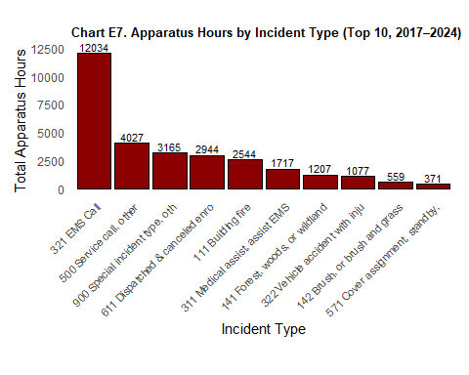

### Part 4: Statisitcal Analysis

**Analyzing “Monthly Count of Incidents”**

**Summary for Policymakers:** An analysis of monthly fire incident counts in El Cerrito from 2017 through 2024 found no meaningful seasonal patterns. While some months saw slightly more incidents than others, the differences were not statistically significant. This suggests that incident volume is relatively stable throughout the year, and resources should be allocated based on overall demand rather than specific months. Technical Explanation

**Technical Explanation:** An ANOVA was conducted on monthly incident totals across the years 2017–2024 to test whether mean incident counts varied by month. The result was not statistically significant (F(11, 84) = 1.02, p = 0.434), indicating that monthly differences in incident volume could plausibly be due to random variation. Therefore, no strong seasonal effect is present in the incident data over this eight-year period.

**Analyzing Response Times By Region**

**Policy Audience Explanation** We compared emergency response times across El Cerrito East, El Cerrito West, and Kensington. The results show a statistically significant difference among these regions. This suggests that where an incident occurs within El Cerrito or Kensington may influence how quickly responders arrive. Policymakers may wish to explore underlying factors — such as road layout, traffic, or station location — that might contribute to these differences.

**Technical Explanation** An ANOVA was conducted to assess whether mean first response times differ significantly across three defined regions: El Cerrito East, El Cerrito West, and Kensington. The model used RESPONSE_TIME_MIN as the dependent variable and REGION as the independent factor. The results were statistically significant, indicating at least one pair of regions exhibits a meaningful difference in average response time. Post hoc tests (e.g., Tukey HSD) can be used to identify which region pairs differ.